Lawrence Berkeley National Laboratory
Annual Report 2018
July 12, 2018
Mentor: Tony Spadafora
Workshop Coordinator: Laurie Kerrigan
Co- Organizer: Ken Cecire (QuarkNet)

The LBNL Physics Division hosted its twelfth “Physics in and Through Cosmology” workshop for QuarkNet Leadership teachers and high school students. The five-day workshop from June 18 to June 22, 2018 was held at the Lawrence Berkeley National Lab. Fourteen science teachers participated. Six of the teachers have been active members of QuarkNet for five or more years. Five new teachers joined the group this year and three from previous years returned. There were 32 students with approximately equal number of boys and girls. The teachers & students represented public and private high schools in the greater San Francisco Bay Area.
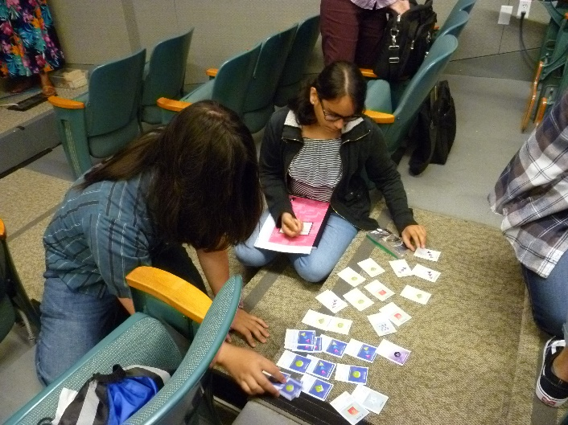

The first day focused on getting all participants familiar with concepts & terms in particle physics & cosmology. This was accomplished through “mini” lectures given by returning QuarkNet teachers. This day also included a discussion by Zachary Slepian, an LBNL researcher, discussing Cosmology Basics. The LBNL 88” cyclotron was also toured.

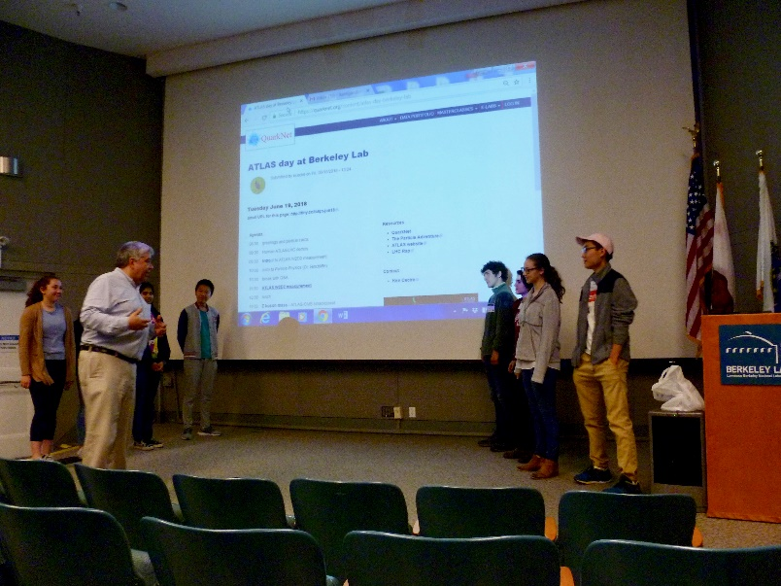
The other days consisted of more tours, and morning & afternoon scientist talks. Between talks, groups worked on hands-on experiments (e.g. QuarkNet activities lead by Ken Cecire using data from ATLAS). Groups consisted of two or three students and a teacher. Groups also discussed the lectures and designed & carried out experiments with Cosmic Ray Detectors. Tours consisted of a virtual tour of the ATLAS Control Room at the CERN Large Hadron Collider, the ALS (Advanced Light Source) and Molecular Foundry or NERSC research facilities at LBNL. We also watched Phantom of the Universe with Michael Barnett at the Chabot Planetarium.

Teachers met with Ken Cecire over lunch on the second day to discuss QuarkNet.

On the last day we had a Panel Discussion with the following researchers from LBL:

Ian Hinchliffe, Nikki Apadula, Ravi Gupta, Parker Anne Fagrelius, Bruce Grossan,

Kelsey Oliver-Mallory, Alex Kim, and Eric Linder.
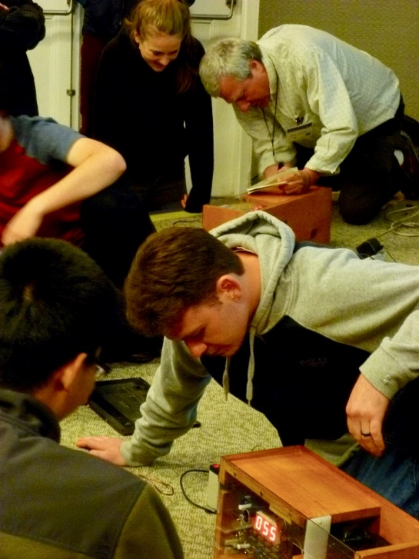
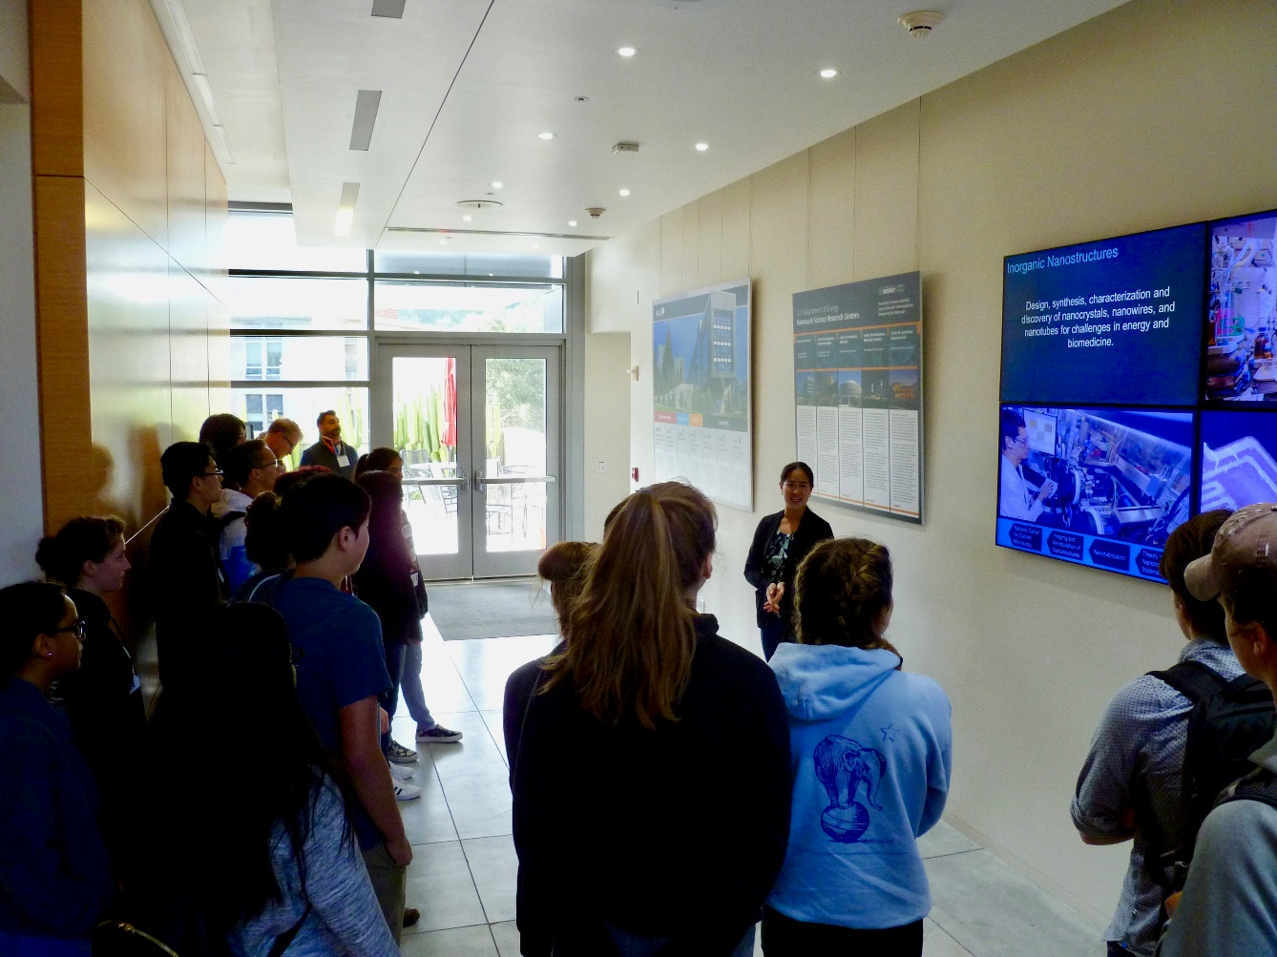

Formal presentations included:

George Smoot - video welcome
Tony Spadafora - Welcome to the Lab & Safety Talk
Zachary Slepian – Cosmo Basics
Ken Cecire - ATLAS activities
Ian Hinchliffe - Particle Physics & Higgs
Nikki Apadula - Heavy Ion Collisions
Ravi Gupta – Super Novae
Parker Anne Fagrelius – DESI
Bruce Grossan – Gamma Ray Bursts
Kelsey Oliver-Mallory - Dark Matter

On the last day students completed a self- evaluation of how much they learned about science concepts during the workshop. They used a scale of 1 (nothing) to 4 (a lot). The overall average was 3.0
Those with 3.5 and up include:
The Red Shift is the stretching of wavelengths revealing time and distance. 3.6
Supernovae are explosions of dying stars, and certain types can serve as a standard candle. 3.5
Space itself is expanding. 3.6
The Universe’s expansion is accelerating due to Dark Energy. 3.6
The Universe is approximately 5% atomic matter, 20% dark matter, and 75% dark energy. 3.7
Scientists use various techniques to determine distances in space. 3.6

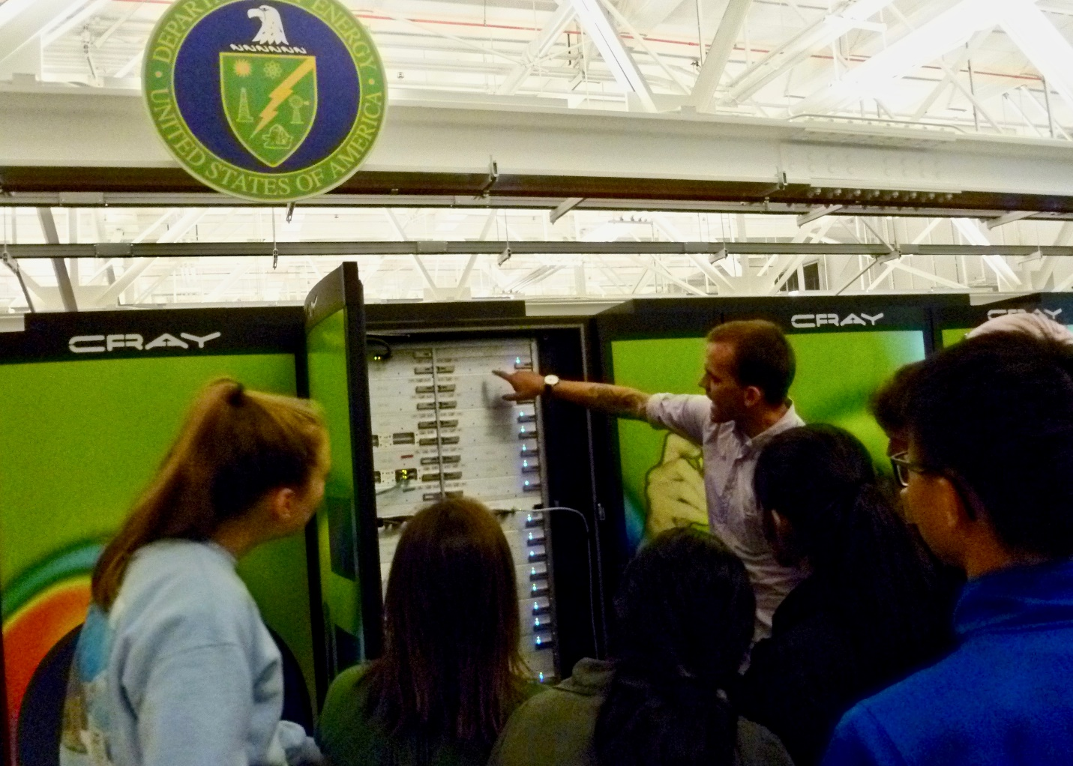

Some comments by the students and teachers include:
“It was uplifting to observe my students make connections between what they had learned in my classroom and the various talks. It was exciting to see that students felt prepared and confident enough to ask questions or volunteer answers.”

“I learned a lot about the universe that I can pass on to my students”.

“I loved going on tours and doing experiments.”
“ The speakers were so informative, it was a great mix of technical and
quantitative information at a level that was great for both students and teachers.”

“I gained a great understanding of the scientific process. I learned a great deal about the universe and how it functions. I like learning about the processing involved in becoming a scientist.”

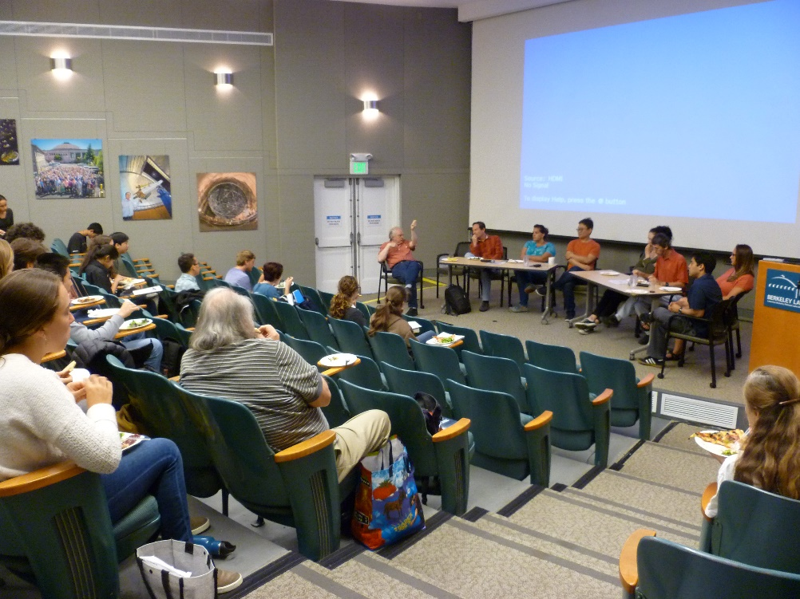
“I enjoyed being treated like we were also smart. I went home feeling so intrigued and interested in my own future.”

“I learned a lot about subatomic particles and their interactions as well as nuclear decay and conversion of mass to energy and back.”

“I really liked having access to such professionals and experts in their field and being exposed to labs and the roles that people play in the professional world of physics and academia. That was very valuable.”

Participating Teachers:
Adams | Raymond
Abdulla | Riaz
Bates | David
Becker | Philip
Eldred | Craig
Guthrie | Laura
Jackson | Virgil
Kerrigan  Marten | Laurie  Bryan
Melnik | Glen
Noblejas | Jeffrey
Risk | Valerie
Stollmeyer | Emily
Williams | Nicholas

