Lawrence Berkeley National Laboratory
Annual Report 2021
Aug. 1, 2021
Mentor: Tony Spadafora
Workshop Coordinator: Laurie Kerrigan
Co- Organizer: Ken Cecire (QuarkNet)

The LBNL Physics Division hosted its fifteenth “Physics in and Through Cosmology” workshop for QuarkNet Leadership teachers and high school students. This four week virtual workshop from June 28 to July 23, 2021 was held via Zoom. Seven physics teachers participated. Five of the teachers have been active members of QuarkNet. One new teacher joined the group this year. There was one retired teacher also, who has been active in QuarkNet throughout his career. 59 students participated. Most of the teachers & students joined from public and private high schools in the greater San Francisco Bay Area, although a few joined from throughout the U.S.

This year we meet about 3 times a week for 3 hours. Most meetings started with short breakout room questions while everyone was joining the Zoom. Then there was a talk by a LBL scientist and either small group work or virtual activities. The small group work included a Scientist Interview Project, and QuarkNet activities led by Ken Cecire. Ken worked with the teachers during one session and then lead three additional sessions guiding everyone through a fundamental particle activity, and analyzing data from ATLAS. The first couple of meetings included some presentations by teachers. Colin Elliot lead a discussion on Wave Basics. Glen Melnik explained Special Relativity in one presentation and in a different presentation discussed cosmic rays. Glen also demonstrated how a cosmic ray detector worked and gave students data to interpret that had been collected in previous years.

Highlights of the program were a drop in visit by Nobel Prize winner, Saul Perlmutter, and a round table panel discussion with the Scientists on the last day. Each small group also presented a short video or Powerpoint about the work the Scientist they interviewed was doing.

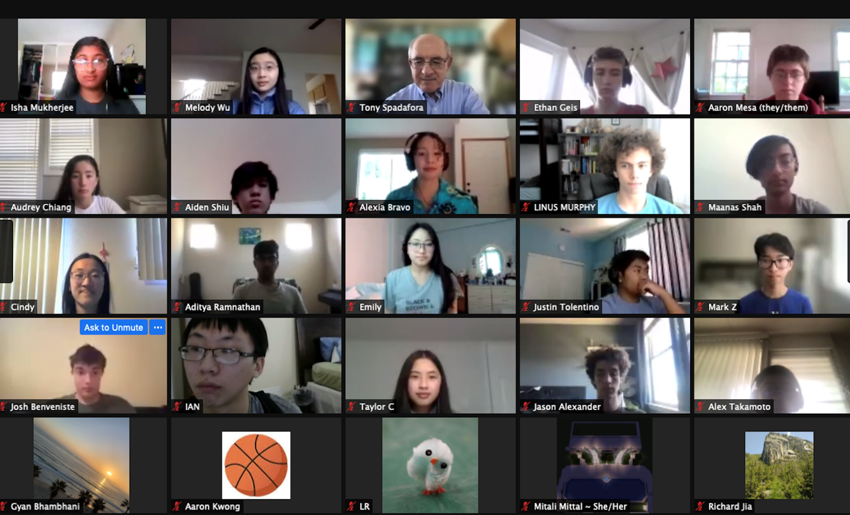
Scientist interviewed by students:
Greg Ottino
Cheng-Ju Stephen Lin
Joe DeRose
George Stein
Elodie Resseguie
Maurice Garcia-Sciveres
Marcelo Alverez
Claire Poppett
Robin Xiong
Peter Madigan
Danny Antrim
Louis-Guillaume Gagnon

Formal presentations by LBNL scientists included:
Natalie Roe Welcome to the Lab
Aritoki Suzuki 13.8 Billion Year Old Photograph
Brooke Morrison The Nu Frontier
Qing (Shilo) Xia In search of his dark materials
George Stein Sloan Digital Sky Survey
Satya Gontcho Unraveling the Dark Universe
Haichen Wang High Energy Physics – ATLAS
Ben Nachman Deep Learning for Particle Physics
Aleksandra Dimitrievska Creating matter from light

Comments from overall evaluations of workshop by teacher & students:
The incredible opportunity to learn more about the universe we live in.

I really liked how we got to learn a variety of topics in particle physics and cosmology. Also, coming into the workshop I barely knew any of the complex physics concepts that were being talked about but by the end of it I have learned a lot. Thank you so much!

I liked how we were able to interview scientists and learn about separate things while simultaneously learning things as a group.

I really liked how we got to learn a variety of topics in particle physics and cosmology. Also, coming into the workshop I barely knew any of the complex physics concepts that were being talked about but by the end of it I have learned a lot. Thank you so much!

I really enjoyed learning about the universe from the presentations and from interviewing with a scientist. It was very informative and supportive learning environment where I feel comfortable asking any questions. I also really liked hearing from other students' questions which makes me think from new perspectives.

I really enjoyed the wide range of panelists/scientists that came onto discuss subjects that high school students are very curious about. Their presentations were very informative and provided one the best learning experiences I have had in science.

The amazing questions from students and the range of expertise of our presenters.

List of Teachers:
Phil Becker
Colin Elliott
Laura Guthrie
Virgil Jackson
Jessica Kellar
Laurie Kerrigan
Glen Melnik

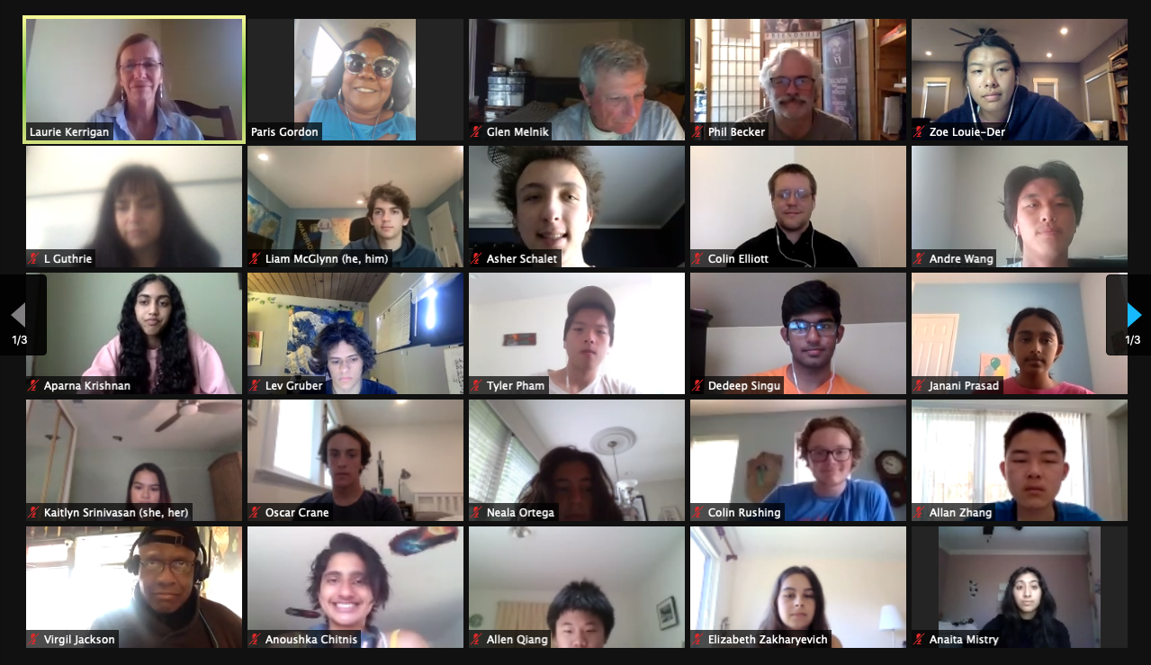

Comments by students on what they learned according to NGSS major areas in Physics:
Structure and Properties of Matter
I learned about particles that I had never heard of, like neutrinos and the Higgs Boson. Neutrinos might be the reason that more matter exists in the Universe.
I learned that the standard model exists, what the particles in it are, and what their properties/quantum numbers are. (I hadn't known anything about the standard model when I started, so I felt like I learned a lot).
I learned about the imbalance of matter and antimatter and how that remains a mystery.
Forces and Interactions
I learned that forces happen through the exchange of force carrying particles (this still blows my mind)
I learned about the strong force, electroweak force, and gravity. I learned that gravity is by far the weakest force, which I found interesting because gravity seems powerful.
Energy

Dark energy is accelerating the Universe's expansion simultaneously helping to create more space.

Energy is related to mass. Small amounts of mass can have large amounts of energy.

Waves and Electromagnetic Radiation

Red/blueshift is a result of the expansion of the universe and can provide information on the distance/direction objects are moving; CMB is light from the earliest point in the universe from which light could escape and be viewed.

Light is both a wave and a particle, experiences doppler effect, and has the same speed for all observers.

Engineering Design

The design process for the many instruments we looked at was incredibly interesting and learning the time scale that many of these projects operate on I got a scope of the patience and iteration and creativity involved in the engineering design process.

I learned about the collaboration that is required between scientists in different fields of study when building instruments. I also learned about how most of the instruments at CERN are custom built since no manufacturer makes these specialized parts.

Earth’s Place in the Universe

I learned that we live in a beautiful time of exploration and experimentation and understanding during which we can look up at the stars or down into the ground or into the devices we've built and learn more about our universe.

The workshop reinforced the idea that Earth is incredibly small when considered in comparison to the Universe (and for example, there are more stars in the Universe than there are grains of sand on Earth).

Earth, a part of our solar system, is but a small planet in the Milky Way. The Milky Way is surrounded by yet more galaxies, most of which are racing away from it.

