Boston QuarkNet Center
2022-2023 Annual Report

Fall Meeting – December 8, 2022.
“Projects in Physics Class,” our fall meeting topic was suggested by participants in our summer workshop last August. Darien Wood, our Northeastern Mentor, was able to join us and discuss possible dates for our student Particle Physics Masterclass in March. In addition to Darien, many of our regulars, including Mike Hamblin, George Odell, Jamison Smith, Mike Wadness, Tim Fitzgibbon, Jon Kelley, Ayo Awobode, and Rick Dower attended. We continue to be fortunate to have hosting by Roxbury Latin School in their Physics Lab.

Mike Hamblin showed off some photoelectric apparatus he had constructed from ole photo tube parts.

Mike Wadness described a project using data from recent Nobel prize winners to measure the mass of the Sgr A* supermassive black holes This value was then compared with the calculated Schwarzschild radius of Sgr A* and the measured size of the black hole shadow image from the Event Horizon Telescope (on which one of his former students worked). The comparison was then extended to the M*& black hole and EHT image.

Tim Fitzgibbon described a sound speed measurement using a function generator and speaker to produce standing waves in the air above the water in a vertical tube. The generator frequency can be adjusted to achieve resonance. The water level can also be adjusted to change the frequencies at which resonances occur.

Jon Kelley described an egg crash project using a double pendulum to regulate the crash speed. Students devise safety mechanisms to prevent the egg passenger from breaking during the crash.

Jamison Smith described a Rube Goldberg construction project to demonstrate conversion of energy from one form to another.

Ayo Awobode described a periscope construction project that helps students understand the process of mirror reflection.

George Odell brought a “Particle Quest” project in which students research the characteristics of a particle and create an imaginative fact or fiction story involving the particle.

Rick Dower described a project for early in the course in which students construct parachutes from materials at home and use them to test Aristotle’s theory that speed of fall is proportional to weight. For late in the course, Rick presented a project involving the construction of an AM crystal radio.
Mike Wadness created a page on the QuarkNet website ( https://quarknet.org/group/boston-area-quarknet-center ) in which to upload written descriptions of the projects.

We also had some discussion on possibly holding the Particle Physics Masterclass on a school day rather than a Saturday. We decided to continue with Saturday for 2023 but poll teachers who have interest in attending to see whether a school day would be desirable.

Particle Physics Masterclass at Northeastern University – March 11, 2023
Thirty-one high school students and five QuarkNet teachers from Massachusetts, Rhode Island, and Vermont converged on the Dana Research building at Northeastern University to participate in this year’s particle Physics Masterclass, the first one held here in person since 2019. For QuarkNet teachers Mike Wadness, Tammy Kjonaas, Nicole Preiser, Tim Fitzgibbon, and Rick Dower, it felt great to be back. Prof. Darien Wood, one of our QuarkNet Mentors, arranged the day to include some get-acquainted exercises for the students, a talk on particle physics by Prof. Wood, a talk on analysis of CMS proton collision images by Mike Wadness, an opportunity for the students to talk with physics grad students at lunch, and a visit to the lab of a Prof. Tsuguo Aramaki, who is building a small liquid argon time projection chamber for a high-altitude balloon launch from Antarctica to search for dark matter. The day culminated with a video conference, moderated by physicists and a QuarkNet Fellow at Fermilab, with students from Williamsburg, VA, Mexico, and Columbia. The students were enthusiastic participants, and a good time was had by all.

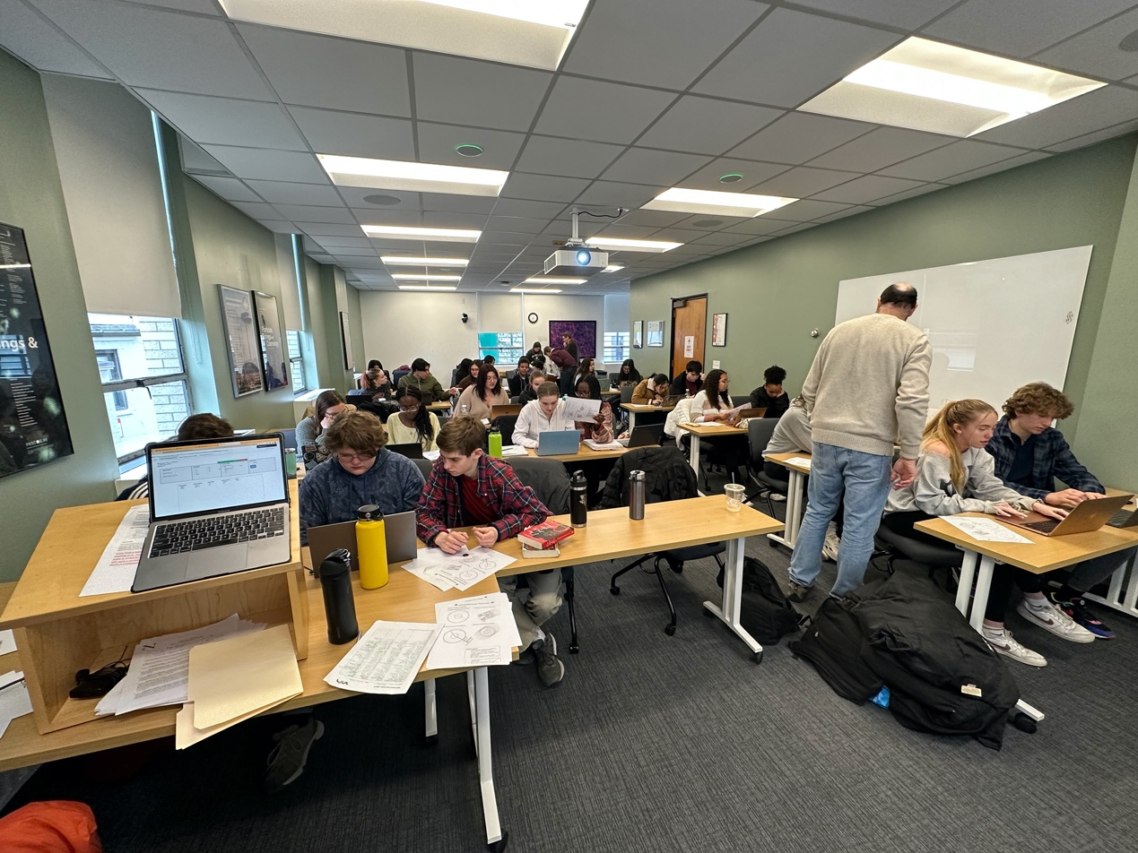

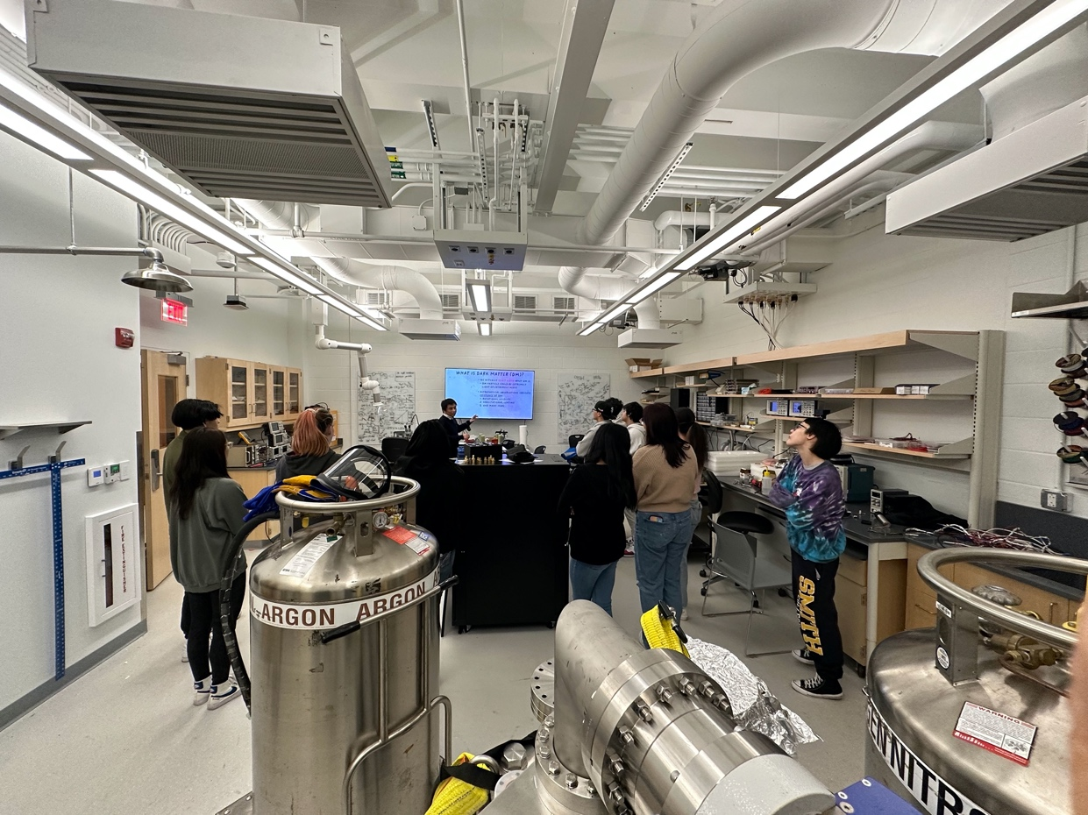

Spring Meeting – June 8, 2023
In addition to our regular attendees Ayo Awobode, Rick Dower, Mike Hirsh, John Kelley, Nicole Preiser (on Zoom), and Mike Wadness, we welcomed newcomers John Sherry and Paul Martenis (on Zoom) to the group. Rick gave a presentation on the supermassive black holes
Sgr A* and M87* and their shadow images from the Event Horizon Telescope (EHT). During the presentation participants worked calculations to become better acquainted with the physical and angular measurements related to the black holes and their shadow images. Participants worked in pairs to help each other catch the inevitable calculation misunderstandings and mistakes. They found it useful to once again be confronted with new material and try to master it, just as our students do in our classes. Rick predicted that Shep Doeleman, the driving organizer behind the EHT collaboration, will be awarded the Nobel Prize in Physics for 2023 – based on two data points from 2017 and 2020 Nobel Prizes.

Summer Workshop – August 9-10, 2023
In addition to our Boston QuarkNet regulars Rick Dower, Mike Hirsh, Jon Kelley, David Kurtz, George Odell, Abe Phelps, and Mike Wadness, we welcomed newcomers Caelan Dammer and Paul Martenis (from Newton South and North High Schools, respectively) to our summer workshop. The title was “New Questions in Particle Physics.” We opened with a consideration of “The Star-Splitter” by Robert Frost and excerpts from Richard Feynman’s 1955 address to the National Academy of Sciences on “The Value of Science.” We had an enjoyable conversation about the importance of entertaining questions and doubt in science while acknowledging that we know a lot about the world and how it works, as derived from observations and ideas of scientists who have gone before. We have good working models of many aspects of nature, but our models are inherently simplifications, not reality.

That conversation was followed by Rick Dower’s review of the discovery of the particles in the standard model of particle physics. After an exercise with loaded dice, we talked about the criterion of 5 -sigma significance for a discovery in particle physics and the dangers of the 2-sigma criterion often used in social science. Ken Cecire from QuarkNet Central was able to join us for the dice exercise and the rest of the workshop.

Our mentor Darien Wood of Northeastern University joined us for lunch and gave a talk about developments in the Deep Underground Neutrino Experiment (DUNE) overseen by a team at Fermilab with construction of detectors in the former Homestake gold mine in Lead, South Dakota. Darien is on the Review Committee for the experiment. He talked about the challenges facing the detector groups in scaling up from a small preliminary detector to the full-sized liquid argon detectors.

After a break, Rick led a conversation about the distinction between explanation for alpha decay in terms of tunneling and beta decay as a form of weak decay mediated by W bosons. We watched a Don Lincoln YouTube video about the transfer of the g-2 experiment apparatus from Brookhaven to Fermilab in anticipation of tomorrow’s Fermilab g-2 presentation. Then we reflected on the day’s activities and adjourned.

Our August 10 session started with another Don Lincoln video. This one described the g-2 experiment and the preliminary results from analysis of its 2019 data. Then Ken Cecire handed out images of Z boson detections form several real experiments and one imagined experiment. We discussed the process of developing consensus in science and how to interpret discrepant results. We were able to watch the Fermilab live stream presentation of the new g-2 experiment results from analysis of 2019 – 2021 data which confirmed the previous more limited result and narrowed the experiment statistical uncertainties significantly. The experimental result was distant several sigma from theoretical predictions of the muon magnetic moment and suggested a possible limitation in the theoretical result and potentially, new physics. The experiment continues, and we are left wondering which of two theoretical calculations is more reliable.

After lunch and more conversation about the g-2 result, teachers filled out the QuarkNet survey forms, considered ideas for implementing ideas in their classrooms related to topics considered in the workshop. They then talked with the QuarkNet program evaluator, Kathy Race, on Zoom about their plans. After a final review, we wrapped up the workshop and went off to enjoy the remaining days of summer.

Respectfully submitted,
Rick Dower

