Lawrence Berkeley National Laboratory
Annual Report 2023
July 20, 2023
Mentor: Tony Spadafora
Workshop Coordinator: Laurie Kerrigan
Co- Organizer: Ken Cecire (QuarkNet)

The LBNL Physics Division hosted its seventeenth “Physics in and Through Cosmology” workshop for QuarkNet Leadership teachers and high school students. This two-week virtual workshop from June 20 to June 30, 2023 was held via Zoom. Six physics teachers, including Workshop Coordinator Laurie Kerrigan, participated. Three of the teachers have been active members of QuarkNet and two new teachers. There was one retired teacher also, who has been active in QuarkNet throughout his career. 49 students participated. Most of the teachers & students joined from public and private high schools in the greater San Francisco Bay Area. A few joined from throughout the U.S. and internationally.
We have been making an effort to include underrepresented students in STEM (which include: African Americans, American Indians/Alaska Natives, Latinos, LGBTQ+, students from low income households, and first-generation college attendees) by outreaching to schools in lower income & underrepresented areas.

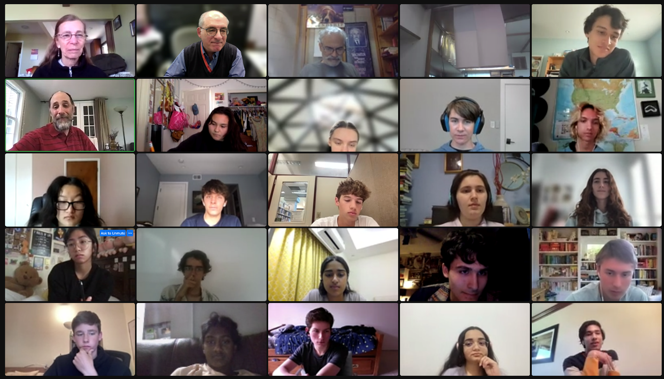

This year we met each weekday for 2 weeks for 3 hours. Most meetings started with a question slide to get students thinking about that day’s topic. Then there was a talk by an LBL scientist and either small group work or virtual activities. The small group work included a Scientist Interview Project, and QuarkNet activities led by Ken Cecire and Michael Wadness. They lead three sessions guiding everyone through Particle Cards and Quark workbench, Z mass measurement, and a search for the Higgs in CMS data. Glen Melnik, retired QuarkNet teacher, lead a discussion on cosmic rays and how a cosmic ray detector worked.

Highlights of the program were a drop in visit by Nobel Prize winner, Saul Perlmutter, and a round table panel discussion with the Scientists on the last day. Each small group presented a short video or PowerPoint about the work the Scientist they interviewed was doing.

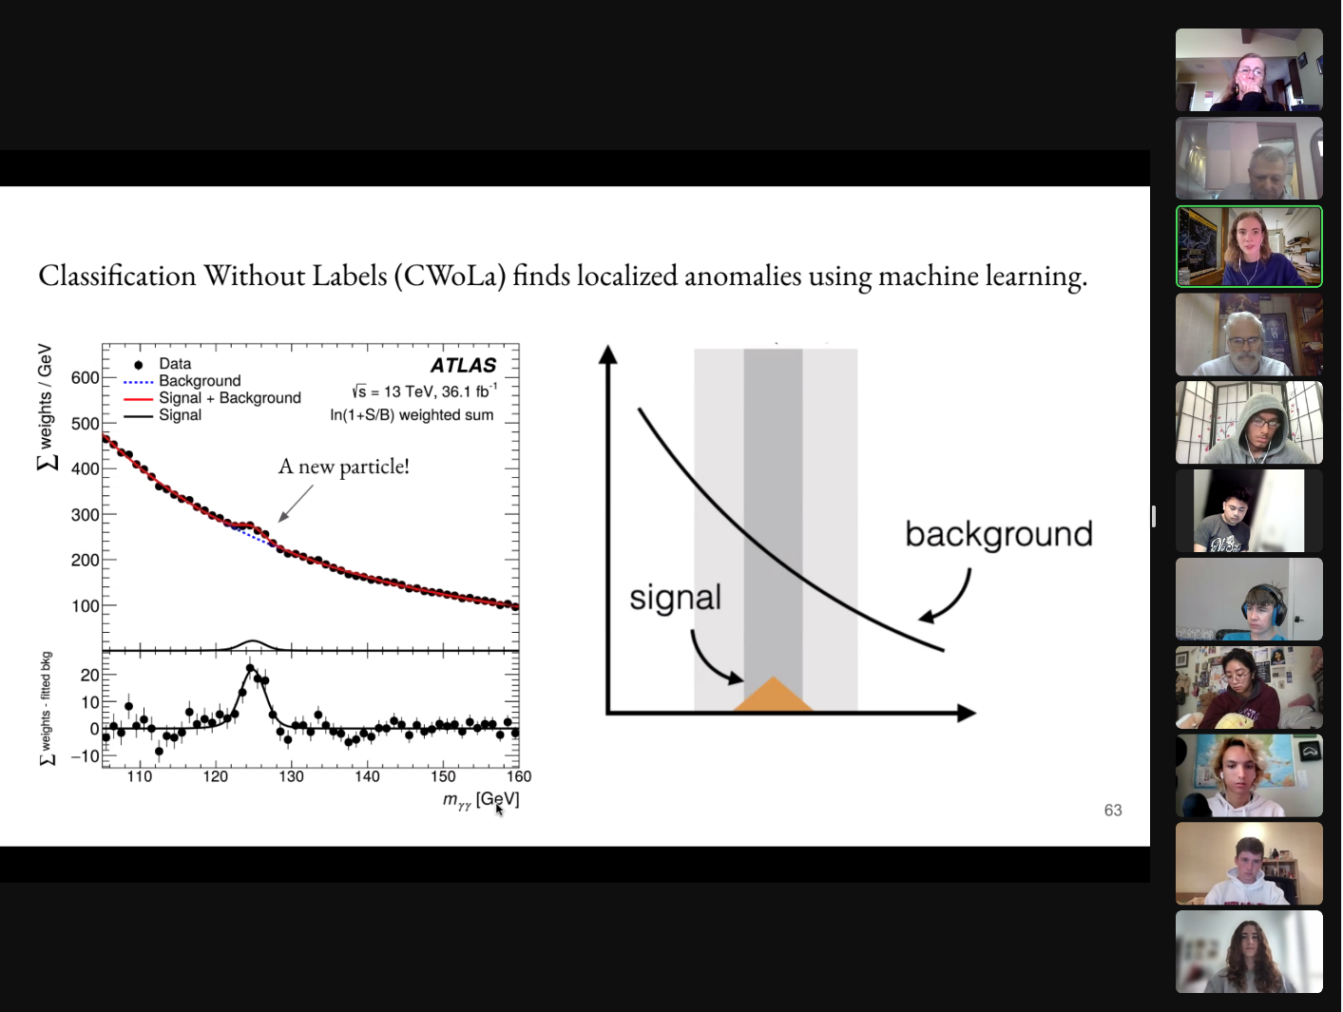
Screen shot from Mariel Pettee’s presentation on Interdisciplinary Machine Learning.

Scientists interviewed by students:
Fernando Torales Acosta Aleksandra Dimitrievska
Louis-Guillaume Gagnon Miao Hu
Anton Baleato Lizancos Clare Poppett
Angira Rastogi Ibles Olcina Samblas
Emily Thompson Rongpu Zhou

List of Teachers:
Phil Becker Sandee Coats-Haan Reynand Dumala-on
Virgil Jackson Laurie Kerrigan Glen Melnik

Formal presentations by LBNL scientists included:
Boryana Hadzhiyska | "The fascinating journey of photons from the Big Bang to us"
Maria Mironova | "Discovering Invisible: Pixel Detectors in Particle Physics”
Miha Muškinja | "Exploring the Frontier of Particle Physics: A Journey into the LHC and ATLAS Experiment".
Mariel Pettee | "Interdisciplinary Machine Learning for Physics (and Art)"
Kaja Rotermund | "Probing the Dark Ages from the Far Side of the Moon"
Joseph Silber | "Want to map the cosmos? Build yourself a tiny robot army!"
Tony Spadafora | "Welcome QuarkNet 2023"
Nao Suzuki | "Grand Tour of the Universe"
Vetri Velan | "Dark Matter: The Hidden Sea"

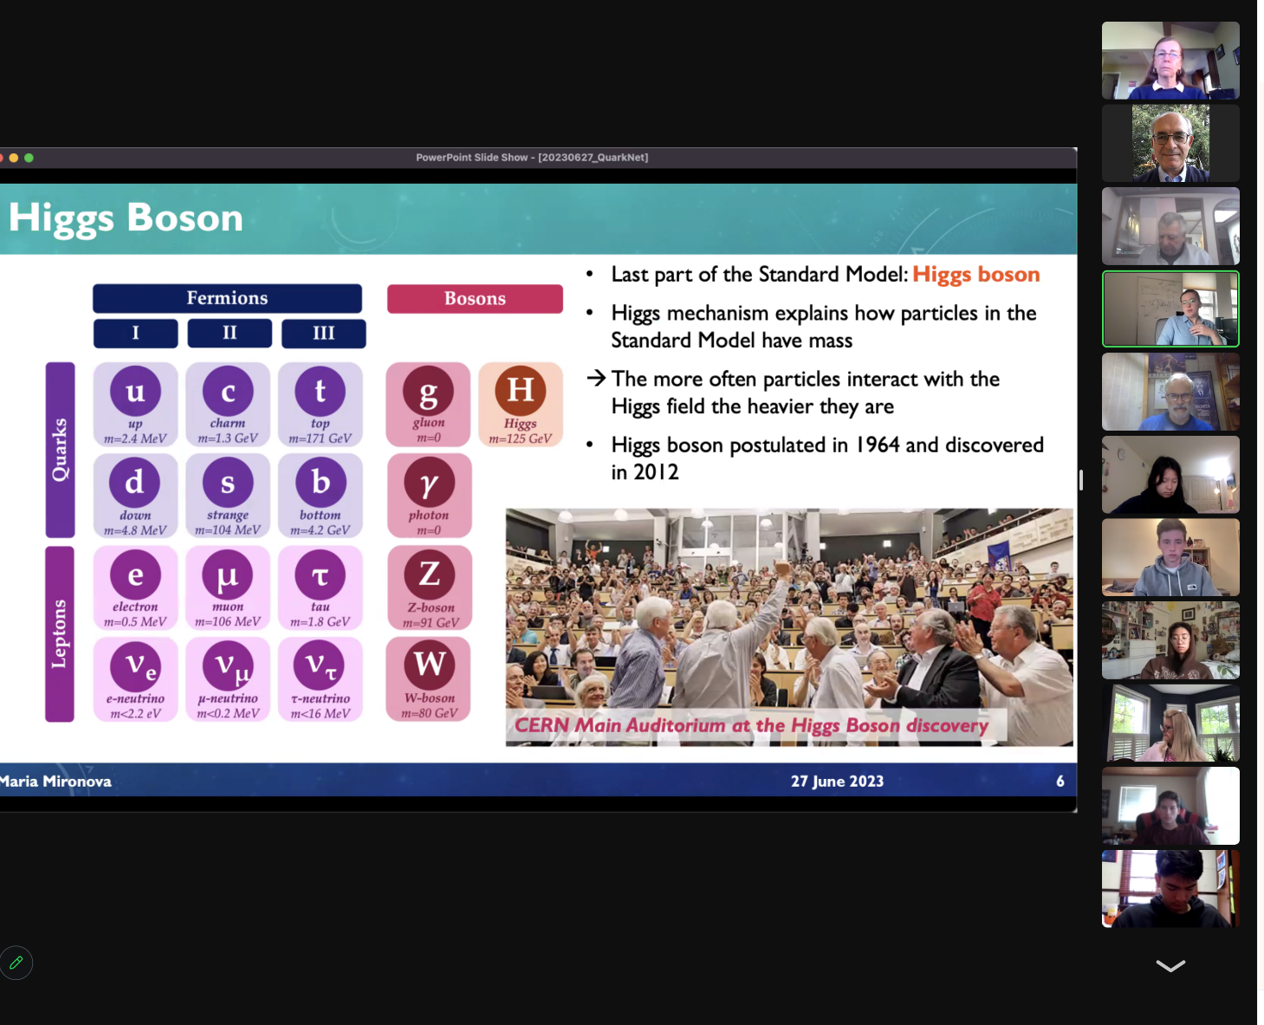
Screen shot from Maria Mironova’s presentation, introducing the Higgs Boson.
Comments from overall evaluations of workshop by teacher & students:
It felt very interactive and personal. I felt that I could ask questions I wouldn't otherwise be able to find the answer to. I also loved being able to meet new people and work with my peers in breakout rooms. I learned a lot!
Immersing myself in the life of physicists and understanding why things work, and even why we don't know why things work. The interview and group presentation was a great way to connect with others over our passion for physics and cool way to learn about physics.

I also really liked the data analysis we got to do with QuarkNet and their staff. Really felt immersed in the world of physicists.

The broad area of physics explored in such a short span of time was easy to understand explanations and had thought provoking content

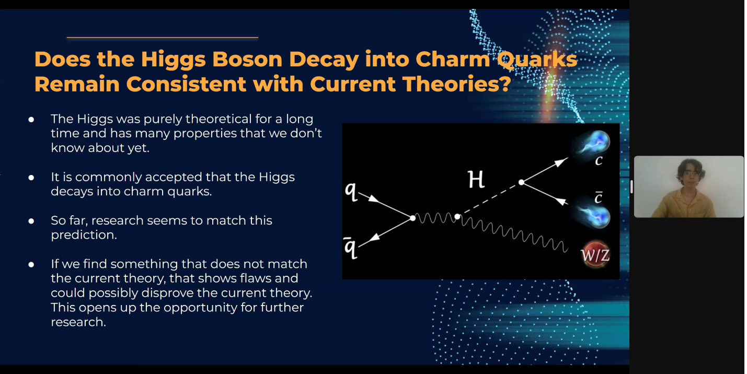
Screen shot from a student presentation.

Comments by students on what they learned according to NGSS major areas in Physics:
Structure and Properties of Matter
I discovered the remarkable connection between the structure and properties of matter and the origin of the universe itself.

The Standard Model consists of Fermions (Quarks and Leptons) and Bosons. The Fermions are what form Baryons and they require very specific combinations to form (Color charges need to cancel out/become white and electrical charges have to be an integer).

I feel like I have the best understanding I have ever had of the standard model.

Forces and Interactions
I learned about the Standard Model for the first time. I also learned about the interactions between the different particles, aka the forces that relate them to each other.
Particles are excitations of forces. Many of gravity's properties are still a mystery to scientists. The Higgs field gives fermions mass.
Gravity is present on a larger scale but on the smaller scale, we don't know how to incorporate it with the standard model yet.

Energy
Energy and mass are related through the equation E=mc^2. The full version of that equation is E^2=p^2c^2+m^2c^4 which incorporates momentum. There is also dark energy which is responsible for the accelerating expansion of the universe.

Energy has become much more fluid for me, with me really being able to visualize energy and mass as one and the same, thus allowing me to get a more comprehensive understanding of what a particle is.

The workshop emphasized the profound relationship between energy and light. I gained an understanding of electromagnetic radiation and its various wavelengths, from radio waves to gamma rays, each carrying different amounts of energy. Exploring the concept of photons, I learned how they serve as carriers of energy in the form of electromagnetic waves.

Waves and Electromagnetic Radiation
Light is actually both a wave and a particle.

I had never heard of redshift, and the way it provides a glimpse into our universe is absolutely fascinating. On the more technical side I realized how electromagnetic radiation can interfere with projects.

For me, this was the most interesting part of the entire workshop. Waves and fields basically synthesized a lot of what I'd learned in math and physics in a way that just put everything together, and it made me really excited for math next year where we'll learn about fields.

Engineering Design
I always knew 3D modeling was an important component of the engineering design process, but to learn how precise these models could be was a shock. I also got to hear about how the engineers behind scientific instruments have to meticulously build mechanisms.

Exploring the various components of DESI, such as the focal plane, fiber positioners, spectrographs, and the data management system, I learned about the engineering challenges and solutions involved in each aspect.

The one area I felt very confident going into the workshop was engineering design, but the descriptions of physics concepts and how they relate to engineering allowed me to connect the concepts. Physics is now much more entwined with engineering in my understanding than it previously was.

Earth’s Place in the Universe
The first presentation highlighted how small Earth is compared with the rest of the universe, and helped me understand why there is no center of the universe.
The universe has been around for billions of years before Earth and before humans.

Earth is small, and the universe is big. However, physics is universal, meaning that we can apply the same physics that works on our planet to the far reaches of our universe.

