Sgr A* _____________________
Name

Modern astronomers have determined that the Sun, Earth, and planetary system are about 26000 light years (ly) from the center of our Milky Way Galaxy and revolve around the center with an orbital period of about 240 x 10⁶ yr. A mass equal to about 10¹¹ solar masses (M_{Sun}) lies within the Sun’s galactic orbit. Recent infrared astronomy observations with our largest telescopes have revealed that a supermassive (4 x 10⁶ M_{Sun}) black hole lies at the heart of our Galaxy. This exercise (inspired by a Student Activity produced by the Perimeter Institute) is designed to acquaint you with the evidence that leads to that conclusion.

Since Harlow Shapley’s description in the 1910s of the spherical distribution of the globular star clusters around the Milky Way, with the center in the direction of the constellation Sagittarius (Sgr), astronomers have known that the Sun is not the center of the Milky Way. The precise location of the center was not obvious because vast clouds of interstellar dust obscure much of Sagittarius. In 1931, Karl Jansky, working at the Bell Telephone Laboratories, was assigned the task of investigating the source of radio noise with wavelength about 15 m (20 MHz). His discovery that a significant source was located in the direction of Sagittarius was the first observation in radio astronomy. Over the years, radio astronomy receivers became more sensitive and able to locate sources more precisely. Finally, in 1974, using a radio interferometer, Bruce Balick and Robert Brown located an apparent radio point source at a location identified as the center of the Galaxy. Brown named the source Sgr A*. Dense clouds of intervening dust absorb any visible starlight from stars near that location. Fortunately, infrared light penetrates the dust. Infrared light in the H band (1.630±0.154 μm) and the K band (2.190±.195 μm) passes through Earth’s atmospheric windows with little absorption. For the past twenty years, a US team led by Andrea Ghez using the twin 10-m Keck telescopes in Hawaii and a European team led by Reinhhard Genzel employing the four 8.2-m mirrors of the Very Large Telescope (VLT) at the European Southern Observatory in Chile have examined the motions of stars in the region of Sgr A*. These telescopes, the largest on Earth, have been equipped with the latest adaptive optics technology. Adaptive optics sharpens optical images by bending the telescope mirrors slightly to greatly reduce the blurring effect of density fluctuations in Earth’s atmosphere that cause star images to twinkle. The combination of infrared detectors and adaptive optics allowed the precise location of stars at the Galactic center, 26000 light years away. Their observations, including recent ones (F. Eisenhauer, et al., ApJ, 628:246-259, 2005, iopscience.iop.org/article/10.1086/430667/pdf ; https://arXiv:11607.06726v1), track the orbits of stars around Sgr A* and allow us to examine the nature of the hidden object that lies at the heart of the Milky Way.

1. Consider a planet in a circular orbit (radius = r, orbital period = P) around the Sun. The Sun (mass = M_{Sun}) is so much more massive than the planet (mass = m) that the Sun’s motion can be neglected. The gravitational force between Sun and planet must equal the centripetal force that keeps the planet in a circle.
Derive the relation $r^{3}=\frac{GM_{Sun}}{4π^{2}}P^{2}$. (1)
2. A circle is a special case (eccentricity = e = 0) of an ellipse. Johannes Kepler demonstrated in 1609 that planetary orbits are ellipses with the Sun at one ellipse focus. In 1619, Kepler found that the cube of the planet’s semi-major axis (a) is proportional to the square of a planet’s orbital period (P). Geometric characteristics of an ellipse are illustrated in Figure 1.
a
M
Figure 1. A star orbiting a large mass (M).
M is at one ellipse focus.
a = semi-major axis, b = semi-minor axis,
c = center-focus distance, a² = b² + c²
e = eccentricity = c/a
b
c

Isaac Newton (1687) mathematically derived the generalization of equation (1) for objects in elliptical orbits around a much larger mass (M) at one ellipse focus:
$a^{3}=\frac{GM}{4π^{2}}P^{2}$. (2)
Astronomers have defined the semi-major axis of Earth’s orbit around the Sun as
a_{Earth} = 1 astronomical unit (AU) ≡ 1.4959787070 x 10¹¹ m ≅ 1.50 x 10¹¹ m.
P_{Earth} ≡ Earth’s orbital period around the Sun ≡ 1 year ≅ 3.16 x 10⁷ s.

Show that G = 4π² (AU³)/(M_{Sun}⋅yr ²), and consequently that, as Kepler discovered, a³/P² = 1 AU³/yr² for all objects orbiting the Sun.

Verify this relation for the largest planet, Jupiter (a_{J} = 5.203 AU, P_{J} = 11.856 yr). (Note: Mass of Jupiter, the largest solar system planet, is M_{J} ≅ 0.001 M_{Sun}.)

For objects orbiting a much more massive central object (mass = M in units of M_{Sun}), show that when a is expressed in AU and P in yr, the central object mass is
M = a³/P² . (3)

3. Figure 2 shows observations and apparent elliptical orbits computed by the Genzel group for six stars near Sgr A* (RA-offset=0, Dec-offset=0). Figure 3 shows observations and apparent orbits of stars orbiting Sgr A* (ΔRA=0, ΔDEC=0) observed by the Ghez group. Stars S2 (Genzel) and S0-2 (Ghez) are the same.
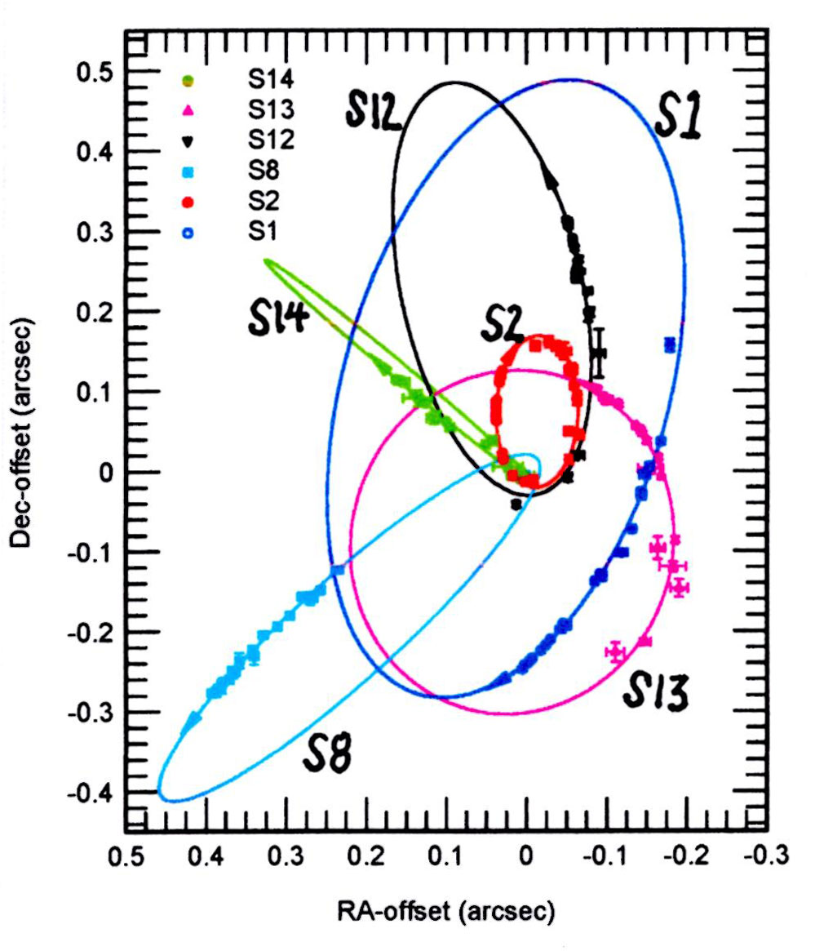

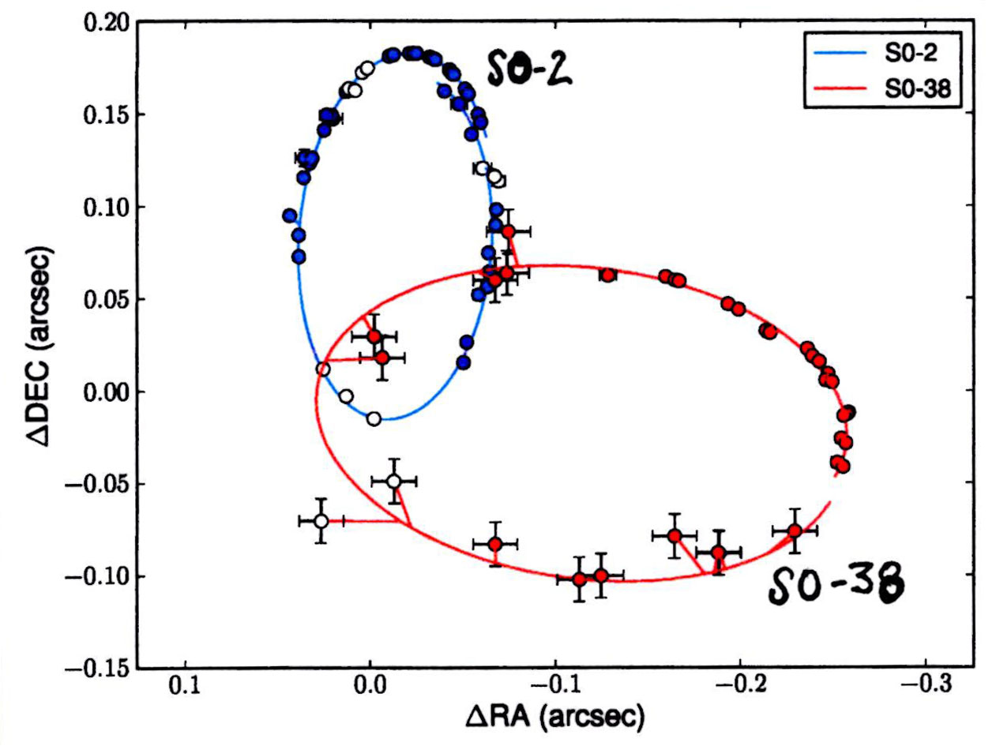

Figure 3. Stars orbiting Sgr A* -
adapted from A. Boehle, et al.,
https://arXiv:11607.06726v1
Figure 2. Stars orbiting Sgr A* - adapted from F. Eisenhauer, et al.,
https://arXiv:astro-ph/0502129

Computing the mass of Sgr A*from the motions of the stars in Figures 2 and 3 requires determining the orientation of the star orbits relative to the tangent plane of the sky at Sgr A* and the distance to Sgr A*. Both the Genzel and Ghez groups obtained measurements of each star’s infrared spectrum as well as position. As a result, they were able to determine the radial velocity of the stars at various points in their orbits from the Doppler shift in the stellar spectral lines. They combined radial velocity and position measurements to determine the three-dimensional orientation of the stellar orbits.
The prominent 2112 nm helium spectral line and the Brackett series 2166 nm hydrogen line in the infrared K-band atmospheric window (2000-2400 nm) are used for Doppler measurements. Recall the Rydberg formula for hydrogen (H) spectral lines $\frac{1}{λ}=R_{H}\left(\frac{1}{n_{f}^{2}}-\frac{1}{n_{i}^{2}}\right)$, where R_{H} = 1.09678 x 10⁻² nm⁻¹ is the Rydberg constant for hydrogen, n_{f} = 4 for the Brackett series, and integer n_{i} >n_{f}.
Find the value for n_{i} for the 2166 nm H spectral line.

According to the Genzel group (2018), the maximum orbital speed of star S2 is v_{max} ≅ 7650 km/s. Calculate the ratio v_{max}/c . (Ans. 0.0255)

Use the classical Doppler shift formula (Δλ/λ ≅ v_{max}/c) to calculate the corresponding wavelength shift Δλ_{max} of the 2166 nm line. (Ans. 55 nm)

Does the shifted wavelength remain in the K band?

4. Table 1 Orbital Data of Stars in Figures 2 and 3.

Star | P (year) |  | a  (arcsec) | a  (AU) | e | i  (deg) | a³/P²  (10⁶ AU³/yr²)
S1 | 94.1 | 0.412 |  |  | 0.358 | 120.5
S2 | 15.24 | 0.123 |  |  | 0.876 | 131.9
S8 | 67.2 | 0.329 |  |  | 0.927 | 60.6
S12 | 54.4 | 0.286 |  |  | 0.902 | 32.8
S13 | 36 | 0.219 |  |  | 0.395 | 11
S14 | 38.0 | 0.225 |  |  | 0.939 | 97.3
S0-2 | 15.92 |  |  |  | 0.892 | 134
S0-38 | 19.2 |  |  |  | 0.810 | 170

Note: The parameters for S2 = S0-2 are slightly different due to the differing data sets and different procedures for fitting parameters to the data. For simplicity, uncertainties associated with all values in the original tables are omitted. e is the orbital eccentricity. i is the inclination of the orbit plane to the plane of the sky.

At a distance of 1 parsec = 1 pc ≅ 3.26 years, 1 AU subtends 1 arcsecond of angle on the plane of the sky. The best-fit analysis of the data for stars S1 – S14 by the Genzel team in 2005 yielded the orbital elements in Table 1 and a distance of 8.0 kpc to Sgr A*. Use that distance value to compute a (AU) values and a³/P² values for those stars and fill in the appropriate spaces in the table.

Comment on the meaning of the a³/P² values in the table.

The orbit of the star S0-38, with its inclination i = 170° is nearly in the plane of the sky. So the apparent ellipse of its orbit is very nearly the true ellipse.

Show that for an ellipse $e=\frac{c}{a}=\sqrt{1-{\left(\frac{2b}{2a}\right)}^{2}}$.

Measure the major (2a) and minor (2b) axis lengths of the S0-38 orbit in Figure 3, and calculate the orbital eccentricity. Compare your value to that in Table 1 derived by the Ghez group in 2016. The mass and distance of Sgr A* derived by the Ghez group are 4.02 x 10⁶ M_{Sun} and 7.86 kpc, respectively. Use those values with the orbital period of S0-38 to determine a (AU) and a (arcsec) for S0-38. Then use the scale of Figure 3 to compare your calculated value to your measured value for a (arcsec).

5.
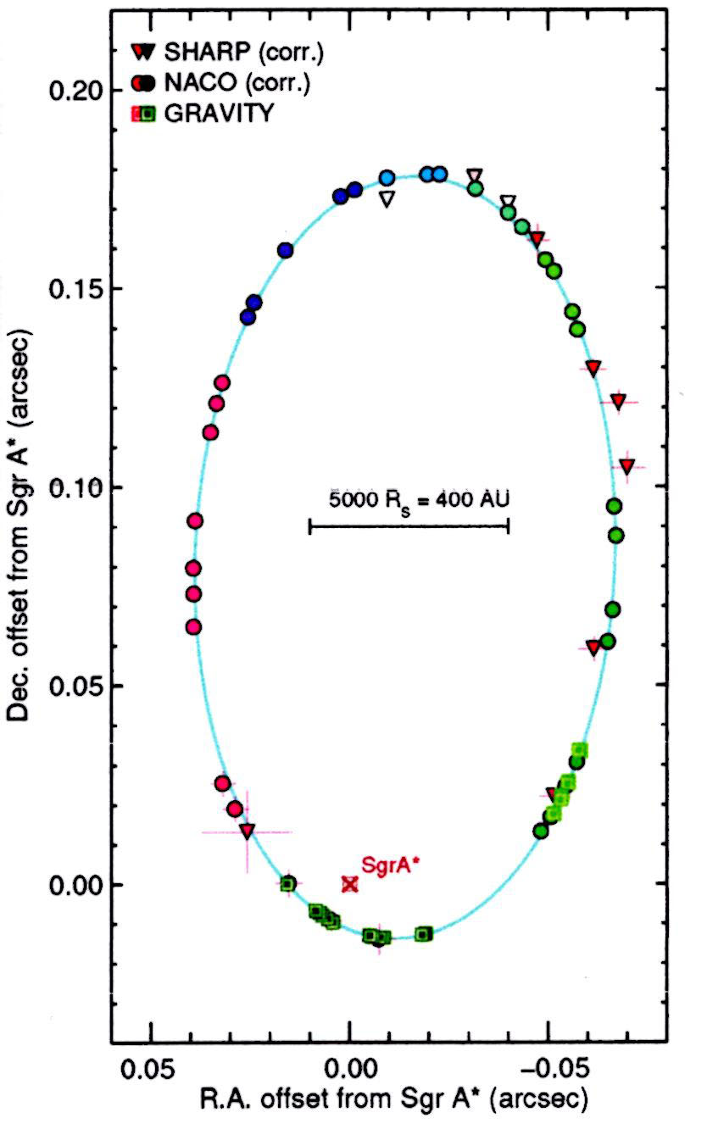
By combining the light from the four 8.2-m mirrors of the VLT, the Genzel group was able to examine star S2 as it passed its periapsis point at its closest to Sgr A* in May 2018. Those observations along with previous observations of S2 contributed to the best-fit orbit shown in Figure 4.

Figure 4. S2 observed positions and best-fit orbit (R. Abuter, et al.; https://arXiv:1807.09409v1). The position of Sgr A* is not at a focus of the apparent ellipse because the true orbit is tilted at inclination i ≅ 134° to the plane of the sky.
Orbit parameters for star S2 determined from the data plotted in Figure 4 include a = 125.4 milliarcsec, e = 0.8847, i = 133.8°. P = 16.052 yr, and d = 8.12 kpc. Calculate the mass of Sgr A*. (Ans. 4.1 x 10⁶ M_{Sun})

Though the positions of Sgr A* calculated from observations of the stars in Table 1 and known from radio observations are essentially coincident, no infrared or visible light is observed at that location. Dust between Earth and Sgr A* absorbs any visible light that might be produced. However, astronomers using the Chandra X-Ray Astronomy Observatory spacecraft have detected a source of high energy x-rays at Sgr A*. Such x-rays typically emanate from matter falling into a compact object. How compact could Sgr A* be?

Show that the closest approach of S2 to Sgr A*, its periapsis distance, is
r_{p} = a_{S2}(1 – e_{S2}). Then calculate r_{p} for S2 in AU units. (Ans. 117.4 AU)

Calculate the Schwarzschild radius (R_{S}) of a non-rotating black hole with the mass of Sgr A* in AU. (Note: c = 6.324 x 10⁴ AU/yr) (Ans. 0.081 AU)
$R_{S}=\frac{2GM}{c^{2}}=$

Convert your R_{S} value from AU to m. (Note: 1 AU ≅ 1.5 x 10¹¹ m)
(Ans. 1.21 x 10¹⁰ m)

A mass 4 x 10⁶ M_{Sun} object in a region smaller than 120 AU that produces x-rays but no appreciable infrared light is most easily modeled as a black hole.

Many other galaxies have been found to have supermassive black holes with 10⁸ to 10⁹ M_{Sun} masses at their cores. Astronomers have concluded that supermassive black holes are a common constituent of galaxy cores.
6. Precise measurements by the Genzel group of star S2 as it passed periapsis have allowed it to become a probe to test for two effects on spectral lines expected from relativity theory: the transverse Doppler shift (special relativity) and the gravitational red shift (general relativity).

Special relativity predicts that the frequency of light received from a source traveling perpendicular (transverse) to your line of sight will be modified by the time-dilation factor $γ=1/\sqrt{1-{\left(\frac{v}{c}\right)}^{2}}$ , so that f_{received} = f_{emitted}/γ .
Show that the transverse Doppler shift would produce (Δλ/λ)_{TD} = (γ -1).

Calculate (Δλ/λ)_{TD} for S2’s v_{max} = 7650 km/s at periapsis. (Ans. 3.25 x 10⁻⁴)

Show that the excess spectral shift due to the transverse Doppler shift is equivalent to an apparent excess Doppler shift speed of about 100 km/s.

7. The gravitational red shift is due to the energy loss of photons as they climb out of the gravitational potential well in the vicinity of an object of mass M. The resulting fractional wavelength change is given by ${\left(\frac{Δλ}{λ}\right)}_{GR}=\frac{{GM}/{c^{2}}}{R}$ , where R = distance from M at which photon originates. Calculate the gravitational red shift (Δλ/λ)_{GR} due to Sgr A* for light from S2 when at periapsis. (Ans. 3.4 x 10⁻⁴)

Show that the excess spectral shift due to the gravitational red shift is equivalent to an apparent excess Doppler shift speed of about 100 km/s.

8. The greatest distance of S2 from Sgr A* is at the apoapsis point in its orbit, at the opposite end of the major axis from the periapsis point. Show that the apoapsis distance from SgrA* for S2 is r_{a} = a_{S2}(1+e_{S2}). Then calculate r_{a} for S2 in units of AU.
(Ans. 1919 AU)

Calculate the gravitational red shift (Δλ/λ)_{GR} due to Sgr A* for light from S2 when at apoapsis in units of equivalent excess implied Doppler speed. (Ans. 6.3 km /s)

Kepler’s Law of Areas for elliptical orbits states that the line joining the Sun and a planet moves over equal areas in equal times. This law is a consequence of angular momentum conservation for a single body orbiting central object due to a radial gravitational force. Show that the law of areas implies that the ratio of speeds of the orbiting object at periapsis (v_{p}) and apoapsis (v_{a}) is inversely proportional to the distances from the central object, i. e. v_{p}/v_{a} = r_{a}/r_{p}.

Calculate the speed of S2 at apoapsis and the equivalent excess implied Doppler speed due to the transverse Doppler shift. (Ans. 468 km/s; 0.4 km/s)

The Genzel group calculated the excess Doppler shift for S2 due to the combined effects of transverse Doppler shift and gravitational red shift. Their calculations give the minimum, at apoapsis, of about 6 km/s, and the maximum, at periapsis, of about 200 km/s (R. Abuter, et al.; https://arXiv:1807.09409v1). Their measurements, including the May 2018 periapsis, and the curve expected from the special and general relativity effects are illustrated in Figure5.
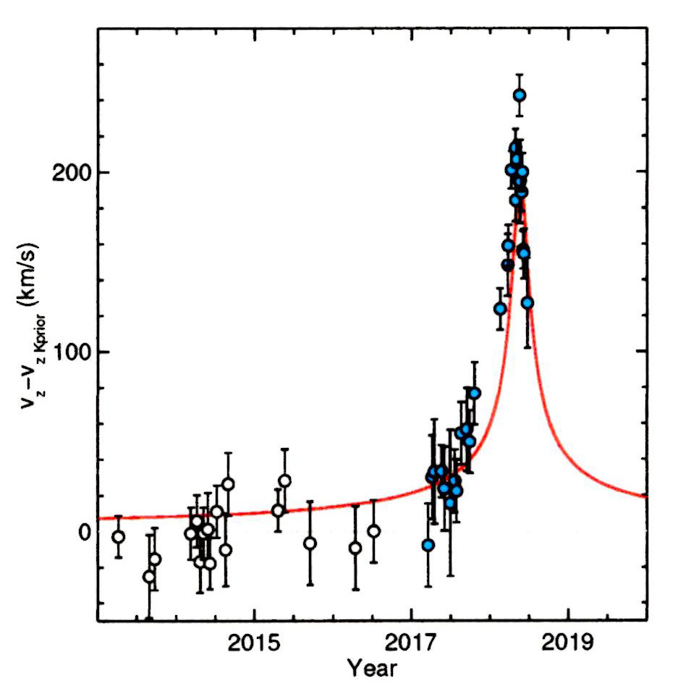

Figure 5. Measurement of the Doppler radial velocity excess compared with the Keplerian orbit value (dashed line) and peaked curve expected from the effect of the transverse Doppler shift and gravitational red shift for the orbit of star S2 around Sgr A*.

9. Calculate the gravitational field strength of Sgr A* (g_{A*}) at the periapsis position of S2. (Ans. 1.76 m/s²)

The radius of curvature (radius of the closest fitting circle) of an ellipse at either end of its major axis is ρ = b²/a, where a and b are the semi-major and semi-minor axis lengths, respectively. Calculate the radius curvature (AU) of the orbit of S2 at periapsis and the corresponding centripetal acceleration (m/s²) of S2 at periapsis.
(Ans. ρ = 221.2 AU; 1.76 m/s²)

Is the correspondence of acceleration values in the above calculations expected or a coincidence? Explain your reasoning.
Additional Resources for the Sgr A* Activity

VIDEOS
A brief history of the discovery of Sgr A* from Coursera can be found at
https://www.youtube.com/watch?v=MV_0ns3JRV4 (duration 7:23).

A zoom-in astronomical view of Sgr A*, concluding with images of stars orbiting a seemingly empty point , from the European Southern Observatory (ESO) can be found at
https://www.youtube.com/watch?v=DRCD-zx5QFA (duration 1:34).

An analysis of infrared flares from Sgr A* by ESO that produced information about it rotation rate can be found at
https://www.youtube.com/watch?v=riJD_5xguig (duration 2:22).

A speculation about asteroids falling into Sgr A* to produce the observed x-ray flares (shown) from the Chandra X-ray Observatory can be found at
https://www.youtube.com/watch?v=j2EgZuT4L5M (duration 2:00).

A tour of the European Southern Observatory and the Very Large Telescope at Cerro Paranal in Chile can be found at
https://www.youtube.com/watch?v=guGnl4SHfvo (duration 23:33).

A tour of the Keck Observatory on Mauna Kea in Hawaii can be found at
https://www.youtube.com/watch?v=DGblreLiWsE (duration 6:40)

