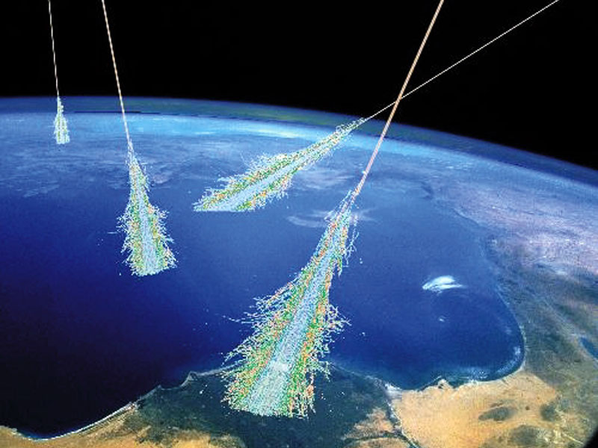

Objectives
Participating teachers will be able to:
- Configure a cosmic ray detector appropriately for acquisition of data for calibration and analysis of measurements
- Identify and describe the e-Lab tools available for conducting studies with data collected using a cosmic ray detector
- Create, organize and interpret a data plot to make a claim based on evidence; provide reasoning and identify data limitations
- Develop a plan for taking students from their current level of data use to subsequent levels using activities and/or ideas from the workshop.
Agenda
Times and specific activities are subject to adjustment
Monday June 25  09:00 Coffee and Registration  09:15 Introduction and Objectives  09:30 What are cosmic rays? Introduction to CRMDs. Workshop theme: Muon absorption in Matter  10:15 Shuffle the Particle Deck  10:45 Standard Model  Noon Lunch  13:00 Explore Cosmic Ray e-Lab, plateau  - Review geometry  - Calibrate barometers  - Distribute GPS signals  - Review EQUIP  - Review uploading data  - Aiming  14:15 Small group research. Select experiment  - Absorption: rate versus overburden  - Imaging wall versus window  Set up experiment for overnight data  15:45 Reflection of day  16:00 End of Day | Tuesday June 26  09:00 Coffee and sign in  09:15 Reflection on previous day  09:30 Upload Data (from overnight)  10:00 Break  10:15 Tour e-Lab I  Performance, Blessing  - Time of flight  - Flux  - Speed of muon  11:00 Prepare report  12:00 Lunch  13:00 Report out  14:30 Set-up for 2nd Data Run  15:45 Reflection of day  16:00 End of Day
Wednesday June 27  FermiLab  08:50 Meet at Information Desk, Wilson Hall. Close toed shoes required. Tours of neutrino and muon campuses.  11:30 Lunch  12:30 Lederman Center with computers  - Penny mass activity  - e-Lab studies of existing workshop data  - Discuss plan to install CRMD and GPS in neutrino enclosure  15:00 Reflection of day  15:15 End of Day  Thursday June 28  09:00 Coffee and registration  09:15 Reflection on previous two days  09:30 Upload/analyze data  10:00 Discussion of Experiment Design  11:15 Presentation work time  12:00 Lunch  13:00 Guest Speaker Neutrinos (tentative)  14:00 Conclude research;  create poster; Teacher implementation plan  15:00 Setup for last overnight data collection  15:45 Reflection and evaluation  16:30 End of day  Contacts  - Mark Adams, QN Staff (cosmic focus)  - Nate Unterman, Cosmic Fellow/Presenter | Friday June 29  09:00 Coffee and registration  09:15 Reflection on previous day  09:30 Upload/analyze data  10:45 Finish poster and power point  12:00 Lunch  13:00 Experiment and Implementation presentations  14:30 Reflections and evaluation  14:45 Clean up.  15:30 Workshop ends.  Resources  - QuarkNet  - Cosmic Ray e-Lab  - https://sites.google.com/view/quarknet2017eclipse/home

