Cosmic Microwaves

Learning Goal: Explain that an expanding universe would cause ancient light to become redshifted, and cite this light (called the CMB) as evidence for the Big Bang model.

Review / Pre-lab
- In a previous class, you did some experiments with spectroscopy. What can you learn about an object by using spectroscopy?

- Examine the two spectra below.
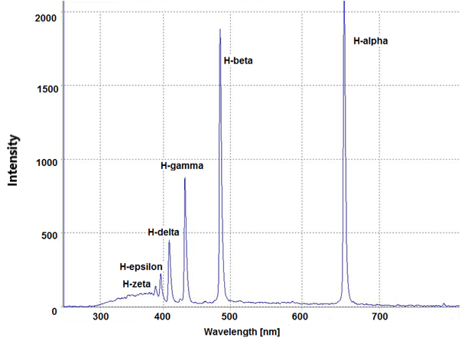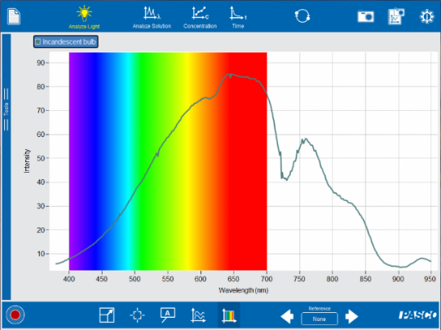

  - Which spectrum is most likely the spectrum for a hot gas, and how do you know?

  - Which spectrum corresponds to a hot metal such as a light bulb filament, and how do you know?

- So far you have mostly seen spectra that use the visible part of the electromagnetic spectrum. What are the other categories of electromagnetic radiation besides visible? You should be able to list at least 5.

- Your instructor may show you a demonstration using a device called a “fire syringe.” What happens to the gas inside a fire syringe when it gets compressed? (alternative: watch this fire syringe video: https://www.youtube.com/watch?v=4qe1Ueifekg)

- Think about the opposite situation to the fire syringe. What would you expect to happen to a gas if it is forced to expand?

- In another lesson, you may have learned about the Hubble-LeMaitre Law, sometimes just called Hubble’s Law. What does this law tell us about what’s happening to the universe over time?

- Based on all the questions you answered previously, what would most likely be true about the early universe? (hint: if the modern universe is very large and filled with cold gas now, what would have been true much earlier?)
Exploration Part 1 – The “Blackbody Spectrum” PhET Simulation
Imagine an early time in the universe, when everything was so hot and compressed that all of space was glowing! Let’s take a look at what happens when objects get hot enough to glow.

Instructions (open inquiry)
- Go to the PhET website. Inside the physics simulations menu, you will find a simulation called “Blackbody Spectrum” (https://phet.colorado.edu/en/simulation/blackbody-spectrum).
- Once you have the simulation open, you will notice a large graph showing the spectrum of light being emitted by a hot object. You will also notice that you can turn on features like graph labels and values, and that you can adjust the scale for both the X-axis and Y-axis.
- Use the simulation to develop a model for how the temperature of an object is related to the kind of light it emits. Try to illustrate your model using a graph or table of evidence gathered from the simulation. Share your graph with other groups in class and compare your results.
- Models are useful for making testable predictions. For example, near the end of the 20th century astronomers discovered a new type of star called a brown dwarf, named this way because they are much cooler than even red stars. What sort of wavelengths would you expect for light emitted by a brown dwarf?
Object Name | Temperature (ºK)
Sun | 5800

Explain Part 1

- What does your investigation tell you about the relationship between the temperature of an object and the types of light it emits? Justify your response with evidence from the data.

- Based on your results, which part of a flame do you think is the hottest – the blue part or the yellow part? Justify your answer.

- A metal object at 1000 degrees K would be hot enough to burn you badly if you touched it, but it would appear the same as a cold piece of metal if you looked at it.
  - What type of light would this object emit, and what would the approximate wavelength be?

  - Adjust the simulation settings (T = 1000K) to prove your answer to the previous question.

  - What special equipment would help you prove that it does emit light?

  - How do the results of this investigation explain why the appearance of an electric stove changes when it heats up? Justify with evidence.

Explain Part 2 – The Cosmic Background
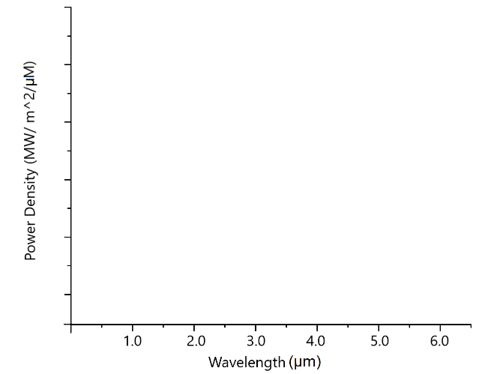
- Based on what you’ve learned so far, you know that the early universe was a hot and dense environment, and it would be emitting light whose wavelength depends on its temperature. Suppose that 13 billion years ago, the average temperature of the universe was 3600 degrees Kelvin.
  - What would you expect the peak wavelength to be for the light being emitted by the early universe?

  - On the graph at right, sketch a curve to represent the type of light you would expect to measure. (notice the graph has the same axes as the graph from the blackbody simulation, so you can use that simulation for help.)

  - What category of light would this be? Circle one.
(Gamma / X-ray / UV / Visible / Infrared / Microwave / Radio)

- Think back to what you learned about Hubble’s Law. How was the redshift of galaxies used to demonstrate the universe expansion?

- Rebecca Smethurst (AKA “Dr. Becky”) is a popular astrophysicist on YouTube. In one of her videos, she said the easiest way to travel back in time is to walk outside at night and look up. What do you think she meant by this?

- If the early universe 13 billion years ago was emitting mostly infrared light, it would still be present in today’s universe. However, this light would be affected by the constant expansion of the universe during that time.

What would you expect to happen to the peak wavelength of this light due to the universe expansion?

Evaluate
- The graph in the figure below comes from a famous article in the 1996 Astrophysical Journal using a microwave telescope called COBE (and an instrument called FIRAS) that was pointed at the entire night sky. The FIRAS instrument produced a curve based on all the wavelengths of light it detected over the entire sky.
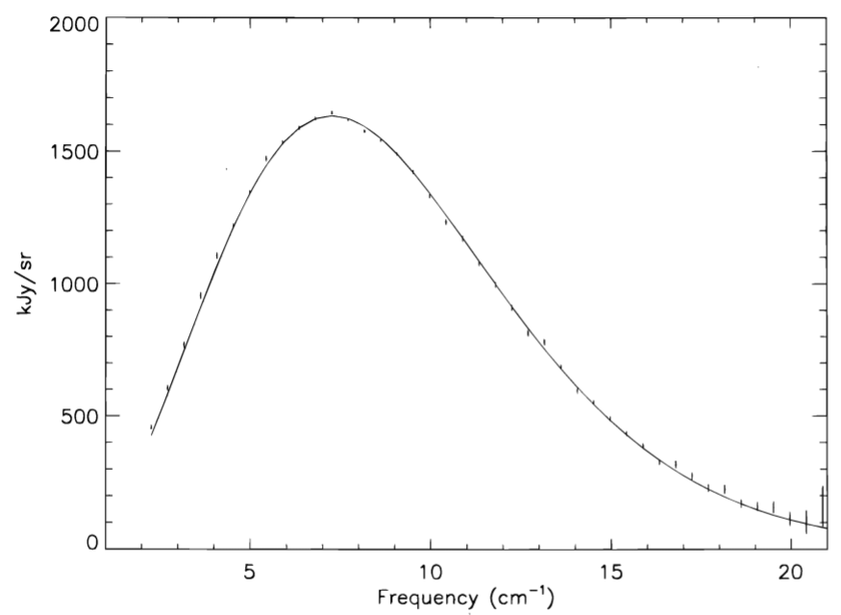
Above: The Cosmic Microwave Background, measured by COBE.
Note: the x-axis is frequency.
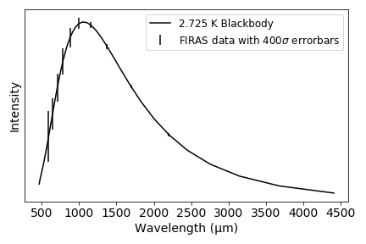
Source: nasa.gov

The graph at right is a simplified version of the same data. Why does this graph support or not support your conclusions in the previous questions? Justify your answer with evidence and reasoning from both this graph and the work you did previously.

- Below are two maps that use a “Mollweide” projection map, which is a useful way to show the entire surface of a sphere. At left is a Mollweide projection of Earth, and at right is a Mollweide projection of the entire night sky using visible light.
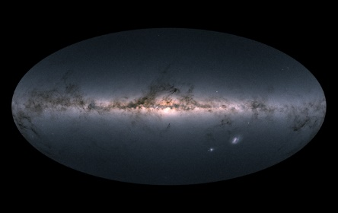
Above left: Mollweide map projection of Earth. Source: map-projections.net Above right: The entire night sky from the GAIA telescope. Source: ESA
A skeptic might complain that this microwave light measured by COBE is simply being emitted all the time by the galaxies in the universe, and therefore is not 13 billion-year-old light! The final map is a Mollweide projection that uses microwave light rather than visible light. How does this image prove that galaxies are not the source of the signal measured by COBE?
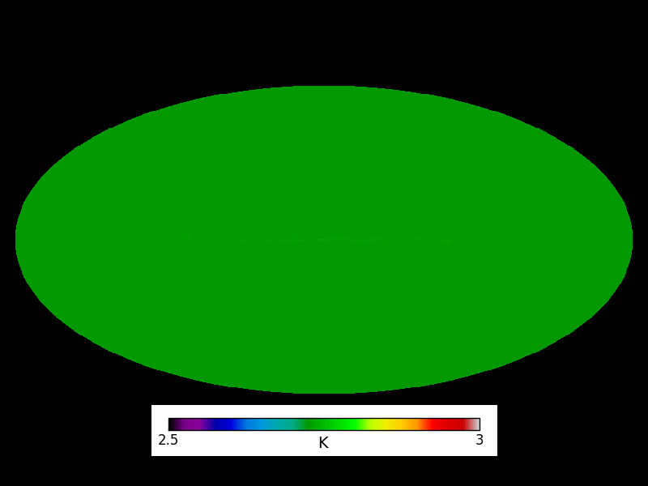
Above: The highly uniform temperature of the CMB at 2.7 degrees Kelvin.
Source: Dr. Katie Harrington, Univ. of Michigan

- The light measured in the graphs and picture above is usually called the “Cosmic Microwave Background” or simply CMB. In a paragraph or two, explain why the CMB is a strong piece of evidence for the Big Bang model of an expanding universe. Be sure to cite evidence for your explanation using the information from this assignment, and justify your evidence with reasoning.

Extension

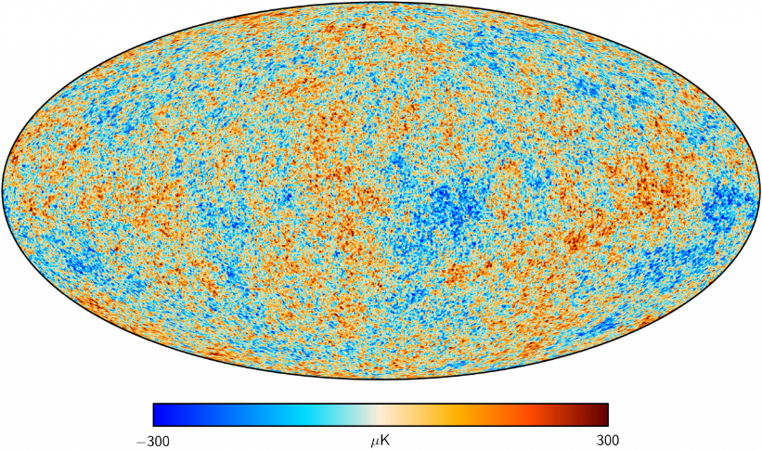
Figure 2: A differential map of the CMB from the Planck telescope.
Source: esa.int
When you do an image search for the CMB, you don’t usually get the solid color shown in the Mollweide map in Figure 6. Instead, you get something that looks like Figure 7, which is called a “differential” measurement of the CMB.

  - What do you think the word “differential” means here? (Hint: compare the scales in figures 6 and 7.)

  - Why are scientists so interested in these tiny differences in the temperature of the CMB? What can be learned by analyzing these maps? (try reading about the NASA telescope called WMAP here: https://map.gsfc.nasa.gov/mission/sgoals_universe.html)

