Cosmic Microwaves

Learning Goal: Explain that an expanding universe would cause ancient light to become redshifted, and cite this light (called the CMB) as evidence for the Big Bang model.

Notes to Teachers:
- The first section called Review is mostly intended to help teachers understand where this activity fits into the scope and sequence of the unit, so you might prefer not to give that part to your students. In the student version, there is only the pre-lab questions and no written review.

- This activity takes some time (estimated 2 hrs) so it’s been divided into two parts, the first focusing on blackbody radiation and the second focusing on the CMB.

- The concepts of expanding and contracting gases are intended to be analogies only, to help students think about how the universe would cool off as it expands, but this is not a literal model used by physicists. More correct explanations would require math and physics skills well above even a typical college level (general relativity, differential geometry, thermodynamics, etc.)

Review
- Hot things glow!
In a previous class, you looked at a tube filled with hydrogen gas, and when the tube was turned on it glowed a pinkish-red color. When you looked at the tube with a handheld spectroscope, it looked like this:
Above: Hydrogen Emission Spectrum. Source: quora.com

This is a good reminder that objects like hydrogen gas will glow brightly when they get hot. It’s also a reminder that hydrogen is very abundant in the universe, because we see this emission spectrum everywhere we look in space.
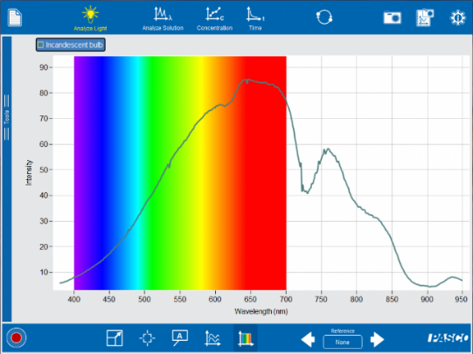
You may have also had a chance to see what happens when you put an old-fashioned (filament-type) light bulb in front of a spectrometer. The spectrum looks something like this:
One thing that’s interesting about this spectrum is that some of the light produced by the bulb cannot be seen by the human eye – it is infrared light, which has a longer wavelength than visible light. So here is another example of something hot producing light, but instead of just a few colors like the hydrogen tube, it produces a wide range of colors.
Above: Incandescent Light Bulb Spectrum.
Source: pasco.com
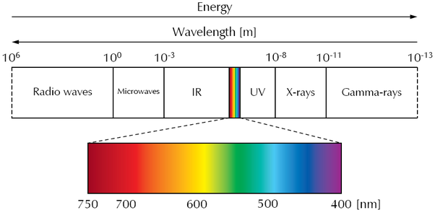
Many things in the universe, especially stars, have this same behavior – think of the rainbow produced by sunlight after a storm, where the rainbow shows the full range of visible sunlight colors. And they don’t just produce light in the infrared and visible parts of the EM spectrum; some stars emit ultraviolet light and radio waves, and some special objects like black holes and neutron stars even emit X-rays and gamma rays!

Above: The Electromagnetic Spectrum.
Source: nist.gov

- Pressure and Temperature
The Hubble Law says that the universe is expanding, based on evidence that almost all the galaxies surrounding us are moving away (they are redshifted). Since most of the universe is made of hydrogen gas, it’s important to understand what happens when a gas expands.
With a demonstration like the “fire syringe,” you saw that when a gas such as air is compressed, it gets extremely hot as long as the air is not able to cool off by its surroundings. (example: Veritasium’s channel on YouTube https://www.youtube.com/watch?v=4qe1Ueifekg)
The reverse is also true: when you force a gas to expand, it will get colder!

Summary

- The universe is mostly hydrogen gas.
- The universe is expanding.
- When a gas expands it cools, and when it compresses it gets hotter.

Based on this information, what do you think the universe might have been like, a long time before the present day? Write a brief description below describing the pressure and temperature.

Answers to Prelab questions
- In a previous class, you did some experiments with spectroscopy. What can you learn about an object by using spectroscopy?

Many things can be learned. For example, you can tell how fast the object is moving if the spectrum is redshifted or blueshifted, and you can tell it is far away if the intensity is lower. You can also determine identity and composition based on features like emission lines and absorption lines.

- Examine the two spectra below.
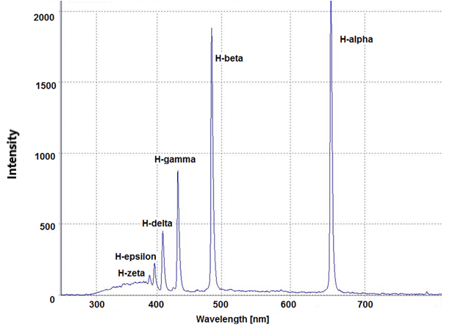

  - Which spectrum is most likely the spectrum for a hot gas, and how do you know?
The spectrum on the left shows only emission lines so it’s the spectrum of a hot gas.

  - Which spectrum corresponds to a hot metal such as a light bulb filament, and how do you know?
Hot metals give off a wide range of light, so the spectrum on the right is correct.

- So far you have mostly seen spectra that use the visible part of the electromagnetic spectrum. What are the other categories of electromagnetic radiation besides visible? You should be able to list at least 5.
Gamma, X-ray, Ultraviolet, Infrared, Microwave, Radio

- Your instructor may show you a demonstration using a device called a “fire syringe.” What happens to the gas inside a fire syringe when it gets compressed? (alternative: watch this fire syringe video: https://www.youtube.com/watch?v=4qe1Ueifekg)
When the gas is compressed it gets hot, hot enough to set the cotton on fire. (Note to teacher: we avoid contrasting adiabatic/isothermal processes here, but a clever student might point out that if the compression happens slowly enough there’d be no temperature increase.)

- Think about the opposite situation to the fire syringe. What would you expect to happen to a gas if it is forced to expand?
When a gas is forced to expand it will cool off. (Note to teacher: this again assumes an adiabatic expansion. In the case of the fire syringe the process is quick enough to be modeled as adiabatic; in the case of the 14 billion year expansion of the universe, one might argue that the process is only adiabatic if the universe doesn’t exchange thermal energy with its “surroundings!”)

- In another lesson, you may have learned about the Hubble-LeMaitre Law, sometimes just called Hubble’s Law. What does this law tell us about what’s happening to the universe over time?
The Hubble-LeMaitre Law gives evidence that the universe is expanding.

- Based on all the questions you answered previously, what would most likely be true about the early universe? (hint: if the modern universe is very large and filled with cold gas now, what would have been true much earlier?)
The universe today is filled with cold gas, mostly hydrogen and helium. The early universe would have been more compact and hotter.

Exploration Part 1 – The “Blackbody Spectrum” PhET Simulation
Imagine an early time in the universe, when everything was so hot and compressed that all of space was glowing! Let’s take a look at what happens when objects get hot enough to glow.

Note to teacher: the student pages only include the “open” version of the instructions. Other versions are provided here to give you some flexibility with differentiation.

Instructions (open inquiry)
- Go to the PhET website. Inside the physics simulations menu, you will find a simulation called “Blackbody Spectrum” (https://phet.colorado.edu/en/simulation/blackbody-spectrum).
- Once you have the simulation open, you will notice a large graph showing the spectrum of light being emitted by a hot object. You will also notice that you can turn on features like graph labels and values, and that you can adjust the scale for both the X-axis and Y-axis.
- Use the simulation to develop a model for how the temperature of an object is related to the kind of light it emits. Try to illustrate your model using a graph or table of evidence gathered from the simulation.
- Models are useful for making testable predictions. For example, near the end of the 20th century astronomers discovered a new type of star called a brown dwarf, named this way because they are much cooler than even red stars. What sort of wavelengths would you expect for light emitted by a brown dwarf?

Instructions (guided inquiry)
- Go to the PhET website. Inside the physics simulations menu, you will find a simulation called “Blackbody Spectrum” (https://phet.colorado.edu/en/simulation/blackbody-spectrum).
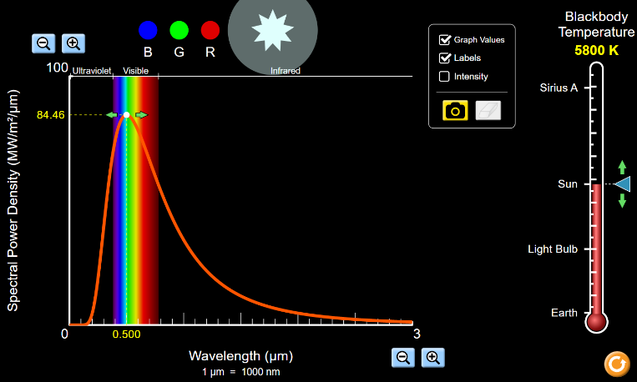
- Once you have the simulation open, you will notice a large graph showing the spectrum of light being emitted by a hot object. You will also notice that you can turn on features like graph labels and values. Go ahead and turn on these options.
- Notice also that you can adjust the scale for the X-axis and Y-axis. This will be important later. If the Y-axis seems confusing, don’t worry – roughly speaking, this is just a graph of brightness vs. wavelength.
- The simulation begins with the Sun, at a temperature of 5800 degrees Kelvin, as shown in Figure 4 at right:
- In the table below, write the temperature for the Sun in the correct column.
Aboe: The PhET Blackbody simulator.
Source: phet.colorado.edu
- Use the graph to determine the wavelength where the Sun is emitting the most amount of light called the “peak wavelength,” and then write this number into the table. (The wavelength is in units of micrometers or µm, which means 0.000001 meters or 1000 nanometers.)
- Repeat the steps above for a light bulb, Earth, and the star named Sirius A.
- Randomly pick two more temperatures that are different from the ones you’ve measured so far. Again measure the peak wavelengths and then add these data to the table.

Object Name | Temperature (ºK) | Peak Wavelength (µm)
Sun | 5800
Light Bulb
Earth
Sirius A
Temp 1
Temp 2

- Use the data from your table to create a graph of Peak Wavelength as a function of temperature, with temperature on the X-axis.
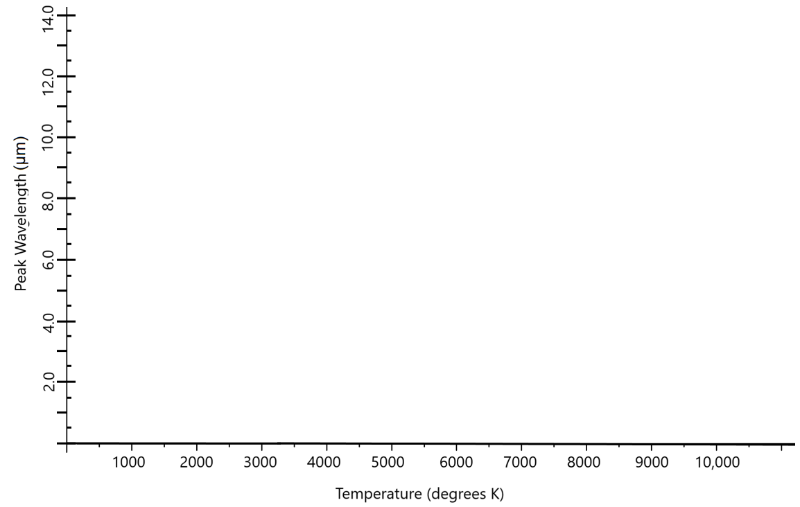

Explain Part 1

- What does your investigation tell you about the relationship between the temperature of an object and the types of light it emits? Justify your response with evidence from the data.

As an object gets hotter, it emits more light. The color of the light also changes – the hotter the object, the lower the wavelength of the light emitted.

- Based on your results, which part of a flame do you think is the hottest – the blue part or the yellow part? Justify your answer.

The blue part of a flame is the hottest, because blue light has a smaller wavelength than yellow light.

- A metal object at 1000 degrees K would be hot enough to burn you badly if you touched it, but it would appear the same as a cold piece of metal if you looked at it.
  - What type of light would this object emit, and what would the approximate wavelength be?

The object would mostly emit infrared light at a wavelength near 10⁻⁶ m (or 1 µm).

  - Adjust the simulation settings (T = 1000K) to prove your answer to the previous question.

As expected, when you use the blackbody simulation the peak wavelength is between 5 and 6 microns.

  - What special equipment would help you prove that it does emit light?

You could use an infrared camera to show the object giving off infrared light. Note to teachers: if you have a FLIR camera or other type of thermal camera, this is a great time to use it.

  - How do the results of this investigation explain why the appearance of an electric stove changes when it heats up? Justify with evidence.

When you first turn on a stove, it is hot but not hot enough to glow. This is because most of the light is infrared light that humans can’t see. As the temperature continues to increase, more of the light moves to shorter wavelengths and you can see the stove glowing red-hot.

Explain Part 2 – The Cosmic Background
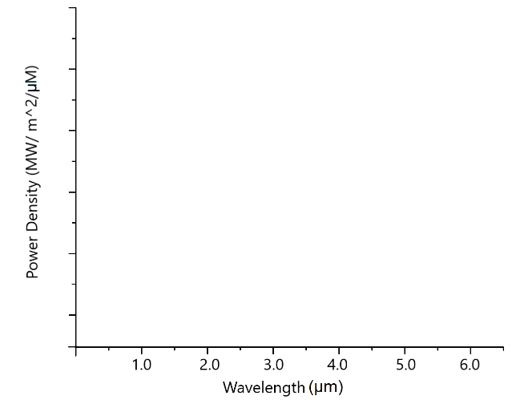
- Based on what you’ve learned so far, you know that the early universe was a hot and dense environment, and it would be emitting light whose wavelength depends on its temperature. Suppose that 13 billion years ago, the average temperature of the universe was 3600 degrees Kelvin. Note to teacher: students may complain that this 3600K number seems arbitrary or pulled out of nowhere. The key idea is that the hot dense universe would have stopped emitting light once it cooled off enough for hydrogen to form. This can be calculated to be 3000-4000K.
  - What would you expect the peak wavelength to be for the light being emitted by the early universe?

Approximately 1 µm.

  - On the graph at right, sketch a curve to represent the type of light you would expect to measure. (notice the graph has the same axes as the graph from the blackbody simulation, so you can use that simulation for help.)

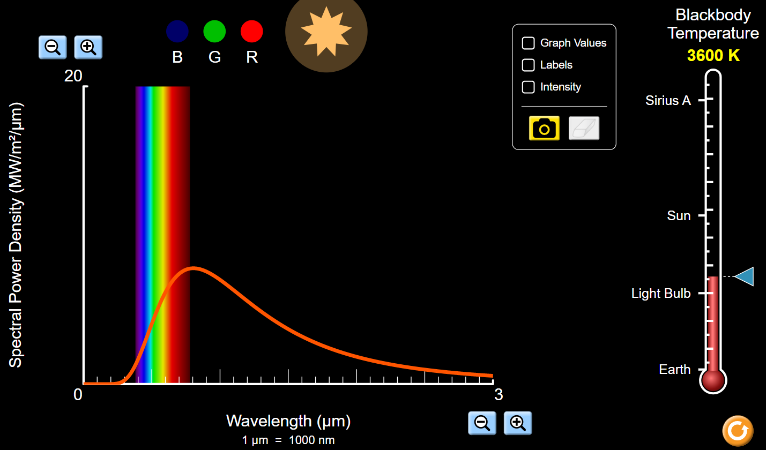

  - What category of light would this be? Circle one.
(Gamma / X-ray / UV / Visible / Infrared / Microwave / Radio)

This would be mostly infrared light.

- Think back to what you learned about Hubble’s Law. How was the redshift of galaxies used to demonstrate the universe expansion?

Because the universe is expanding, the light from galaxies is redshifted because all of the galaxies (outside our local neighborhood) are moving away from us.

- Rebecca Smethurst (AKA “Dr. Becky”) is a popular astrophysicist on YouTube. In one of her videos, she said the easiest way to travel back in time is to walk outside at night and look up. What do you think she meant by this?

All of the light we see in the night sky is old, because it takes time for the light to reach us. For nearby stars the light is a few years old, for nebulas the light is a few thousand years old, and you can even see light from galaxies that is millions of years old. Even on nights where the Moon is visible, the light takes 8 minutes to reach the Moon from the Sun, and another 1.5 seconds to reach the Earth from the Moon!

- If the early universe 13 billion years ago was emitting mostly infrared light, it would still be present in today’s universe. However, this light would be affected by the constant expansion of the universe during that time.

What would you expect to happen to the peak wavelength of this light due to the universe expansion?

In a similar way to how the light from moving galaxies is redshifted, the infrared light from the early universe is also redshifted. Because the light is over 13.5 billion years old, the redshift is very dramatic. So the peak wavelength of the light would be much longer than 1µm.

Evaluate
- The graph in the figure below comes from a famous article in the 1996 Astrophysical Journal using a microwave telescope called COBE (and an instrument called FIRAS) that was pointed at the entire night sky. The FIRAS instrument produced a curve based on all the wavelengths of light it detected over the entire sky.
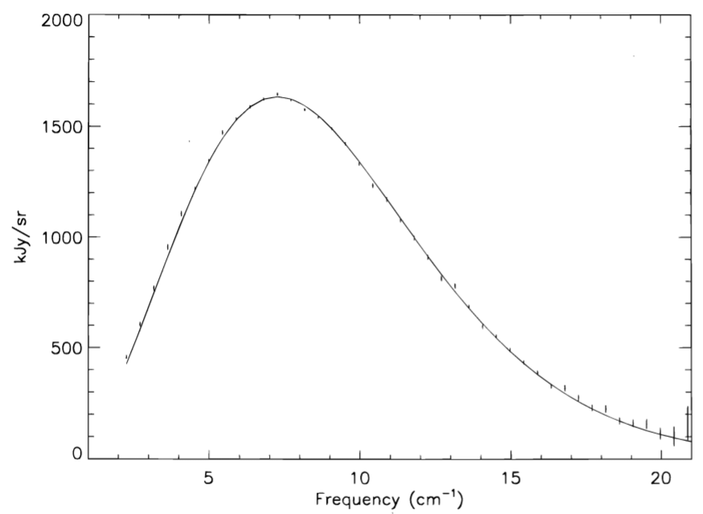
Above: The Cosmic Microwave Background, measured by COBE.
Note: the x-axis is frequency.
Source: nasa.gov

The graph below is a simplified version of the same data:
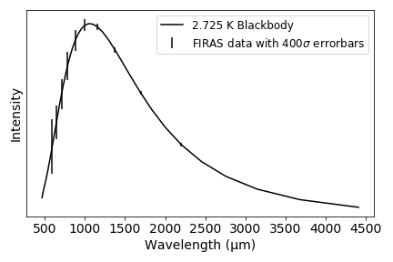

Why does this graph support or not support your conclusions in the previous questions? Justify your answer with evidence and reasoning from both this graph and the work you did previously.
An example of a sufficient answer might be: The peak wavelength of the light detected by FIRAS was about 1000µm, which is in the microwave part of the EM spectrum. This is about a thousand times longer than the peak wavelength of infrared light at 3600K. So the FIRAS graph does support the idea that the infrared light from the early universe was extremely redshifted.

- Below are two maps that use a “Mollweide” projection map, which is a useful way to show the entire surface of a sphere. At left is a Mollweide projection of Earth, and at right is a Mollweide projection of the entire night sky using visible light.
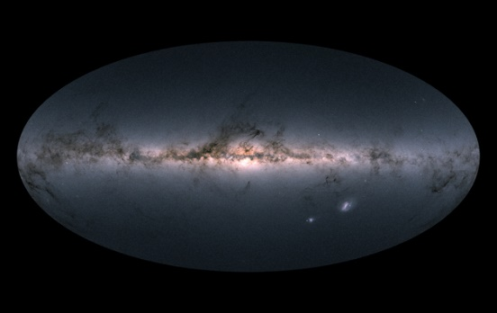
Above left: Mollweide map projection of Earth. Source: map-projections.net Above right: The entire night sky from the GAIA telescope. Source: ESA

A skeptic might complain that this microwave light measured by COBE is simply being emitted all the time by the galaxies in the universe, and therefore is not 13 billion-year-old light! The final map is a Mollweide projection that uses microwave light rather than visible light. How does this image prove that galaxies are not the source of the signal measured by COBE?
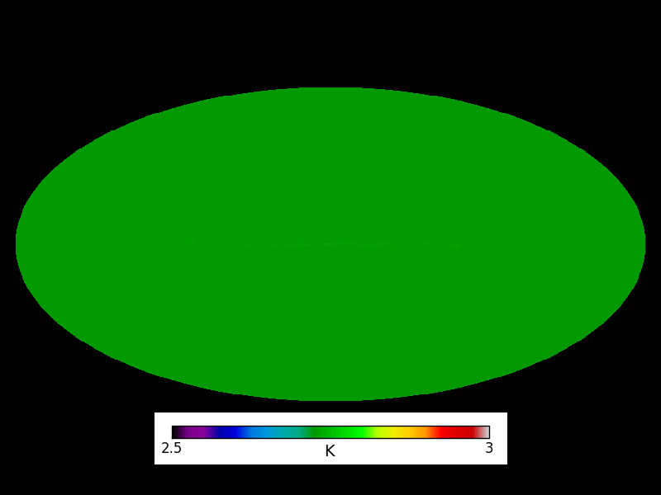
Above: The highly uniform temperature of the CMB at 2.7 degrees Kelvin.
Source: Dr. Katie Harrington, Univ. of Michigan

If the 1000µm light were coming from galaxies, then you would expect bright spots scattered all over the map from the nearby galaxies. There aren’t any bright spots, the light is coming from everywhere at the same temperature so it’s not coming from galaxies. Note to teacher: a student with sharp eyes may notice a faint bright line across the middle – this is coming from the Milky Way!

- The light measured in the graphs and picture above is usually called the “Cosmic Microwave Background” or simply CMB. In a paragraph or two, explain why the CMB is a strong piece of evidence for the Big Bang model of an expanding universe. Be sure to cite evidence for your explanation using the information from this assignment, and justify your evidence with reasoning.

An example of a highly proficient paragraph-length response:
We have evidence that the universe is expanding based on redshifted galaxies, called Hubble’s Law. Physicists realized that if this model of expansion were true, then there would be a time in the early universe when it was too hot and dense for atoms to even form. This hot and dense universe would constantly be emitting a lot of light. Once the universe expanded and cooled enough for hydrogen to form, its temperature would be about 3000 degrees Kelvin so the light would be infrared light. Over time, this infrared light would be extremely redshifted and would seem to come from everywhere. This is exactly what we see: microwave light at a temperature of 2.7 degrees Kelvin that comes from everywhere at once. The presence of this light supports the idea of an expanding universe.

Extension

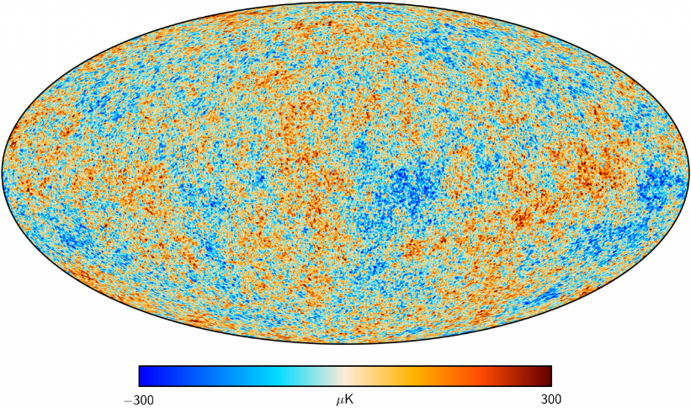
Figure 2: A differential map of the CMB from the Planck telescope.
Source: esa.int
- When you do an image search for the CMB, you don’t usually get the solid color shown in the Mollweide map in Figure 6. Instead, you get something that looks like Figure 7, which is called a “differential” measurement of the CMB.

  - What do you think the word “differential” means here? (Hint: compare the scales in figures 6 and 7.)

A differential map is only showing the small differences between the different parts of the map. The whole sky is still 2.7 degrees Kelvin but this map is showing small differences about 10,000 times smaller than that.

  - Why are scientists so interested in these tiny differences in the temperature of the CMB? What can be learned by analyzing these maps? (try reading about the NASA telescope called WMAP here: https://map.gsfc.nasa.gov/mission/sgoals_universe.html)

These maps provide stronger evidence for the Big Bang model and also give us a lot of information about what the early universe was like. We can learn about what the universe is made of and get hints that there are other types of matter and energy we haven’t detected yet and know very little about (dark matter and dark energy). Analyzing these details allows us to trace the universe all the way back to the first one-billionth of a second after the Big Bang!

Note to teacher: some additional interesting ideas for discussion with students might include the following:
- The large hot and cold “blobs” are thought to be traces of slight irregularities in the density of the universe at the moment of the Big Bang. These so-called quantum fluctuations, which initially appeared on a very tiny scale, have been “frozen” into the density of galaxies today on a huge scale!
- By analyzing the hot and cold spots and getting a sense of the “average size” of a hot spot, we see evidence for dark matter: in the early universe, dark matter was pulling ordinary matter back inwards, but the hot radiation pressure of the ordinary matter would push it back out. This push-pull caused a set of ripples to form in the universe, which also became “frozen” into the structure of the universe.
- Just like a slinky that can be shaken up/down or left/right as waves move from one side to the other, light can be polarized so that it only vibrates up/down or left/right. By measuring the polarization of the CMB light, physicists are trying to get glimpses to a time even earlier and closer to the Big Bang. If certain types of polarization are detected, this could answer questions about why the universe is so uniform and why its expansion is not faster or slower.

