CMS Data Express
Teacher Notes

Description
CMS Data Express is a short investigation using events from the Compact Muon Solenoid (CMS) at the Large Hadron Collider (LHC). Students are assigned “on-shift” to CMS Data Quality Management (DQM). They check the data quality to see that CMS is performing to specification by giving a good fit for the Z mass and/or the W⁺/W⁻ ratio. The students will do this by:
- Separating Z candidate events from other events by visual inspection and create a mass plot for the Z boson.
- Separating W candidate events from other events by visual inspection and determine the ratio of W+ to W- candidates.
While this activity is richest pursuing both goals; however, each can stand on its own as a separate activity. This activity helps prepare students for a masterclass or to give students a masterclass-like experience in a short time (1-2 class periods).
The Z boson is important in LHC discovery science. It is a well-known particle, so the location and width of the mass plot give physicists a good idea of how the detector is performing. Z candidate events are “dimuon” events; the Z can decay into a muon-antimuon pair. Z candidates are identified by two long muon-type tracks.
W candidate events consist of decays into single muons and neutrinos. However, the neutrinos do not interact with the detector and hence leave no tracks or energy deposits. Their momenta are estimated by summing all the momenta in the event to determine what is “missing.” Thus, a W candidate appears as a single long muon–type track.

Standards Addressed
Next Generation Science Standards
Science Practices
1. Asking questions
2. Developing and using models
4. Analyzing and interpreting data
5. Using mathematics and computational thinking
6. Constructing explanations
7. Engaging in argument from evidence
8. Obtaining, evaluating, and communicating information
Disciplinary Core Ideas – Physical Science
PS1.A: Structure and Properties of Matter
PS2.B: Types of Interactions
PS2.C: Stability and Instability in Physical Systems
PS3.B: Conservation of Energy and Energy Transfer
PS3.C: Relationship Between Energy and Forces

Crosscutting Concepts
1. Patterns.
2. Cause and effect: Mechanism and explanation.
3. Scale, proportion, and quantity.
4. Systems and system models.
7. Stability and change.
Common Core Literacy Standards
Reading
9-12.4 Determine the meaning of symbols, key terms . . .
9-12.7 Translate quantitative or technical information . . .
Common Core Mathematics Standards
MP2. Reason abstractly and quantitatively
MP6. Attend to precision.
IB Physics Standard 1: Measurement and Uncertainty
1.2.6 Describe and give examples of random and systematic errors.

1.2.8 Explain how the effects of random errors may be reduced.

1.2.11 Determine the uncertainties in results.

IB Physics Standard 7: The Structure of Matter
Aim 4: particle physics involves the analysis and evaluation of very large amounts of data
Standard 7.3.4: Apply the Einstein mass-energy equivalence relationship

Enduring Understandings
Scientists continuously check the performance of their instruments by performing calibration runs using particles with well knows characteristics.

Learning Objectives
As a result of this activity students will be able to:
- Predict the electric charge of a particle from its motion in a magnetic field.
- Describe the method of determining which kinds of decay particles are present in each event.
- Describe how candidate events can be accepted or eliminated using conservation of charge.
- Make a list of events sorted into the following categories: Z decay, W⁺ decay, W⁻ decay or random event.
- Make a histogram of the mass of the particles represented in the chosen Z candidate events.
- Calculate the W⁺/W⁻ ratio for the chosen candidate events.
- Describe how the mass plot for Z candidates and the W⁺/W⁻ ratio can be used to determine if the detector is calibrated.

Background Material
The images the students analyze are CMS events. There are a variety of resources on CMS and the LHC at http://cms.cern.ch. Other resources are available from the web page (see below).
Prior Knowledge
Students will know and be able to:
- Use the Lorentz Force that determines the direction of charged particles moving through a magnetic field
- Use the right-hand rule to determine the (positive or negative) charge of the particle.
- Make a histogram from data.
The Plotting LHC Discovery lesson can serve as introductory activity for the importance of calibration in interpreting new discoveries.

Resources/Materials
Data file: https://quarknet.i2u2.org/sites/default/files/cms_deevents_mass.pdf

Screencast: http://leptoquark.hep.nd.edu/~kcecire/drupal_lib/video2014/2014-08-19_1456.swf

Implementation
Students start with background from the two topmost videos at http://cms.physicsmasterclasses.org/cms.html

There are 80 events in the PDF data file (linked above in Resources), one per page. Students work in pairs. Two students working together on one analysis (Z or W) should be able to do about 40 events in perhaps 10- 15 minutes; working on both (Z and W), 20 events is a more reasonable number. Since different students have different interpretations, this will likely give fairly good results.
For Z analysis, students identify Z candidate events as those with two red tracks indicating a muon-antimuon pair. They can check if these are “good” Z candidates by looking at the curvature of the tracks: the two tracks should have opposite curvature indicating opposite electrical charge. The Z boson being neutral, it must decay into both a negative muon and a positive antimuon to conserve charge. Each event has a mass printed at the upper right. Students should round these to the nearest odd number and record the mass for the events that they determine are Z candidates. Students should count the number of events they have at “mass bin” (e.g., 2, at 83 GeV, 7 at 89 GeV, 12 at 91 GeV . . . ) and contribute these to a class data table. The class creates a mass plot by summing up the events in each mass bin and creating a histogram. One of the most successful ways to construct the histogram is with sticky notes.
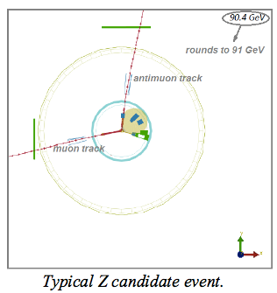 | 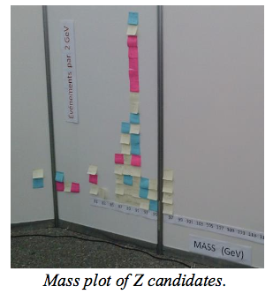

For the W analysis, the W is charged; therefore, it can only create one charged decay product thus conserving charge. Students identify W candidates as those with only one muon or antimuon track. The decay also creates a neutrino; this conserves momentum. The neutrino is not directly detected. To find if the possible W particle is a W⁺ or a W⁻, students use the curvature of the muon (or antimuon) track. A track with clockwise curvature indicates the positive charge carried by the antimuon after its decay from the W⁺. An anticlockwise curvature indicates the presence of a muon decaying from the W⁻. Students count and report the number of W⁺ and W⁻ candidates. The total number of W⁺ candidates divided by the total number of W⁻ candidates in the class yields a W⁺ to W⁻ ratio. Students ignore the mass of these events.
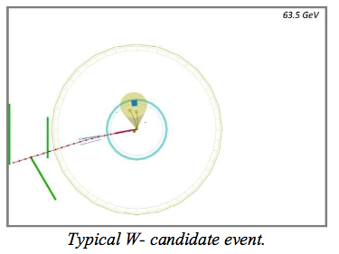
Teachers lead a discussion at the end of the activity; it is crucial to understand the significance of the results. The initial results of the investigation are:
- A readable mass plot of the events that appear to contain Z bosons.
- A count of W⁺ and W⁻ particles.
Students use the evidence from their analysis to make a claim about the mass of the Z boson and the ratio W⁺ to W⁻. Then the discussion digs deeper into the evidence with questions like:
- How sure are we of the results we have?
- What affects the accuracy of our results?
Introduce the expected values: approximately 91 GeV for the mass of the Z and approximately 1.4 for W⁺/W^{-.} Then ask: Are your results reasonable based on what we know?
[Note: the "expected" value of W+/W- is not necessarily 1.4 - it depends on the experiment but is also constrained by the physics. There is more to this. Using the term "expected value" can be problematic.]
Assessment
- Quality of their plots
Check for the following: correct labeling of axes, identifying the background level; appropriate bin size selection
- Interpretation
Check for the following: correct identification of the peak and the particle mass; indication that the width of the peak represents the uncertainty in the value of the mass.
Did the analysis indicate that the detector is well calibrated? That is, did the mass plot yield a result in agreement with accepted values for the Z mass? (91GeV/c² )
- Discussion
Divide the class into groups. Each group then presents their findings to the class with open discussion of the claims, evidence and reasoning provided by each group. Questions addressed during the discussion include:
- What is the most likely mass of the Z boson?
- What is the range of Z boson masses sampled in your data?
- What is the ratio of the W+ events to the W- events?
- What evidence do you have for these values?

- Written report
A written report should stress claims, evidence, and reasoning:
What claims can scientists make based on the Z plot?
  - Examples: mass, discovery, uncertainty.
What is the evidence for and against the validity of the claims?
  - Examples: signal-to-background, width.
Explain the reasoning linking the evidence to the validity of the claim.
  - Example: the Z signal is large compared to background, with a width narrow compared to the height of the peak.

What claims can scientists make based on the W+/W-?
  - Examples: the ratio was well below the approximate value of 1.4 because we accepted too many W- candidate events because the curvature was very small and we guessed incorrectly

Are some claims more valid than others? Why?
  - Example: a smaller signal-to-background ratio gives weaker evidence of discovery.
Provide the evidence for these claims, and the reasoning behind them over to the shift manager in your “Shift Report.”
Extension
This activity is well suited to a more detailed analysis of error, using readily available tools in a spreadsheet or graphing calculator. Below is a selection of indicators from the IB standards, with a description of how these indicators can be met using this activity.
Understandings:
Random and systematic errors
On a histogram with a “bell-shaped” distribution, random error can quantified by determining the “width” of the distribution, and systematic error can be related to the mean of the distribution. Examples in the case of a Gaussian distribution would be by calculating the FWHM (full width half-maximum) or the standard deviation. In either case, a narrow peak (such as the narrow mass distribution of the J/Psi in muon production events in CMS) can be identified as one with a small random error, while a broad peak (J/Psi candidates from electron-positron production, for example) would represent a large random error.
A student can calculate standard deviation easily in a spreadsheet program, and by inspection of the histogram explain how the standard deviation relates to the width of the distribution; the FWHM would be more difficult but could be estimated by printing the histogram, sketching a normal distribution curve over it, and measuring with a ruler.
Calculating the mean of a distribution, on the other hand, can shed light on possible systematic error. If the published mass of the J/Psi particle is 3.1 GeV/c² for example, but the mean of a given distribution is 3.2, then this may indicate something systematic that is skewing mass values to be too heavy. When the CMS and ATLAS team publish discoveries or describe their process, they include both systematic and random uncertainties.
Error bars
For the data in each bin of the histogram, the error can be approximated as the square root of the number of events in the bin. Using a spreadsheet program, this is easily accomplished as they have options to include “standard error” bars, or even error bars with user-defined width.

