Compton Scattering Activity

Rick Dower ______________________________
8/28/2021 Name

J. J. Thomson developed the classical theory of scattering of electromagnetic radiation (light, including x-rays and gamma rays) by charges in matter. He based his theory on a model in which the oscillating electric field of the incident light causes electrons in matter to vibrate at the same frequency as the incident light. The oscillating electrons would, in turn, radiate scattered light of the same frequency uniformly in all directions. Experiments seemed to show that this prediction was generally correct. However, in the early 1900s when high energy (hard) x-rays or gamma-rays were used, the scattered energy was found to be reduced below expected values and concentrated in the forward direction. Arthur Compton suggested that “this reduced scattering of very short wave-length X-rays might be the result of interference between rays scattered from different parts of the electron, if the electron’s diameter is comparable to the wave-length of the radiation.” (A. H. Compton, Phys. Rev. 21, 484, May 1923) When investigating the discrepancy with Thomson’s theory in greater detail, Compton found that the scattered radiation of hard x-rays had longer wavelength than the incident radiation. This led him to abandon the classical theory and apply a quantum theory to explain his results. Einstein had proposed that light energy comes in small packets that he called radiation quanta. Millikan’s photoelectric measurements affirmed that Einstein’s quanta carried energy. Compton’s results showed that radiation quanta carried vector momentum as well. Compton’s use of the term “photon” for a quantum of radiation, after his 1927 Nobel Prize for the experiment described below, led to the general adoption of the term in physics.

1. On a separate sheet, derive an equation for the energy of scattered radiation from the following scenario. A high energy (E₀) photon (γ₀) strikes a stationary charged particle, e. g. an electron, (mass = m) and transfers some energy and momentum (p_{e}) to the electron. A scattered photon (γ₁), with reduced energy (E₁), leaves the interaction at angle θ relative to the direction of the incident photon. See the diagram below.

Interaction Diagram Momentum Conservation Triangle
p₁
p_{e}
γ₁
γ₀
θ
θ
p₀
m

Use relativistic energy conservation, momentum conservation (with the law of cosines), and the energy-momentum-mass relations for photons (E_{γ} = p_{γ}) and particles (E² = m² + p²), all quantities in energy units, to derive the relation for the energy of the scattered photon:
$E_{1}=\frac{E_{0}}{\left[1+\left({E_{0}}/m\right)\left(1-\cos{θ}\right)\right]}$ . (1)
2. On a separate sheet, use equation (1) to derive Compton’s relation between the scattered photon wavelength (λ₁) and the incident photon wavelength (λ₀)
$λ_{1}-λ_{0}=\left(\frac{h}{mc}\right)\left(1-\cos{θ}\right)$ , (2)
here m is in kg units rather than MeV units, h = Planck’s constant, and c = speed of light.

3. Show that $\frac{h}{m_{e}c}=2.43$ pm, where m_{e} = electron mass and 1 pm = 10⁻¹² m.
This quantity is called the Compton wavelength of the electron.

4. A side-view diagram of Compton’s x-ray tube is shown in Figure 2 (from A. Compton, Phys. Rev. 22, 411, November 1923.) The dashed line in the figure shows water flow to prevent the molybdenum (Mo) anode melting due to the high energy (1.5 kW) deposited by the electron current from the cathode on the left. Only about 1% of the cathode ray energy is converted to x-ray photons. About 99% of the cathode ray energy heats the anode.
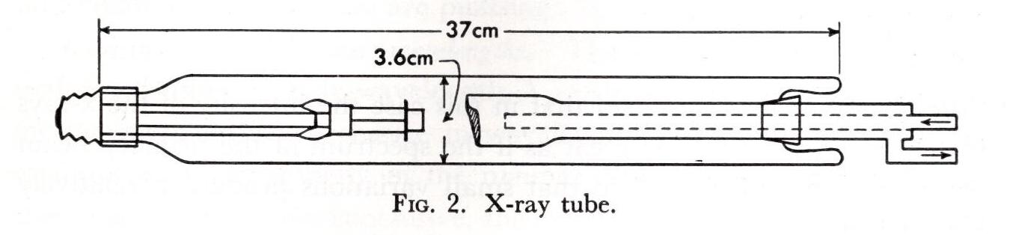
A diagram of Compton’s apparatus with the x-ray tube end-on, molybdenum anode (T), graphite scatterer (R), and a crystal spectrometer, is given in Compton’s Figure 1.
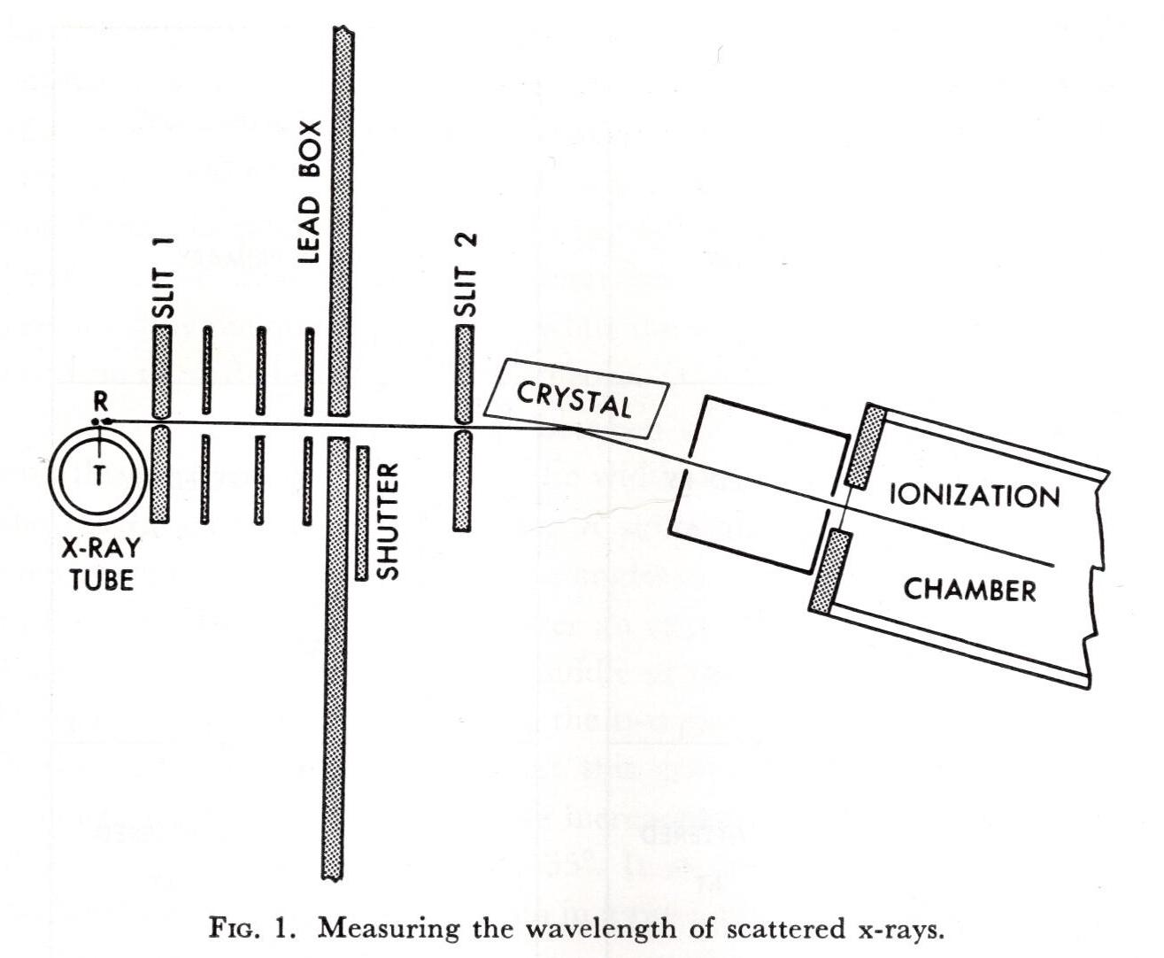
In Figure 1, the angle between Mo K_{α} x-rays incident on the graphite and x-rays scattered from the graphite into the spectrometer is 90°.
Compton’s scattering values for two different data runs are given in his Figures 3 and 4.
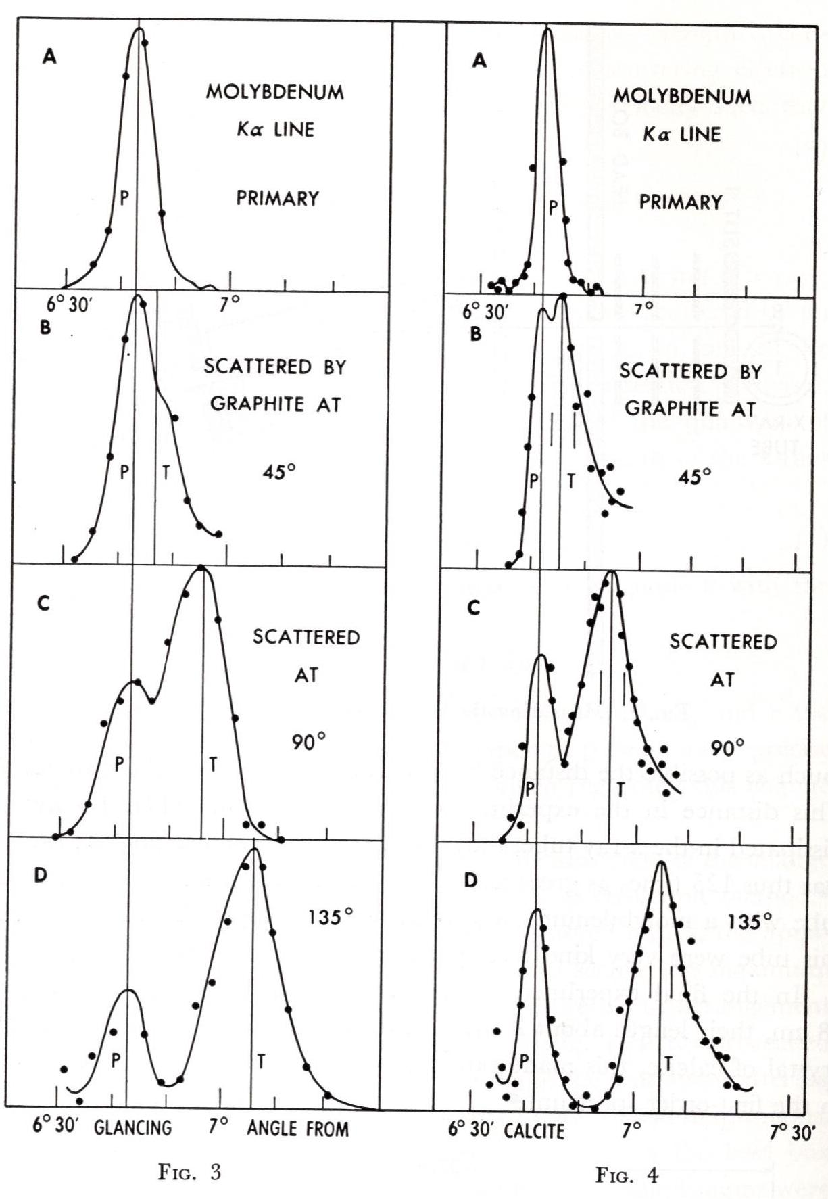
For each data set there are peaks (P) indicating the position in the spectrometer of the unmodified Mo K_{α} radiation from the 0.1 mm wide slits and peaks (in C, D, and E) indicating the scattered longer wavelength radiation. Data values in Figure 4 were obtained with smaller angular increments between data points.

Compton used a calcite (CaCO₃) crystal in his spectrometer and a value of λ_{Kα} = 70.8 pm
(E = 17.5 keV) for the characteristic Mo x-ray. Determine the scale of the horizontal axis in Figure 4, and calculate the angle (φ) in the spectrometer of the for the first order (n=1) unmodified K_{α} peak in Figure 4 A.

5. Use the Bragg equation for the direction of enhanced diffraction from a crystal surface
(nλ = 2dsinφ ) to calculate the distance (d) between atomic scattering planes in the calcite crystal of Compton’s spectrometer.

6. Measure displacement from 6.5° of the peaks of the modified K_{α} radiation in Fig. 4 B, C, and D. Use your plot scale to calculate the angular positions of the peaks, and enter you values in the table below.

7. Use the Bragg equation to calculate the measured wavelengths of the modified K_{α} radiation in Fig. 4 B, C, and D. Enter you values in the table below.

8. Use Compton’s equation in #2 to calculate the modified wavelength values expected from Compton’s theory for the scattered K_{α} radiation in Fig. 4 B, C, and D.
Enter you values in the table below. Compare the measured and calculated values.

Compton Values
Scattering Angle  from Graphite | Diffraction Angle  from Crystal | Measured modified  λ_{m}=2dsinφ | Calculated scattered  $$λ_{1}=λ_{0}+\left(\frac{h}{m_{\text{e}}c}\right)\left(1-\cos{θ}\right)$$
θ (degree) | φ (degree) | (pm) | (pm)
0
45
90
135

9. The Compton formula was derived for stationary electrons. How would the scattered wavelength change for an electron moving toward or away from the incident photon?

10. Suppose the Incident photon scatters from the whole carbon atom (M = 12*1833m_{e}) in the graphite. So that the mass in the Compton formula is the carbon atom mass rather than the electron mass. Calculate the maximum Compton wavelength shift (φ = 180°) and angular shift in Compton’s apparatus.

Would that shift be measurable with Compton’s apparatus?

11. For the inverse Compton effect, a high energy particle interacts with an incoming photon to boost the photon’s energy. Suppose a particle with mass m, momentum p, and energy E traveling to the right interacts with a photon of energy E₀ traveling to the left. The scattered photon with increased energy E₁ travels to the right and the particle continues to the right with reduced energy (E_{A}) momentum (p_{A}) after the interaction.

a. Show that E₁ is given by the equation $E_{1}=\frac{E_{0}(E+p)}{2E_{0}+(E-p)}$ (all quantities in energy units).

b. For high energy particles with p >> m, E >> m, and, consequently, E ≅ p, show that
E₁ ≅ E , i.e., the outgoing photon energy is nearly equal to the incoming particle energy.

