How to use EQUIP
Teacher Notes

Description
EQUIP is a JavaTM based program used to control QuarkNet’s cosmic ray muon detectors (CRMD). It must be installed on the computer that is being used to operate the CRMDs and can be obtained, for free, from the QuarkNet Cosmic Ray e-Lab website.

Standards Addressed (Fill in as appropriate. this list shows format.)
Next Generation Science Standards
Science and Engineering Practices
4. Analyzing and interpreting data
5. Using mathematics and analytical thinking
Crosscutting Concepts
1. Observed patterns
Common Core Literacy Standards
Reading
9-12.4 Determine the meaning of symbols, key terms . . .
9-12.7 Translate quantitative or technical information . . .
Common Core Mathematics Standards
MP2. Reason abstractly and quantitatively.

Enduring Understandings
· One EU per activity
· Data are organized in charts, tables, and/or graphs for analysis that often includes recognition of patterns in the data.

Learning Objectives (Begin with verb that can be measured.)
As a result of this activity, students will know and be able to:
- Install EQUIP on a computer.
- Read the data output.
3. Identify if the GPS signal is valid or invalid.
4. Identify the readings for latitude, longitude and altitude.
5. Access the list of commands, using commands H1 and H2
6. Execute special commands such as ST and SA
7. Locate the data files on the computer.
8. Interpret time and date from the Log file format.
9. Control the coincidence level for the CRMDs.
10. Compare and contrast time over threshold graphs for consistency.
11. Interpret channel and coincidence rates.
12. Measure temperature and pressure as a function of time.
Background Material
This is content information for the teacher, often including links for where to get more information.

Prior Knowledge
Cosmic rays are spontaneously created particles that exist in our atmosphere. They are created by the arrival of a proton (or a similar particle) from outer space. The proton interacts with the atoms in the atmosphere and, via mass and energy interactions, new particles are created, included muons. Muons are charged leptons, and are therefore similar to electrons, but about 200 times as massive. Muons exist for about 2.2µs. Due to relativistic effects, some muons reach the surface of Earth, where they can be detected by various means.
The CRMDs are designed to detect muons and relay the optical and electrical signals they produce to a data acquisition card (DAQ), and computer and be analyzed using a program such as EQUIP and the Cosmic Ray e-Lab. https://www.i2u2.org/elab/cosmic/home/project.jsp EQUIP gives students and teachers the tools needed to do preliminary analysis of cosmic ray muon data. Every CRMD has up to four channels, which can be operated independently according to the plans of the experimenter. When the channels are placed directly on top of one another, they are called “stacked” and when they are spread out they are called an “array”. Variations of both arrangements exist, as well as hybrid arrangements.

Resources/Materials
CRMD
Dedicated computer
DAQ driver installed
EQUIP installed on the computer https://www.i2u2.org/elab/cosmic/data/equip.jsp
GPS antenna installed and located at an appropriate window or outdoor location.

Implementation
EQUIP allows the CRMD user to control all aspects of data collection, from a GUI format. Time over threshold (TOT), Rate, Shower, and Geometry tabs allow the user to read information related to the data, as well as access other important features of the CRMDs.

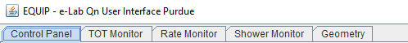

Figure 1 Tabs for EQUIP operation.

Control Panel

- Position the GPS unit near a window, preferably facing south, but at least near a window with a clear view of the sky. (If your windows are facing a narrow or tree-lined street, without a clear view of the sky, you may need to re-position the GPS).
Measure the geometry (the distance and relative location north, south, east or west) of the GPS relative to the four channels. (For more information, see the geometry tutorial in the Cosmic Ray e-Lab). This geometry must be directly entered into the e-Lab. NOTE: EQUIP does NOT upload geometry. Latitude, longitude, and altitude are found on EQUIP Control Panel tab and the Geometry tab, once linked. If connected to the Internet, the Geometry tab in EQUIP will show an approximate location of the GPS. No geometry information is automatically uploaded from EQUIP.
The DAQ should be receiving power, have several flashing lights and the numbers on the counter should be changing.

- Start EQUIP. After opening EQUIP, select under Serial port, the COM port for the DAQ. On PCs, it is often COM3 or COM4. There are other possibilities on Apple platform. If you have a blank or no connecting ports, check that the correct driver is downloaded and installed. The URL for the DAQ driver is printed on the underside of the DAQ.

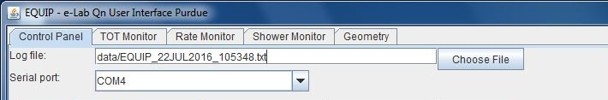

Figure 2 Log file and Serial port of the Control Panel.

If connected, a number of preprogrammed commands should execute and show in the data capture window. If data continues streaming, press Disable (CD) near the bottom of the window.

- Select the following sequence of commands to make sure the detector is working properly and to record the status of the DAQ into the data file to be uploaded to the Cosmic Ray e-Lab.

Command | Comment
GPS (DG) | Information for geometry is displayed here and under the Geometry tab. The geometry in EQUIP does not automatically upload to e-Lab. Check that there are at least 4 satellites. This may take up to 30 minutes after a cold start of the DAQ.
Page 1 (H1) | This displays page 1 of the help menu. It verifies the DAQ number, version number, and other details.
Page 2 (H2) | This displays page 2 of the help menu.
Barometer (HB) | This displays the help menu for the barometer. The barometer should be calibrated according to the instructions.
Status (HS) | Shows Help Status information
Trigger (HT) | Shows Help Trigger information
Setup (V1) | Check for any error messages.
Voltages (V2) | Monitors voltages on the board.
GPS Lock (V3) | Gives readouts of satellite timing.
Scalars (DS) | Displays the scalar values.
Control Registers (DC) | Displays the control registers.
Timing Registers (DT) | Display of timing registers.
--Trigger-- | Check the channels, coincidence level, gate width, and pipeline delay. Gate width is often 300 ns, and pipeline delay is 100 ns.
Threshold (TL) | Shows the threshold voltage levels, usually 300 ms.
--Status Output-- | From the drop-down menu, select Reset Scalars 3 x, and set the Time Interval to 5 minutes. This allows for data to regularly include GPS information, counts for each channel, refreshed at 5 minute intervals, and for that configuration to be saved and used again without more command prompts.
Type BA on Command Line | Verifies the setting of the barometer, if it has been calibrated. Does not work when over 1000 meters altitude.
Save (SA 1) | Saves the setup.
Enable (CE) | The detector is now collecting enabled, as seen in the data window.

Table 1 Sequence of commands at start up, beginning near the top of the Control Panel, and moving down. See Figure 3.

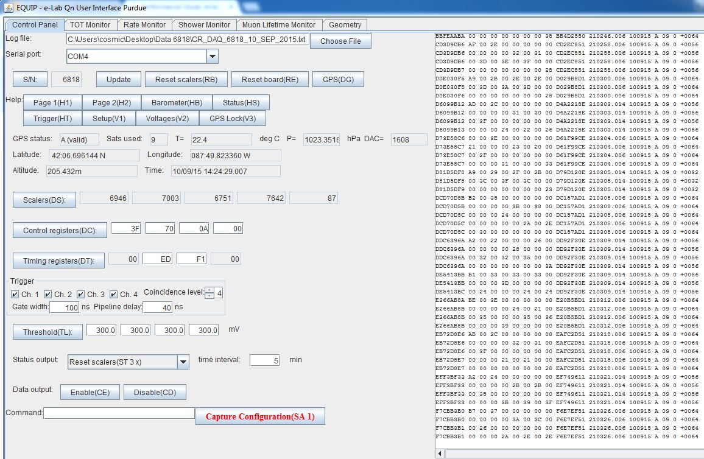
Raw data output
Figure 3 Control Panel page with commands and settings highlighted.

{The ending sequence is similar. It begins with Disable (CD), followed by the commands from the top, ending with Threshold (TL).}

- The data are in hexadecimal format and will likely be indecipherable at first. However, seeing the data tells you if the CRMD is transmitting readings to the computer. As time goes on, you will be able to recognize parts of the raw data. It is NOT important for you to recognize and decipher each part of the output, although it does tell you more about the data.

(5) Where are the data file located on the computer? You will need to identify the location of the data files to upload the files to the e-lab for analysis. Identify the location of the EQUIP JavaTM program. There will be a folder named data in that folder. That is the default location of the data files. More information can be found on the Cosmic Ray e-Lab site https://www.i2u2.org/elab/cosmic/home/index.jsp . An e-Lab account is necessary to upload and use all of the tools on the e-lab. Contact your mentor teacher or a QuarkNet staff member for assistance. Cosmic Ray e-Lab accounts can be requested at https://quarknet.i2u2.org/sites/default/files/qn_accounts.pdf

(6) When was this file created? As you collect more data, you will have to differentiate among the various data files. It is easy to decipher the format of the date and time settings for the EQUIP data files. Each time you turn on EQUIP and start collecting data, the current time and date are embedded in the file name. The time stamp uses coordinated universal time (UTC) as well as the date. This indicated the time and date upon which the EQUIP file was created.
EQUIP_13JUL2016_165339
(It is obvious that the file was created on July 13, 2016, but what about the time? Remember that it is UTC, which was once known as Greenwich Mean Time.)

(7) Coincidence levels. The CRMD channels record data independently, but they are more useful when they work in coincidence. Coincidence refers to a single event being recorded simultaneously in multiple channels, reducing the chances of mistaking noise for a real muon event. When the coincidence level is set at two, the DAQ waits for any two channels to detect an event within a certain time frame, known as gate width. When the coincidence level is set at three, the DAQ waits for three channels to detect an event within the gate, etc.

Common Settings (yellow boxes):
TRIGGER
Coincidence Level: 2
Gate Width: 300 ns Pipeline Delay: 100 ns

STATUS OUTPUT Reset Scalers (ST 3x) time interval: 5 minutes

Time Over Threshold (TOT) Monitor

The Time Over Threshold (TOT) Monitor is a histogram that accumulates measurements of the amount of time the signal pulse from each photon from the scintillator is above the threshold voltage value. In most cases, the threshold level is 300 mV. Upon setup, the bin width can be changed, but the default is 1.25 ns.

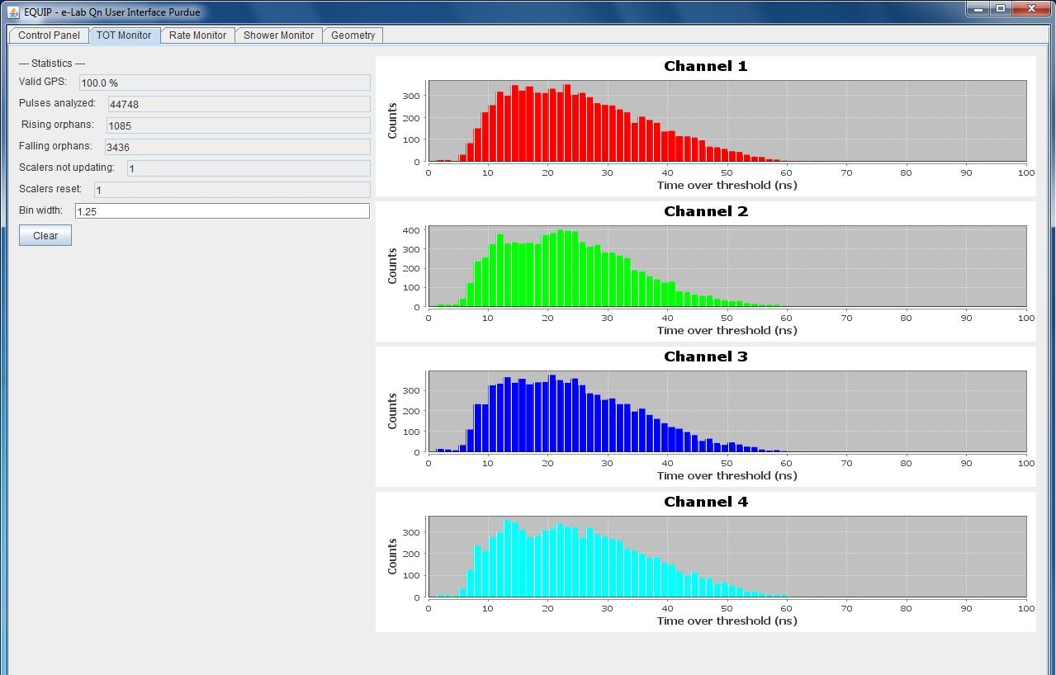
Figure 4 Time Over Threshold Monitor
The channels should have a similar shape and count range. An array setup (shown) tends to be wider than a stacked arrangement. After EQUIP is closed, these graphs are no longer accessible within EQUIP, but after uploading to e-Lab, may be viewed and manipulated using the Performance analysis tool in the Data section.

Rate Monitor

The Rate Monitor shows the rates of each channel, the coincidence rate, barometric pressure, and temperature. In general, the single channel rates should be relatively close to each other, and stable, and the coincidence rate should be stable and lower than the channel rates. If there is an anomaly, this can be due to an event of some sort or a problem with a counter.
The Temperature Pressure graph should show some variation through time. The barometer should be calibrated and show local pressure, and not sea-level corrected pressure. Depending on how the temperature probe is mounted, the readings may not be accurate. In the example shown below, the probe is mounted an outdoor, polymer, weather resistant electrical box. When the sun shines on it (noon to about one hour before sunset), the temperatures are not accurate. Daily peak temperatures of 45 C do not occur in Northbrook, IL. When uploading files to e-Lab, there is a comment box. It is helpful if you indicate if the barometer has been calibrated, and any temperature variances that need noting.

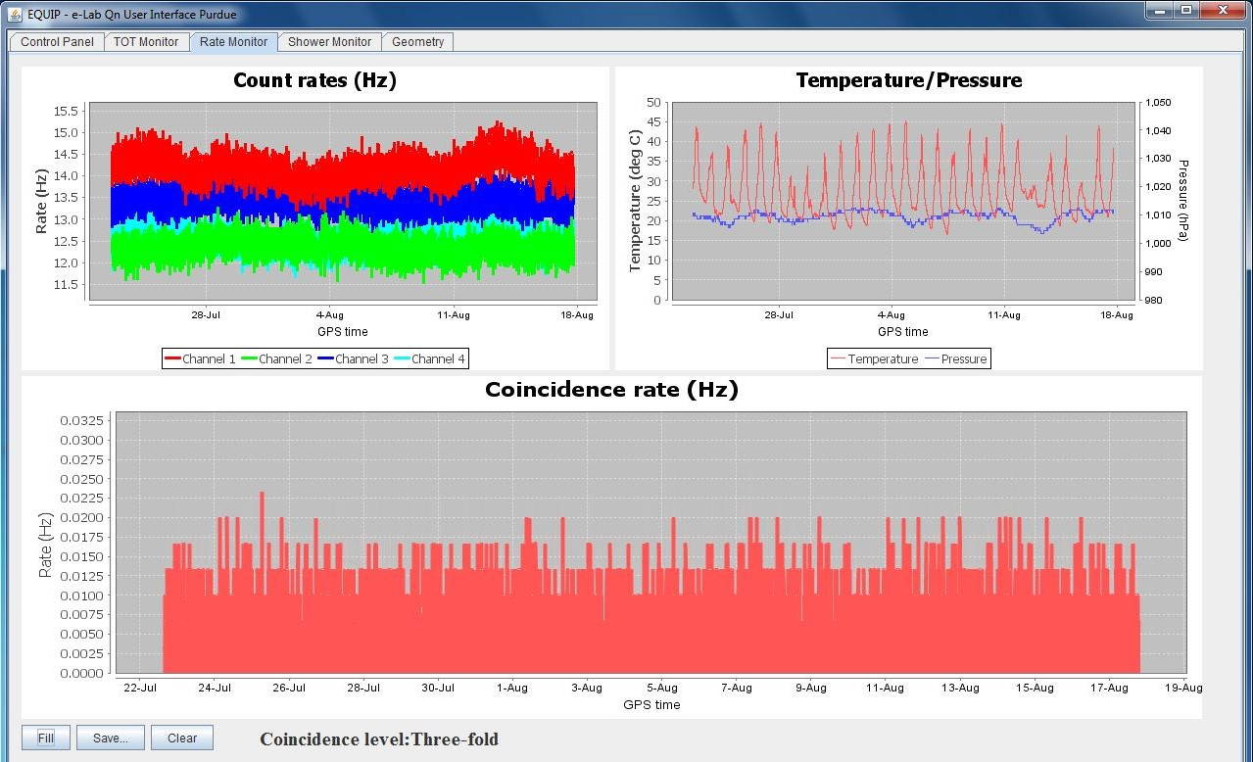
Figure 5 Rate Monitor

The Rate Monitor information is lost when you close EQUIP. When the data file is uploaded to e-Lab, the information can be found under the Data tab, View Data section and is part of the Show Blessing Charts option when a specific file is opened.

Geometry

The Geometry tab is for local information only. These data are not uploaded to e-Lab.
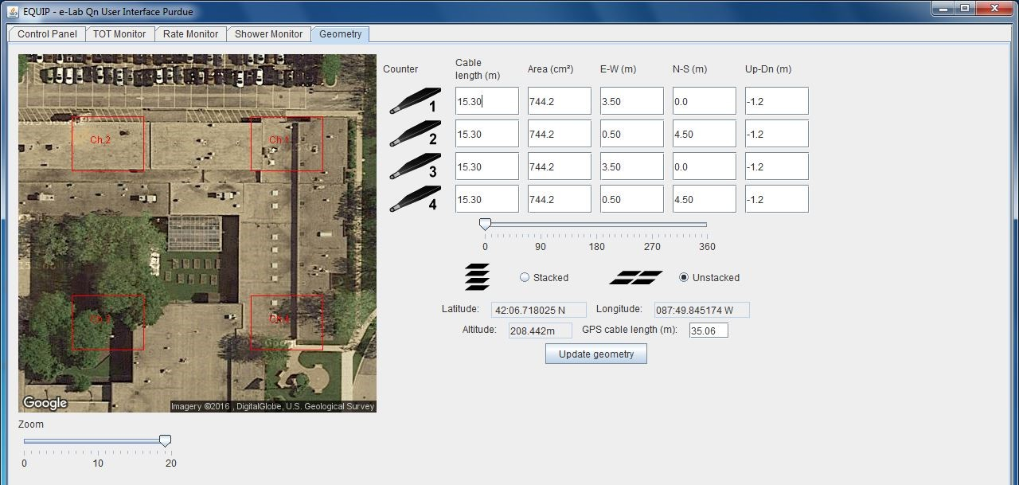
Figure 6 Geometry

Assessment
1a. What is a coincidence setting?
1b. How does it change the rate at which CRMD channels recognize a muon candidate?
1c. Do you detect more muons if the CRMDs are in 1 fold coincidence? (Or is something else happening?)
1d. What happens if you stack all 4 channels, set the CRMDs to 4 fold coincidence, and then remove one channel from the stack? What happens to the count rate?
1e. What is the general trend in the count rate (faster, slower or the same) if you start with 4 channels stacked in 4 fold coincidence, and then change to 3 fold, then 2 fold and then 1 fold.

2a. What information is included along with the GPS signal?
2b. After reading the GPS data several times, without moving the CRMDs or the GPS unit, the GPS data may fluctuate by a small amount. What does that indicate about the GPS and its accuracy?

