Modeling Neutrino Oscillations

Neutrino oscillation is a consequence of quantum mechanics, defined as ‘the branch of mechanics that deals with the mathematical description of the motion and interaction of subatomic particles, incorporating the concepts of quantization of energy, wave-particle duality, the uncertainty principle, and the correspondence principle’. Mathematically, the fact that neutrinos oscillate means that their motion is coupled.
If you picture a 50 yd dash where kids are running across a grassy field, this is how most objects behave, or how we observe them behaving.
Now picture the same 50 yd dash, what would happen if the kids are tied together at the knee and ankle of one leg creating a three-legged race. How would this affect the behavior of the of object, or what we would observe?
Take the same 50 yd three-legged race, but now tie a short person to a tall person by the knee and ankle and run the race. How would this affect the behavior of the object, and what would we observe?
A macroscopic example of coupled motion is coupled pendulums.

YOUR CHALLENGE IS TO USE COUPLED PENDULUMS TO MODEL NEUTRINO OSCILLATION.

Two examples of how you can couple two pendulums (you can find others online):
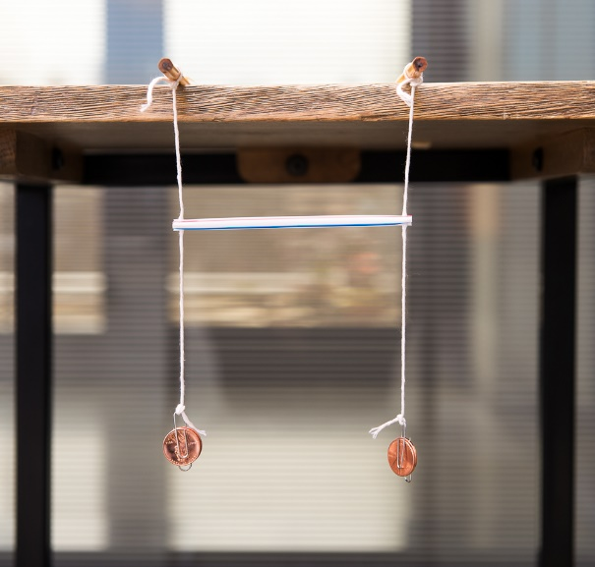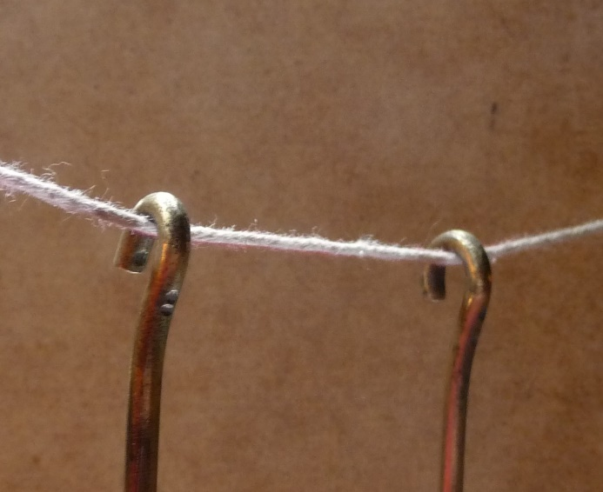
In the first example, the apex of the pendulums is rigid and the straw acts as the coupling element. In the second example, the apex of the pendulums is a non-rigid string that couples the two pendulum.
- With your partner, design and build two identical coupled-pendulums and explore their motion. Then try one or more of the following:
  - Make a three coupled pendulum system.
  - With your two coupled-pendulum system, explore what happens if the two pendulum are not identical (there are three variables you can explore; do you know what they are?)
What is happening with two unequal masses? The lower graph shows the time evolution.
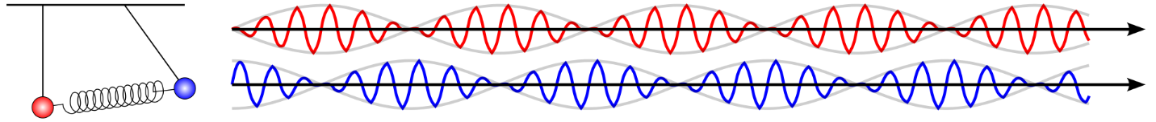
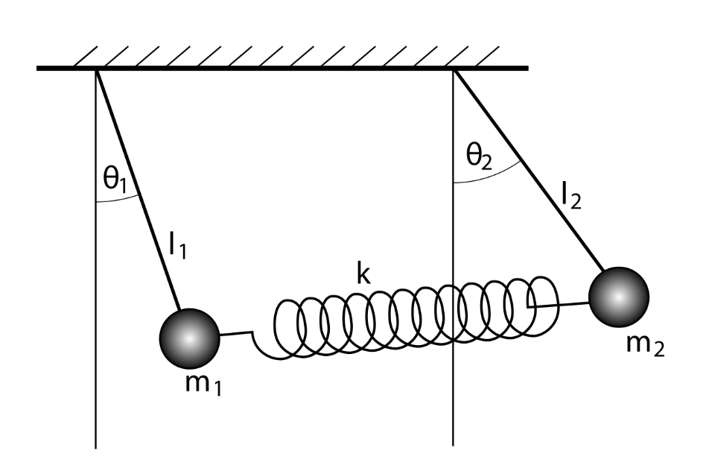

https://en.wikipedia.org/wiki/Neutrino_oscillation#Origins_of_neutrino_mass

How good is your model at representing neutrino oscillations?
