**Mean Lifetime Part 3: MINERvA**

**Teacher Notes**

**Description**

Often physics students often have experience with the concept of half-life from lessons on nuclear decay. Teachers may introduce the concept using M&M candies as the decaying object. Therefore, when students begin their study of decaying fundamental particles, their understanding of half-life may be shaky. The introduction of mean lifetime as used by particle physicists can cause more confusion.

*Mean Lifetime Part 3: MINERvA* builds on the *Mean Lifetime Part 1: Dice* which uses dice as a model for decaying particles, and *Mean Lifetime Part 2: Cosmic Muons* which uses muon data collected with a QuarkNet Cosmic Ray Muon Detector (CRMD); however, these activities are not required prerequisites. In this activity, students access authentic muon data collected by the Fermilab MINERvA detector in order to determine the half-life and mean lifetime of these fundamental particles. This activity is based on the *Particle Decay* activity from Neutrinos in the Classroom (<http://neutrino-classroom.org/particle_decay.html>).

**Standards Addressed**

*Next Generation Science Standards*

Science and Engineering Practices

4. Analyzing and interpreting data

5. Using mathematics and computational thinking

Crosscutting Concepts

1. Patterns.

2. Cause and effect: Mechanism and explanation.

3. Scale, proportion, and quantity.

4. Systems and system models.

7. Stability and change.

*Common Core Literacy Standards*

Reading

9-12.7 Translate quantitative or technical information . . .

*Common Core Mathematics Standards*

MP5. Use appropriate tools strategically.

MP6. Attend to precision.

*IB Physics Standards*

Topic 7.1

Understandings. Half-life.

Application. Investigation of half-life experimentally (or by simulation).

Utilization. Exponential functions.

Topic 7.3

Understandings. Quarks, leptons, and their antiparticles.

Topic 12.2 (AHL)

Understandings. The law of radioactive decay and the decay constant.

Applications and Skills. Solving problems involving the radioactive decay law for arbitrary time intervals.

**Enduring Understandings**

* Particles decay in a predictable way, but the time for any single particle to decay is probabilistic in nature.
* Scientists can use data to develop models based on patterns in the data.

**Learning Objectives**

Students will know and be able to:

* Describe the method for determining the decay time of a muon in a MINERvA event.
* Build a histogram of number of undecayed (remaining) muons vs. time based on a large number of muon decay measurements from MINERvA.
* Using a decay curve describe how half-life and mean lifetime can be used to explain how particles decay randomly yet decrease in number in a predictable way.
* Determine the half-life and mean lifetime using a decay curve of a system of particles.
* Explain the difference in the mathematical models used to determine half-life and mean lifetime.
* Provide evidence to refute the claim that “All particles of a particular type decay in exactly a time described by the particle mean lifetime.”

**Prior Knowledge**

Students must be able to:

* Keep careful records of observations and add integers.
* Make and interpret graphs.
* Distinguish between an exponential curve which is a power of e and a quadratic curve which is a power of x.

**Background Material**

When elementary particles decay into daughter particles, each particle takes a different amount of time to decay. The process is governed by probability such that different kinds of particles have different probable rates of decay. For example, a π+ or π- meson might have a mean lifetime on the order of tens of nanoseconds while a muon might have a mean lifetime in the microsecond range. This means that in the case of the π+ meson, an initial sample N0 will reduce to N0/e after one mean lifetime, N0/e2 after two mean lifetimes, etc. For any one of these mesons, we cannot predict when it will decay; we can only predict the most likely time it will take to decay.

We can probabilistically predict the decay behavior and the typical mean lifetime of each type of “particle” using the analysis of an exponential decay curve. We use muons in this activity. The MINERvA detector at Fermilab measures one muon decay at a time. What matters is that the decay behavior can be probabilistically predicted and the typical mean lifetime of each type of particle can be predicted using the analysis of an exponential decay curve.

* The *half-life* of the particle (not generally used by particle physicists but useful to compare with radioactive half-life) is the time for ½ the sample to decay according to the mathematical model

$$N=N_{0}2^{{-t}/{T_{1/2}}}$$

where N is the number of muons in the sample, N0 is the initial number of muons, t is time, and T1/2 is the half-life.

* The *mean lifetime* of the muon is the time for 1/e of the sample to decay according to the mathematical model

$$N=N_{0}(e^{{-t}/τ})$$

where N is the number of muons in the sample, N0 is the initial number of muons, t is time, and τ is the mean lifetime.

The mean lifetime is defined as the time for a sample size of N0 cosmic muons to decay to a sample size of N0/e cosmic muons; it takes two mean lifetimes to decay down to a sample size of N0/e2 cosmic muons, etc.

The mathematical model for half-life and mean lifetime must describe the same exponential decay curve. For this to be true the following equality must hold:

$$N_{o}2^{{-t}/{T_{1/2}}}=N_{o}e^{{-t}/τ}$$

Notice that N0 cancels. Now operate on both sides with ln().

$$\frac{-t}{T_{1/2}}\ln\left(2\right)=\frac{-t}{τ}$$

The equation relating mean lifetime to half-life simplifies to

$τ=\frac{T_{\frac{1}{2}}}{\ln\left(2\right)}$.

Students will use data from muon decays collected from the MINERvA detector to determine the mean lifetime of the muon, a fundamental particle found on the Standard Model chart.

A series of particles that appear and decay at different times can all be included in the same sample size, N0, as long as we keep careful track of the time to decay for each particle.

What matters is that the decay behavior can be probabilistically predicted and the typical mean lifetime of a fundamental particle can be predicted using the analysis of the exponential decay curve

$N=N_{0}(e^{{-t}/τ})$.

In the MINERvA detector, muon lifetime is measured as the time to decay for muons that are stopped in the detector:

* A muon enters the detector, leaves a track, and then stops.
* The mean time tm of the resulting muon track is recorded.
* After some time, the muon decays into two undetected neutrinos and an electron (Michel electron) resulting in a deposition of energy in the detector.
* The time te of resulting signal from this electron energy deposition is recorded.
* The time difference t = te – tm is calculated for each muon; this is the amount of time for this particular muon to decay.
* The process is repeated for many more low-energy muons; each has its own value of t.
* A histogram of values of t is made, with time on the horizontal axis and the number of remaining muons not decayed on the vertical axis.
* The shape of this histogram can be modeled as an exponential decay; from this graph, students determine muon half-life and lifetime.

**Resources/Materials**

* Neutrinos in the Classroom website: <http://neutrino-classroom.org/>
* Link to data: <http://neutrino-classroom.org/particle_decay.html>, scroll down to Group A through Group T
* Link to screencast 1 for teachers*, Accessing The Data and Event Analysis*: <https://tinyurl.com/minervaDE1>
* Link to screencast 2 for teachers, *Compiling Class Data and Determining Muon Lifetime and Half-Life*: <https://tinyurl.com/minervaDE22>

**Implementation**

We provide two data tables: one for student groups and one for class results.

1. Accessing the Data and Event Analysis – see link to screencast 1 for teachers above.

Students access the MINERvA events from the event files link (<http://neutrino-classroom.org/particle_decay.html>). Scroll down the page to the list of data groups, A-T; each of these data groups contains 20 events for analysis using the Arachne event display. Your students should work in pairs, each analyzing one group of 20 events that you assign. Students navigate to their assigned events by clicking on the appropriate group, then event number, staring with event 1.

Click this link (<https://tinyurl.com/minervaDE1>) for a screencast showing how to access and analyze the events.

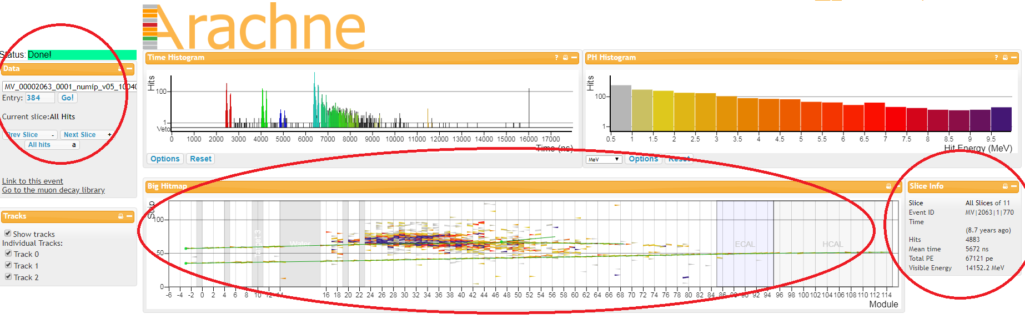

**Figure 1.** Arachne event display for the summary view of Event 1 from Group A.

1. Compiling Class Data and Determining Muon Mean Lifetime and Half-life – see link to screencast 2 for teachers above.

Once your students analyze all 20 events in their data group, they tally their decay times and then contribute to a class data table. You can use this class data to build a graph of remaining muons vs. time in order to determine the muon mean lifetime and half-life.

Click this link (<https://tinyurl.com/minervaDE22>) for a screencast showing how to compile results and build a graph that allows your students to calculate mean muon mean lifetime and half-life.

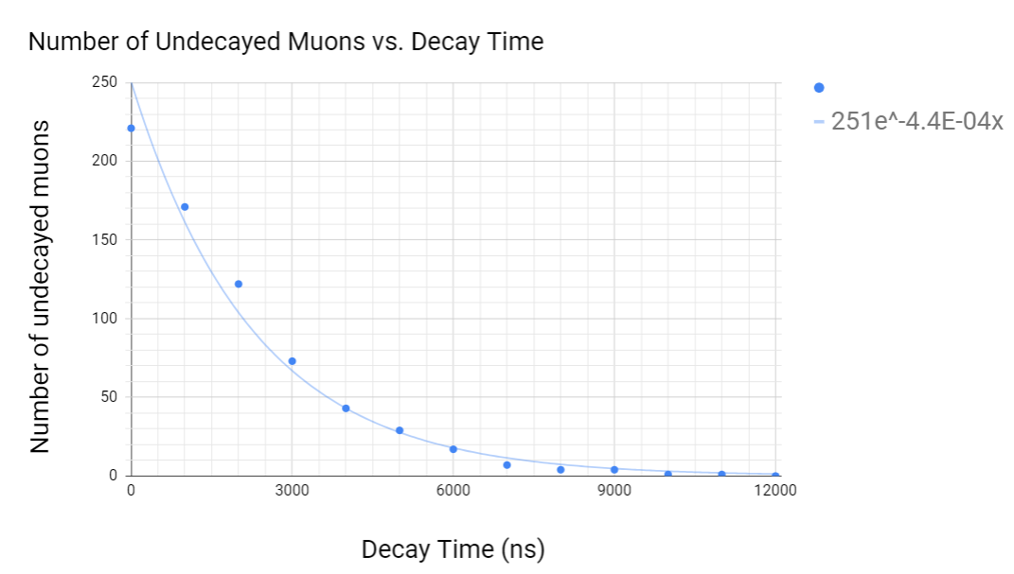

**Figure 2.** This example graph consisting of muon decay time data from a whole class can be used to calculate mean lifetime and half-life.

Possible extensions for independent student work, with increasing levels of sophistication:

1. If there are multiple classes doing this activity, collect the data from all classes into a table and have students plot it and analyze the data on their own.
2. Have students repeat the plot creation and analysis using a spreadsheet and exponential trendline with an equation like N=N0e-kt. The lifetime should be 1/k and the half-life should be (ln 2)/k. See Background Material above.
3. Have students make their own plot from classroom data by hand, make a best fit curve, and then mathematically derive the equation, the lifetime, and the half-life.

**Assessment**

Have students discuss the plots and analysis in small groups and then report. They should address these questions as well as their own:

* Describe in a paragraph the method for determining the decay time of a muon in a MINERvA event.
  + *Students should describe the process detailed in the first screencast: For each event, find the mean time for the muon track and the mean time for the electron deposition of energy at the end of the muon track (where the muon decayed). The difference between these two times represents the decay time for that particular muon.*
* Using a decay curve, describe how half-life and mean lifetime can be used to explain how particles decay randomly yet decrease in number in a predictable way.
  + *Students may sketch a decay curve like the example below, then describe that though the decay time for any individual particle is random, when a curve is drawn representing the decay of a large number of the same type of particle, the shape of the curve is always the same and will result in the same half-life and lifetime measurements.*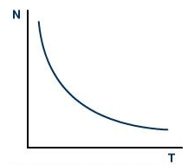
* Given the following data table of MINERvA muon decay events, build a histogram of the number of undecayed (remaining) muons vs. time using the data from the table below.

|  |  |  |
| --- | --- | --- |
| **Bin Time Interval (ns)** | **Center of Bin (ns) - for graphing** | **Number of Muons Remaining** |
| 0 | 0 | 685 |
| 1-1000 | 500 | 530 |
| 1001-2000 | 1500 | 378 |
| 2001-3000 | 2500 | 226 |
| 3001-4000 | 3500 | 133 |
| 4001-5000 | 4500 | 90 |
| 5001-6000 | 5500 | 53 |
| 6001-7000 | 6500 | 22 |
| 7001-8000 | 7500 | 12 |
| 8001-9000 | 8500 | 12 |
| 9001-10000 | 9500 | 3 |
| 10001-11000 | 10500 | 3 |
| 11001-12000 | 11500 | 0 |

* Add a decay curve to the histogram created above, then use this decay curve to determine the half-life and mean lifetime for this type of particle.
  + *Students should determine that the half-life is near 1500 ns and that the value for lifetime is near 2200 ns.*
* In a paragraph, provide evidence to refute the claim that “All particles of a particular type decay in exactly a time described by the particle mean lifetime.”
  + *Students should point out using the data table above and/or the decay curve they draw that there are several (in fact, most) particles that decay in a time period either less than or greater than the measured lifetime of 2200 ns.*
* Distinguish between half-life and lifetime by using an exponential decay curve to find the half-life and lifetime of a particular type of particle.
  + *Given a new plot as an assessment item, the students can complete the analysis described above.*

If your students did the activity *Mean Lifetime Part 1: Dice*, the following analysis is appropriate.

* Describe the characteristics of the plot using the dice model. Compare the characteristics with the plot using muon data from MINERvA.
  + *The plots from the dice model are very similar to the plots from the muon data. They both represent exponential data.*
* Are the values for half-life and lifetime using the dice model the same as the values found using MINEvA muon data? How are they similar and why?
  + *The plots are similar, but the values for half-life and mean lifetime are different.*

If your students did the activity *Mean Lifetime Part 2: Cosmic Muons*, the following analysis is appropriate.

* Describe the characteristics of the plot muons measured by the cosmic ray detector. Compare the characteristics with the plot using muon data from MINERvA.
  + *The plots from the cosmic ray muons very similar to the plots from the MINERvA muon data. They both represent exponential data. The big difference is that with the cosmic ray muon data, an N0 must be chosen and the background must be subtracted.*
* Are the values for half-life and lifetime using the cosmic ray detector the same as the values found using MINERvA data? How are they similar and why?
  + *The plots are similar in shape and will result in the same values for half-life and mean lifetime since they are both measuring muons.*

Students can also do one of the extensions for evaluation by the teacher. These extensions can be evaluated using the questions listed above.