Plotting LHC Discovery
Interpreting the Latest from LHC
Student Page

Note: This exercise is for educational purposes only; any combination of results from these data is not valid for research.

Description
The J/Ψ particle is important in LHC discovery science. It is a well-known particle, so the location and width of the mass plot give physicists a good idea of how the detector is performing. J/Ψ can decay into a muon-antimuon pair; therefore the J/Ψ candidate events are “dimuon” events. Students will make a histogram from data provided from experimental measurements and the background model to determine if this mass plot yields a mass in line with the well known mass of a J/Ψ particle. This process of collecting data from well understood particle is called calibration and is a crucial technique for understanding the data from any detector. The analysis of these mass plot histograms will then enable students to interpret plots from similar discoveries to decide if the data provides evidence for a new particle.
Physicists working at CERN’s Large Hadron Collider (LHC) may have discovered a new particle. Is there evidence to support the claim of the discovery of a new particle? Why is this true?
You will review this result by first learning from a well-understood, previous result. Your review will involve analyzing the main features of mass plots. These features include: peak, width and background.

ANALYSIS PART 1: “RE-DISCOVERY” OF THE J/Ψ MESON
Physicists discovered the J/Ψ meson in 1974. Its mass is well understood. “Seeing” it in modern detectors allows physicists to be sure that the detector is performing as expected.
The table contains the result of measurements made by the CMS detector near the mass of the J J/Ψ. The detector measures the energy and momentum of particles. The table has three columns:
- Mass (GeV): The mass of the particle that decayed
- Data: The number of events (x 103) observed with that mass.
- Background Model: The number of events expected because of other physics (i.e., NOT the J/Ψ meson)

CMS 2010 Dimuon data
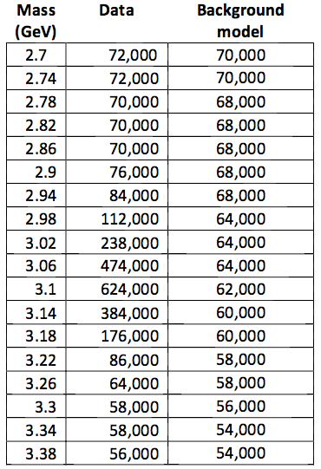 | 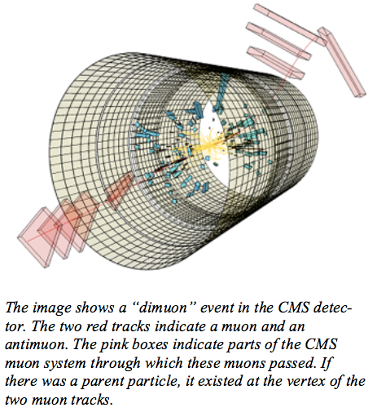
Draw a histogram to represent these data.
After you have made your plot, discuss your results with 1-3 other students. Here are a few points to consider:
- Explain the peak of the plot.
- Determine the contribution to the peak from the experimental data and the background model.
- What is the mass of the J/Ψ meson?
- Explain the distribution around peak of the histogram. How does the width of the distribution impact your confidence in the value of the mass?
- Is this detector calibrated? Provide evidence and reasoning to support your claim.
After you have drawn conclusions in your small group, present and defend these in class discussion.

ANALYSIS PART 2: DISCOVERIES
Your team will be given a recent discovery plot. The analysis software used filters to select particles that are more likely to have come from the decay of an unobserved particle. Use what you learned in Part 1 to identify:
- where the signal rises above background to form a peak or “bump.”
- the mass value at the peak.
- the meaning of and uncertainty in the mass value at the peak.
In your small group, discuss these and make a determination of the mass at the peak as well as your confidence in that mass. Take a position on whether you can validate the new discovery. Be prepared to present the evidence and explain your reasoning in class discussion.

BACKGROUND MATERIAL
The links below provide useful background material.
Detectors at the LHC:
- http://aliceinfo.cern.ch/Public/Welcome.html
- http://atlas.cern
- https://cms.cern
- http://lhcb-public.web.cern.ch/lhcb-public/

Histograms, useful units:
- http://quarknet.fnal.gov/toolkits/new/histograms.html
- http://quarknet.fnal.gov/toolkits/ati/whatgevs.html
- http://en.wikipedia.org/wiki/Full_width_at_half_maximum

