Plotting LHC Discovery
Teacher Notes

Note: This exercise is for educational purposes only; any combination of results from these data is not valid for research.

Description
The J/Ψ particle is important in LHC discovery science. It is a well-known particle, so the location and width of the mass plot give physicists a good idea of how the detector is performing. J/Ψ can decay into a muon-antimuon pair; therefore the J/Ψ candidate events are “dimuon” events. Students will make a histogram from data provided from experimental measurements and the background model to determine if this mass plot yields a mass in line with the well known mass of a J/Ψ particle. This process of collecting data from well understood particle is called calibration and is a crucial technique for understanding the data from any detector. The analysis of these mass plot histograms will then enable students to interpret plots from similar discoveries to decide if the data provides evidence for a new particle.

Standards Addressed
Next Generation Science Standards
Science Practices
1. Asking questions
2. Developing and using models
4. Analyzing and interpreting data
5. Using mathematics and computational thinking
6. Constructing explanations
7. Engaging in argument from evidence
8. Obtaining, evaluating, and communicating information
Disciplinary Core Ideas – Physical Science
PS1.A: Structure and Properties of Matter
PS2.B: Types of Interactions
PS3.B: Conservation of Energy and Energy Transfer
Crosscutting Concepts
1. Patterns.
3. Scale, proportion, and quantity.
4. Systems and system models.
Common Core Literacy Standards
Reading
9-12.4 Determine the meaning of symbols, key terms . . .
9-12.7 Translate quantitative or technical information . . .
Common Core Mathematics Standards
MP2. Reason abstractly and quantitatively
MP6. Attend to precision.
IB Physics Standard 1: Measurement and Uncertainty
1.2.6 Describe and give examples of random and systematic errors.

1.2.8 Explain how the effects of random errors may be reduced.

1.2.11 Determine the uncertainties in results.

1.2.12 Identify uncertainties as error bars in graphs.
1.2.13 State random uncertainty as an uncertainty range (±) and represent it graphically as an "error bar".
IB Physics Standard 7: The Structure of Matter
Aim 4: particle physics involves the analysis and evaluation of very large amounts of data
Standard 7.3.4: Apply the Einstein mass-energy equivalence relationship

Enduring Understandings
Well-understood particle masses provide data to calibrate detectors.
Learning Objectives
As a result of this activity students will be able to:
- Describe the meaning and uncertainty in the value at the peak in a histogram.
- Describe the meaning of the background and why it appears on many scientific plots.
- Evaluate the results of their mass plot to determine if the detector is properly calibrated.

Background Material
The links below provide useful background material.
Detectors at the LHC:
- http://aliceinfo.cern.ch/Public/Welcome.html
- https://atlas.cern
- https://cms.cern
- http://lhcb-public.web.cern.ch/lhcb-public/

Histograms, useful units:
- http://quarknet.fnal.gov/toolkits/new/histograms.html
- http://quarknet.fnal.gov/toolkits/ati/whatgevs.html
- http://en.wikipedia.org/wiki/Full_width_at_half_maximum

Prior Knowledge
The student must be able to construct a graph from data and interpret the meaning of significant features.
Students should have some practice with units for mass, energy and momentum as used by particle physicists
Students should be able to construct a histogram given data.

Resources/Materials
- Data provided in the Student Page.
- Graph paper or computer program to generate histograms.

Implementation
ANALYSIS PART 1: “RE-DISCOVERY” OF THE J/Ψ MESON
Students plot data collected in 2010 by the CMS detector. The result yields the mass of a well-understood particle: the J/Ψ. The students discuss the results.
When CMS detects a decaying J/Ψ particle it also detects other things that mimic this decay. These other things are called “background events.” There is no way to tell if any particular event is from a decaying J/Ψ or from the background. Only many, many observations will provide enough statistics to allow the mass of the J/Ψ to appear in the plot. The students construct a plot that shows:
- data from a measurement of dimuon masses in CMS which includes a J/Ψ signal.
- the background “model” created from simulation of understood background processes.
Students discuss their results in small groups with these points as possible prompts:
- Explain the peak of the plot.
- Determine the contribution to the peak from the experimental data and the background model.
- What is the mass of the J/Ψ meson?
- Explain the distribution around peak of the histogram. How does the width of the distribution impact your confidence in the value of the mass?
The small groups can present their plots and conclusions, with questions from fellow students.
The teacher should sum up, taking care to remind students of the following:
- No single dimuon event is distinguishable as J/Ψ or background; the signal is found in the numbers of events, not in specific events.
- A “bump” does not guarantee a particle discovery: it has to be high enough above background to show valid measure, and it must persist after all attempts to explain it away.

The data table and resulting plot are given below:
CMS 2010 Dimuon data and plot:
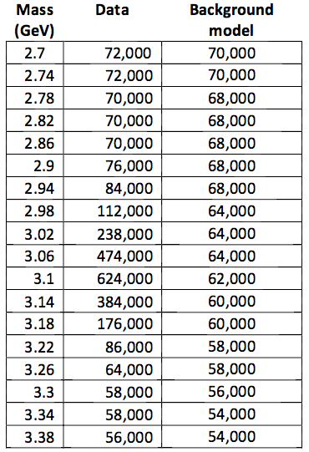 | 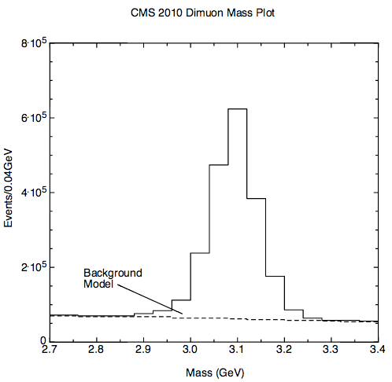
Data reference: https://twiki.cern.ch/twiki/pub/CMSPublic/PhysicsResultsMUO/JPsi40pb-1_endcap.pdf
ANALYSIS PART 2: DISCOVERIES
After the discussion of the student plots in Part 1, students investigate a mass plot that indicates a discovery. Students look for and discuss features that they believe are significant. The teacher should provide the context for the plot so students can address:
- Where does the signal rise above background?
- What is the mass value at the peak?
- Discuss the difference in how much larger the signal is than the background in both of your plots. Comment specifically on why the background makes it harder to “see” new particles. Why was the J/Ψ discovered so much earlier than the particle in the second plot?
In their small group discussions, students should discuss these questions and make a determination of the mass at the peak as well as their confidence in that mass. They take a position on whether they can validate the new discovery. The student groups present their evidence and explain their reasoning in class discussion.
At the time of a discovery, IPPOG, QuarkNet, or a similar group will provide discovery plots and context for teachers. A set of plots is available in slides at: https://quarknet.i2u2.org/sites/default/files/discoveryplots.pdf.
The slides contain the following plots:
- Slide 1 – CMS Higgs search 2012 – invariant masses from pairs of photons..
- Slide 2 – CMS Higgs search 2012 – invariant masses from pairs of Z bosons.
- Slide 3 – ATLAS Higgs search 2012 – invariant masses from pairs of photons.
- Slide 4 – ATLAS Higgs search 2012 – invariant masses from pairs of Z bosons.
- Slide 5 – LHCb plot of 2017 discovery of Ξ_{cc}⁺⁺, a particle with 2 charm quarks; invariant mass in MeV plotted from a complicated decay.

Assessment
Part 1:
- Quality of their plots
Check for the following: correct labeling of axes, identifying the background level; appropriate bin size selection
- Interpretation
Check for the following: correct identification of the peak and the particle mass; indication that the width of the peak represents the uncertainty in the value of the mass.
Did the analysis indicate that the detector is well calibrated? That is, did the mass plot yield a result in agreement with accepted values for the J/Ψ mass? (3.1 GeV/c² )
Part 2:
- Discussion
Divide the class into groups and assign each group a different plot. Each group then presents their findings to the class with open discussion of the claims, evidence and reasoning provided by each group.

- Written report
A written report should stress claims, evidence, and reasoning:
What claims can scientists make based on the J/Ψ plot? the discovery plot?
  - Examples: mass, discovery, uncertainty.
What is the evidence for and against the validity of the claims?
  - Examples: signal-to-background, width.
Explain the reasoning linking the evidence to the validity of the claim.
  - Example: the J/Ψ signal is large compared to background, with a width narrow compared to the height of the peak.
Are some claims more valid than others? Why?
  - Example: a smaller signal-to-background ratio gives weaker evidence of discovery.
Extension
This activity is well suited to a more detailed analysis of error, using readily available tools in a spreadsheet or graphing calculator. Below is a selection of indicators from the IB standards, with a description of how these indicators can be met using this activity.
Understandings:
Random and systematic errors
On a histogram with a “bell-shaped” distribution, random error can quantified by determining the “width” of the distribution, and systematic error can be related to the mean of the distribution. Examples in the case of a Gaussian distribution would be by calculating the FWHM (full width half-maximum) or the standard deviation. In either case, a narrow peak (such as the narrow mass distribution of the J/Psi in muon production events in CMS) can be identified as one with a small random error, while a broad peak (J/Psi candidates from electron-positron production, for example) would represent a large random error.
A student can calculate standard deviation easily in a spreadsheet program, and by inspection of the histogram explain how the standard deviation relates to the width of the distribution; the FWHM would be more difficult but could be estimated by printing the histogram, sketching a normal distribution curve over it, and measuring with a ruler.
Calculating the mean of a distribution, on the other hand, can shed light on possible systematic error. If the published mass of the J/Psi particle is 3.1 GeV/c² for example, but the mean of a given distribution is 3.2, then this may indicate something systematic that is skewing mass values to be too heavy. When the CMS and ATLAS team publish discoveries or describe their process, they include both systematic and random uncertainties.
Error bars
For the data in each bin of the histogram, the error can be approximated as the square root of the number of events in the bin. Using a spreadsheet program, this is easily accomplished as they have options to include “standard error” bars, or even error bars with user-defined width.

