QuarkNet
Fermilab/University of Chicago
Student Summer Research
and Teacher Workshop
Annual Report 2022

The Fermilab/University of Chicago QuarkNet Center held its annual teacher workshop for its 16th year. High school student summer research was conducted remotely this summer due to the continued quarantine.
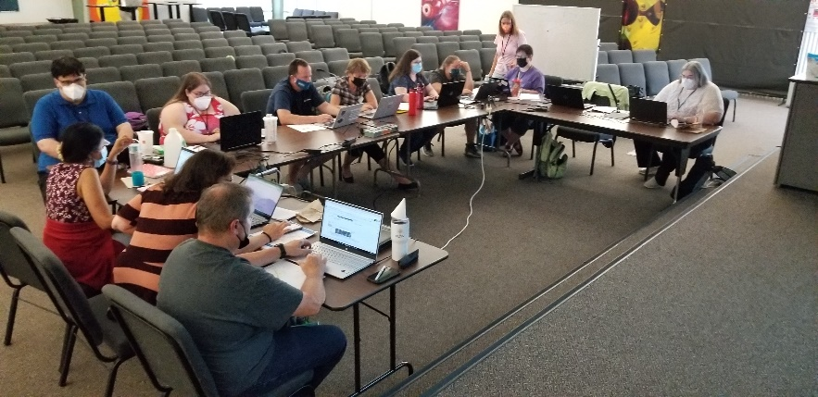
Eight high school students worked with research scientists on projects in areas of Applied Physics/Magnets, Cosmic Ray Muon Detectors, Deep Skies/Computing, Test Beams/Detectors, and AstroPhysics/Galaxy Clusters. Throughout the summer, the SHIRE research skills seminar was scheduled, introducing the students to tasks they would encounter during their journey. Presentations on the student research projects were conducted at the teacher’s workshop at the end of the summer.
The three half-day teacher workshop was held from August 2nd to August 4th. LHC Fellows Marla Glover and Susan Wetzler conducted this year’s summer workshop and 10 teachers of physics attended. Teachers from the workshop were primarily from the Chicago metropolitan area, incorporating physics in their teaching. We continue to show variety in gender, age, and years of experience in the classroom.
The teacher workshop was successful in meeting in-person. Teachers immersed themselves in QuarkNet data activities, revisiting the CMS Masterclass materials, and experiencing the Higgs @ 10 years workshop. The Teaching with Data workshop included a number of activities working towards the introduction of statistical analysis of data while learning physics. We revisited the APS STEP UP resources, and shared a number of physics education resources on the web. Teachers developed plans for continued improvement of the integration of physics research data into their classrooms.
The Fermilab/University of Chicago QuarkNet Center continues to provide a quality research experience and educational workshop. Both teachers and students continue to express their satisfaction.
FNAL Director of Education: Spencer Pasero
Lead Teacher: George Dzuricsko

