QuarkNet
Fermilab/University of Chicago/College of DuPage
Student Summer Research and Teacher Workshop
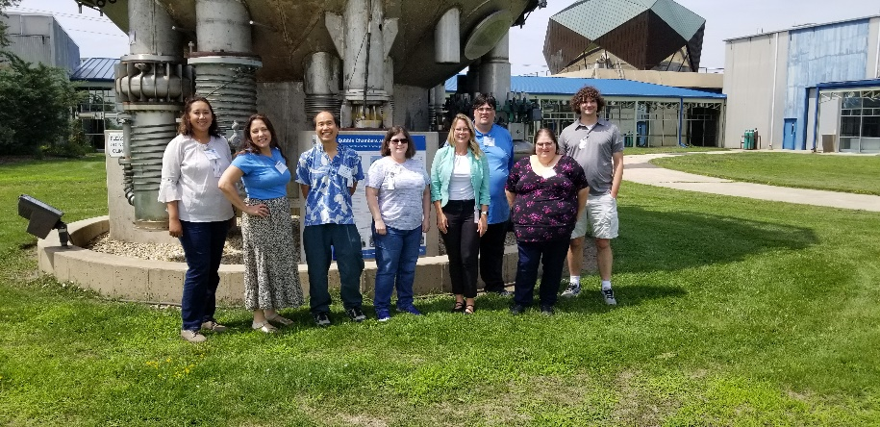
Annual Report 2023
The Fermilab/University of Chicago/College of DuPage QuarkNet Center held its annual teacher workshop for its 17th year. High school student summer research was conducted in person this summer, after a one year interruption and two years of remote activity.
Eight high school students worked with research scientists on projects in areas of Cosmic Ray Muon Detectors, Deep Skies/Computing, Test Beams Facility/Detectors, Short Baseline Neutrinos/Near Detector, and Dark Matter/Axion Detectors. Presentations on the student research projects were conducted at the teacher’s workshop during the final week of the summer.
The three-day teacher workshop was held from August 1st through August 3rd. Neutrino Fellow Mike Plucinski conducted this year’s summer workshop and 8 teachers of physics attended. Teachers from the workshop were primarily from the Chicago metropolitan area, incorporating physics in their teaching. We continue to show variety in gender, age, and years of experience in the classroom.
The teacher workshop was successful in meeting in-person. Teachers participated in QuarkNet data activities, highlighting the pilot of the NOvA Master-Class experience. The Teaching with Data workshop included a number of activities working towards the introduction of statistical analysis of data while learning physics. In addition, a number of physics education resources on the web were shared. Teachers developed plans for continued improvement of the integration of physics research data into their classrooms.
The Fermilab/University of Chicago/College of DuPage QuarkNet Center continues to provide a quality research experience and educational workshop. Both teachers and students continue to express enthusiastic satisfaction.
Spencer Pasero
Office of Education and Public Engagement
Fermi National Accelerator Laboratory

George Dzuricsko
Lead Teacher

