Robert Millikan Photoelectric Data Activity

Rick Dower ______________________________
8/10/2021 Name

In 1916 Robert Millikan published the result of his effort over several years to investigate Albert Einstein’s 1905 proposal to explain the known characteristics of the photoelectric effect [Phys. Rev. 7 (1916), 355-390.]. Millikan described Einstein’s idea as a “bold, not to say reckless, hypothesis of an electro-magnetic corpuscle of energy hν [the Greek ν refers to the light frequency], which energy was transferred upon absorption to an electron (Millikan, p. 355).” Millikan thought the idea reckless “because an electromagnetic disturbance which remains localized in space seems a violation of the very conception of an electromagnetic disturbance [which was assumed to spread out as a wave in space, not concentrate at a point such as an atom or electron] (ibid.).” In addition, “it flies in the face of the thoroughly established facts of interference [which demonstrated the wave behavior of light] (ibid.).”

Einstein’s hypothesis was designed to explain the experimental facts of the photoelectric effect, as determined by Philipp Lenard (Nobel Prize in Physics 1905) and others. The energy of electrons knocked out of a metal surface depends on the characteristics of the metal surface and the frequency of the incident light but not on the light intensity. Einstein’s photoelectric equation is simply stated:
$\frac{1}{2}mv^{2}=hν-W$ , (1)
where hν = energy of incident light quantum,
mv²/2 = the kinetic energy of the ejected electron,
and W = energy required to separate electron from metal surface = metal work function.

Einstein described the simple assumption behind his equation in his paper (Ann. Physik, 17 (1905), 132ff). “[W]hen one attempts to explain the photoelectric phenomena, … one can conceive of the ejection of electrons by light in the following way. Energy quanta penetrate into the surface layer of the body, and their energy is transformed, at least in part into kinetic energy of electrons. The simplest way to imagine this is that a light quantum delivers its entire energy to a single electron; we shall assume that this is what happens.” (trans. A.B. Aarons and M. B. Peppard, Amer. J. Phy., 33 (1965), 373)

In Millikan’s paper, he described earlier efforts to investigate Einstein’s equation and their experimental difficulties. Then he described his own experimental apparatus and approach. He constructed several versions of what he called “a machine shop in vacuo” (Millikan, p. 361). A diagram of one version of his apparatus is pictured in Figure 1. The high vacuum quartz tube (transparent to UV light) contains a wheel (W) that holds cast cylinders of lithium, sodium, and potassium, selected for their response to visible as well as UV light, on its perimeter. A rotating knife (K) can be activated by a magnet to shave a thin slice from the easily corroded surface of one of the highly reactive soft alkali metals. The wheel is then turned so that the clean metal surface faces the end (O) through which monochromatic light is projected. Electron ejected from the metal surface are collected in a Faraday cup of copper gauze mesh (B) and solid copper (C) connected electrically. The contact potential can be measured between the metal surface and the copper electrode (S) to assess the constancy of surface characteristics (and work function, W) of the easily corroded alkali metal surfaces.

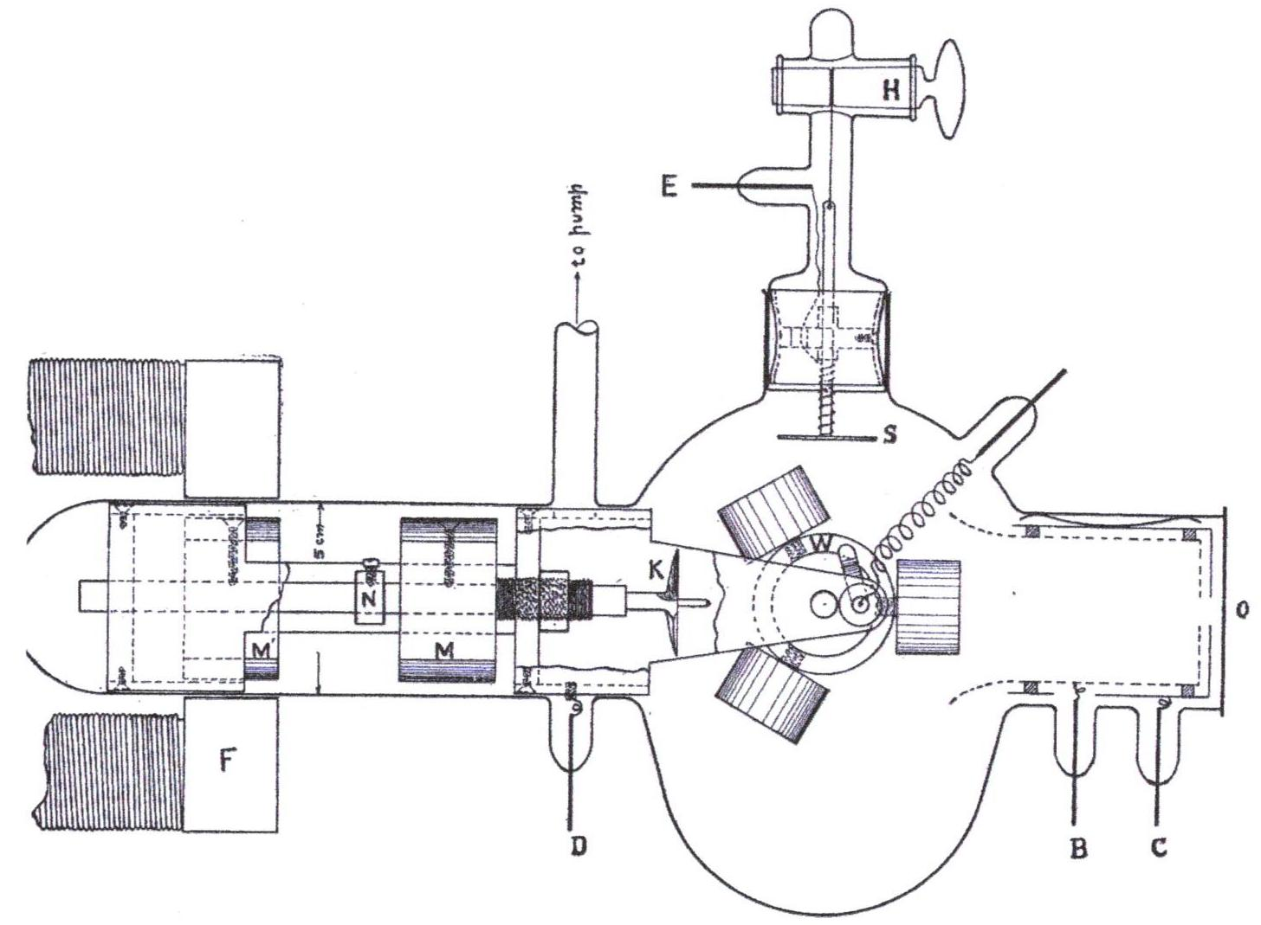
Figure 1

Millikan noted that “an accident prevented the inclusion of data on potassium” (Millikan, p. 362). However, he was able to present data he collected for sodium and lithium. Millikan found that the work function values (as indicated by contact potentials) of the metal surfaces were strongly dependent on the “age, absorbed gas, etc., of the surfaces tested” (Millikan, p, 366). So, he only reported data taken during times when those values remained constant. To determine the frequency (ν) of the light incident on his metal surfaces, Millikan used a monochromater to select light of a single known frequency from the spectrum of a mercury lamp in a quartz tube. Quartz is transparent to ultraviolet light.

Millikan measured the kinetic energy of the electrons ejected by light of a single frequency entering through the opening O at the right end of the apparatus in Fig. 1. The ejected electron kinetic energy was measured by applying a negative voltage (V) to the Faraday cup electrodes (B and C in Fig. 1) relative to the metal (sodium or lithium) cylinder on the wheel (W) attached, through the metal support structure, to electrode D in Fig. 1. The voltage between C and D that prevented electrons from reaching the Faraday cup and reduced the current between C and D to zero is traditionally called the stopping voltage (V_{stop}). At voltage (V_{stop}) for zero current, electrons (charge e) stop moving just short of the collecting screen and fall back to the alkali metal surface. Then eV_{stop} = mv²/2.

Measuring very small currents close to zero is subject to large relative uncertainties. So, for each incident wavelength of incident light, Millikan measured currents produced for several voltages in the vicinity of the zero-current point. He plotted photocurrent as a function of voltage for each wavelength and extrapolated the resulting curves to determine V_{stop}. His data plots for sodium and lithium are given in Figure 2 and Figure 3, respectively.
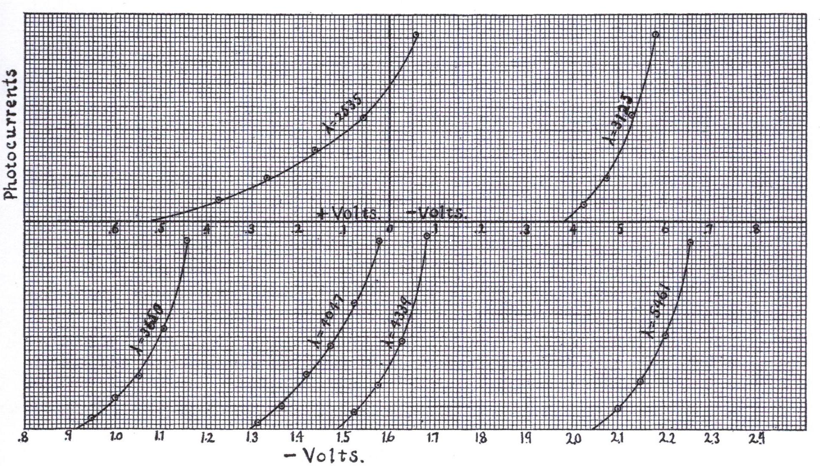
Figure 2 Millikan’s Photocurrent vs. Voltage curves for several mercury wavelengths incident on a sodium surface (Millikan, p. 371).

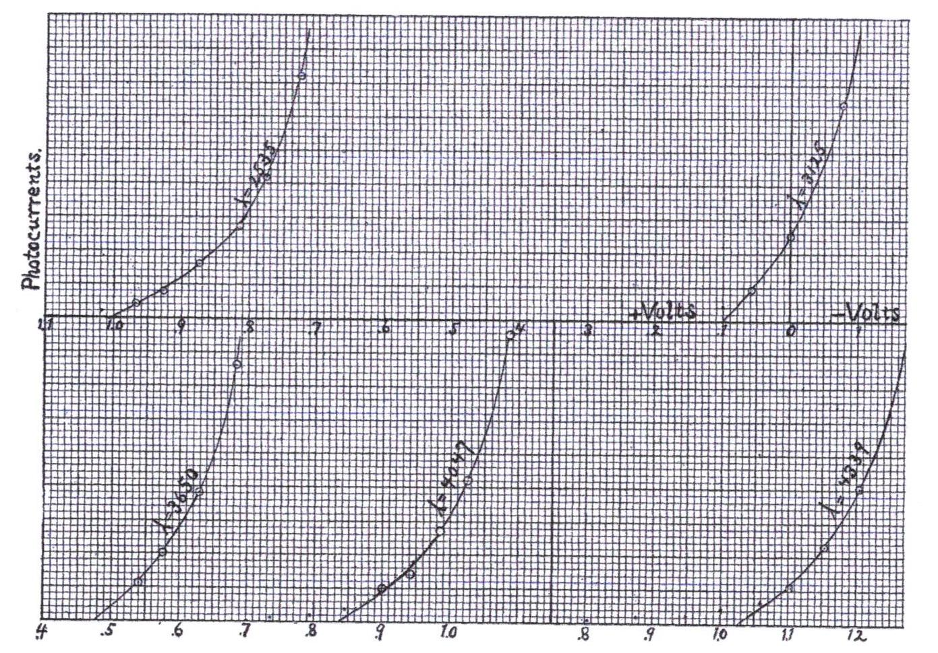
Figure 3 Millikan’s Photocurrent vs. Voltage curves for several mercury wavelengths incident on a lithium surface (Millikan, p. 376).

Calculate the frequency (ν = c/λ) of the incident light wavelength (λ) that Millikan used for his measurements. Millikan’s wavelength units are angstroms = 0.1 nm. Measure the voltage for zero current (V_{stop}) from the extrapolated plots for each of the incident light wavelengths in Figures 2 and 3. Enter your values in Tables 1 and 2. Notice that the lower half of each graph is the extension to larger negative voltages of the right side of the upper half of the graph.
Table 1 Sodium
λ  (nm) | ν  (10¹⁴ Hz) | V_{stop}  (volt)
546.1
433.9
404.7
365.0
312.5
253.5

Table 2 Lithium
λ  (nm) | ν  (10¹⁴ Hz) | V_{stop}  (volt)
433.9
404.7
365.0
312.5
253.5

Plot points for the measurements on a ν (horizontal axis) vs V_{stop} (vertical axis) graph. Draw your best straight line for the sodium points and another for the lithium points.

Calculate the slope of the sodium and lithium lines on your graph.

Explain why the slope of each line, when multiplied by the charge of an electron, should be Planck’s constant, according to Einstein’s equation (1).

Calculate Planck’s constant (h) from each line slope.
Compare your calculated values to the recently defined value of h = 6.62607015 x 10⁻³⁴ J Hz⁻¹.

Even though Millikan verified the validity of Einstein’s photoelectric equation, he remained hesitant to accept Einstein’s explanation for the photoelectric effect. “Yet the semi-corpuscular theory by which Einstein arrived at his equation seems at present to be wholly untenable” (Millikan, p. 383). If the Einstein conception is abandoned, “there is no alternative but to assume that the corpuscles[electrons] which are ejected are already possessed of an energy almost equal to hν” (italics in original - Millikan, p. 385). Einstein received the 1921 Nobel Prize in Physics for his photoelectric theory. Millikan received the 1923 Nobel Prize for his elementary charge and photoelectric measurements.

As Millikan noted, the contact voltage “between the alkali metals and the test plate [on which they were fastened] varied from 0.4 volt up to 3.0 vlots – depending upon the condition as to age, absorbed gas, etc., of the surfaces tested.” (Millikan, p. 366). Consequently, the V_{stop} intercepts of the graphs are not equal to the pure metal work functions:
W_{Na} = 2.36 eV and W_{Li} = 2.93 eV.

