Rolling With Rutherford
Teacher Notes

Description
Ernest Rutherford was one of the most influential physicists in the early stages of understanding the structure of atoms. Rutherford’s influential experiment gave the first hint that atoms have a small massive inner structure that later became known as the nucleus. The significance for students today is that this experiment made this ground-breaking discovery using indirect measurements. In our classrooms today, students can use indirect measurements to determine the size of small object by firing a probe at a target and observing how often the path of the probe changes. In this case, the “probe” and the “target” are balls and the “firing” is replaced with “rolling.” Students will use their data to calculate the diameter of the target balls. This activity allows the students to use indirect measurements to determine a parameter; it also allows the students to see how Rutherford made his influential discovery.

Standards Addressed
Next Generation Science Standards
Disciplinary Core Ideas – Physical Science
PS1.A: Structure and Properties of Matter
PS2.A: Forces and Motion
PS2.B: Types of Interactions
PS3.C: Relationship Between Energy and Forces
Science and Engineering Practices
2. Developing and using models
4. Analyzing and interpreting data
5. Using mathematics and computational thinking
7. Engaging in argument from evidence
8. Obtaining, evaluating, and communicating information

Crosscutting Concepts
1. Patterns.
2. Cause and effect: Mechanism and explanation.
3. Scale, proportion, and quantity.
4. Systems and system models.
6. Structure and function.

Common Core Literacy Standards
Reading
9-12.4 Determine the meaning of symbols, key terms . . .
9-12.7 Translate quantitative or technical information . . .
Common Core Mathematics Standards
MP2. Reason abstractly and quantitatively.
IB Physics
Topic 1: Measurement and Uncertainties
1.2.6 Describe and give examples of random and systematic errors.

1.2.7 Distinguish between precision and accuracy.

1.2.8 Explain how the effects of random errors may be reduced.
1.2.11 Determine the uncertainties in results.
Topic 7: Atomic & Nuclear Physics
7.1.1: Describe a model of the atom that features a small nucleus surrounded by electrons
7.1.2: Outline the evidence that supports that nuclear model of the atom.

Enduring Understandings
Indirect evidence provides data to study phenomena that cannot be directly observed. In this case, particles are too small and fleeting to see.

Learning Objectives
Students will know and be able to:
- Describe the process that Ernest Rutherford used to determine the size of the nucleus.
- Apply simple probability laws to experimental data.
- Use indirect measurement to determine properties difficult (or impossible) to determine otherwise.
- Create and interpret a histogram.

Background Material
Ernest Rutherford (1871-1937) is credited with the first measurements of the distribution of the positive charges in the atom. He showed us that the atomic charge is concentrated in a small nucleus. That model of the atom survives to this day. Rutherford learned this by firing alpha particles at gold foil and observed the deflection in the alpha particle’s path. This is an enduring example of indirect measurement. Rutherford used the data to determine the diameter of the nucleus. Scientists often use indirect measurement in their work. For example, indirect evidence tells us all that we know about atoms, confirms the existence of black holes, and suggests the need for dark energy and dark matter.

Prior Knowledge
Students must be able to keep careful records of observations and divide one integer into another.
Students must be familiar with the procedures used in the original Rutherford experiment.

Resources/Materials
- 4 marbles, all the same size
- flat horizontal surface, e.g. table top
- paper template (print 3 copies per student group)
- sticky notes
Implementation
Set-up:  For each student group, print 3 copies of the template. Cut out the crossed holes on one of these. Align and tape the pages together so the cut out section is at one end of the track. Then fold the edges to make a barrier on each side. Back the holes with tape so the sticky side faces out through the holes. Tape the whole assembly down on a flat surface. Place a marble on each hole. The result should look something like the image to the right.  The places where the papers join should be completely taped over so that the path of a marble rolled from the beginning (where the single marble is in the image) to the end (past the 5 marbles) has as little obstruction to its course as possible,  You should also make a 0-10 horizontal axis on the wall, in a window, or on a chalk/whiteboard. Label the axis as the number of hits out of 10. This will serve for the histogram you will make. | 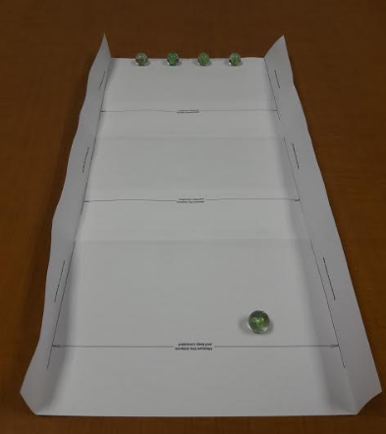
What happens:
Each student gets 10 rolls of the marble. He or she must take care to roll toward the 5 target marbles but must not aim. Misses are as valid as hits. When a target marble is hit, it should be noted and the target marble returned to its place. The sticky-side-up tape should help keep the target balls in place. The student will get a score: the number of hits out of 10. The student should then take a sticky note and put it above her or his score on the histogram. Even if you have multiple groups working, all students put their scores on the same histogram. Get others to try, e.g. an administrator who happens to be passing by. You want statistics. If you do this activity in multiple classes during the day, let the histogram build over the course of the day.
Here is an example of building a histogram with a relatively small group in a workshop setting: 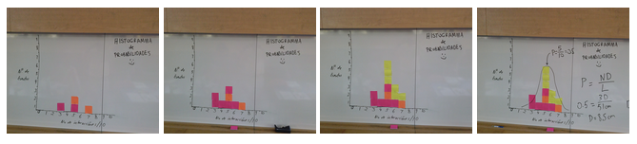

Note that, in the last frame, the group found a peak value of the number of hits out of 10. You should do the same with your students. Note also that the simplest version of mathematical model of the diameter of the target is used in the last frame. This model does not take into account the size of the rolled marble: in the workshop from which the images come, the group used targets much larger than the marble which was rolled. Thus, perhaps the simple approximation was acceptable. In our case, the target and the projectile are the same size.
To analyze the data, you need:
- The width of the paper between the two barrier ridges, L
- The peak number of hits out of 10, n.
- The number of target marbles N (in our example, N=4).
The probability of a hit from the point of view of the experimental data is P = n/10.
The probability of a hit for marbles of diameter D in the simple approximation above is
P = ND/L,
based on the fraction of distance L that is blocked by target marbles. Life is not that simple, of course, so we modify that equation based on what we know about the marbles and their collisions.
Looking at the diagram on the right, note that the center of the rolled marble can approach a target marble within a cross-section of 2D to make a collision. There are N target marbles, so the total target cross-section is N(2D). For the cross-section of the rolling area, the center of the rolled marble can get no less than D/2 from a side barrier; our actual rolling cross section is L-D. Thus we can refine our original simple mathematical model:
P = [N(2D)] / (L-D).

Set the probabilities from experiment and from the model equal to each other, so
(n/10) = (2ND) / (L-D).
After some algebra,
D = Ln / (20N+n).

Question:
Do we "check" our result against a measurement made with a ruler? The physicist measuring those atoms has no such luxury. The indirect measurement is the measurement. Maybe we do, maybe we don't.

Resources:
- Student Video from Rossville High School, Indiana.

Assessment
- Would you expect more or fewer hits if you increased the number of balls in the target area? Why?
- Is the relationship between radius and the number of hits direct or indirect? Why is that?
- How many hits occurred in the runs that appear at the peak of the histogram?
- Look at the histogram and determine which is more likely to occur: 2 hits out of 10 or 6 hits out of 10.
- What is the diameter of the ball? How do you know this?
- Draw a simple sketch of the experiment that Rutherford used to measure the size of the nucleus. What evidence did he use to make his determination?
- Contrast the activity that you did today with Rutherford’s experiment.
Extension:
- Select objects for targets that are much larger than the probe marble. In this case, the students can determine which mathematical model works the best. The question could be: How large must the targets be before the simpler model works?
- Students could also investigate irregularly shaped objects and discuss how the uncertainty of the result is changed with the use of irregular targets.

