Summer 2020 QuarkNet Workshop at Syracuse University
The Syracuse group hosted a QuarkNet workshop from Aug 20 – 21. Unlike in previous years, this year, due to COVID-19, it was held entirely online via zoom. Also, in order to not exhaust the teachers, the workshop was only run from 8:30 am – 12:30 pm. Profs Steven Blusk and Matthew Rudolph co-organized the event along with QuarkNet staff Shane Wood, Ken Cecire and Michael Fetsko. The agenda for the workshop can be found at the following URL:
https://quarknet.org/content/2020-cms-data-virtual-workshop-syracuse-university
This year, we had nine teachers join us:
 | 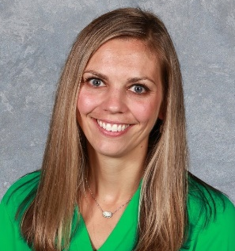 |  | 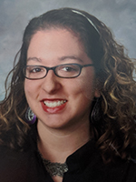
 |  | 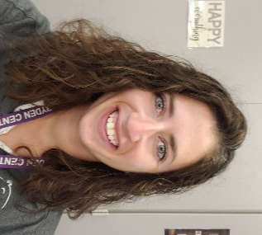 | 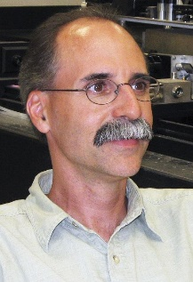
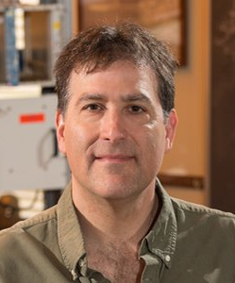 | 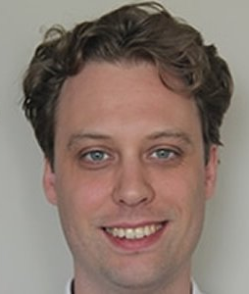 | 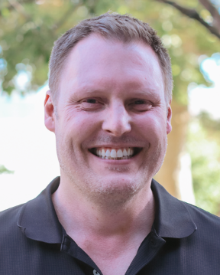 | 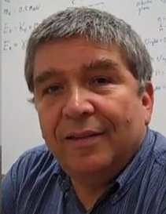
Teachers participating in the workshop, top 2 rows from top left to middle right: Linda Wicks (Cincinnatus HS), Stephanie Metzmiller (Webster HS), Brian Bealer (Auburn HS), Elise Jutzeler (Jamesville-Dewitt HS), Josh Buchman (Fayetteville-Manlius HS), Anne Huntress (South Lewis HS), Cynthia Lamphere (West Genesee HS), Margaret Hartquist (Dryden HS), and Patrick Ferrick (West Hills HS). Bottom row: Profs. Steve Blusk and Matt Rudolph; QuarkNet Staff Shane Wood, Ken Cecire and Michael Fetsko.
The two-day workshop featured activities organized by Shane Wood. The first day included the following activities.
- Particle Cards
- Rolling with Rutherford
- Making Tracks I: Cloud Chamber
- Making Tracks II: Bubble Chamber
- Calculating the Z mass with CMS data
Each of the activities was done remotely, and, with the exception of the first, we used breakout rooms for teachers to work in small groups. In addition, the activities were promoted with an eye toward being able to carry out the activity with students connecting remotely from home. As a bonus, Patrick Ferrick (West Hills HS) showed us how he made his own spark chamber using some cheap components scavenged from old science equipment.

The agenda for the second day included
- Talk: “The CMS Detector”, by Prof. Rudolph
- Data Activity: Big Analysis of Muons in CMS
- Implementation plan
Again, here we broke into small groups (breakout rooms) to carry out the activity, and then re-convened to discuss the results as a larger group. Afterward, we discussed some ideas for implementing some of the things that we came across during the workshop. Some of the thoughts about implementation and general points were as follows:
- Patrick - Rolling with Rutherford toward beginning of year - in person
- Linda - I've tried Rolling with Rutherford at the beginning and at the end of the year and thought it worked well either way.
- Patrick - Spark chamber info - 2 kV Am Power Design DC-DC converter
- Patrick - BAMC - uses very recent data, 21st c physics
- Anne - doing labs at home - combine data from many students ("joint data")
- Josh - build Patrick's mini-spark chamber, bubble chamber activity
- Josh - study momentum and then incorporate Z mass calculation
- Elise - use histograms; unusual year - try different activities - use the building sequentially on concepts - "embrace the chaos" and try new things, even if you cannot cover all content
- Steve - knowing every topic is not the big thing, more important to learn to think critically - "do the stuff you do and do it well" - "it's not a matter of how much you cover, it's a matter of how much you uncover"
- Matt - 1st semester university physics is mostly F=ma, but students learn to think and analyze

