**QuarkNet 2017 at the University of Pennsylvania**

Introduction

This year’s QuarkNet team: Elizabeth Berzin, Andrew Chen, Hita Kambhamettu and Jonathan Okasinski have the distinction of being the first group in 8 years of attempts to complete the construction readout and analysis of a scintillator and proportional drift tube based cosmic ray tracking tower. Their work benefitted from the efforts of previous summer Quarknet groups archived at Penn as well as their ability to self organize and manage their time. Successful tasks included physical setup and construction of the cosmic ray tower, electronics and cabling as well as programming the FPGA for data readout and data transfer into the Rasperry pi readout computer. In the last few days of the program they were able to set up track re-construction programs and sorting routines to select tracks with a suitable goodness of fit to a straight line. The system they constructed is described below.

1. Equipment and Set-up

The detector, which uses parts from one originally constructed many years ago at UPenn High Energy Physics, and designed to be placed in the Fermilab accelerator been modified over a ten year period of the Quarknet Program. The goal of the redesigned detector was to identify ionizing cosmic particles, primarily muons, created in the upper atmosphere.



Figure Cosmic Ray Tower setup with plastic scintillator covered in black electrical tape visible at bottom and two planes of 16 Proportional Drift Tubes held in place with all thread. .

Two scintillators are placed above and below two vertically aligned chambers, each consisting of sixteen identical proportional drift tubes (PDTs). A solution of carbon dioxide and argon is continuously flushed through the PDTs, and a large potential difference (~ 2000 Volts) is created between the outer surface of the PDT and a wire running down the center of the PDT. When a muon passes through the detector, it strikes both scintillators and produces two effectively coincident signals. These signals are transmitted through a discriminator to a logic gate, which registers them as coincident. This pulse is then sent to an FPGA board programmed using Verilog, a machine language that controls timing and data collection.

When a coincidence is detected, the FPGA starts a counter clocked at 100 MHz.  As the muon passes through the drift tubes, it ionizes the molecules of gas in each PDT, sending electrons towards the central wire. The signals created by the cascade of electrons in each struck PDT pass through an amplifier, discriminator, and buffer board before they are sent to the FPGA, which stops the counter for each PDT hit signal.

The FIFO buffer inside the FPGA stores data to send data to a Raspberry Pi, which records the data for each event in a file.  The Raspberry pi in turn ships, the data to a computer, where the PDT hits are analyzed to reproduce the particle’s track. The radius of each hit is determined by measuring the time it takes the electrons to travel to the wire in each PDT, using the known electron velocity.  The FPGA programming accounts for the different times the scintillator signals and PDT signals take to pass through their respective electronics.  Given the radius of each PDT that was hit, all possible tracks are generated and the most probable track is selected and an image is created to illustrate the particle’s path through the detector.

2. Methods

Once data is collected and sent into the FIFO buffer, it is transmitted to the Raspberry Pi through a handshake process.  The Raspberry Pi initiates the handshake by setting a flag high to the FPGA.  When the pulse is received, the FPGA sends a new piece of data to the bus and again sets a flag high to indicate that it has completed its operation.  After the Raspberry Pi reads the bus, it brings the initial flag low, to indicate that it is finished.  The bus is two bytes wide and represents data for a single PDT.  In order to help detect errors, data for every PDT is sent regardless of whether or not it fired. Additionally, a stop flag is sent in place of data after every event.  The data consists of the PDT number and the radius of the tube hit and is written to a file by the Raspberry Pi.  When the data is corrupted by an early stop flag, then the Raspberry Pi sets the file aside in a separate location.  Since the radius of the physical PDT is 22 clock cycles, a PDT not firing is recorded at 255 clock cycles.

The file from the Raspberry Pi is then transferred onto a computer to analyze the data and reconstruct the particle tracks.  First, the algorithm takes the set of PDT hits and finds all possible combinations of tangent lines.  These lines are then filtered to remove tracks that do not pass through both scintillators.  Once this is done, a cost is calculated for each line. The cost function is the average distance between the tangent line and the PDT hits. The area surrounding the tangent line of least cost is then exhaustively searched for a line with an even lower cost. Finally, this line is plotted to produce an image of the particle’s track.

      3.   Conclusion

The detector was able to record, gather, and illustrate information about the location of incident muons. Plots of this data depict linear tracks with up to four tubes hit, such as the one below. The image depicts a muon track (blue) through the detector (black); the red circles indicate the radius of each tube’s recorded strike. This track is the least-cost line given the corresponding radii, using the search function described above.

Future work is planned in improving the efficiency of the detector. Scintillator coincidences are detected at a rate of ~1800 per hour.  Because of the limited rate at which the Raspberry Pi can read and write data, about 800 events per hour are recorded on the Raspberry Pi.  Thus, the speed of the FPGA/Raspberry Pi interface may be further improved.  After the algorithm removes outliers, the 800 events produce approximately 250 images of events with two or more PDTs registering a hit. Given that the scintillators produce only two chance coincidences per hour, the other registered coincidences represent events in which PDTs fail to register a hit despite an incident muon.

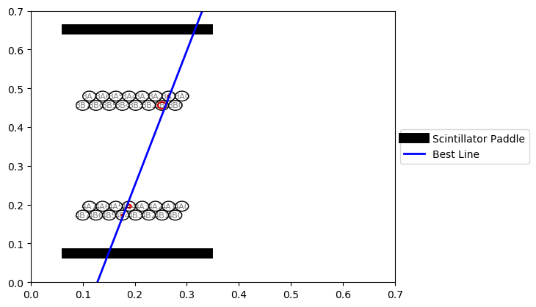

Figure 2 A re-constructed track with timing circles indicating the closest point of approach of the track to the wire in the center of the tube inferred from the time of arrival of the first avalanche signal from the tubes.

According to the collected data, the low efficiency can be attributed to decreased sensitivity near the edge of the PDTs, the differing sizes of the scintillators, and poorly calibrated PDT voltages. Breakdown tests on the PDTs showed varying breakdown points among the 32 tubes, ranging from around 2200V to 3200V.  For this reason, the implementation of individually adjustable power supplies, through a voltage divider or other means, is another area for future work.

More chambers could be added to provide greater accuracy of tracks, to aid in the calibration of the current chambers, and to produce three-dimensional data acquisition and analysis of the particle’s tracks.

Penn’s QuarkNet Team.