Using the Fluid Filled
Accelerometer

The Fluid Filled Accelerometer (FFA) is a useful tool in teaching the concept of natural (unaccelerated) motion and unnatural (accelerated) motion. This concept is not intuitive because humans are ill-equipped to measure acceleration, we tend to respond to changing frames of reference to detect motion.

Isaac Newton said that an object at rest will remain at rest and an object in motion in a straight line will remain in motion in a straight line unless acted on by an outside force. Galileo called this Natural motion. Newton said that it would not change unless an outside force acts on it. He also said that all natural motion is the same and it is impossible to tell the difference between motion in a straight line and being at rest, without visual clues. The FFA is a good visual device to demonstrate to students that all natural motion is the same.

Students also have problems identifying the direction of the force acting on an object. The "point" of colored liquid will always point toward the direction of the force and the direction of acceleration. It also easily demonstrates that acceleration may be high and velocity be low or vice versa.

Instructions for construction of FFA's:
Materials:
Plexiglas Solvent
Plexiglas Pieces
2@ 5"x 8"x 1/8
1@ 1"x 8"x 3/16
1@ 1"x 5 7/8” x 3/16
2@ 1"x 4" x 3/16

Recommended Supplier
TAP Plastic – This company sells plastic cut to size at a reasonable price, good quality plastic glue, and glue applicators.
You want the acrylic cut to size, the applicator bottle, and the Acrylic solvent.
$73.32 Materials
+ $21.54 Shipping
$94.86 Total = $11.85/Device (11/3/13)
Commercial product $76 each (11/3/13)
http://www.tapplastics.com
Procedure:
1. Make sure the edges of the 1" strips do not have a scallop (see diagram #1). If they do, you need to remove this with a file or sander. This happens when the plastic is cut with the scribing and snapping method. You want to buy saw-cut plastic.
2. Glue the 1"X8" strip to the bottom edge of the 5"x8" piece (see diagram #2).
3. Glue the remaining 0.5" strips around the other edges of the 5"x8" piece (see diagram #2).
4. Glue the second 5"x8" piece to form a sandwich (see diagram #3).
5. Squirt solvent into the opening and allow it to make a puddle in the first corner and then rotate to flow around the inside edges to ensure a seal.
6. Using a fine point bottle or syringe (The empty ink bottle from an Inkjet refill kit works well) half fill with colored water.

Diagram #1
Drill holes where needed
scallop

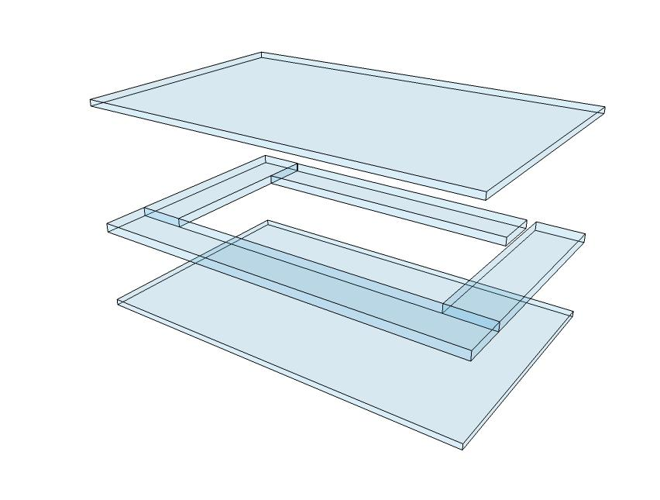

Flinn - $130
Science First - $34.60
Arbor Scientific - $52.00
Fisher - $31.75

https://www.tapplastics.com/
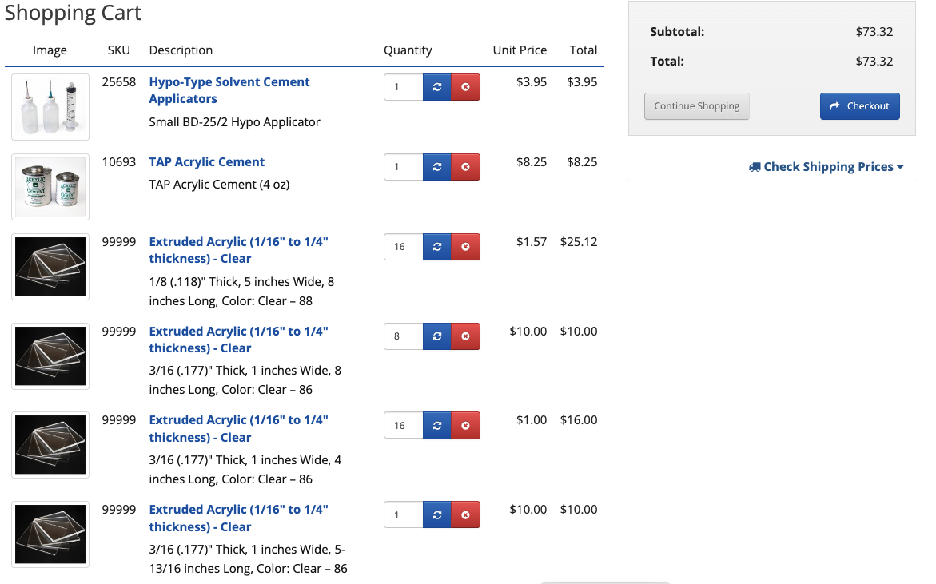

Investigation of Fluid Filled Accelerometers

The “Law of the FFA”

Instruct the students that we are looking for how the colored water in the Fluid Filled Accelerometer (FFA) reacts under various levels of acceleration. They are to look at how the fluid moves under different conditions. Allow students to take the Fluid Filled Accelerometer (FFA) onto the playground or home with them overnight. Allow them to suspend them by strings in various ways and roll them up and down ramps on low friction carts. Encourage students to write about their observations with the FFA.

Student observations should include:
- Location
- What is going on (Stopping at stop sign etc.)
- How the fluid acted.
- What they “felt” at the time.
- Why the fluid acted the way it did.
- Predict how the fluid might act under similar/different conditions.

These should be formal writing using appropriate techniques for writing descriptive paragraphs.

Have the students form small groups and compare their observations. Instruct them to identify the things that they observed that were similar and those that were different. The groups should develop a presentation of their observations noting their areas of agreement and disagreement. The groups should then develop test that would allow them to reconcile their areas of disagreement. The test “experiments” should be appropriately written up as “how to paragraphs.” Allow students to conduct their test and collect data.

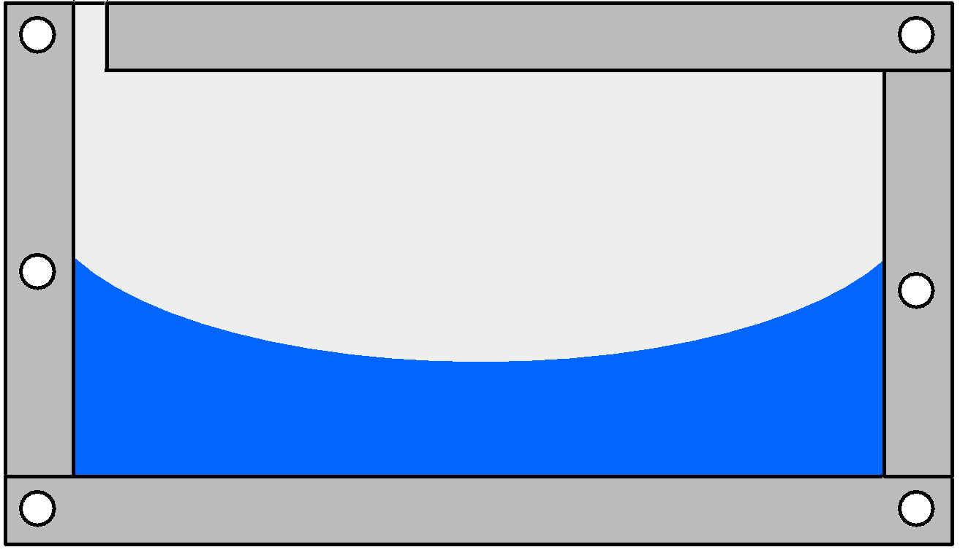
After collecting additional data, the groups should attempt to develop a series of descriptive statements about the action of the FFA under various conditions. These statements form the “Law of the FFA”.

Students should develop persuasive paragraphs in support of their “Law.”

Groups should then share their “Law” with another group to be tested. Each group will then develop and conduct test to determine the validity of the other group’s “Law of the FFA”.

Each group will then present the other group's “Law” and the results of their investigation into the validity of the “Law”. After the presentations the class will attempt to develop a “Grand Unified Theory of FFA’s” that will include all of the validated “Laws” from each group. This may require additional testing to decide between two conflicting “Laws”

The teacher may then introduce Newton’s three laws of motion and lead the students in a guided discussion to compare and contrast the “Law of FFA” and Newton’s Laws.

Fluid Filled may be purchased from Dr. Palmer at a price of $20 Plus S/H

Contact him at:
Science Education Services
Joel Palmer, Ed.D.
1908 Chapman
Mesquite, TX 75149

Cell. (469) 844-1699
SciEduServices@gmail.com
http://scieduservices.weebly.com/

