Operator(s): _________________________________ Experiment: __ATLAS __CMS

Materials needed: internet-connected computer, protractor (or protractor plug-in or app)

Tallies for angles ϕ1 and ϕ2 (measure and place tick mark for each near the closest angle):
Angle (degrees) | Tick marks |  | Angle (degrees) | Tick marks
10 |  |  | 190
30 |  |  | 210
50 |  |  | 230
70 |  |  | 250
90 |  |  | 270
110 |  |  | 290
130 |  |  | 310
150 |  |  | 330
170 |  |  | 350

Tallies for opening angle ΔΦ (calculate and place tick mark near the closest angle):
Angle (degrees) | Tick marks
10
30
50
70
90
110
130
150
170

Make histograms from your own data!

PHI (ϕ1 and ϕ2):
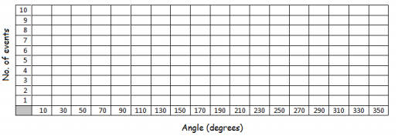

Delta-PHI (ΔΦ):
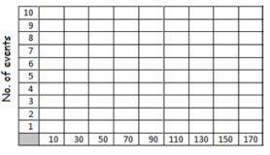

Angles measured:
