X-ray diffraction, Rosalind Franklin, and DNA
8/27/2021
Rick Dower MEASUREMENT RESULTS INCLUDED

This exercise is adapted from G. Braun, D. Tierney, and H. Schmitzer, “How Rosalind Franklin Discovered the Helical Structure of DNA: Experiments in Diffraction,” The Physics Teacher, 49, 140-143 (March 2011).

The world’s most famous x-ray diffraction photo is pictured in Figure 1. Called Photo 51 by Rosalind Franklin, it was published by Dr. Franklin and R. G. Gosling (King’s College, London) in Nature 171, 740-741 (25 April 1953).

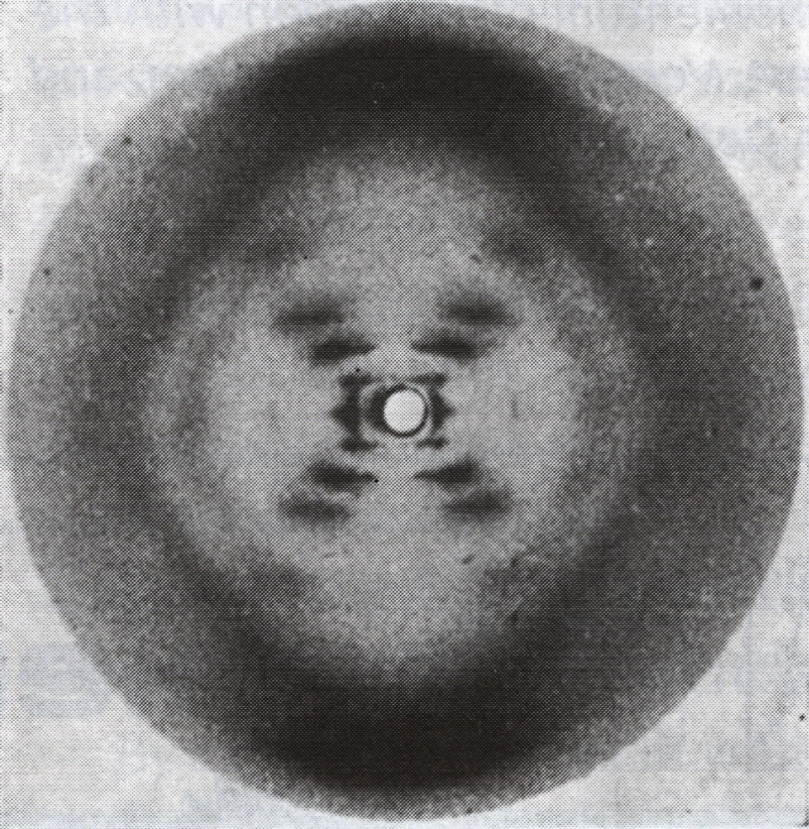
Figure 1 Rosalind Franklin's Photo 51 DNA diffraction photo. The zero order and some of the first order diffraction images are blocked by a lead disc (white circle in center) to avoid over exposure of the film.
This diffraction photo of hydrated sodium thymonucleate (DNA) provided crucial evidence supporting the double helix DNA structure proposed by James Watson and Francis Crick (Cavendish Laboratory, Cambridge University) based on published chemical clues and a physical molecular model they constructed. As they acknowledged, “We have also been stimulated by a knowledge of the general nature of the unpublished experimental results and ideas of Dr. M. H. F. Wilkins, Dr. R. E. Franklin, and their co-workers” Nature 171, 737-738 (25 April 1953).

In this exercise, students use the power of x-ray diffraction analysis to confirm this relatively simple, yet fundamentally important, molecular structure. We start with the analogy of the visible light diffraction pattern of a portion of a single helix formed by the small coil spring from a retractable pen (Figure 2).
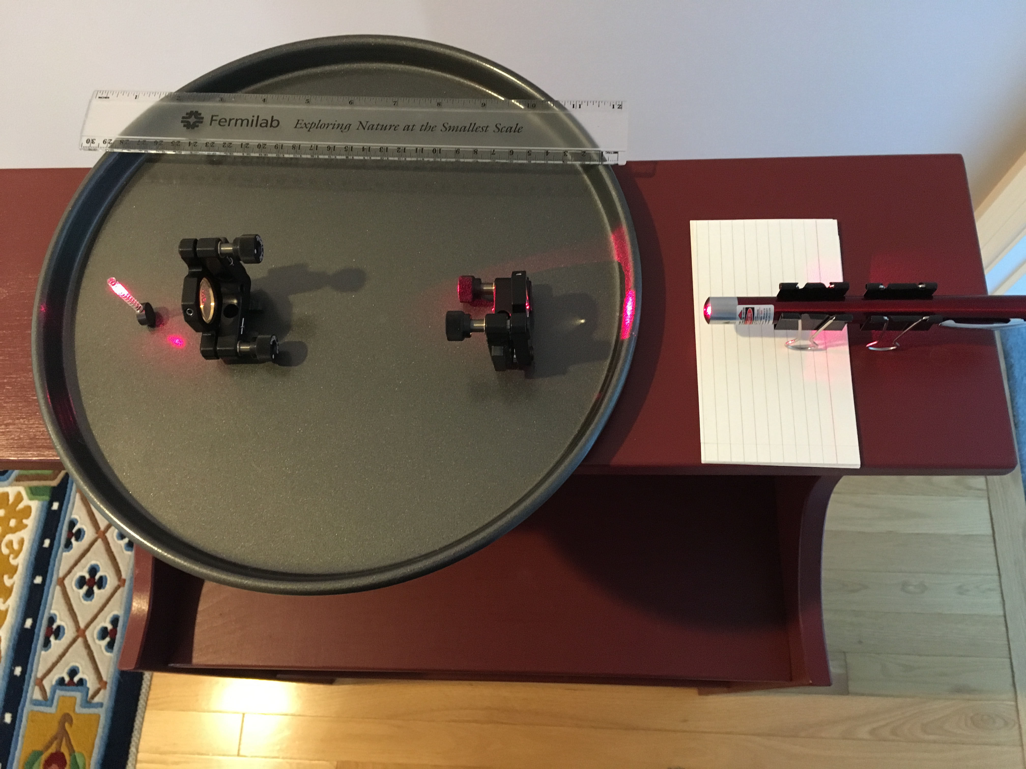
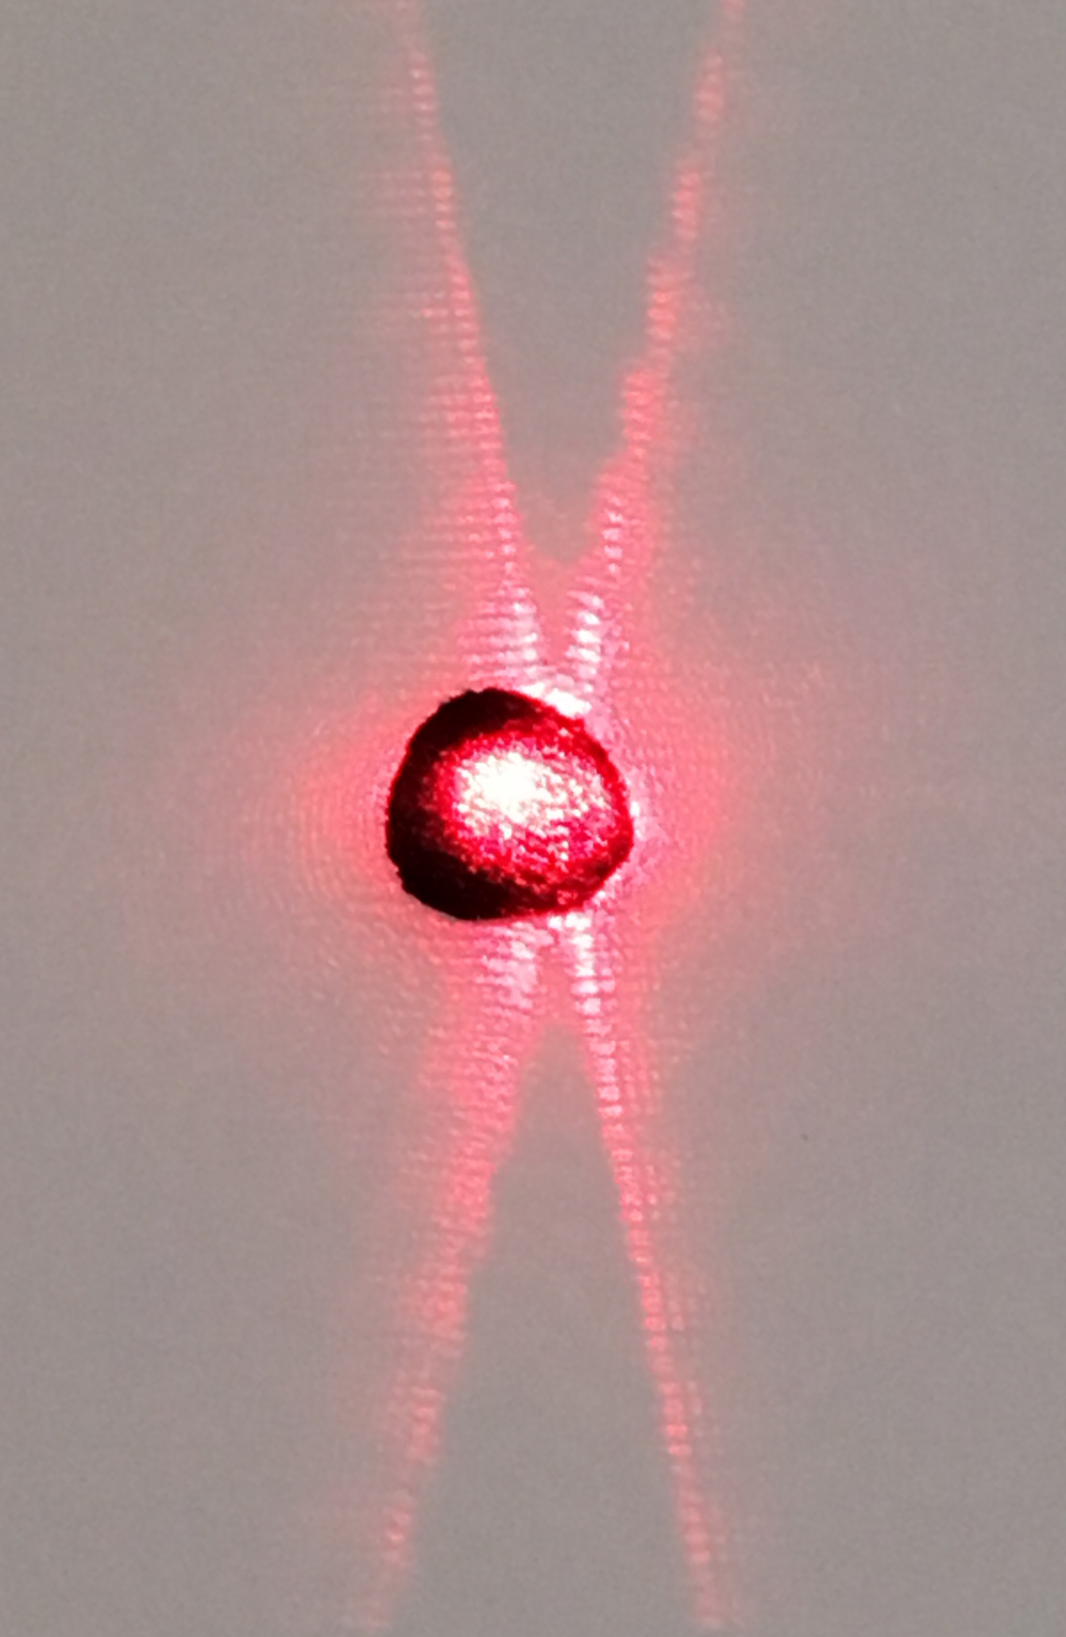

Figure 2 Diffraction pattern of a coil spring Figure 3 Laser, beam expander lenses, and spring coil
Interpretation of this image is assisted by a projection of a right-handed circular helix in the y-z plane. The parametric expressions for a particle moving in a circular helix about the z-axis as time t progresses are
x = Rcos(2πt/T), y = Rsin(2πt/T), z = P(t/T) , as t varies continuously.

R = radius of helix circle projected in the x-y plane,
P = pitch of helix, i.e., distance between corresponding points on successive turns of the helix.
T = period of the particle on the helix, i.e. time for one full turn

The projection of this helix in the y-z plane is y = Rsin(2πz/P),
which is shown in Figure 4 with y the vertical axis and z the horizontal axis.
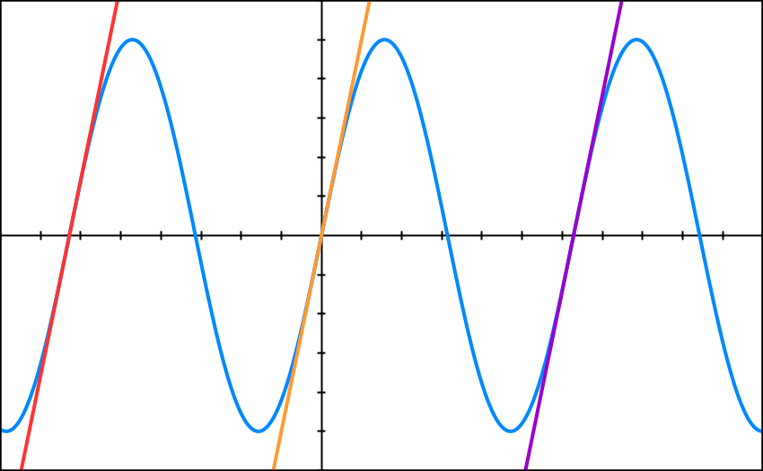
α
P

R
α

d

Figure 4 Graph of helix in the y-z plane with lines
y = R(2πz/P+2π), y = R(2πz/P), and y = R(2πz/P-2π)

The three equidistant parallel lines slanted to the upper right in Figure 4 approximate half of the sine curve shown. The slope of those lines is the slope of the tangent to the sine curve as it crosses the z-axis (y = 0), i.e., the derivative (dy/dz) at z = 0. The helix pitch angle (α) is the complement of the angle made by the tangent line with the
z-axis (horizontal axis) at (0,0).

tangent line slope = $\frac{dy}{dz}=R\left(\frac{2π}{P}\right)\cos\left(\frac{2πz}{P}\right)$= R (2π/P) = tan(90° – α) (1)

Equidistant, parallel lines slanted to the left at an equal angle α approximate the other half of the sine curve. The angle between lines in these two groups is 2α. To determine the diffraction pattern of these two groups of parallel lines, we apply Babinet’s principle: the diffraction pattern of an opaque body is opposite in phase, equal in amplitude, and, therefore, equal in intensity to that of a hole in an opaque screen of the same size and shape as the original opaque body. Consequently, the diffraction pattern of a helix is approximately the same as the pattern of two diffraction gratings of equidistant parallel slits with angle 2α between the slit direction of one set and the slit direction of the other set.

The spreading direction of the diffraction pattern of a diffraction grating is perpendicular to the slit orientation. So, the diffraction pattern of a helix looks like an “X” with angle 2α (<90°) between the arms of the “X”.

The angles from the grating to image maxima for a diffraction grating are given by

sin(θ_{max}) = mλ/d , (2)
where m = integer
d = perpendicular distance between parallel lines in grating
λ = wavelength incident on grating

Measuring the location of diffraction maxima on a screen and the distance from the helix to the screen allows the calculation of the diffraction angles θ_{max}. Counting images outward from the zero-order maximum in the center of the pattern determines the integer m. With knowledge of the illuminating wavelength λ, one can calculate the grating spacing d. The helix pitch is then given by

P = d/cosα , (3)

as seen in Figure 4. The helix radius R can be calculated with Equation 1.

The laser beam is expanded to intercept several coils of the spring (Figure 3) for greater uniformity in the diffraction pattern in Figure 2. A piece of black velvet absorbed much of the light in the center region in Figure 2 to avoid overexposure.

Spring Coil Activity
- Use a diffraction grating with known line spacing to determine the wavelength (λ) of a laser.
- Use convex lenses to collimate and expand a beam from the laser so it will intercept several coils of the spring from a retractable pen. Aim the laser at a wall several meters away and make sure the beam is collimated.
- Place the coil spring in the laser beam and stick a piece of paper on the wall to intercept the far field diffraction pattern.
- Use a straightedge to mark the axes of the diffraction patterns on the paper. Mark on the paper the locations of 10 or more closely spaced node (dark) lines along one (or more) of the arms of the diffraction “X” pattern.
- Measure the distance (L) from the coil spring to the center of the diffraction pattern.
- Measure the angle 2α between your straightedge lines on the paper that indicate the diffraction pattern. If your spring is mounted vertically, the angle will be between the top arms of the “X”.
- The wire thickness of the coil spring will create a secondary pattern that produces large dark nodes along the diffraction “X”. These will obscure some of the closely and evenly spaced nodes of the coil pattern. Take this into account and determine the average distance (x_{avg}) between the closely spaced nodes in the pattern. This is the same as the distance between antinode (maxima) centers in the pattern. When the distance to the screen is large, the diffraction angles are small and the tangent and sine of the diffraction angles are nearly the same. Then for m = 1, sin (θ_{max}) ≅ x_{avg}/L.
- Calculate the perpendicular distance between coils in the spring (d), the spring coil pitch (P), and the coil radius (R) from your diffraction pattern measurements.
- Measure the coil pitch and radius with a ruler or calipers and compare to your diffraction measurements.

Below are measurements and calculations, corresponding to the steps indicated above, that Rick Dower made with the apparatus pictured in Figures 2 and 3 on 07/20/2016.

1. Replica grating: 13,400 lines/inch ⇒ d = 1896 nm
screen
Laser beam

0.460 m

grating

0.610 m

Let θ = angle between central zero order beam and diffracted first order
(m = 1) beam.

tan θ = (0.460/2)/0.610 = 0.3770 ⇒ θ = 20.7° ⇒ sin θ = 0.3535

Laser wavelength: λ = (d/m)sinθ = (1896nm/1)sin(20.7°) λ = 670 nm

5. Coil-to-Diffraction-Pattern Distance: L = 6.020 m

6. Twice the coil pitch angle = 2α = 22° ⇒ α = 11°

7. Average distance between closely spaced diffraction nodes:
x_{avg} = 28 mm/15 x_{avg} = 1.87 mm

8. Diffraction calculations:
$\frac{x_{\text{avg}}}{L}=\frac{λ}{d} ⇒ d=λ\left(\frac{L}{x_{\text{avg}}}\right)$ d = 2.16 mm

$P=\frac{d}{\cos{α}}=\frac{2.16 \text{mm}}{\cos{11°}}$ P = 2.20 mm

$R=\frac{P}{2π}\tan{(90°-11°)}$ R = 1.80 mm

9. Direct measurements:
P = 22 mm/10 coils P = 2.2 mm

The measured P is equal to the coil pitch calculated from the diffraction pattern.

Outside diameter of spring coil = 3.9 ± 0.1 mm, wire diameter ≈ 0.1 mm
R = 3.8 mm/2 R= 1.9 mm
The measured R is nearly equal to the coil radius calculated from the pattern.

Photo 51 DNA Activity
- Assume that Rosalind Franklin used the copper Kα x-ray line for her photo.
Then λ = 0.154 nm.
- Assume the x-ray photo emulsion was placed L = 90 mm from the DNA sample. (This assumption is based on the assumption above and the 94 mm diameter of the largest circle in the original photo.)
- With a straightedge draw lines through the approximate centers of the dark spots of the diffraction “X” in Figure 1 and measure the angle 2α at the top for the vertical DNA sample.
- A lead disc blocked to zero order diffraction spot on the photo. Measure the distance (y) along the arms of the “X” to the m = 1 (somewhat obscured), 2, 3, and 5 diffraction spots on each of the arms and take an average (y_{avg}) for each m value.
- Calculate the θ_{max} values from tan(θ_{max}) = y_{avg} /L for each m value.
- Calculate the d, P, and R values for each m value.
- Calculate an average value for P and R of the DNA helix in Photo 51.
- Compare your values to Franklin’s values of P = 3.4 nm and R “about” 1 nm.
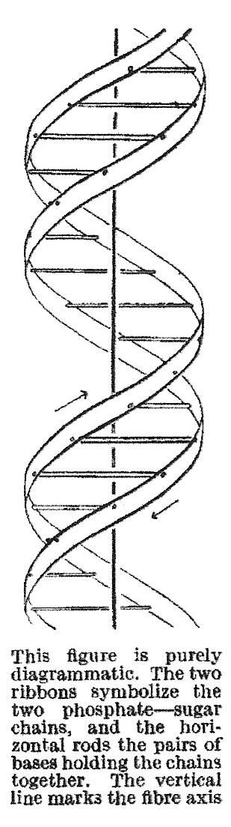
- Evidence for a second identical helix in the DNA molecule is obtained from the absence of an m = 4 diffraction spot. As Franklin and Gosling noted, “The structural unit probably consists of two co-axial molecules [helices] which are not equally spaced along the fibre [DNA] axis, … if one molecule [helix] is displaced from the other by about three-eighths of the fibre-axis period, this would account for the absence of the fourth layer line and the weakness of the sixth. Thus our general ideas are not inconsistent with the model proposed by Watson and Crick in the preceding communication. [Nature 171, 737-738 (25 April 1953)]”
The Watson and Crick paper cited above includes the DNA structure diagram on the left. Measure the diagram to show that the second helix is displaced about 3/8 of a helix period from the first helix.

A grating with spacing (3/8)d, where d is the grating spacing of the original helix, would produce diffraction minima at angles given by sin(θ_{min}) = (n+1/2)λ/(3/8)d, where n is an integer. As indicated in Equation (2) above, a single helix would give diffraction maxima at angles given by sin(θ_{max}) = mλ/d, where m is an integer. Find the n value for which the minimum of the two helix pattern would coincide with the m = 4 maximum of the one helix pattern to produce the absence of the m=4 spots.

Below are measurements and calculations, corresponding to the steps indicated above, that Rick Dower made on Figures 21 on 07/20/2016.

3. Angle between diffraction axes = 2α = 74° ⇒ α = 37°

4. m y(mm) ± 0.5 mm Average (mm)
1 6.0 5.5 5.5 6.0 5.8
2 10.5 9.5 10.5 10.5 10.1
3 15.0 14.5 15.0 15.0 14.9
5 24.0 24.0 23.5 23.5 23.7

5. For the calculations below: tan(θ_{max}) = y_{avg} /L = y_{avg} /(90 mm),

6. $d=\frac{mλ}{\sin{θ_{\text{max}}}}=\frac{m(0.154 nm)}{\sin{θ_{\text{max}}}}$

$P=\frac{d}{\cos{α}}=\frac{d}{\cos{37°}}$

$R=\frac{P}{2π}\tan\left(90°-α\right)=\frac{P}{2π}\tan{53°}$

m tan(θ_{max}) θ_{max} (deg) d (nm) P (nm) R (nm)
1 0.064 3.687 2.39 3.00 0.63
2 0.112 6.403 2.76 3.46 0.73
3 0.166 9.400 2.83 3.54 0.75
5 0.263 14.753 3.02 3.79 0.80

7. Average: 2.75 3.45 0.73

There is a notable steady increase in values for d (and, consequently, P and R) as m increases.

8. The average values for P and R are close to Franklin’s values (less close for R).

9. Diagram measurements:
P = 3.80 cm, displacement of 2nd helix = 1.20 cm

(2nd helix displacement)/P ≅ 1.2/3.0 = 0.32 close to 3/8 = 0.375

We want to find n, such that the minimum of the (3/8)d grating appears at the same y value as the m = 4 maximum of the d grating :
(n + ½)λ/(3/8)d = 4λ/d or (n + ½) = (3/8)*4 = 3/2.
∴ n = 1

