**Mass Calc: Z**

**Relativity Used in the Creation of the Z Boson!**

**Analysis of LHC Data from CERN**

Today, you will use (a form of) Einstein's famous equation with experimental data collected in CERN’s ATLAS and CMS experiments to determine the mass of the Z boson. Experiments at CERN first observed this particle in the 1980s. Measuring it in modern detectors is one way to calibrate the detectors—to be sure that they are behaving as designed. Z bosons are also important in understanding weak interactions and the decay of heavier particles such as the Higgs boson.

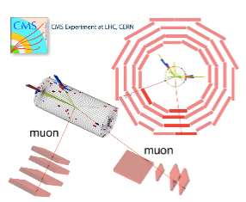

The cartoon to the right shows what happens in one of these events. The tracks (at about 6 and 8 o’clock) are the paths of a muon and an anti-muon. These were created from the prompt decay of a Z boson (invisible here). The Z itself was created in the collision of two protons from the LHC beam.

Large particle accelerators often have several experiments so that one can verify the discoveries made by the other. Do CMS and ATLAS agree on the mass—and other measurables—of the Z boson?

You will receive a more detailed plot from data collected by the ATLAS or CMS detector. A sample of one of these “events” is below. You will need to determine the total energy of the muon, anti-muon pair and their net momentum.

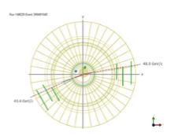

Data from LHC events are displayed in images like the one to the left. It shows the recorded momentum (in GeV/c) of the particle debris that came from the collision. Your class has eight event displays.

Can you identify the muons in this event? Physicists do not detect the Z boson directly but rather reconstruct it from the muon data. These muons carry the momentum and mass-energy of the Z boson parent.

**What do we know?**

1. Momentum is conserved. Energy is too.

2. Momentum is a vector. Energy is not.

3. The invariant mass of the Z boson becomes the momentum and mass of the muon anti-muon pair.

4. The net momentum of the muon, anti-muon pair is the same as the net momentum of the Z boson.

5. Muons have small mass. In these events, we can say that their energy and momentum are equivalent.

6. Einstein actually wrote E2=p2+m2 (This requires using units that make the speed of light=1.) This allows us to solve for energy, momentum or mass if we know the other two.

**What are our claims? What is our evidence?**

Complete a data table like this one for each event that you analyze.

Event Number: ______

____________________________

|  |  |  |
| --- | --- | --- |
| Exp: ___ATLAS ___CMS | Measured/Calculated Results | Remarks |
| Momentum of muon 1 |  | Vector: Report two quantities |
| Momentum of muon 2 |  | Vector: Report two quantities |
| Net momentum |  | Vector sum; report the magnitude. |
| Energy of muon 1 |  |  |
| Energy of muon 2 |  |  |
| Total energy |  |  |
| Mass of Z candidate |  | Calculate using Einstein’s Equation |