Activity: Know your Muon Detector
Basic Background for Beginners:
Muons are a type of lepton; they are essentially a rarer cousin to the electron and share electrons’ negative charge. They are much lighter than quarks (the building blocks of protons and neutrons), but still 200 times heavier than electrons. Where do they come from? When protons with a lot of energy from stars out in space interact with Earth’s atmosphere, they produce cosmic rays (and this happens a lot!). The cosmic rays ionize the atmosphere making a bunch of matter and anti-matter particles called pions that quickly decay into lighter leptons (including muons!) and electromagnetic radiation. The muons formed have more energy than, say, the electrons and neutrinos (other leptons) produced, so they are the most likely to make it to the Earth’s surface. If you hold out your hand, rough estimates say that one or two muons will pass through it every second.
Further Background:
What are Cosmic Rays?
What is a Muon?
What is Quarknet?
About your CRMD
In-Depth Guide to using the CRMD

Standards Addressed
Next Generation Science Standards
Science and Engineering Practices
1. Analyzing and interpreting data
2. Using mathematics and computational thinking
3. Constructing explanations
Crosscutting Concepts
4. Systems and system models
Common Core Literacy Standards
Reading
9-12.4 Determine the meaning of symbols, key terms . . .
9-12.7 Translate quantitative or technical information . . .
Common Core Mathematics Standards
MP1. Make sense of problems and persevere in solving them.
MP2. Reason abstractly and quantitatively.
MP4. Model with mathematics.
Learning Objectives
- The students will learn how to plateau the counters.
- The students will learn how to upload their data to e-lab and run a performance study.
- The students will learn how to create benchmark file in order to BLESS all further files.
- The students will learn how to run a flux, shower, and lifetime study in order to download the raw data for further analysis.

Working the Equipment: (EQUIP)
To Plateau…
Plateauing the counter is a very important process that must be completed before you start running experiments because it verifies that the counters are reporting accurate numbers of hits. The counters can pick up a variety of things besides muons. The counters work by keeping a tally of how many times the scintillator is excited by something passing through. When it is excited, it sends a signal to the DAQ board through the PMT (Photomultiplier tube). The threshold voltage is the minimum voltage that the scintillator must be excited to register a reading. If the threshold voltage is too low, the detectors will pick up and count a lot of “noise”.
If the voltage is too high, some of the muons may not be picked up. Plateauing must be done once a year because drifts in tube gain or voltage occur over time and cause counting variations. You will need a voltmeter for plateauing.
- Set all voltages on photomultiplier tubes (PMTs) to minimum on the 4-way power distribution unit (PDU) all the way counterclockwise (CCW).
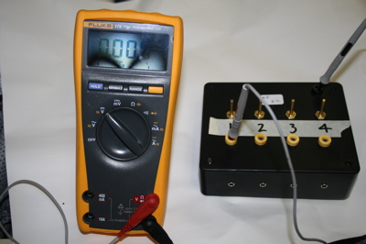
- Place counter 0 and counter 1 in a stacked configuration.
- Open the EQUIP shortcut on the desktop.
- Select Status output to “Reset scalars (ST 3 x)” and the time interval to 1” minute.
- Select “Coincidence level” to “1”. 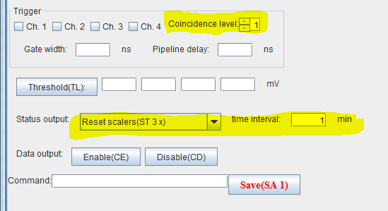
- Select serial port as “COM 3”. This should begin the data collection.
- Increase the PMT voltage for counter 0 until it counts between 40 – 60 events per second. Use the Count Rate graph under the “Rate Monitor” tab in EQUIP.
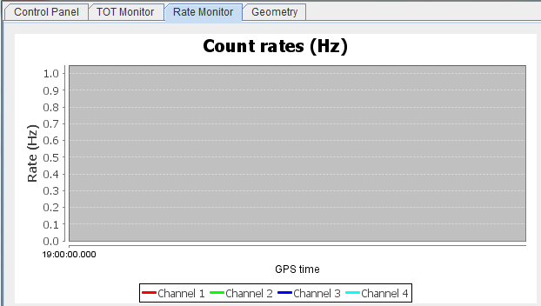
- Now change the coincidence level to 2.
- Increase the voltage on channel 1 until it begins to read a hit.
- Let the counter run for a minute and record the singles count as well as the coincidence count.

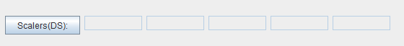
Coincidence Count
Ch 1
Ch 2
Ch 3
Ch 0

- Record into the Excel plateauing template.
- Increase the PMT voltage by .02V and record the Scalar(DS) line.
- Repeat until 1.1V.
- Look where the coincidence counts level off or “plateau”. See below…
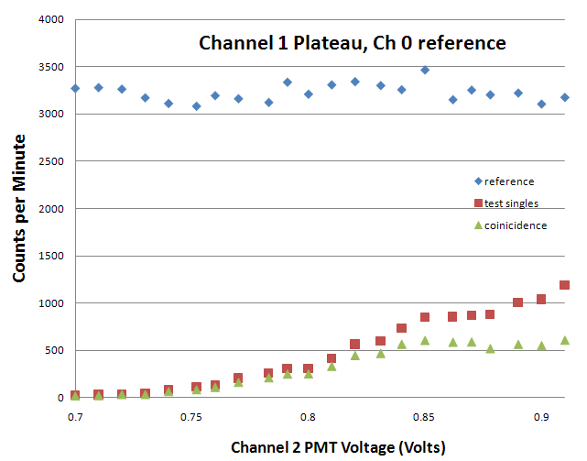
You should set the PMT voltage near the start of this plateau.
- Repeat with counter 0 and 2, 0 and 3 and then finally 1 and 0 with 1 as your reference.
- Once the detector is plateaued, let it run for a couple of hours and save the file through EQUIP.
- Upload the file to e-Lab and run a performance study on the data (see directions below).
- Make minor adjustments to PMT voltages to bring all of the channel’s ToT (time over threshold) together.
- An ideal performance plot is shown below.

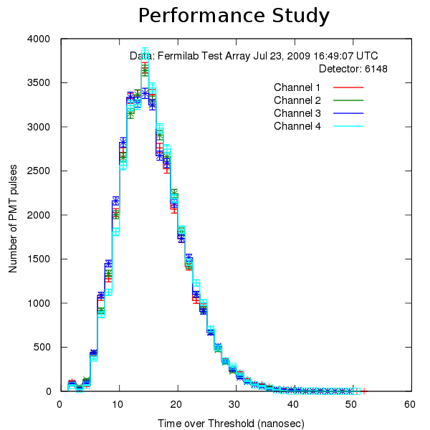
- Be aware that the detector might drift over time. This plateau calibration process ought to be repeated at least once a year.
Uploading the data…
- Go to e-lab. https://www.i2u2.org/elab/cosmic/home/project.jsp
- Click upload.
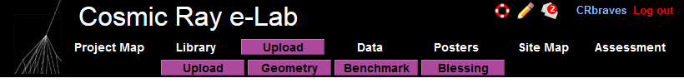
- Select your detector and browse for the saved file.
- Click upload.
Running a Flux Study:
Once you have uploaded the data, run a flux study under the DATA and analyze under FLUX. Put in the necessary parameters, including setting the appropriate bin width, and when completed you may view the study under VIEW PLOTS. Don’t forget to save your plot!

Activities
Distance between counters
Angle from Zenith
Trigger count as a function of pressure
Trigger Count as a function of Solar Activity

