ATLAS Data Express
You are on shift to analyze events from the ATLAS detector
in the Large Hadron Collider at CERN.

Welcome to your ATLAS student operations shift. Today you are on the Data Quality Management (DQM) team. You will be given a sample of ATLAS events and will have two assignments:
- Sort the events by characterizing whether the decays were dielectron or dimuon.
- Gather data to determine a good value for the “reconstructed mass” of the observed tracks.

What do we know?
- The events we will use come from the collisions of protons. Pieces of those protons (quarks or gluons) come together to make Z bosons and other particles.
- Z particles have no electric charge.
- All of the decays in our data are into electrons and positrons, or into muons and antimuons. Electrons and positrons generally show up in our event display as short red tracks. Muons and antimuons generally show up as long red tracks. Other collision by-products (background) also show up in our displays.
- Momentum, energy, and charge are conserved in decays.
- The energy of parts of the proton colliding can be converted to a Z boson or other particles. Many newly created particles promptly decay into smaller particles. The mass and the momentum of the original particle becomes the mass and momentum of the decay products. Applying conservation of energy and momentum to the event allows physicists to calculate the mass of the presumed original particle in each event. That mass is shown at the upper-right of the event-display.

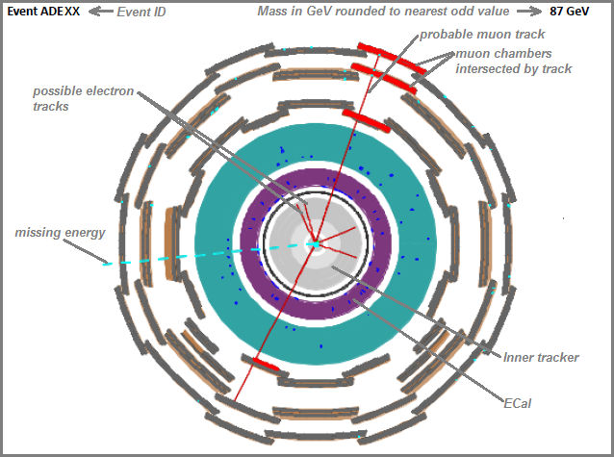
This sample event shows some of the main features of the events you will see. The details of each event will vary, of course.

The ATLAS detector is roughly cylindrical. This event display shows a cutaway view of the middle of the detector. The proton-proton beam and the collision point are at the center of the two circles.

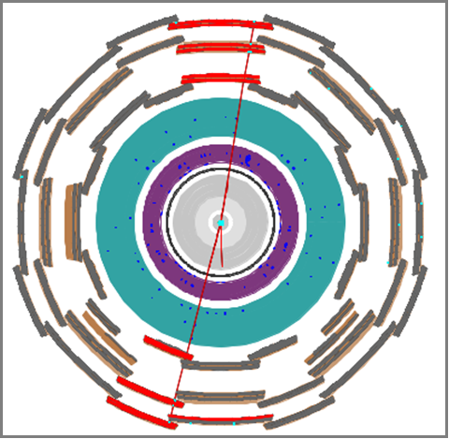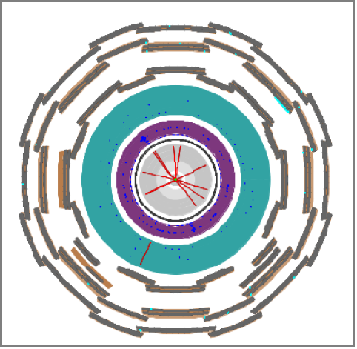
Which of these events is a Z dielectron candidate? Which is a dimuon candidate? Which might be a background event?

Learn about the ATLAS detector from the video at:
http://www.atlas.ch/multimedia/how-atlas-detects-particles.html.

What tools do we need for our analysis?
We need a notebook to record masses and decay types (dielectron or dimuon). We need our data file.

What will we do?
We will work in teams of two. The shift manager will help us determine which events to examine, which analyses to do, and how to incorporate our results into overall results for the DQM team.

What are our claims? What is our evidence?
You may need to share your results and observations with your classmates. Follow your teacher’s advice, assemble your evidence and you prepare to answer the following questions:
- What is the mass of the Z boson?
- What is the ratio between the number dielectron events and the number of dimuon events?

We claim that we can produce one or both of these:
- A readable mass plot (histogram) with a clear peak which reveals the mass of the Z particle.
- A count of dielectron and dimuon events that enables us to find the ratio between them.
Once you have assembled your evidence and analyzed it, you can refine these claims and make them more specific. It is very important that we do this analysis as blind study. We must not aim at a known value but rather construct the value from our data and our analysis. We will hand these DQM results over to the shift manager who can then use them in the calibration of the detector or adjustment of analysis software.

After your class has discussed results, you may make your ATLAS Student Operations Shift Report.

