ATLAS Data Express
Teacher Notes

Description
ATLAS Data Express is a short investigation using events from A Toroidal LHC Apparatus (ATLAS) at the Large Hadron Collider (LHC). Students are assigned “on-shift” to CMS Data Quality Management (DQM). They check the data quality to see that CMS is performing to specification by giving a good fit for the Z mass. The students will do this by separating Z candidate events from other events by visual inspection and create a mass plot for the Z boson.
The Z boson is important in LHC discovery science. It is a well-known particle, so the location and width of the mass plot give physicists a good idea of how the detector is performing. Z candidate events are “dimuon” events; the Z can decay into a muon-antimuon pair. Z candidates are identified by two long muon-type tracks.
This activity helps prepare students for a masterclass or to give students a masterclass-like experience in a short time (1-2 class periods).

Standards Addressed
Next Generation Science Standards
Science Practices
1. Asking questions
2. Developing and using models
4. Analyzing and interpreting data
5. Using mathematics and computational thinking
6. Constructing explanations
7. Engaging in argument from evidence
8. Obtaining, evaluating, and communicating information
Disciplinary Core Ideas – Physical Science
PS1.A: Structure and Properties of Matter
PS2.B: Types of Interactions
PS2.C: Stability and Instability in Physical Systems
PS3.B: Conservation of Energy and Energy Transfer
PS3.C: Relationship Between Energy and Forces
Crosscutting Concepts
1. Patterns.
2. Cause and effect: Mechanism and explanation.
3. Scale, proportion, and quantity.
4. Systems and system models.
7. Stability and change.
Common Core Literacy Standards
Reading
9-12.4 Determine the meaning of symbols, key terms . . .
9-12.7 Translate quantitative or technical information . . .
Common Core Mathematics Standards
MP2. Reason abstractly and quantitatively
MP6. Attend to precision.
IB Physics Standard 1: Measurement and Uncertainty
1.2.6 Describe and give examples of random and systematic errors.

1.2.8 Explain how the effects of random errors may be reduced.

1.2.11 Determine the uncertainties in results.
IB Physics Standard 7: The Structure of Matter
Aim 4: particle physics involves the analysis and evaluation of very large amounts of data
Standard 7.3.4: Apply the Einstein mass-energy equivalence relationship

Enduring Understanding
Scientists continuously check the performance of their instruments by performing calibration runs using particles with well knows characteristics.

Learning Objectives
As a result of this activity students will be able to:
- Predict the electric charge of a particle from its motion in a magnetic field.
- Describe the method of determining which kinds of decay particles are present in each event.
- Describe how candidate events can be accepted or eliminated using conservation of charge.
- Make a list of events sorted into the following categories: Z decay or random event.
- Make a histogram of the mass of the particles represented in the chosen Z candidate events.
- Describe how the mass plot for Z candidates can be used to determine if the detector is calibrated.

Background Material
The images the students analyze are ATLAS events. There are a variety of resources on ATLAS and LHC at http://atlas.ch. Other resources are available from the web page (see below).

Prior Knowledge
Students will know and be able to:
- Use the Lorentz Force that determines the direction of charged particles moving through a magnetic field
- Use the right-hand rule to determine the (positive or negative) charge of the particle.
- Make a histogram from data.
The Plotting LHC Discovery lesson can serve as introductory activity for the importance of calibration in interpreting new discoveries.
Resources
Data file: https://quarknet.i2u2.org/sites/default/files/adeevents.pdf
ATLAS masterclass: http://atlas.physicsmasterclasses.org/en/index.htm
Implementation
Students should start with background from the video at
http://www.atlas.ch/multimedia/how-atlas-detects-particles.html.

There are 30 events in the PDF data file (linked above in Resources), one per page. Students work in pairs. Two students working together should be able to do 10 events in a short time. Several groups will analyze each event. Since students will have different interpretations of the same event, duplicating event analysis will allow the opportunity to discuss that small variations contribute to experimental uncertainty.

Each event shows a cut-away view of the center of ATLAS, perpendicular to the beamline; the two proton beams collide in the center of the event display. These collisions create new particles; some are Z-bosons, some are Top Quarks. This process can make a zoo of particles. ATLAS scientists make initial measurements of the events and use pre-defined criteria to filter some events for later analysis. This process creates candidate events which are these all “look like” Z-bosons. The filter selects events in which particles that promptly decay and leave two tracks. It’s possible to observe the Z decay into an electron and positron (dielectron event) or decay into a muon and antimuon (dimuon event). The selection process isn’t perfect; it sometimes allows other events through.

Students can do two tasks with these data. You will find an explanation of each below.
- Sort the events by characterizing whether the decays were dielectron or dimuon.
- Gather data to determine a good value for the “reconstructed mass” of the observed tracks.

Dielectron candidate events are those with two short red tracks. These tracks end before they reach the electromagnetic calorimeter (ECal) which absorbs electrons, the thick purple circle in the event display. The students will often observe blue splotches in ECal at the ends of these tracks: these are indications of energy deposition from the electrons or positrons. There may be other electron-like tracks with the electron pair. If there are more than two extra or if there are ECal deposits with no tracks, these are usually background events.

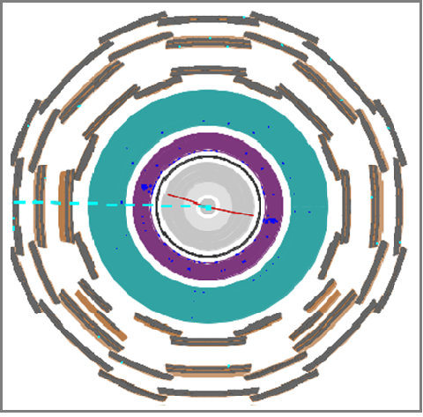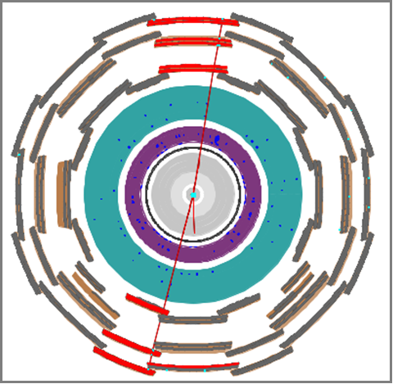
Dielectron event: note the two short red lines and the blue energy deposits in ECal. The dashed blue line indicates “missing energy.”
Dimuon event: note the two long, red lines and the red “lit-up” muon chambers. Note the short extra track .

\\\\

Dimuon events will have two long red tracks; both reach all the way (or nearly so) to the outside of the event display. This is because muons and anti-muons are very penetrating particles and are usually not stopped in the ECal or any other detector parts. They do leave tracks in the inner tracker (central gray region) and the muon chambers (jagged thick gray and brown outer circles). There are often other tracks (many electron-like) with the muon and anti-muon tracks from other processes. If the student sees those two long red tracks, he or she should declare it a “dimuon” event.

Software determines the “reconstructed mass” of the observed tracks and prints it on the event display. The calculation uses the energy and momentum of the observed tracks and uses conservation rules to determine the mass and energy of a parent particle that would have decayed into the particles that left the tracks. Students should round the mass to the nearest odd number for each Z candidate. They should pool their results to make a histogram (a “mass plot”) to find the most likely value of the mass of the Z boson.

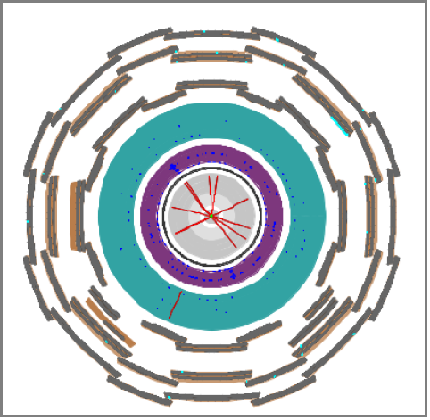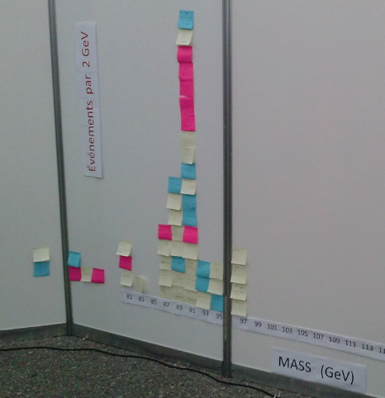
Possible background event. Mass plot of Z candidates.

Discussion at the end is very important to understand the significance of the results. Students should be able to make the following claims:
- The mass of the Z boson.
- The ratio between the number of dielectron and dimuon events.

Students should use the evidence from their analysis to support (or refute) these claims. They should then dig deeper into the evidence to discuss questions like:
- How sure are we of the results we have?
- What affects the accuracy of our results?

You may or may not decide to introduce the expected values: approximately 91 GeV for the mass of the Z and approximately 1for e/μ ratio. The directions to students indicate that they are to analyze data blind to any expected results.

Assessment
- Quality of their plots
Check for the following: correct labeling of axes, identifying the background level; appropriate bin size selection
- Interpretation
Check for the following: correct identification of the peak and the particle mass; indication that the width of the peak represents the uncertainty in the value of the mass.
Did the analysis indicate that the detector is well calibrated? That is, did the mass plot yield a result in agreement with accepted values for the Z mass? (91GeV/c² )
- Discussion
Divide the class into groups. Each group then presents their findings to the class with open discussion of the claims, evidence and reasoning provided by each group. Questions addressed during the discussion include:
- What is the most likely mass of the Z boson?
- What is the range of Z boson masses sampled in your data?
- What is the e/μ ratio?
- What evidence do you have for these values?

- Written report
A written report should stress claims, evidence, and reasoning:
What claims can scientists make based on the Z plot?
  - Examples: mass, discovery, uncertainty.
What is the evidence for and against the validity of the claims?
  - Examples: signal-to-background, width.
Explain the reasoning linking the evidence to the validity of the claim.
  - Example: the Z signal is large compared to background, with a width narrow compared to the height of the peak.
What claims can scientists make based on the e/μ ratio?
  - Examples: the ratio was well below the approximate value of 1because we accepted too many dimuon candidate events because the curvature was very small and we guessed incorrectly
Are some claims more valid than others? Why?
  - Example: a smaller signal-to-background ratio gives weaker evidence of discovery.
Provide the evidence for these claims, and the reasoning behind them over to the shift manager in your “Shift Report.”

Extension
This activity is well suited to a more detailed analysis of error, using readily available tools in a spreadsheet or graphing calculator. Below is a selection of indicators from the IB standards, with a description of how these indicators can be met using this activity.
Understandings:
Random and systematic errors
On a histogram with a “bell-shaped” distribution, random error can quantified by determining the “width” of the distribution, and systematic error can be related to the mean of the distribution. Examples in the case of a Gaussian distribution would be by calculating the FWHM (full width half-maximum) or the standard deviation. In either case, a narrow peak (such as the narrow mass distribution of the J/Psi in muon production events in CMS) can be identified as one with a small random error, while a broad peak (J/Psi candidates from electron-positron production, for example) would represent a large random error.
A student can calculate standard deviation easily in a spreadsheet program, and by inspection of the histogram explain how the standard deviation relates to the width of the distribution; the FWHM would be more difficult but could be estimated by printing the histogram, sketching a normal distribution curve over it, and measuring with a ruler.
Calculating the mean of a distribution, on the other hand, can shed light on possible systematic error. If the published mass of the J/Psi particle is 3.1 GeV/c² for example, but the mean of a given distribution is 3.2, then this may indicate something systematic that is skewing mass values to be too heavy. When the CMS and ATLAS team publish discoveries or describe their process, they include both systematic and random uncertainties.
Error bars
For the data in each bin of the histogram, the error can be approximated as the square root of the number of events in the bin. Using a spreadsheet program, this is easily accomplished as they have options to include “standard error” bars, or even error bars with user-defined width.

