

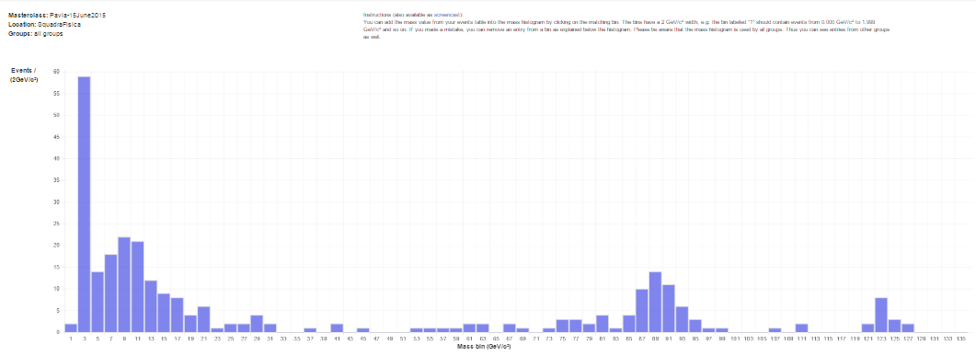

**BIG DATA**

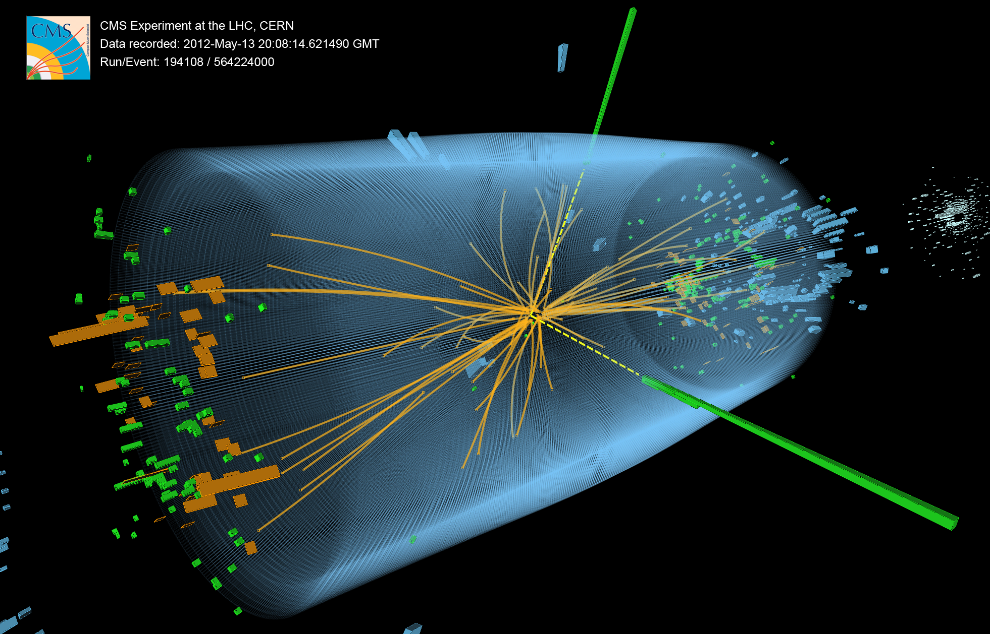

**BIG IDEAS**

**BE PART OF IT**

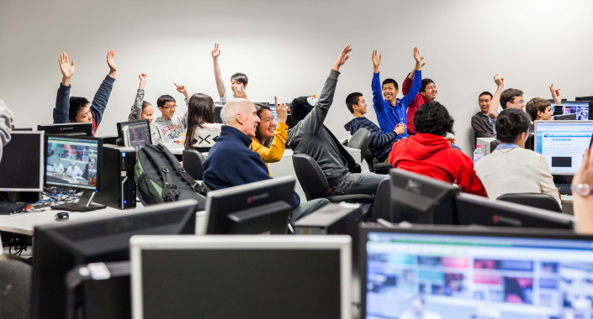

[**www.physicsmasterclasses.org**](http://www.physicsmasterclasses.org)

**talk with your physics teacher**

