Bubble Chamber Detectives
Introduction
Bubble chamber photographs were used to make many important discoveries and measurements in particle physics. They also provided a unique window on the properties of elementary particles recorded in great detail, the trajectories of charged particles, and their decays and interactions. In this assignment, a small number of photographs taken at the 2 meter bubble chamber at CERN near Geneva will be analyzed.
All the pictures were recorded in a bubble chamber filled with liquid hydrogen exposed to a "beam" of negative kaon particles (K⁻) each with the same momentum. The paths of all moving charged particles in the chamber are recorded on the photograph as a series of small dots (bubbles). The only target particles are the proton and electron of the hydrogen atom and we expect that most beam particles will pass through the mainly empty spaces of each atom without deviation. The beam kaons are always traveling from the bottom of the image up to the top. As they all have the same direction and momentum and are traveling in a uniform magnetic field, the curvature and direction of each beam particle should be the same. The beam particles are negatively charged and if you look along the track you will see that these curve to the right. The magnetic field is directed into the page. In most photographs you will also see a few particles at a different angle to the majority of the beam particles; these are due to cosmic rays or particles produced in interactions outside the bubble chamber.
In order to help you identify the particle interactions and decays on the enclosed photographs look at the following picture and the event descriptions below.

Identifying Particle Events in Bubble Chamber Pictures
Your first task when looking at the bubble chamber pictures is to identify the interesting events. To help you find those events some of them have been labeled with a letter. In this first picture, each interesting event is labeled with a letter a through g. Take a moment and find all seven events and attempt to determine what they are labeling.

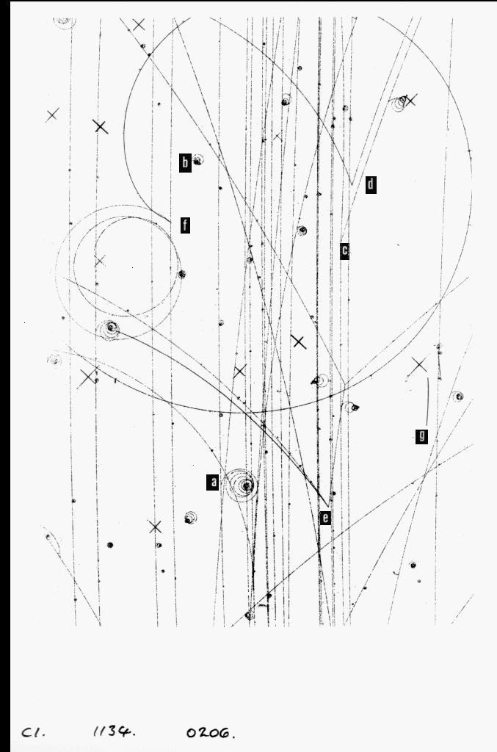

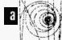
Event a identifies a collision of a beam particle with an electron. Notice the nearly straight vertical path of the beam particle and spiraling off to the right is another path. The spiral path is an electron. When electrons (or, positrons) experience an electromagnetic force they are accelerated more than other particles and this leads to a loss in their energy because they radiate energy as photons. This loss of energy results is the characteristic spiral nature of an electron (or positron) track where the radius of the track gradually decreases. We know this is an electron because it curves to the right due to the magnetic field and its negative charge.
Event b identifies a Compton electron. A photon that knocks an electron out of an atom creates a single track that bends to the right and spirals inward. Notice there is no path leading into the electron spiral, this is indicates that a neutral particle is involved.
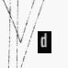
Event c identifies a collision between the negatively charged kaon beam particle and a proton. Following the two particle paths after the collision shows that they curve in opposite directions, this is important to show charge conservation. Also, when you look at the path before the collision you can see the near straight path of a beam particle, but the path then curves farther up the picture, representing a lower energy positive particle.
Event d identifies the decay of a neutral particle into two oppositely charged pions. Note before the event there is evidence of a particle path. Only electrically charged particles can leave a trail in the bubble chamber. Again, it is also important to note the oppositely directed curvature of the two pions that are created by the decayed neutral particle.
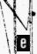
Event e identifies the collision of a neutral particle with a proton producing two positive particles and a negative particle. Charge conservation is useful here again to help identify what particles are involved in the interaction. One might conclude that this event might be the decay of a neutral particle (since there is no path leading into the interaction), but it would then be impossible for charge to be conserved since there are three particles coming from the interaction point (two positively charged and one negatively charged particle).
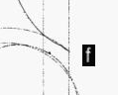
Event f identifies the decay of a positively charged pion into a positively charged muon and eventual decay into a positron. In this picture the actual source of the pion is outside top of picture so one can’t identify where the pion comes from. The positive pion clearly ends up as the spiralling positron but the problem is that there is an intermediate track (muon) which is hard to see on this view because it overlaps with the pion by going back in the opposite direction for a short distance. Positive pions slow down and when they decay at rest the resulting two body decay to muon and neutrino always gives a muon of a characteristic energy and this has a range of around 1 cm in the chamber. So, it is not a very good example of pi mu electron decay because it is so hard to identify!
Event g identifies the interaction of a neutral particle (neutron) with a proton. The recoiling proton leaves the dark track (notice the curvature of the path). The large mass of the proton means that it can sometimes be clearly identified by the density of bubbles (or darkness) of the track. The lack of any other tracks means that there was a neutral particle involved in the event. This event is similar to the event that produces a Compton electron; a neutral particle knocking out a bubble chamber particle. In this case, it is a very slow moving proton that eventually comes to rest.

Practice Bubble Chamber Picture
Find the locations marked h, i, and j in the above bubble chamber photo. Determine what particle event is occurring at that specific location and then label the following descriptions with the appropriate letter.

Collision of beam particle with an electron. _____
Collision of beam particle with a proton. _____
Decay of a neutral particle. _____

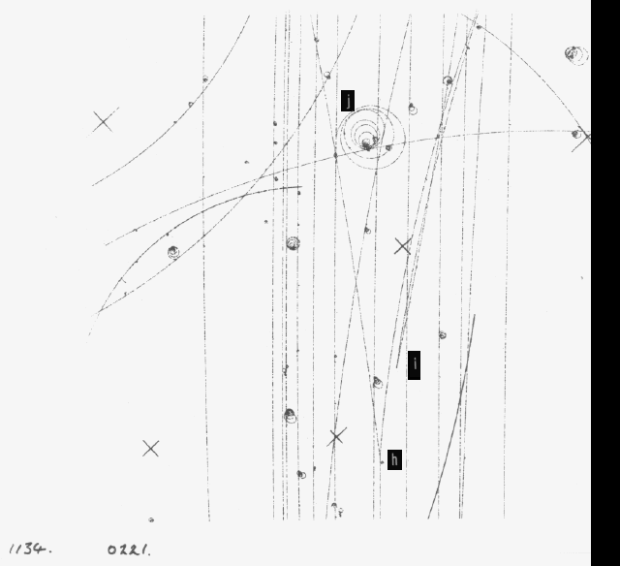

The correct answers are j, h, i. The descriptions for each event are given below.
- Interactions of a beam (K⁻) with a proton producing two oppositely charged particles.
- Decay of a neutral particle (Kº) into two oppositely charged pions (π ⁺ and π ⁻).
- Electron recoiling from collision with a beam particle.
Now, it is your turn!
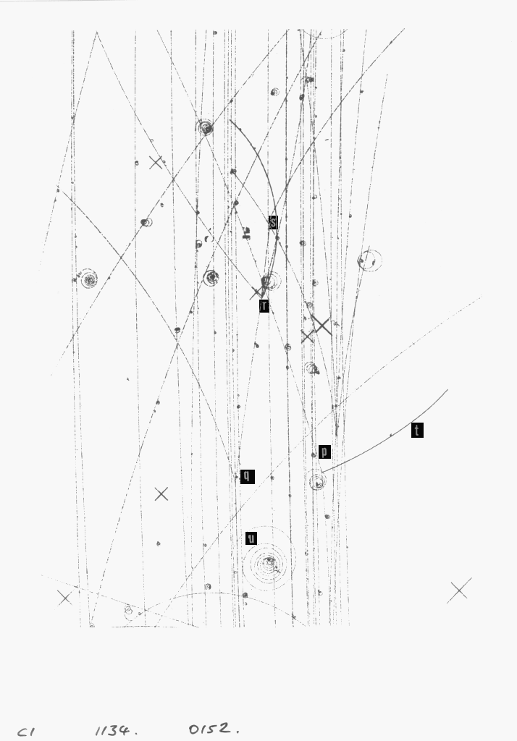

I. Find the locations marked p, q, r, s, t, and u in the above bubble chamber photo. Determine what particle event is occurring at that specific location.

1. Collision of beam particle with a proton. _____
2. A proton track. _____
3. Collision of a positive (non beam) particle with a proton. _____
4. Collision of negative (non beam) particle with a proton. _____
5. Decay of a negative particle. _____
6. Describe what occurred at the event for the letter that you did not use.
________________________________________________________________________________________________________________________________________________
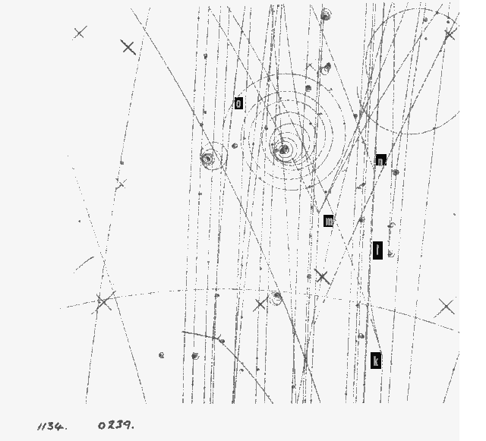
II. Find the locations marked k, l, m, n, and o in the above bubble chamber photo.

7. Collision of beam particle with a proton producing two positive and two negative particles. _____
8. Decay of a neutral particle. _____
9. Collision of a beam particle with an electron. _____
10. Collision of a beam particle with a proton producing two oppositely charged particles. _____
11. Describe what occurred at the event for the letter that you did not use.
________________________________________________________________________________________________________________________________________________
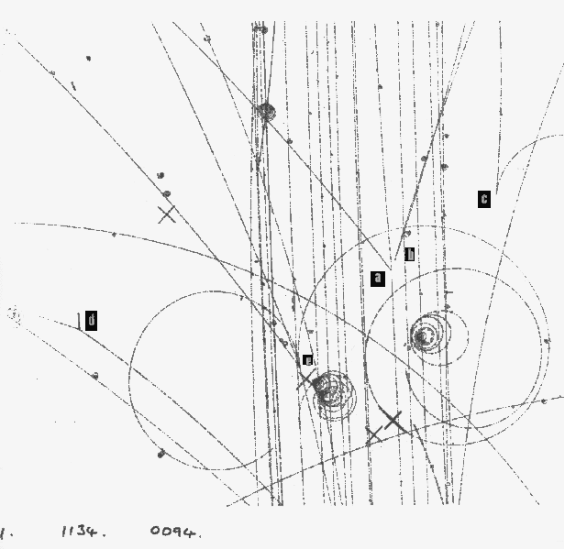
III. Find the locations marked a, b, c, d, and e in the above bubble chamber photo.
12. Photon conversion into an electron-positron pair. _____
13. Collision of a beam particle with a proton producing one positive and one negative particle. ______
14. Decay of a neutral particle. _____ 15. Interaction of a positive particle(non beam) and a proton producing three positive particles and one negative particle. _____
16. Describe what occurred at the event for the letter that you did not use.
________________________________________________________________________________________________________________________________________________
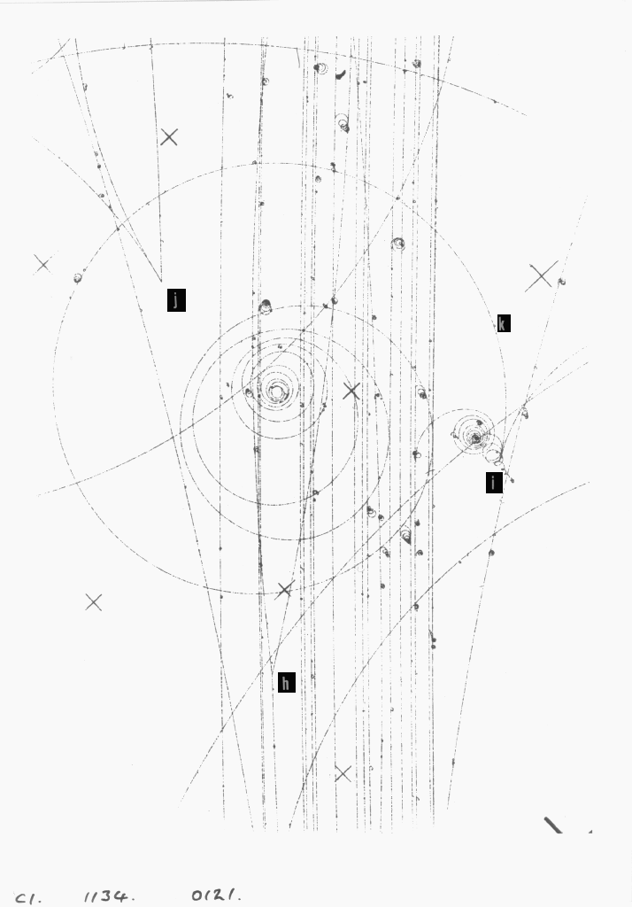
IV. Find the locations marked h, i, j, and k in the above bubble chamber photo.
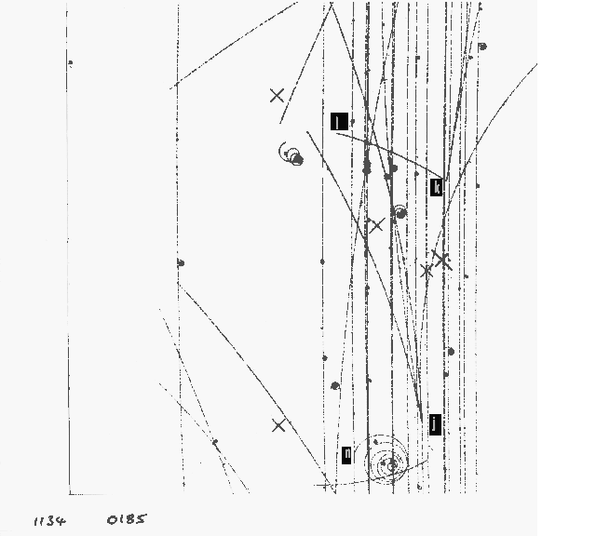
17. A positron track. _____
18. Collision of a neutron with a proton. _____
19. Collision of a beam particle with a proton. _____
20. Describe what occurred at the event for the letter that you did not use.
________________________________________________________________________________________________________________________________________________V. Find the locations marked j, k, l, and n in the above bubble chamber photo.
21. Collision of neutron and a proton. _____
22. Collision of a beam particle with an electron. _____
23. Collision of a beam particle with a proton. _____
24. Describe what occurred at the event for the letter that you did not use.
________________________________________________________________________________________________________________________________________________
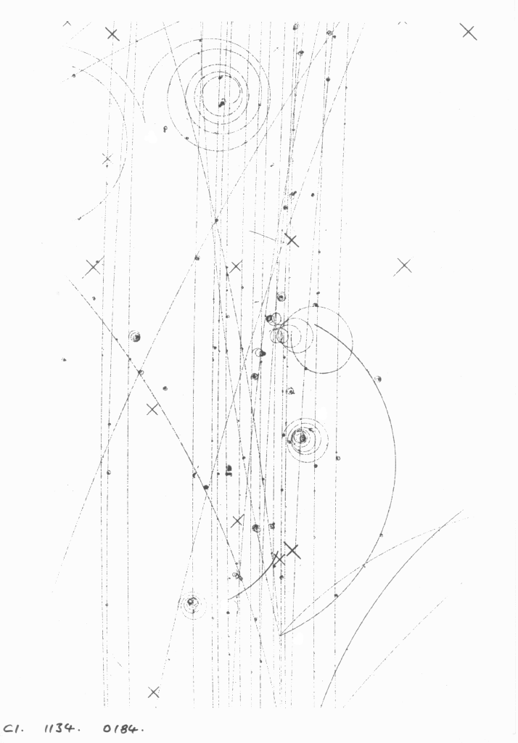
VI. Now, here you have a blank bubble chamber picture. Try to identify, at least, four interesting events in this picture. Label the picture with letters and place your own descriptions for the events below the picture. Make sure to turn in your group’s answers in to your teacher.

