CMS Data Express
You are on shift to analyze actual events from the CMS detector
in the Large Hadron Collider at CERN.

Welcome to your CMS student operations shift. Today you are on the Data Quality Management (DQM) team. You will receive a sample of actual CMS events with two possible assignments:
- Determine which events are from the decays of Z particles and use these to construct the mass of the Z.
- Determine which events are from the decays of W+ or W- particles and use these to find a meaningful ratio of W+ to W- events.

What do we know?
- The events come from the collisions of protons. Pieces of those protons (quarks or gluons) come together to make Z and W particles.
- Z particles are neutral. W particles are singly charged: either W+ or W-.
- All of the decays in our data are into negatively-charged muons, positively-charged antimuons, or neutrinos, which have no charge and are virtually undetectable. Muons and antimuons generally show up in our event display as long red tracks. Other collision by-products (background) also show up in our displays.
- Momentum, energy, and charge are conserved in decays.
- The paths of charged particles are bent in a magnetic field: in our events, the paths bend clockwise if the particle is positively charged and anti-clockwise if the particle is negatively charged.
- The energy of parts of the proton colliding can be converted to a Z or W particle. The mass and the momentum of that particle become the energies and momenta of its daughter particles when it decays. Physicists use these to calculate the mass in GeV of the presumed parent particle in each event, shown at the upper-right of the display.

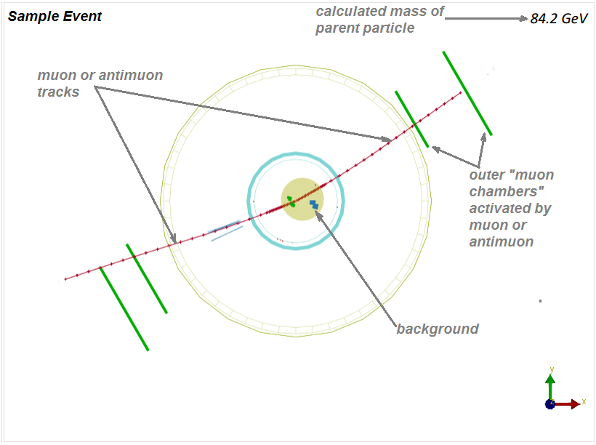
This Sample Event shows the main features of the events you will see. The details of each event will vary, of course.

The CMS detector is roughly cylindrical. This event display shows a cutaway view of the middle of the detector. The proton-proton beam and the collision point are at the center of the two circles.
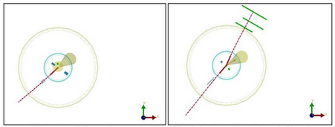
Which of these events is a Z candidate? Which is a W candidate? Can you tell the charge of the
W candidate?

Learn about the Large Hadron Collider and CMS from the two topmost videos at:
http://leptoquark.hep.nd.edu/~kcecire/mc/cms.html.

View the screencast:
http://leptoquark.hep.nd.edu/~kcecire/drupal_lib/video2014/2014-08-19_1456.swf.

What tools do we need for our analysis?
We need a straight-edge to determine particle curvature (clockwise or anti-clockwise), pencil and paper for notes and figuring, and some materials on hand to make a histogram. We need our data file.

What will we do?
We will work in teams of two. The shift manager will determine which events to examine, which analyses to do, and how to incorporate our results into overall results for the DQM team.

What are our claims? What is our evidence?
We claim that we can make one or both of these:
- A readable mass plot with a clear peak, which reveals the mass of the Z particle.
- A count of W+ and W- particles that enables us to find the ratio between them.
Once you have assembled your evidence and analyzed it, you can refine these claims and make them more specific. It is very important that we do this analysis as a blind study. We must not aim at a known value but rather construct the value from our data and our analysis. We will hand these DQM results over to the shift manager who can use them in the calibration of the detector or adjustment of analysis software.

After your class has discussed results, you may make your CMS Student Operations Shift Report.

