**CMS DATA EXPRESS**

**YOU ARE *ON SHIFT* TO ANALYZE ACTUAL EVENTS FROM THE CMS DETECTOR IN THE LARGE HADRON COLLIDER AT CERN.**

Welcome to your CMS student operations shift. Today you are on the Data Quality Management (DQM) team. You will receive a sample of actual CMS events with two possible assignments:

* Determine which events are from the decays of Z particles and use these to reconstruct the mass of the Z.
* Determine which events are from the decays of W+ or W- particles and use these to find a meaningful ratio of W+ to W- events.

DQM is vital to help us understand if the CMS muon system is calibrated and performing to specifications. Do we read the momenta of muons correctly? If so, creation of a mass plot of the Z boson—a well-understood particle—should give us something very close to the published value. Can we consistently distinguish between positively charged antimuons and negatively charged muons? One way to tell is from our ratio of W+ to W- decays.

# What do we know?

1. The events come from the collisions of protons. Pieces of those protons (quarks or gluons) come together to make Z and W particles.
2. Z particles are neutral. W particles are singly charged: either W+ or W-.
3. The data here are very “filtered.” They represent decays into negatively charged muons, positively charged antimuons, or both. It’s also possible that the decay produced neutrinos; however, these have no charge and CMS cannot detect them. Muons and antimuons generally show up in our event display as long red tracks. Other collision (or decay) by-products (background) also show up in our displays.
4. Charge is conserved in decays; the paths of charged particles are bent in a magnetic field. In our events, the paths bend clockwise if the particle is positively charged and anti- clockwise if the particle is negatively charged.
5. The energy of the collision can be converted to a Z or W particle. When the new particle decays, its mass and momentum are both conserved. These become mass and momentum of the newly created particles.
6. Each event has a number in the upper right-hand corner. This is a calculation of the mass of the particle that would have decayed into the particles measured in the detector. Physicists determine this by measuring the energy and momentum of the decay products. In your data, these decay products are all muons.

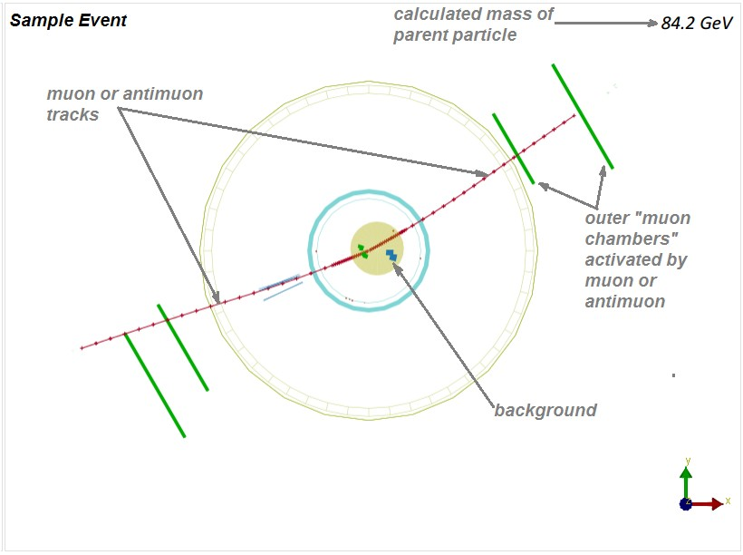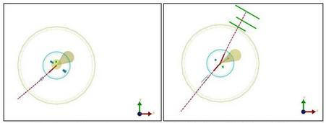

*This sample event shows the main features of the events you will see. The details of each event will vary, of course.*

*The CMS detector is roughly cylindrical. This event display shows a cutaway view of the middle of the detector.*

*The proton-proton beam and the collision point are at the center of the two circles.*

*Which of these events is a Z candidate? Which is a W candidate? Can you tell the charge of the*

*W candidate?*

Learn about the Large Hadron Collider and CMS from the two topmost videos at <http://cms.physicsmasterclasses.org/cms.html>.

View the screencast: https://www.screencast.com/t/Rah5UUlH

# What tools do we need for our analysis?

We need a straightedge to determine particle curvature (clockwise or anticlockwise), pencil and paper for notes and figuring. We also need our [data file.](https://quarknet.org/sites/default/files/cms_deevents_mass_0.pdf)

# What do we do?

We work in teams of two. The shift manager determines which events to examine, which analyses to do, and how to incorporate our results into overall results for the DQM team.

# What are our claims? What is our evidence?

Your results may include:

* A readable mass plot of the events that appear to contain Z bosons.
* A count of W+ and W- particles.

These results can allow you to make a claim that answers these questions:

* What is the most likely mass of the Z boson?
* What is the range of Z boson masses sampled in your data?
* What is the ratio of the W+ events to the W- events?
* What evidence do you have for these values?

These questions may help you provide *reasoning* for your claim as to the extent to which the detector is operating as expected.

Discuss results with your peers and with the shift manager.

Hand your claims, the evidence for these claims, and the reasoning behind them over to the shift manager in your “Shift Report.” The shift manager will use them in the calibration of the detector or adjustment of analysis software.