CMS Data Express
Teacher (Shift Manager) Notes

Description
CMS Data Express is a short particle physics investigation using CMS dimuon and single-muon events. The main goals are:
- To separate Z candidate events from other events by visual inspection and create a mass plot for the Z boson.
- To separate W candidate events from other events by visual inspection and make a determination of the ratio of W+ to W- candidates.
While this activity is richest when pursuing both goals, each can stand on its own.

The Z boson is important in LHC discovery science and as a marker for calibration of LHC detectors: it is a well-known particle, so the location and width of the mass plot give physicists a good idea of how the detector is performing. The Z candidate events are the “dimuon" events; the Z can decay into a muon-antimuon pair. Z candidates are identified by 2 long muon-type tracks. Participants will search for Z candidates in the data.

The W candidate events consist of decays into single muons and neutrinos. However, the neutrinos do not interact with the detector and hence leave no tracks or energy deposits; their momenta are estimated by a process of summing all the momenta in the event to determine what is "missing.” Thus a W candidate appears as a single long muon-type track in the detector.

This activity helps prepare students for a masterclass or gives students a short masterclass-like experience (1-2 class periods).

Standards Addressed
Next Generation Science Standards
Science and Engineering Practices

4. Analyzing and interpreting data
5. Using mathematics and analytical thinking
8. Obtaining, evaluating and communicating information
Crosscutting Concepts
Common Core Literacy Standards
Reading
9-12.4 Determine the meaning of symbols, key terms . . .
9-12.7 Translate quantitative or technical information . . .
Common Core Mathematics Standards
MP1. Make sense of problems and persevere in solving them.
MP2. Reason abstractly and quantitatively.
MP4. Model with mathematics.

Enduring Understanding
Particle physics research uses indirect evidence to support claims.

Learning Objectives
Students know and are able to:
- Determine the identities of force carrier particles by their decays into leptons.
- Identify the electric charge of a particle from its motion in a magnetic field.
- Give examples of conservation of charge in particle decays.

Prior Knowledge
Little is needed. It is helpful if students are familiar with conservation of momentum, energy, and charge.

Background Material
The images the students analyze are actual events from the Compact Muon Solenoid (CMS) detector in the Large Hadron Collider (LHC) at CERN. There are a variety of resources on CMS and LHC at http://cms.cern.ch. Other resources are available from the web page (see below).

Resources
Web page: https://quarknet.i2u2.org/document/cms-data-express
Data file: http://leptoquark.hep.nd.edu/~kcecire/drupal_lib/files2013/CMS_DEevents_mass.pdf
Screencast: http://leptoquark.hep.nd.edu/~kcecire/drupal_lib/video2014/2014-08-19_1456.swf
CMS masterclass: http://leptoquark.hep.nd.edu/~kcecire/mc/cms.html

Implementation
Students should start with background from the two topmost videos at http://leptoquark.hep.nd.edu/~kcecire/mc/cms.html.

There are 80 events in the PDF data file, one per page. Students should work in pairs on a reasonable number of events for the time available and how much analysis they are asked to do. Roughly, two students working together on one analysis (Z or W) should be able to do about 40 events in less than one class period; working on both, 20 events is a more reasonable number. Even as you break the data up, there will be oversampling of the 80 events. Since different students have different interpretations, this will likely give you fairly good results.

For Z analysis, students should identify Z candidate events as those with two red tracks indicating a muon-antimuon pair. They can check if these are “good” Z candidates by looking at the curvature of the tracks: the two tracks should have opposite curvature indicating opposite electrical charge. The Z boson being neutral, it must decay into both a negative muon and a positive antimuon for charge conservation. Each event has a mass printed at the upper right. Students should round these to the nearest odd number and record them for Z candidates only. At the end, all pairs of students should count the number of events that have at each odd-rounded mass and contribute these to a class mass plot. The mass plot can be made in various ways: one of the most successful has been construct it out of sticky notes.
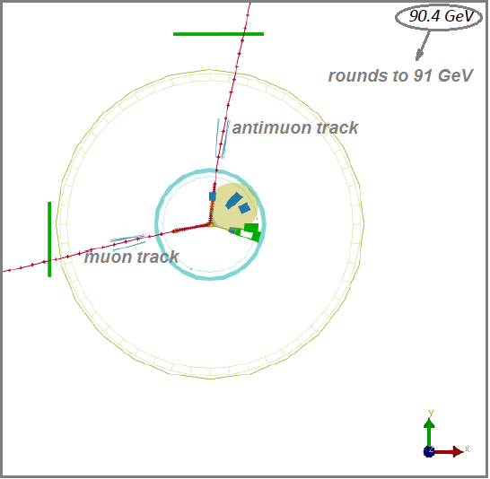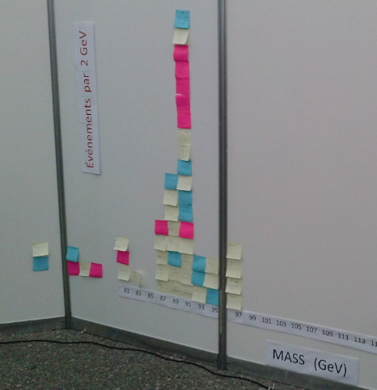
Typical Z candidate event. Mass plot of Z candidates.

For W analysis, students should identify W candidates as those with only one muon or antimuon track. There is an unseen partner: a neutrino, which is not directly detected. To find if the possible W particle is a W+ or a W-, students should use the curvature of the red track: a clockwise (anti-clockwise) curvature indicates positive (negative) charge and thus an antimuon (a muon) which came from the decay of a W+ (W-). Students should count the number of W+ and W- candidates and report these. The total number of W+ candidates divided by the total number of W- candidates in the class yields to W+ to W- ratio. In the case of W candidates, students should ignore the mass as it is not useful here.
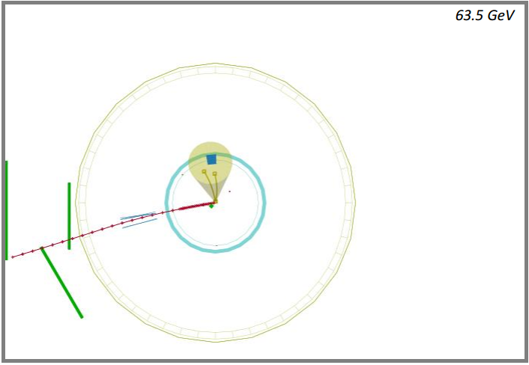
Typical W- candidate event.

Discussion at the end is very important to understand the significance of the results. The initial claims of the investigation are:
- A readable mass plot with a clear peak, which reveals the mass of the Z particle.
- A count of W+ and W- particles that enables us to find the ratio between them.
Students should use the evidence from their analysis to determine if these claims are accurate. They should then dig deeper into the evidence to discuss questions like:
- How sure are we of the results we have?
- What affects the accuracy of our results?
- Are these results reasonable based on what we know.
The teacher may or may not decide to introduce the expected values: approximately 91 GeV for the mass of the Z and approximately 1.4 for W+/W-. The directions to students indicate that they are to analyze data blind to any expected results.

Assessment
Assessment is based on claims, evidence, and reasoning. Students complete a “Shift Report” in which they assess based on evidence and reasoning the accuracy of the claims and how useful the results are.

