CMS Data Express
Teacher Notes

Description
CMS Data Express is a short investigation using events from the Compact Muon Solenoid (CMS) at the Large hadron Collider (LHC). Students are put assigned “on-shift” to CMS Data Quality Management (DQM). They check the data quality to see that CMS is performing to specification by giving a good fit for the Z mass and/or the W+W- ratio. They:
- Separate Z candidate events from other events by visual inspection and create a mass plot for the Z boson.
- Separate W candidate events from other events by visual inspection and determine the ratio of W+ to W- candidates.
While this activity is richest pursuing both goals, each can stand on its own as a separate activity. This activity helps prepare students for a masterclass or to give students a masterclass-like experience in a short time (1-2 class periods.)

The Z boson is important in LHC discovery science. It is a well-known particle, so the location and width of the mass plot give physicists a good idea of how the detector is performing. Z candidate events are “dimuon” events; the Z can decay into a muon-antimuon pair. Z candidates are identified by 2 long muon-type tracks.

W candidate events consist of decays into single muons and neutrinos. However, the neutrinos do not interact with the detector and hence leave no tracks or energy deposits. Their momenta are estimated by summing all the momenta in the event to determine what is “missing.” Thus, a W candidate appears as a single long muon–type track.

Standards Addressed
Next Generation Science Standards
Science and Engineering Practices
4. Analyzing and interpreting data
5. Using mathematics and analytical thinking
8. Obtaining, evaluating and communicating information
Crosscutting Concepts
Common Core Literacy Standards
Reading
9-12.4 Determine the meaning of symbols, key terms . . .
9-12.7 Translate quantitative or technical information . . .
Common Core Mathematics Standards
MP1. Make sense of problems and persevere in solving them.
MP2. Reason abstractly and quantitatively.
MP4. Model with mathematics.

Enduring Understandings
- Particle physics research uses indirect evidence to support claims.
- Scientists continuously check the performance of their instruments.

Learning Objectives
Students will know and be able to:
- Determine the identities of force carrier particles by their decays into leptons.
- Identify the electric charge of a particle from its motion in a magnetic field.
- Give examples of charge conservation in particle decays.
- Develop pattern recognition skills for identifying data that fit a well-known system.

Prior Knowledge
Students should be aware of the Lorentz Force on charged particles moving through a magnetic field and how to use the right hand rule to determine the (positive or negative) charge of the particle.

Background Material
The images the students analyze are CMS events. There are a variety of resources on CMS and the LHC at http://cms.cern.ch. Other resources are available from the web page (see below).

Resources
Data file: https://quarknet.i2u2.org/sites/default/files/cms_deevents_mass.pdf
Screencast: http://leptoquark.hep.nd.edu/~kcecire/drupal_lib/video2014/2014-08-19_1456.swf

Implementation
Students start with background from the two topmost videos at http://cms.physicsmasterclass.org/cms.html
.

There are 80 events in the PDF data file (linked above in Resources), one per page. Students work in pairs. Two students working together on one analysis (Z or W) should be able to do about 40 events in perhaps 10-15 minutes; working on both, 20 events is a more reasonable number. Since different students have different interpretations, this will likely give fairly good results.

For Z analysis, students identify Z candidate events as those with two red tracks indicating a muon-antimuon pair. They can check if these are “good” Z candidates by looking at the curvature of the tracks: the two tracks should have opposite curvature indicating opposite electrical charge. The Z boson being neutral, it must decay into both a negative muon and a positive antimuon to conserve charge. Each event has a mass printed at the upper right. Students should round these to the nearest odd number and record the mass for the events that they determine are Z candidates. Students should count the number of events they have at “mass bin” (e.g., 2, at 83 GeV, 7 at 89 GeV, 12 at 91 GeV. . . ) and contribute these to a class data table. The class creates a mass plot by summing up the events in each mass bin and creating a histogram. One of the most successful ways to construct the histogram is with sticky notes.

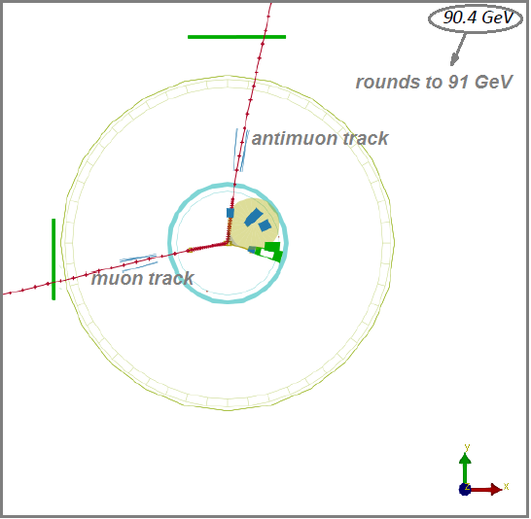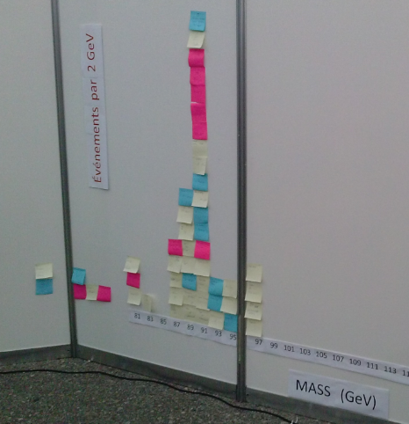
Typical Z candidate event. Mass plot of Z candidates.

Since the W is charged, it can only create one charged decay product; this conserves charge. Students identify W candidates as those with only one muon or antimuon track. The decay also creates a neutrino; this conserves momentum. The neutrino is not directly detected. To find if the possible W particle is a W+ or a W-, students use the curvature of the muon (or antimuon) track. A track with clockwise curvature indicates the positive charge carried by the antimuon after its decay from the W+. An anti-clockwise cuvature indicates the presence of a muon decaying from the W-. Students count and report the number of W+ and W- candidates. The total number of W+ candidates divided by the total number of W- candidates in the class yields a W+ to W- ratio. Students ignore the mass of these events

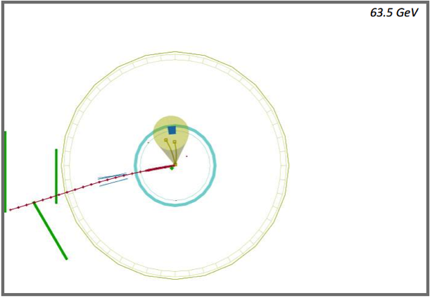
Typical W- candidate event.

Teachers lead a discussion at the end of the activity; it is crucial to understand the significance of the results. The initial results of the investigation are:
- A readable mass plot of the events that appear to contain Z bosons..
- A count of W+ and W- particles..
Students use the evidence from their analysis to make a claim about the mass of the Z boson and the ratio W+ to W-.

Then the discussion digs deeper into the evidence with questions like:
- How sure are we of the results we have?
- What affects the accuracy of our results?
Introduce the expected values: approximately 91 GeV for the mass of the Z and approximately 1.4 for W+/W- . Then ask: Are your results reasonable based on what we know?

Assessment
Assessment is based on claims, evidence, and reasoning. Students complete a “Shift Report” in which they assess based on evidence and reasoning the accuracy of the claims and how useful the results are.

