T Zero (T0) Wire Timing Calibration Instructions

In order to obtain the most accurate results in any type of muon detector experiment, accounting for time delays due to differences in signal cables, connectors, and photomultiplier tubes of the counters is recommended. This tutorial demonstrates how to change the reported (not physical) cable length in uploaded geometry to correct for these time delays.

Stack all of the counters one on top of the other as close as possible (about 0.03 meter separation) while maintaining the counters parallel to the ground. Upload this new geometry (Figure 1). Begin a data run for about 24 hours. Upload the data file. It is not unusual for it to be about 200 - 300 Mbytes. Channel 1 or Channel 4 may be on the top, followed sequentially with the other channels. What is shown here is Channel 4 on top, followed by Channels 3, 2, 1 going down.
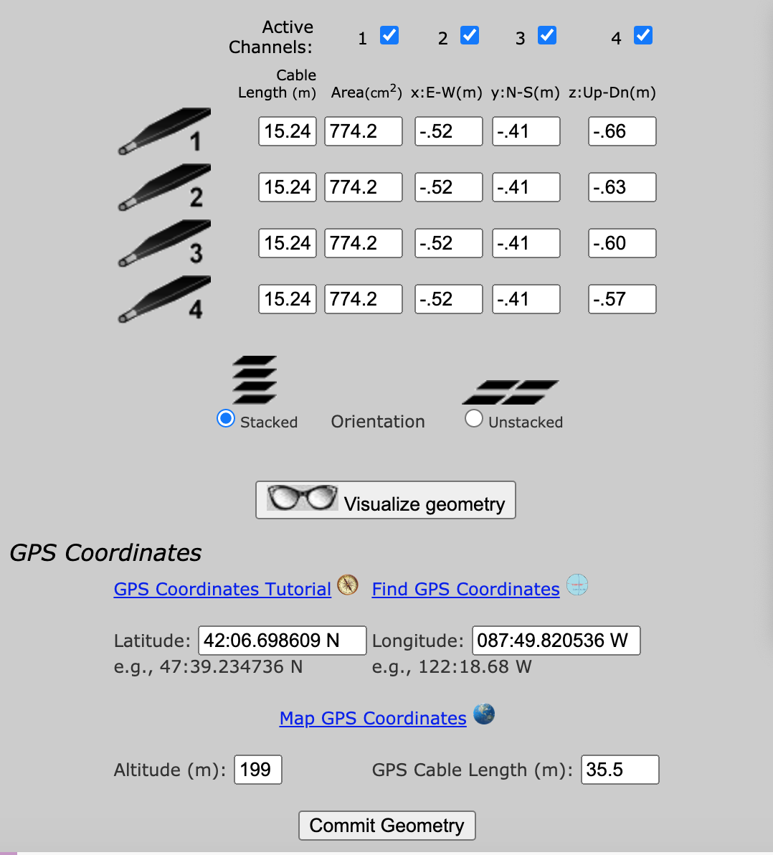

Figure 1. Geometry window.

Conduct a Time of Flight (T of F) study with a 500 ns Event Gate, two Channel Coincidence, and no Required or Veto Channels (Figure 2).
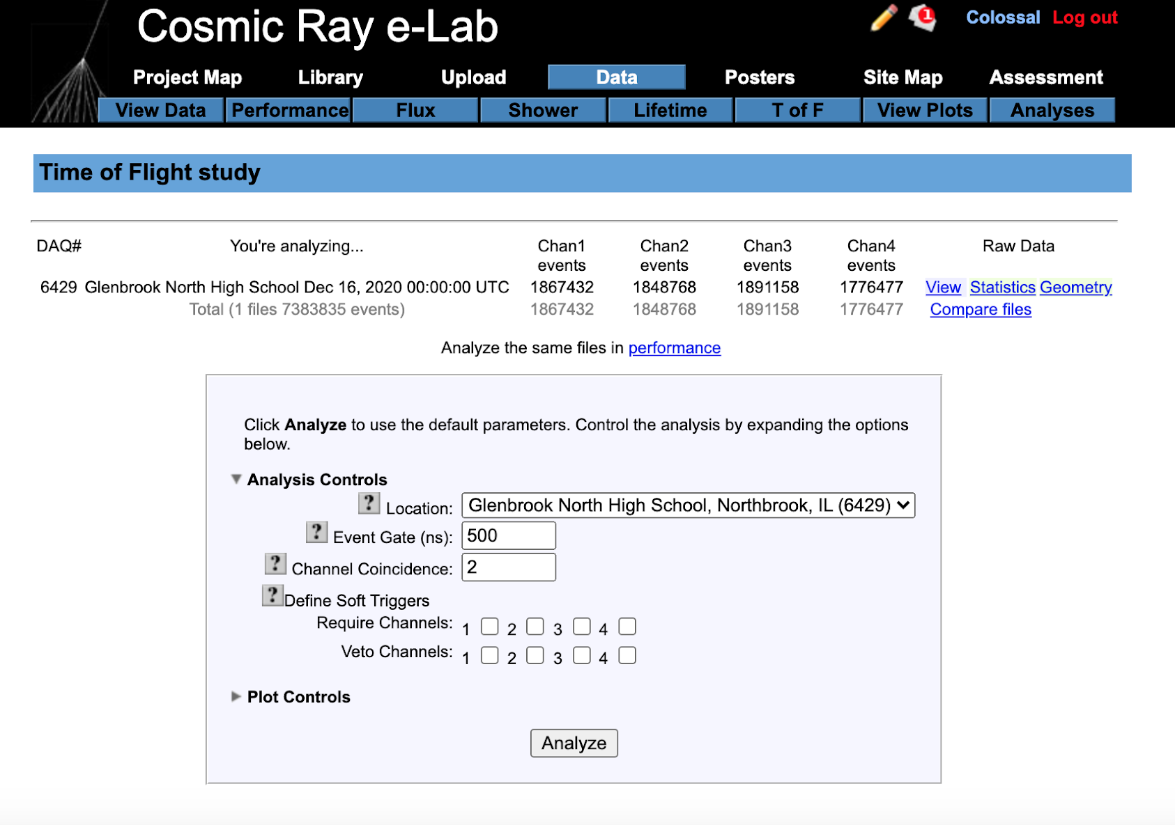

Figure 2. Time of Flight (T of F) Analysis Controls settings

When the study is completed, a series of six graphs are displayed (Figure 3). Hovering the cursor above “Advanced Controls” for the time differences between channel 1 and channels 2, 3, and 4, record the signed (plus or minus) mean time value in nanoseconds. This order will make channel 1 the reference zero value, or the unchanged cable length.
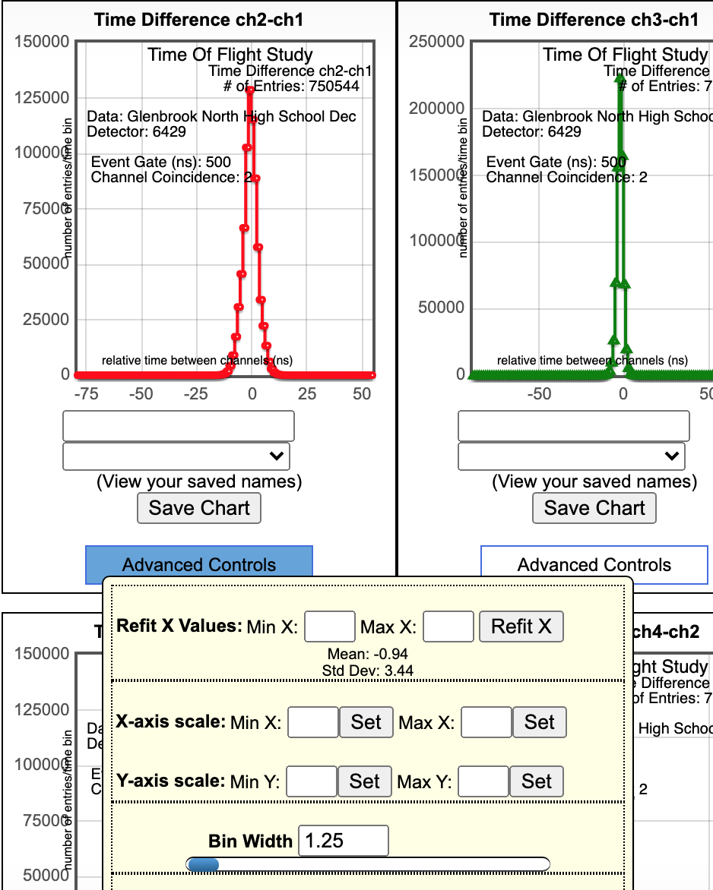

Figure 3. Truncated Time of Flight results for Channel 2 and Channel 1, showing time value when hovering over the Advanced Controls button.

Continue with Channel 3 and Channel 1; Channel 4 and Channel 1.
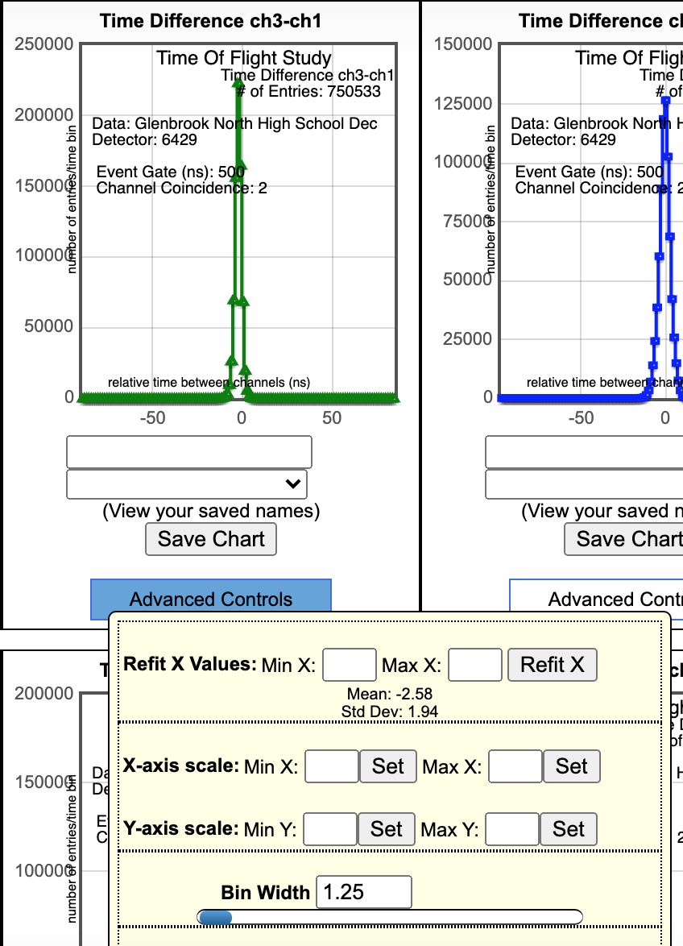
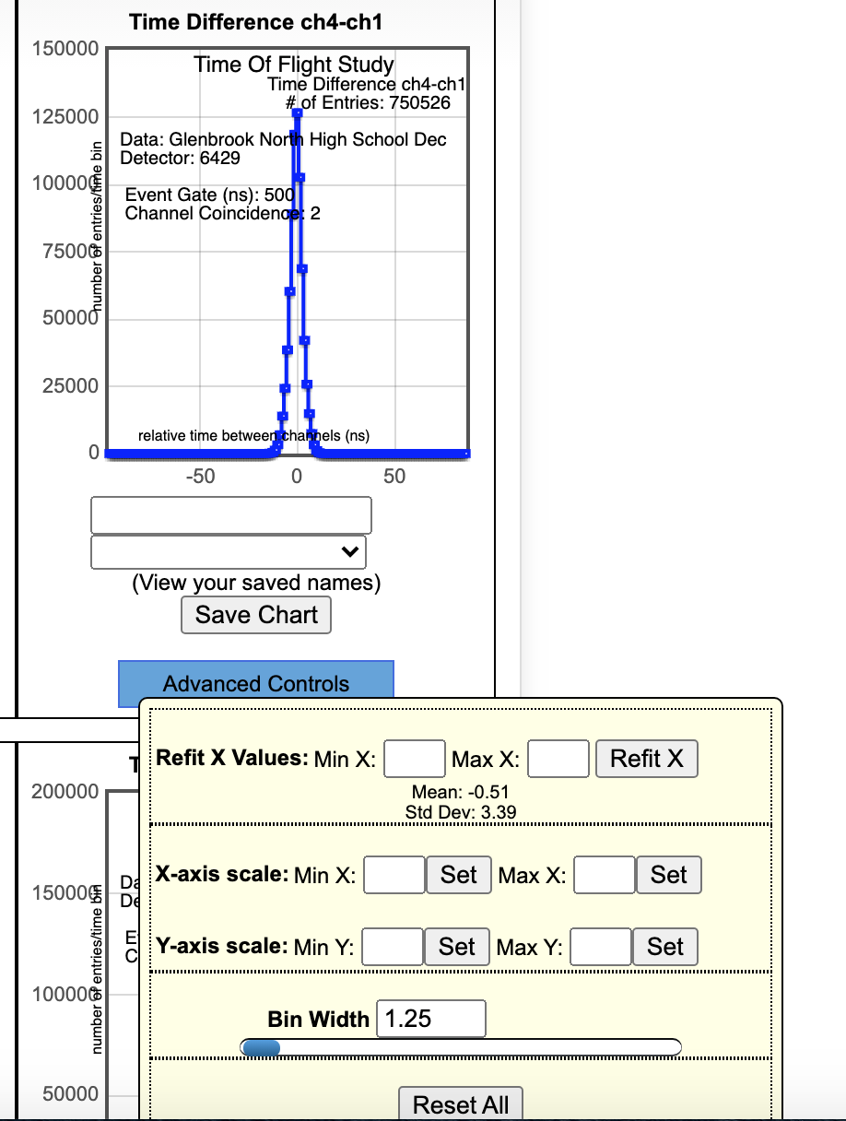

Figure 4. Channel 3 and Channel 1 Figure 5. Channel 4 and Channel 1

Since an electrical signal moves about 0.2 m/ns in a coaxial data cable, to determine the length of cable to add to the geometry to correct for time delays in Channels 2, 3, and 4, use the following formula:

Signed Mean Time x 0.2 + Actual Cable Length = New Cable Length (Eq. 1)

From the Time of Flight analysis shown above:
Channel 2: -0.94 * 0.2 + 15.24 = 15.052
Channel 3: -2.58 * 0.2 + 15.24 = 14.72
Channel 4: -0.51 * 0.2 + 15.24 = 15.13

Using the edit feature (pencil icon) in the Upload - Geometry window, enter the new cable length into your uploaded geometry (Figure 6).
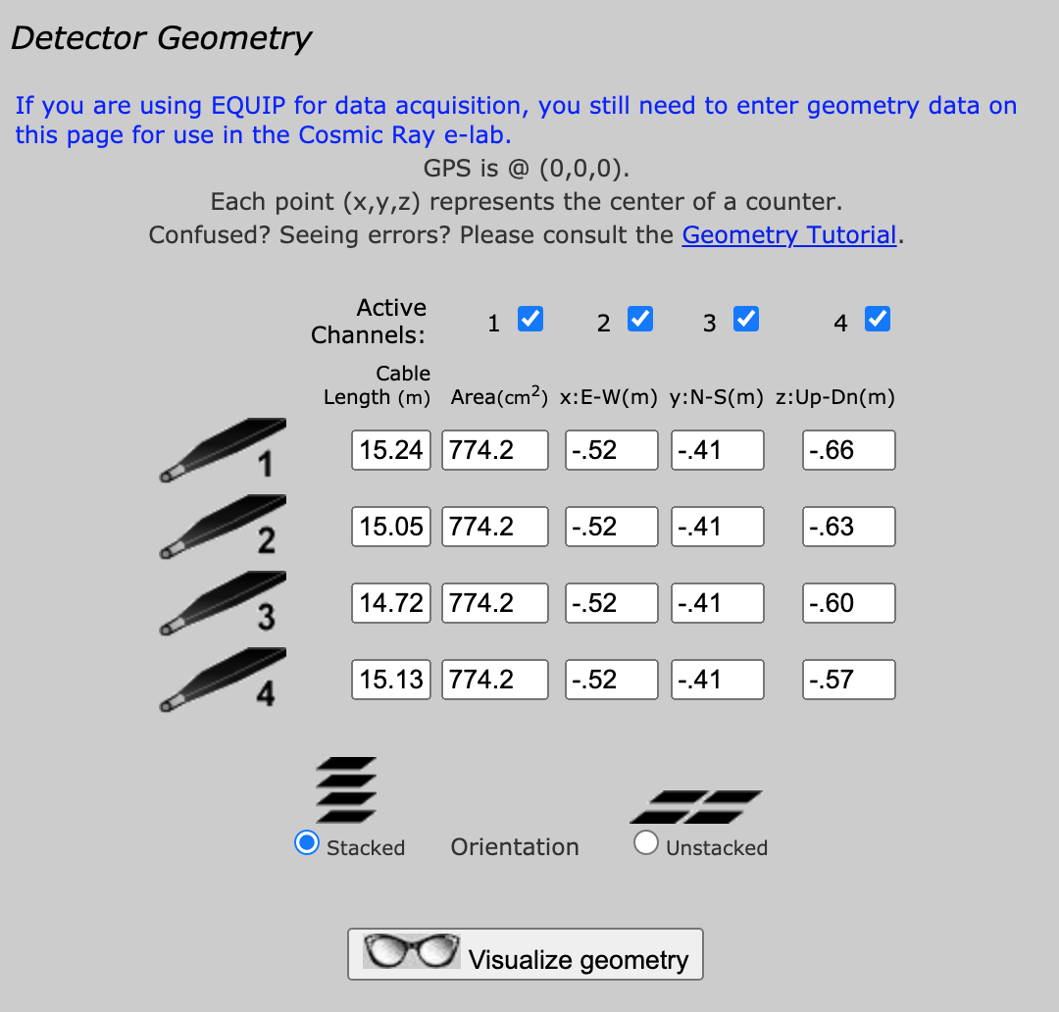

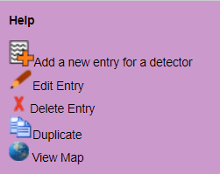

Figure 6. Note the new cable lengths.

To ensure that the time delays have been corrected for properly, run a new Time of Flight analysis on the same data file. All means should now read 0.00, ±0.01 ns. You may need to do further minor adjustments.

Create a new geometry by separating the counters vertically. Complete a new data run. Plot a graph of Counter Separation (vertical) versus Change in Time. The slope of this graph should be close to the speed of light.

11.January.2021

