Muon Lifetime

Go to https://www.i2u2.org/elab/cosmic/home/index.jsp
Username: GoCosmic
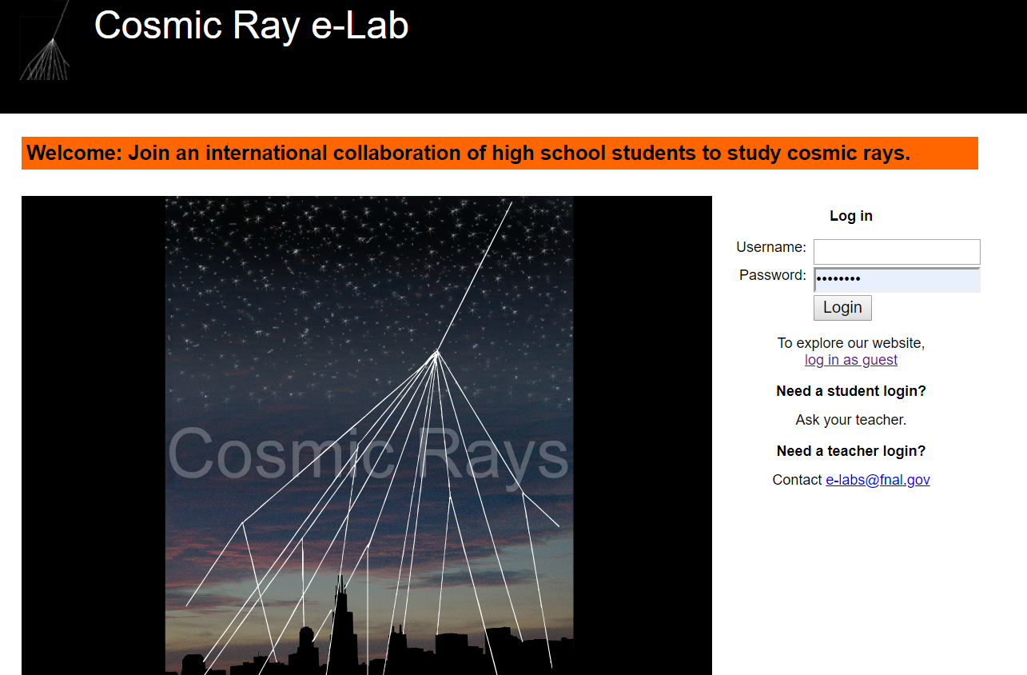

On the landing page, select Data
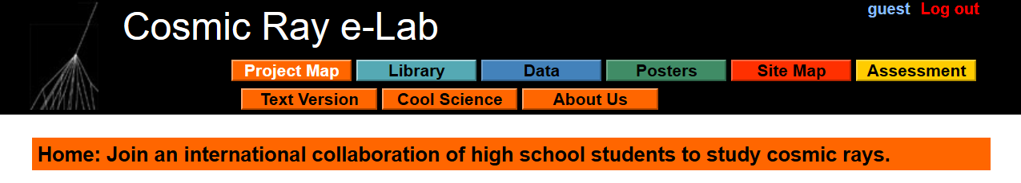

From the Data landing page, select Lifetime
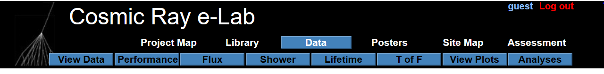

On the Lifetime landing page, you need to make several selections.
- On the first drop-down box, select Detector ID.
- In the middle box, enter 6678.
- Select >Advanced Search and use the Start Date of 08/15/2020
- Press Search Data. 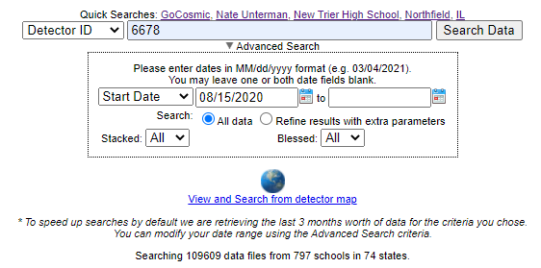

Part of the screen is shown below.
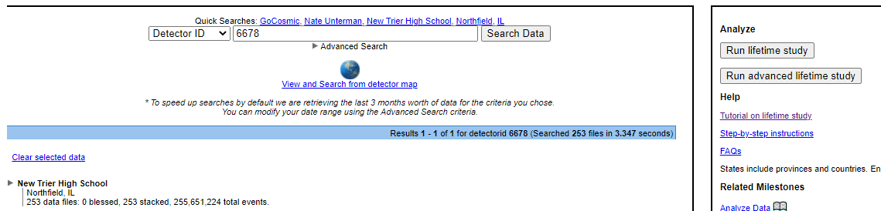

Two important parts: to get to the data, click on the triangle. Please note the Run Lifetime study (and advanced).
It will expand, showing months and year. Click on the triangle to expand January 2021.
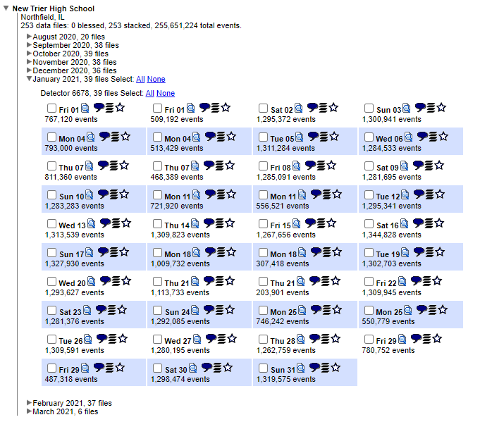
There is much to learn here, but for the purposes of this tutorial, select the rectangle for Tuesday 12.January.2021. There are 1,295,341 events. Then click the Run advanced lifetime study on the right side of the screen as noted above.
This should be the result:
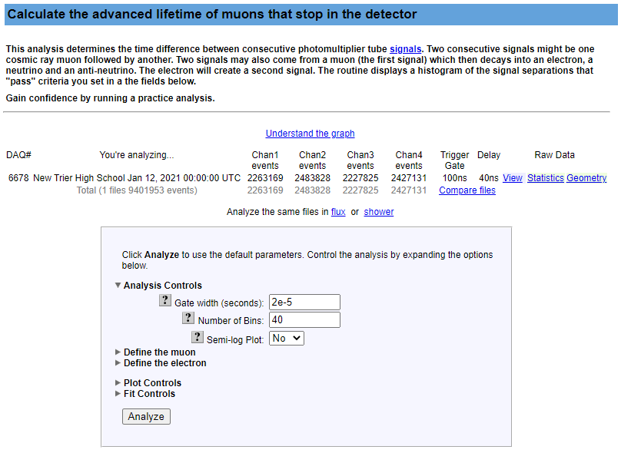
There are many controls her. Under Fit Controls, be sure to change the Fitting Turned On to YES.
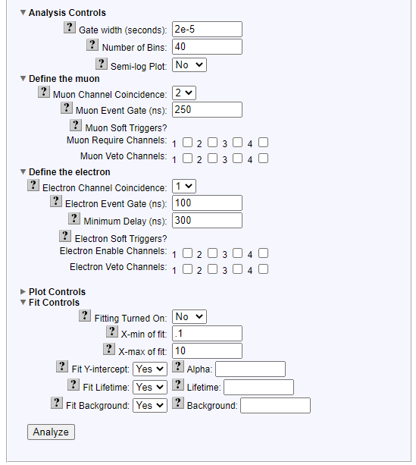

Click on Analyze at the bottom. There are many ways to test and refine your study.

You will get a progress bar. It may take a few minutes, depending on available computer time at Notre Dame University, web traffic, etc. The result is one graph. If the frame come in, but not the graph, try the refresh button on your browser.
The results should look something like this:

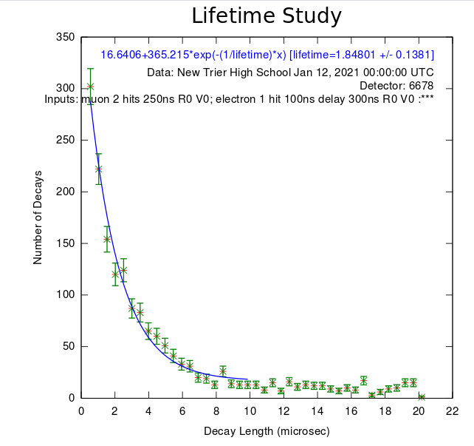

You can ask what happens with a smaller file? What happens if I select 7 consecutive days? There are many other possibilities.

