Safety Placard

Cosmic Ray Detector Room A405

FIRE * * * * POLICE * * * * AMBULANCE
Press 911
NO known hazards
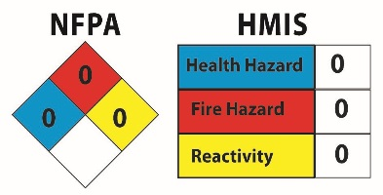
Electricity: 120 v AC to 5 v DC, under 3 amps
No Personal Protection Equipment required.
Responsible Faculty or Staff Persons
Nathan Unterman Early Childhood Activity Room WSC
Home: 773 338-0464
Cell: 773 758-0464
Dan Alkhovsky, Co Director
Walder Science/Teacher programs: 773 649-5355
Date of above information: 9.July.2020

Safety Placard

Cosmic Ray Detector Room A405

FIRE * * * * POLICE * * * * AMBULANCE
Press 911
NO known hazards
Electricity: 120 v AC to 5 v DC, under 3 amps
No Personal Protection Equipment required.
Responsible Faculty or Staff Persons
Nathan Unterman Early Childhood Activity Room WSC
Home: 773 338-0464
Cell: 773 758-0464
Dan Alkhovsky, Co Director
Walder Science/Teacher programs: 773 649-5355
Date of above information: 9.July.2020

