Setting Student Accounts in eLab

Using your Teacher Account Login, you will arrive at the following landing page:
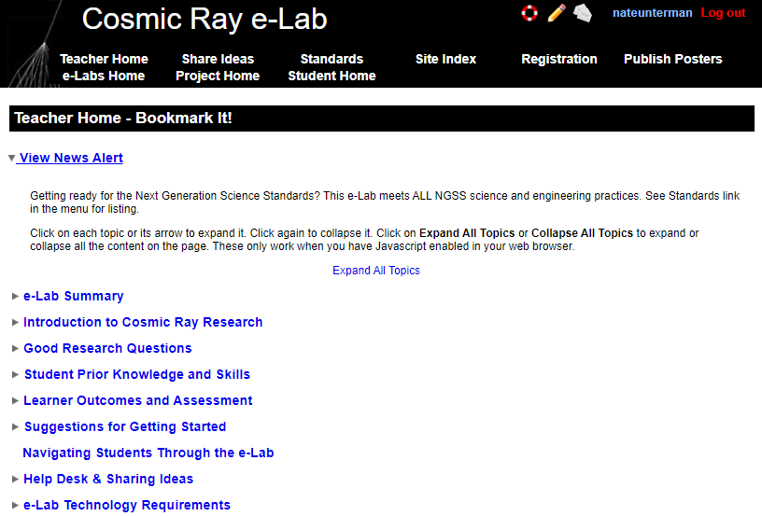

Select Registration from the top menu. Then Register student research groups.
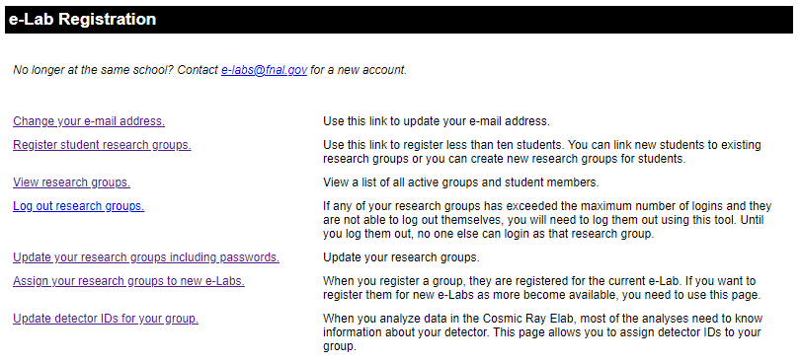

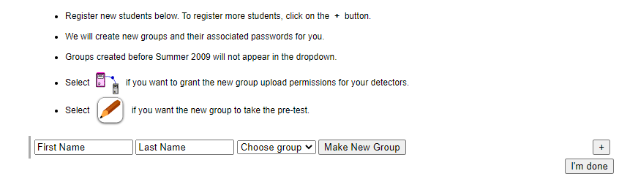
There must be a student name entered. Justin Case, Anna Graham, Gail Force, Ray d’Ation, and the like is what is common used as place holders. You may use real names. Then press Make New Group, followed by Group Name.
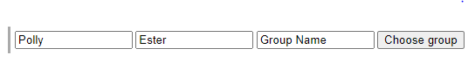

The new group name entered is CosmicCardinals and then select I’m done.
NOTE: If you have different detectors on the same experiment, you may want a common name and DAQ like: GreatExperimentnnnn where nnnn is the DAQ number for each respective detector.
eLab returns the actual Group Name and Password.
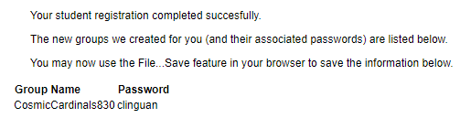

Since most teachers want to assign a Password that can be easily remembered, we will now proceed to Change Password.

Change Password

Select Registration at the top of the page.
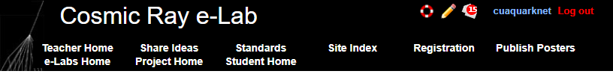

Select Update your research groups including passwords.
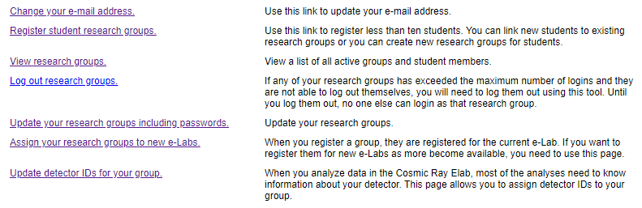

Select Show Group Info.
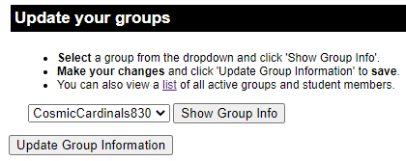

There are several updates to be done here.
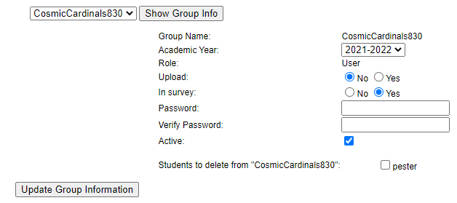
Changing Password to CosmicCardinals830
Upload: Yes In survey: No
Check for correct year.
Update Group Information

Update Detector IDs

Select Registration at the top of the page.

Select Update detector IDs for your group.

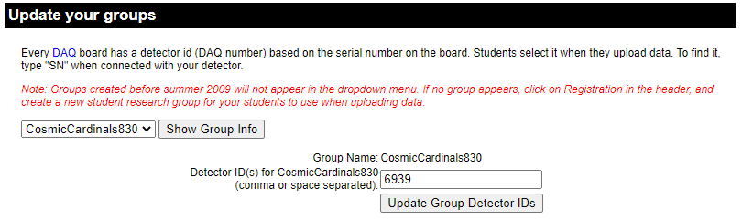
Select your group from the drop down menu. In the Detector IDs, place new DAQ numbers (check old one’s). Update Group Detector IDs.

