Boston QuarkNet Center
2024-2025 Annual Report

Fall Meeting – November 25, 2024.
We had another good turn-out for our fall meeting with participants Dave Kurtz, Mark Brooks Hedstrom, Tim Fitzgibbon, Matt Heising, John Sherry, Mike Wadness, Paul Martenis, George Odell, Mike Hirsh, Ayo Awobode, Jon Kelley, and Rick Dower. After our usual time for snacks and conversation, Rick gave a presentation on the history and math of Fermat’s Least Time Principle. That single principle accounts for straight-line travel, mirror reflection, and refraction with one fundamental principle which corresponds to the wave nature of light. Rick distributed a hand-out that provided references and notes about the presentation.

After the presentation, we took a short break. Then we watched a Veritasium video by Derek Muller titled “The Strange Physics Principle That Shapes Reality” (https://www.youtube.com/watch?v=Q10_srZ-pbs&t=3s) about the Least Time Principle and the development of the Least Action Principle. Q&A during Rick’s presentation and the video provided some lively discussion.

With wishes for a refreshing Thanksgiving, we departed and looked forward to our next gathering with students for the Particle Physics Masterclass at Northeastern in March.

Particle Physics Masterclass – March 29, 2025
This past Saturday (3/29) we had a great\Particle Physics Masterclass with 24 students and 6 teachers from Massachusetts, Rhode Island, and Vermont. The Vermonters got up at 4:15 am to get to the Northeastern venue. After some get-acquainted exercises supervised my Mike Wadness, the students were treated to an introduction to the standard model, particle accelerators, and cosmology connections by a trio of Northeastern professors: Johan Bonilla Castro, Steven Kautsch, and our Mentor, Darien Wood. After a break for snacks, Mike Wadness gave the students an overview of the data analysis process for examining CMS collision data images. In addition, students got a look at a Northeastern physics lab where a grad student showed the liquid argon time projection chamber (LArTPC) that he was preparing for a balloon flight to examine cosmic rays. I think it will be the first LArTPC to be flown in a balloon. After each student pair analyzed about 100 event records and entered appropriate data in a spread sheet, the group examined to histograms the totals and discussed their implications. Then we had a videoconference, Moderated by Ken Cecire from Fermilab, with students from Maryland, Houston, and Stoney Brook to compare data sets. Finally, the students were sent home with backpacks and other swag from the 2024 Particle Physics at Northeastern. A good time was had by all.

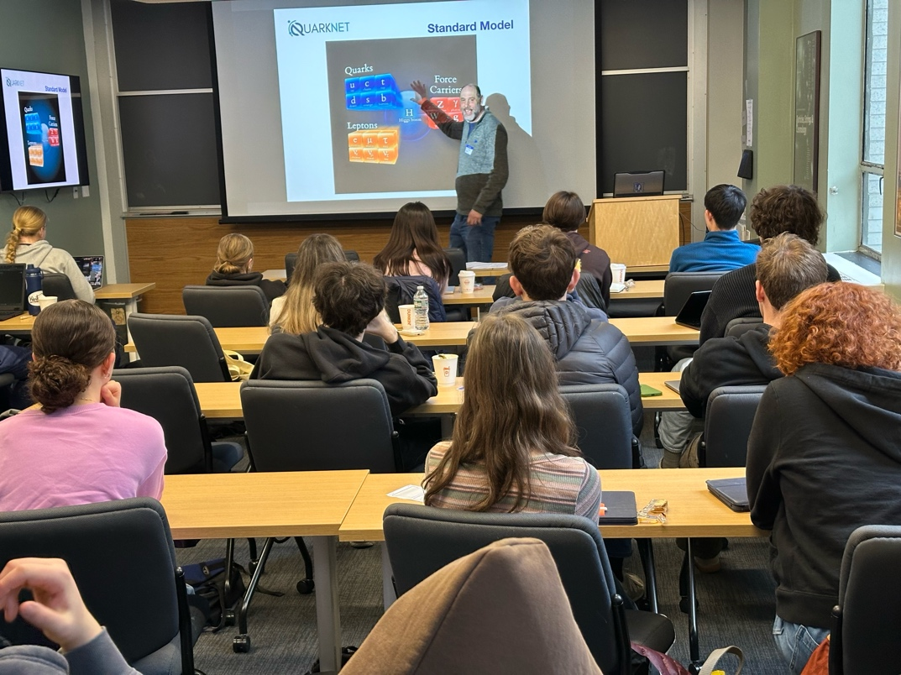

Mike Wadness describing the standard model of particle physics.

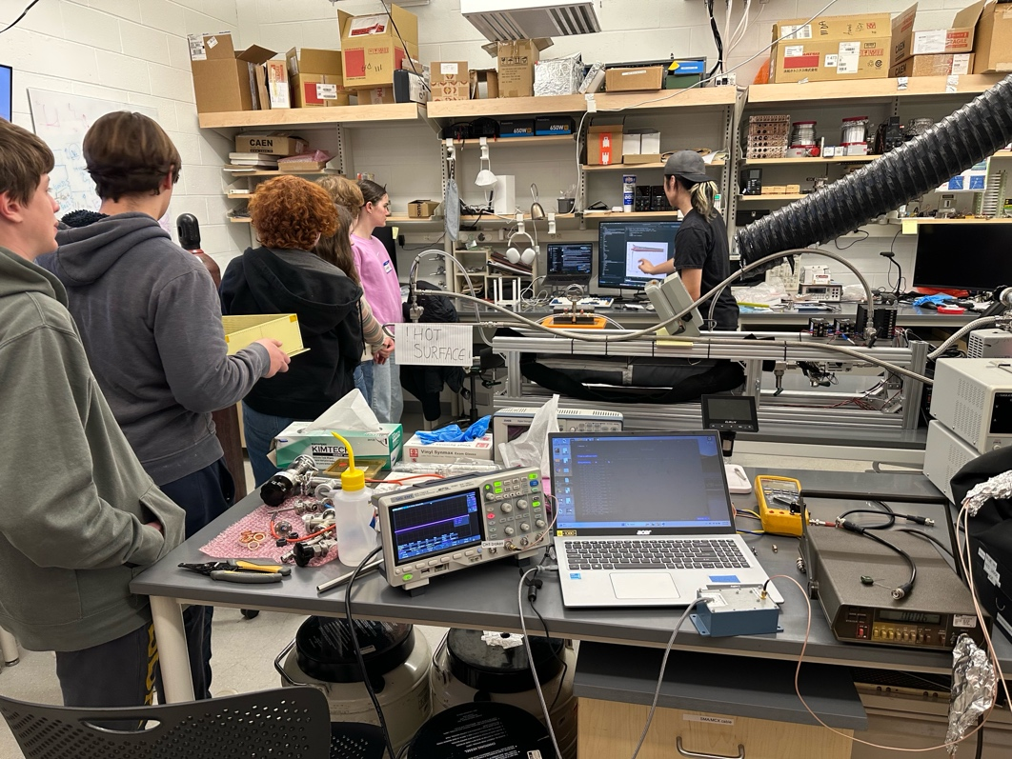

Students visiting a Northeastern physics lab to see development of a balloon-borne liquid argon time projection chamber.

Spring Meeting – June 16, 2025
We held our spring QuarkNet meeting of the Boston group on Monday (6/16/2025) evening at Roxbury Latin School. In addition to the local regulars (Mike Wadness, Mark Brooks Hedstrom, David Kurtz, and Caelan Danner, Rick Dower), we welcomed Nicole Preiser from Vermont and Abe Phelps and Adam LaMee from western Massachusetts. Adam is an old QuarkNet hand currently working for the American Physical Society (remotely). Rick gave a presentation on the principle of least action. Also, we talked about some QuarkNet Data Activities, e.g. Top Quark, and how to use them (straight or modified) in the classroom.

Summer Workshop on Quantum Science – August 6-7, 2025
Thanks to Adam LaMee, MIke Wadness, and all the participants (Mark Brooks Hedstrom, Scott Carlson, Mike Hirsh, Kurt Murphy, Gerry Gagnon, David Kurtz, Jon Kelley, and Abe Phelps) for an informative and enjoyable workshop on quantum science. Adam led us on Wednesday morning in an LED exercise that emphasized teaching and learning techniques. Mike Wadness took charge Wednesday afternoon with online measurements of electron diffraction and a discussion of how to determine the order of the diffraction rings in graphite. I took over on Thursday morning with the QuarkNet Data Activity “TOTEM 2” to infer the size of a proton and an exercise related to Henry Moseley’s X-ray research on atomic number (Z). In the afternoon, I described the discovery of the neutron by James Chadwick in 1932 and showed an analogy to Chadwick’s measurement of nuclear size by neutron scattering. We finished the day with some calculations of the relation between quantum tunneling and alpha decay.
This was the 25th anniversary of our first summer QuarkNet Workshop in Boston!
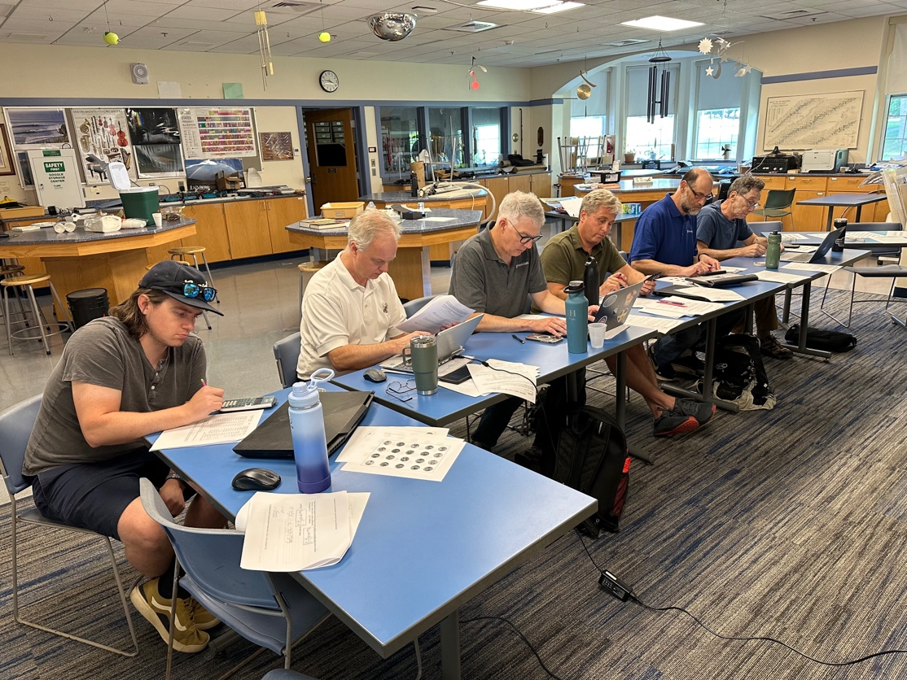
Workshop participants deep in calculations related to alpha particle tunneling.

