Lawrence Berkeley National Laboratory
Annual Report 2025
June 26, 2025
Mentor: Tony Spadafora
Workshop Coordinator: Laurie Kerrigan
Co- Organizers: Ken Cecire & Joel Klammer (QuarkNet)

The LBNL Physics Division hosted its nineteenth “Physics in and Through Cosmology” workshop for QuarkNet Leadership teachers and high school students. This one-week in person workshop from June 16 to June 20, 2025 was held at the Lawrence Berkeley National lab. Three physics teachers, including Workshop Coordinator Laurie Kerrigan, participated. Two of the teachers have been active members of QuarkNet and one is new to QuarkNet. One retired teacher, a past active member of QuarkNet and 43 students participated. The teachers & students joined from public and private high schools in the greater San Francisco Bay Area.

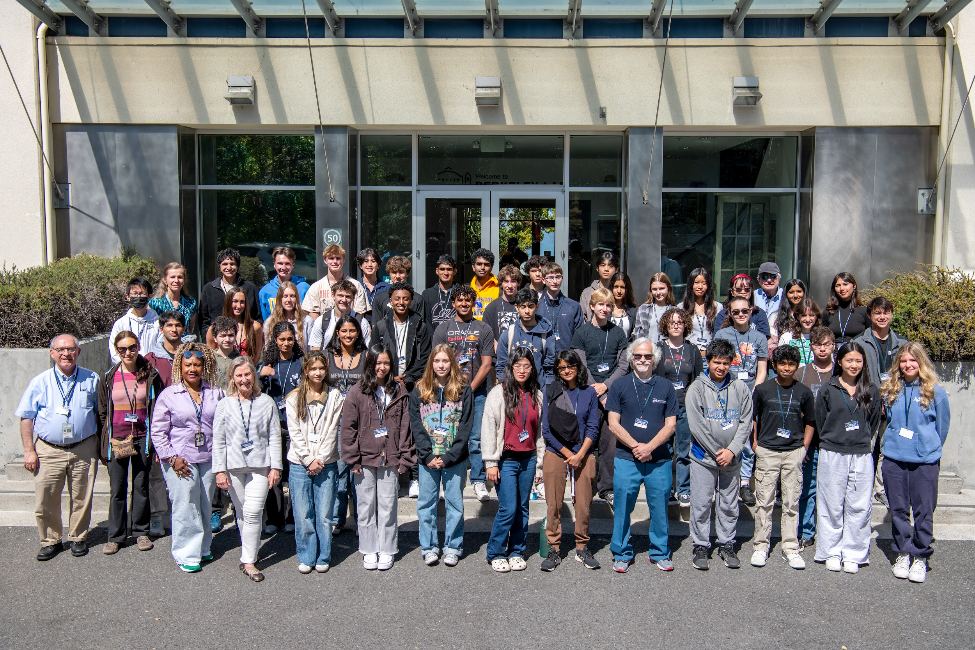

2025 Physics in and Through Cosmology Workshop
We have been making an effort to include underrepresented students in STEM (which include: African Americans, American Indians/Alaska Natives, Latinos, LGBTQ+, students from low income households, and first-generation college attendees) by outreaching to schools in lower income & underrepresented areas.
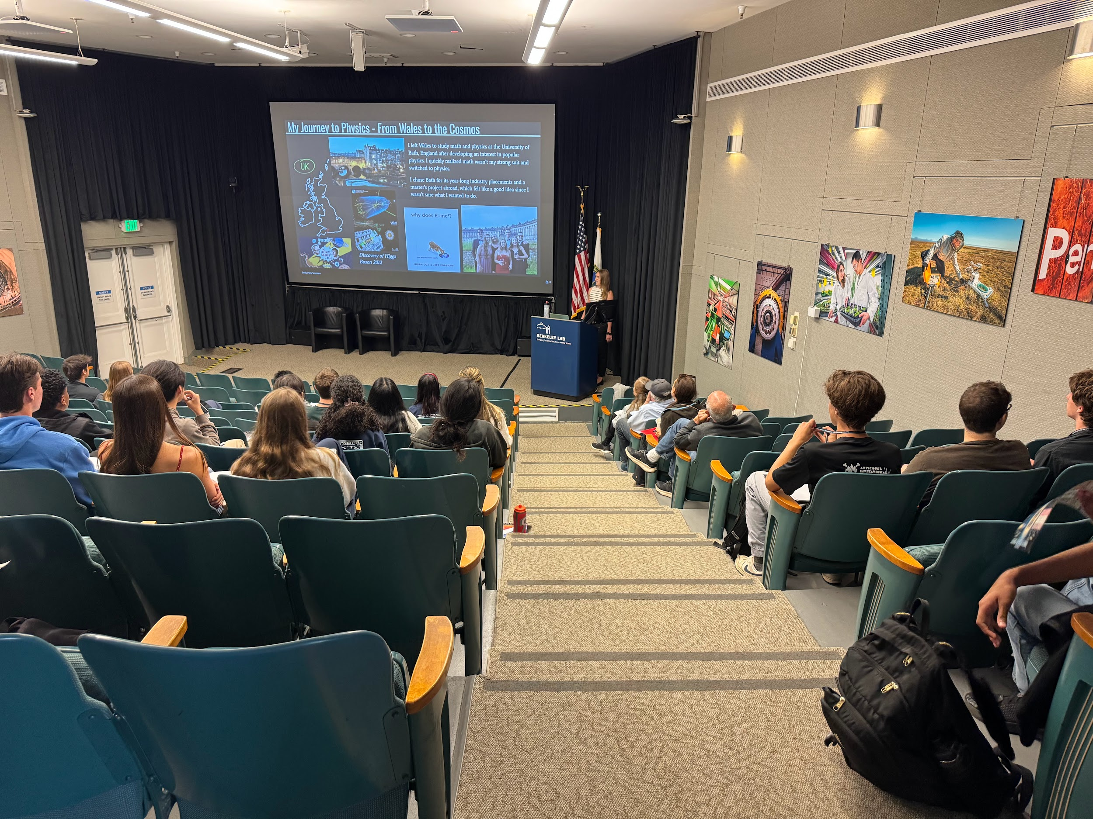
Emily Perry "Journey towards the discovery of galactic dark matter".

This year we met Monday, Tuesday, Wednesday & Friday with teachers and students together and on Thursday with just the teachers from 8:30am-4pm. Most meetings started with a quick activity or question to get students thinking about that day’s topic. Then there was a talk by an LBL scientist and either small group work, tours, or Quarknet activities. The small group work included a Scientist Interview Project and cosmic ray detectors.
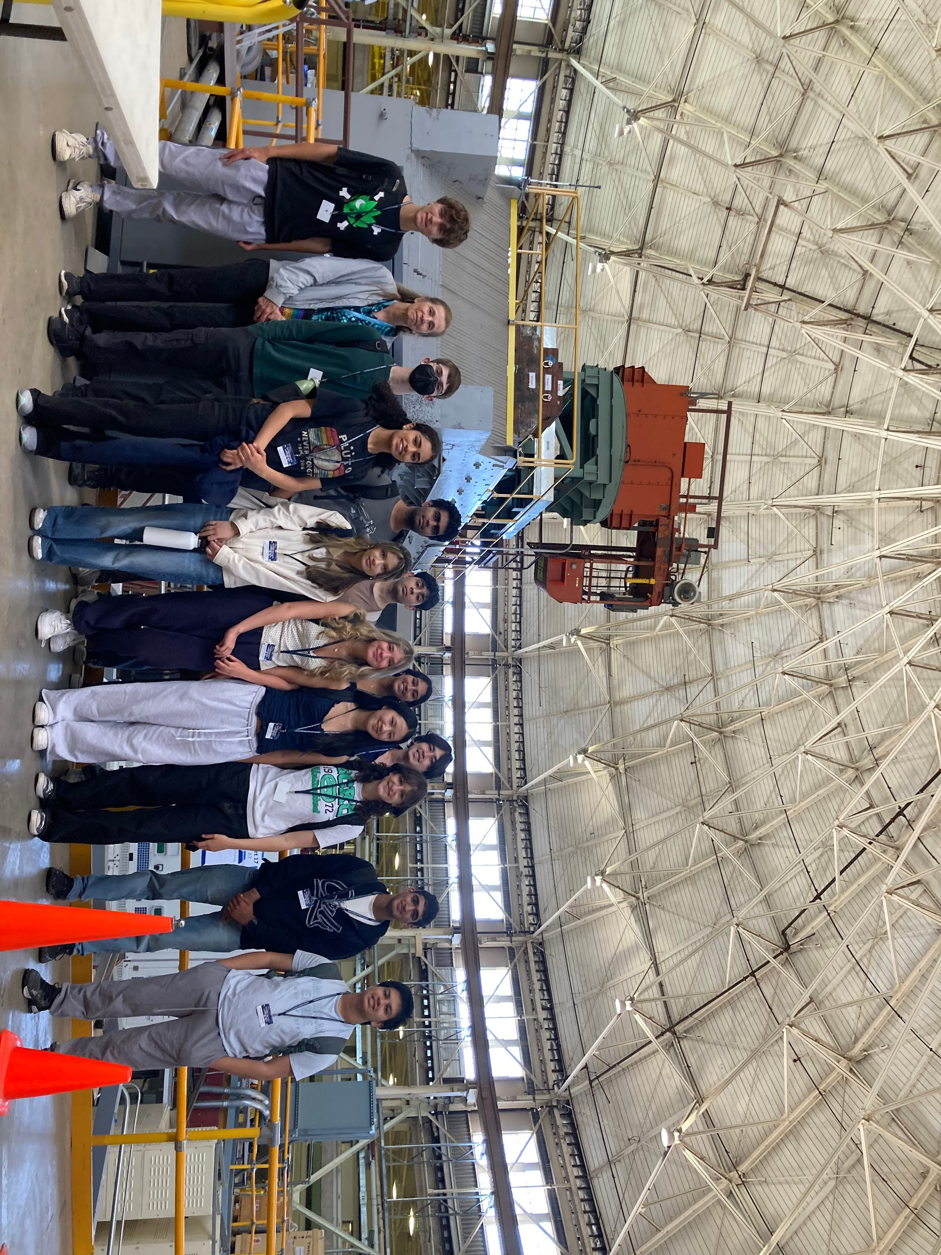
Touring the Advanced Light Source (ALS)

We toured the ALS (Advanced Light Source). QuarkNet activities, led by Ken Cecire & Joel Klammer included Particle Cards and Quark Workbench, and the Z mass measurement for everyone. The teachers also worked on: How Speedy Are These Muons?, Mean Lifetime, Part 2: Cosmic Muons, and TOTEM Data Express. Retired QuarkNet teacher, Glen Melnik, led the discussion on cosmic rays and how a cosmic ray detector worked and directed students in their small group work with the detectors.

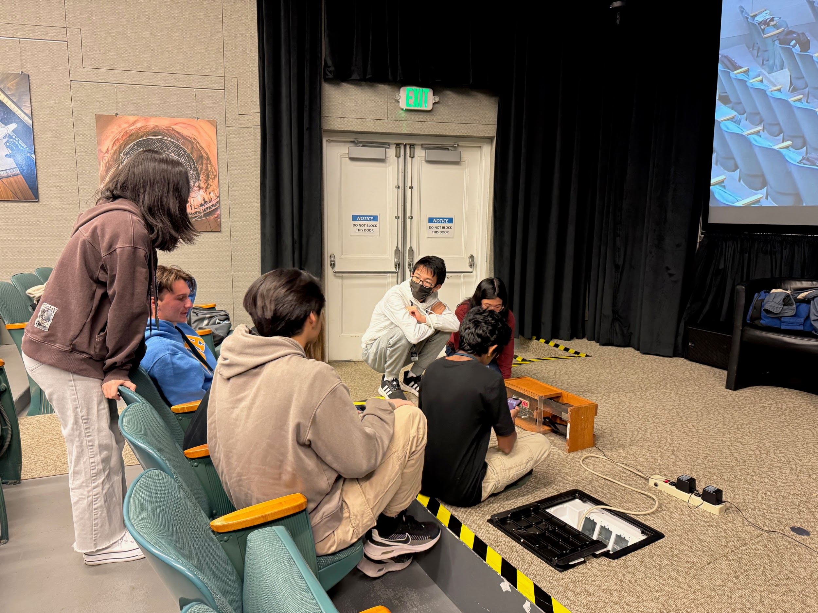
Students working on Cosmic Ray Detectors

Highlights of the program were a drop in visit by Nobel Prize winner, Saul Perlmutter, and a round table panel discussion with the Scientists on the last day. Each small group did a short report back to the group about the work the Scientist they interviewed was doing.

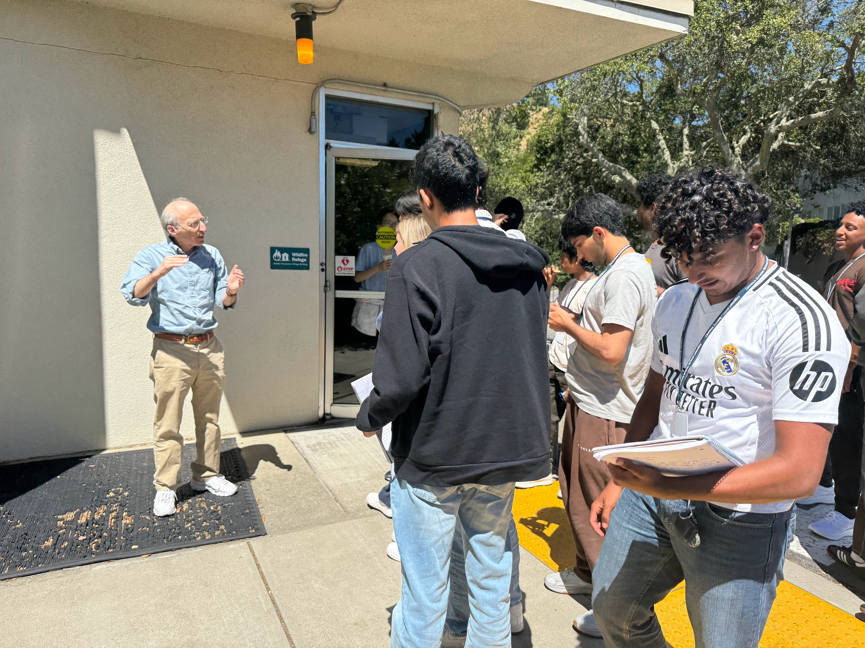

After Nobel Prize laureate Saul Perlmutter’s drop-in visit, students followed him to
continue their discussion.
List of Teachers:

Phil Becker Bob Bessin Laurie Kerrigan Tricia (Kalee) Tock

Scientists interviewed by students:

Aritoki Suzuki Maria Mironova Michael Williams David Woodward Anne Fortman
Tucker Hwang John Groh Louis-Guillaume Gagnon Botho Paschen Abby Bault

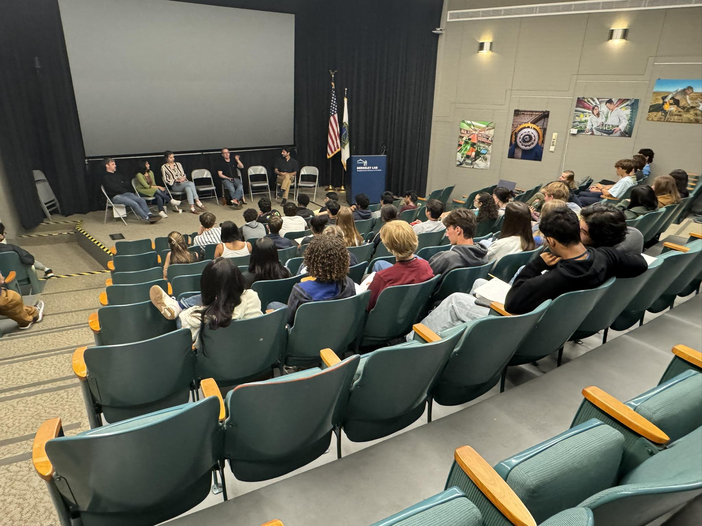

Question and Answer session with the speakers.

Formal presentations by LBNL scientists included:

Nathalie Palanque-Delabrouille “Welcome to the Lab”
Nick Rodd "Dark Matter: the search for the heaviest and lightest particle in the universe"
Roger Huang "Neutrinos: Studying the Ghosts of the Universe".
Emily Perry "Journey towards the discovery of galactic dark matter".
Anton Baleato Lizancos "What is Dark Energy? Clues from the Clustering of DESI Galaxies"
Maria Mironova “Discovering the Invisible: Tracking Detectors for Particle Physics”.
Angria Rastogi "Designing a multi-TeV muon collider"
Claire Poppett "More Than a Pretty Picture: Seeing the Universe Through 5000 Eyes"
Clara Verges "A journey to our cosmic origins with the oldest light in the Universe."
Christian Bauer “Quantum Computing - A New Paradigm”

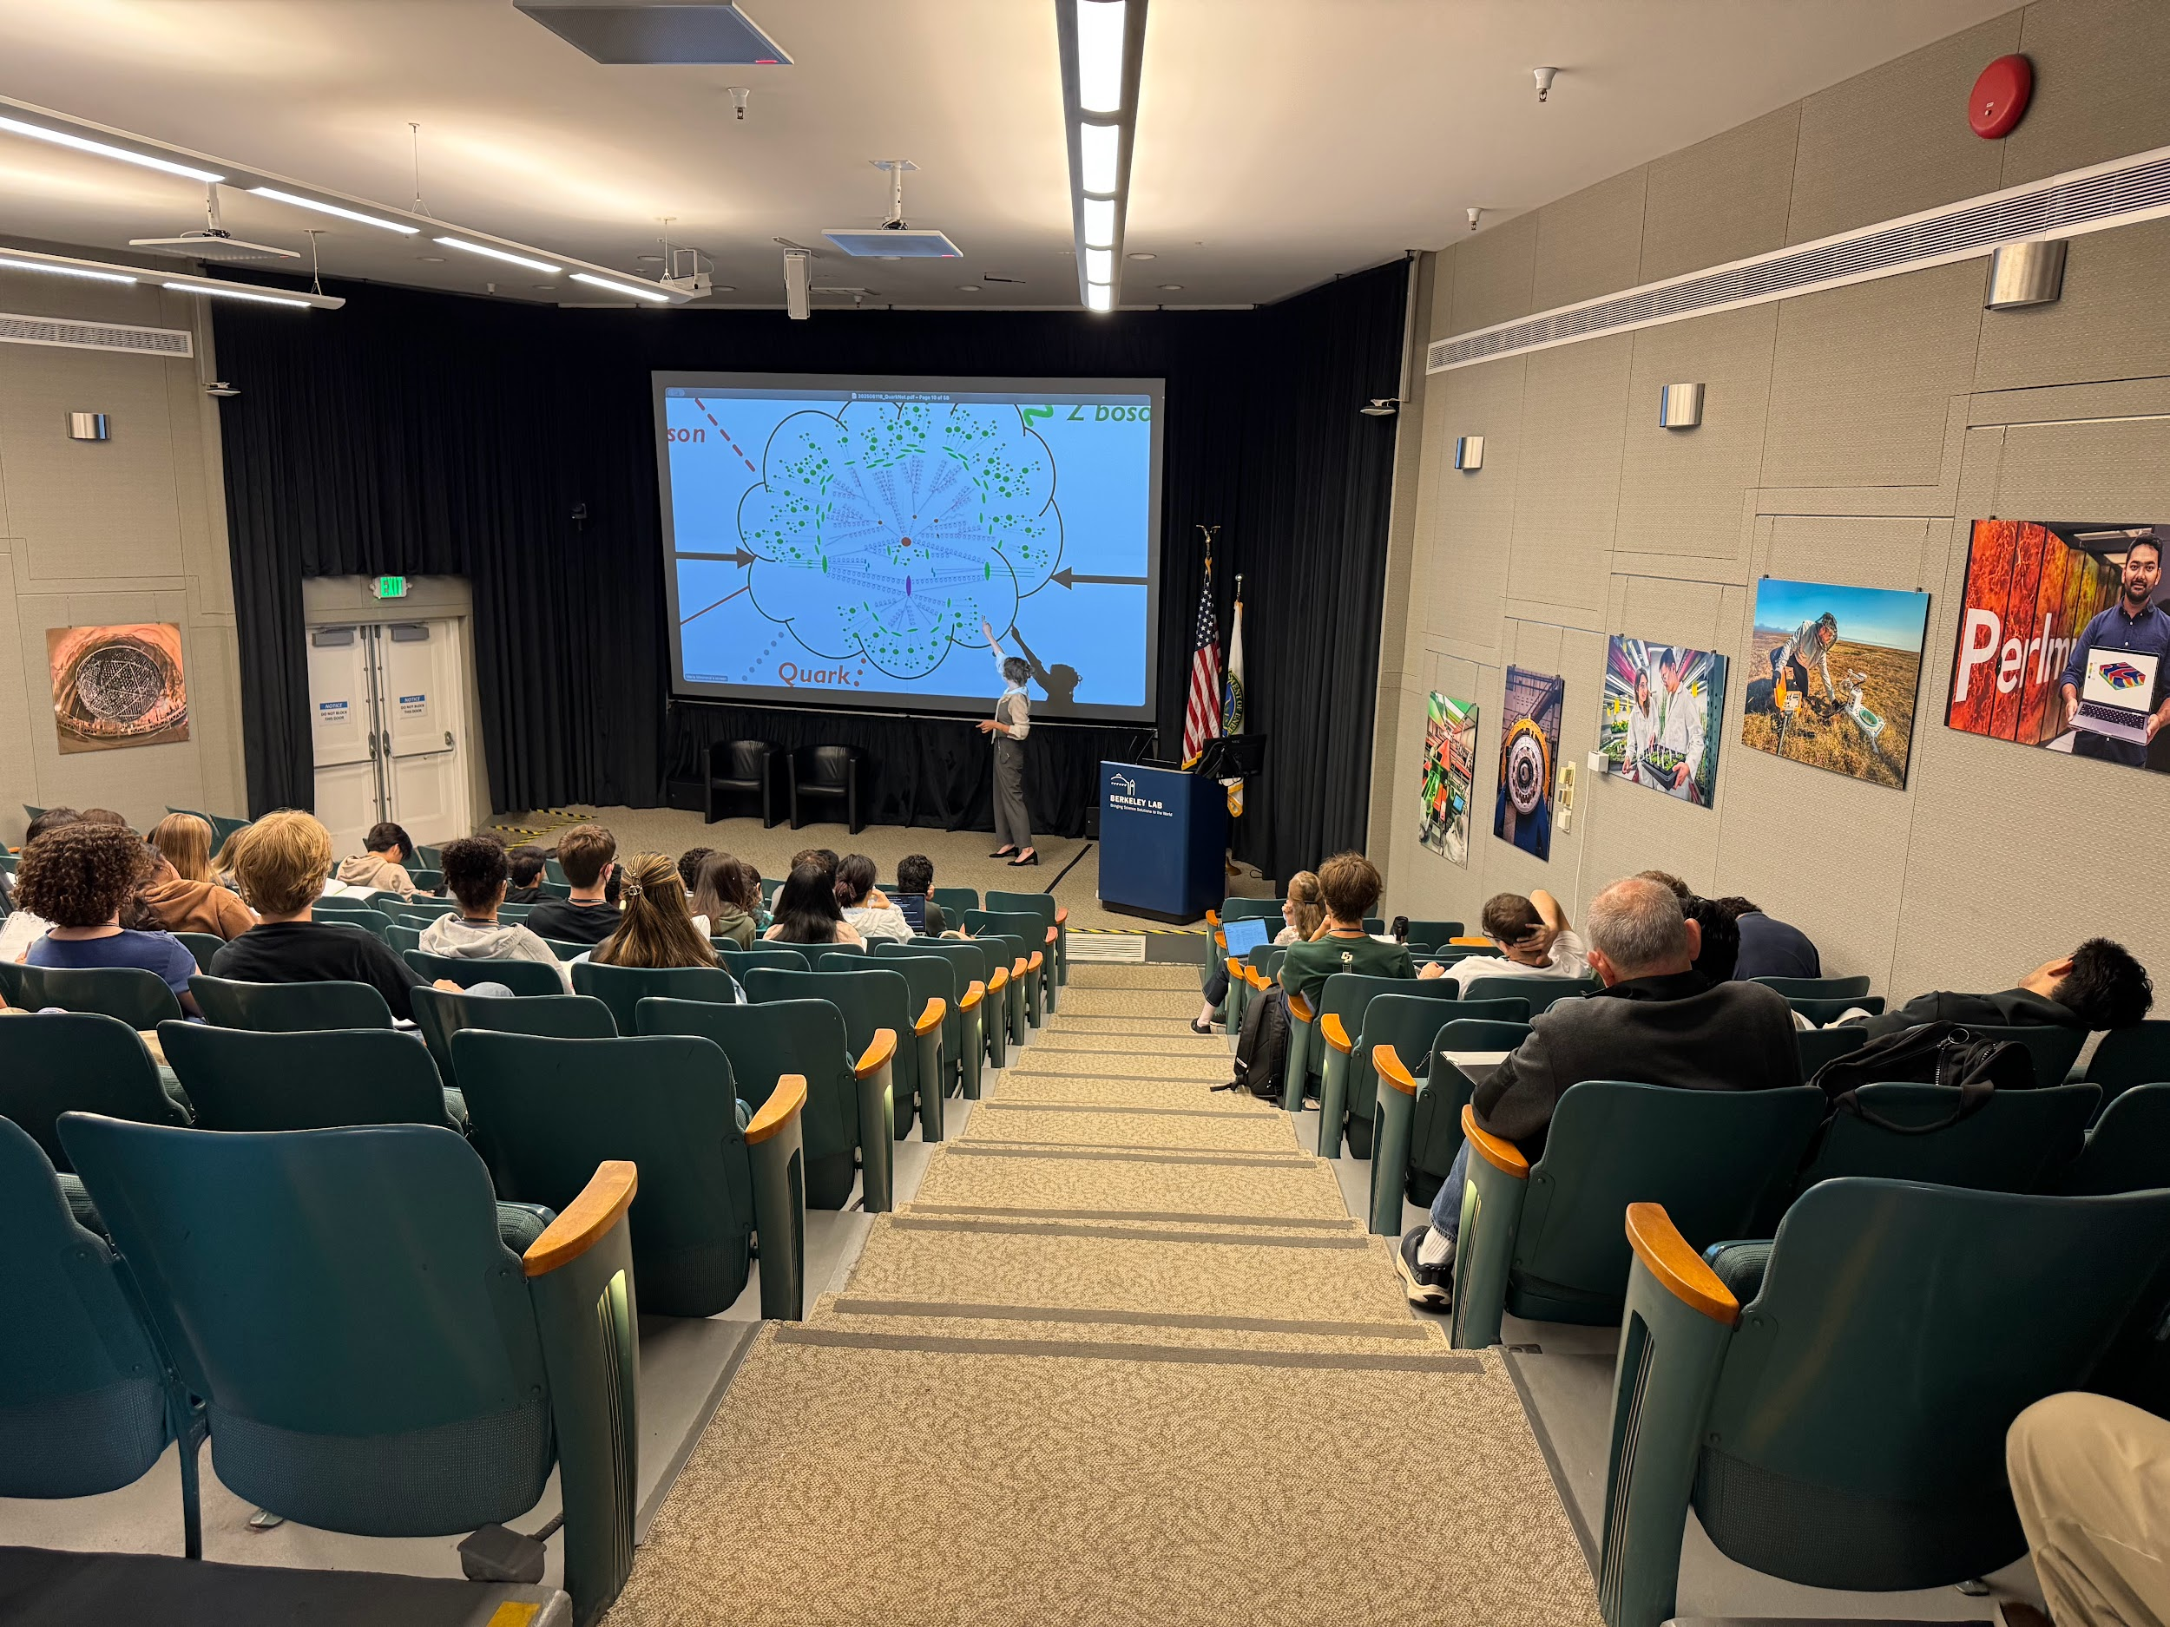
Maria Mironova “Discovering the Invisible: Tracking Detectors for Particle Physics”.

Response Summary from the overall evaluation comments by teachers & students:
- Lectures & Speakers: Attendees enjoyed the diverse and in-depth lectures, appreciating the speakers' enthusiasm, unique perspectives, and willingness to share their research and personal stories.
- Hands-on Experiences & Tours: The workshop was praised for providing opportunities for hands-on activities, including the ALS tour, lab visits, and the cosmic particle detector activity.
- Researcher Interaction: Many participants valued the chance to meet, interview, and ask questions of scientists and researchers, finding these interactions insightful and inspiring.
- Learning & Exploration: Attendees highlighted the significant learning experience, covering a wide range of topics in cosmology and particle physics, which helped them explore potential future study paths.
Response summary of comments by students on what they learned according to NGSS major areas in Physics:

Structure and Properties of Matter
- Standard Model & Fundamental Particles: Many respondents learned about the Standard Model of Particle Physics, including quarks, leptons (such as muons, tau, and electrons), neutrinos (and their oscillation), and the Higgs boson/field. They gained a deeper understanding of how these particles interact and form matter.
- Subatomic Structure: Respondents learned that protons and neutrons are made of quarks, and that matter has a complex structure at the subatomic level.
- Antimatter: Several respondents learned about antimatter and its interaction with matter, leading to annihilation.
- Properties of Matter: Respondents discovered there are more than four properties of matter and how these properties allow particles to be detected.
- Experimental Considerations: One respondent learned about the importance of material selection in experiments to minimize noise.
Forces and Interactions

- Four Fundamental Forces: The strong, weak, electromagnetic, and gravitational forces are recognized as the four fundamental forces in the universe.
- Bosons and Force Carriers: Bosons are understood to be force-carrying particles that mediate interactions between elementary particles.
- Gravity and the Standard Model: Gravity is not fully incorporated into the Standard Model, and its behavior is more complex than simple calculations.
- Dark Matter and Dark Energy: These concepts were explored in relation to galactic rotation, the expansion of the universe, and their gravitational effects.
- Particle Interactions and Detection: The seminar provided insights into particle interactions, including annihilation and decay, and methods for detecting particles using noble gases.

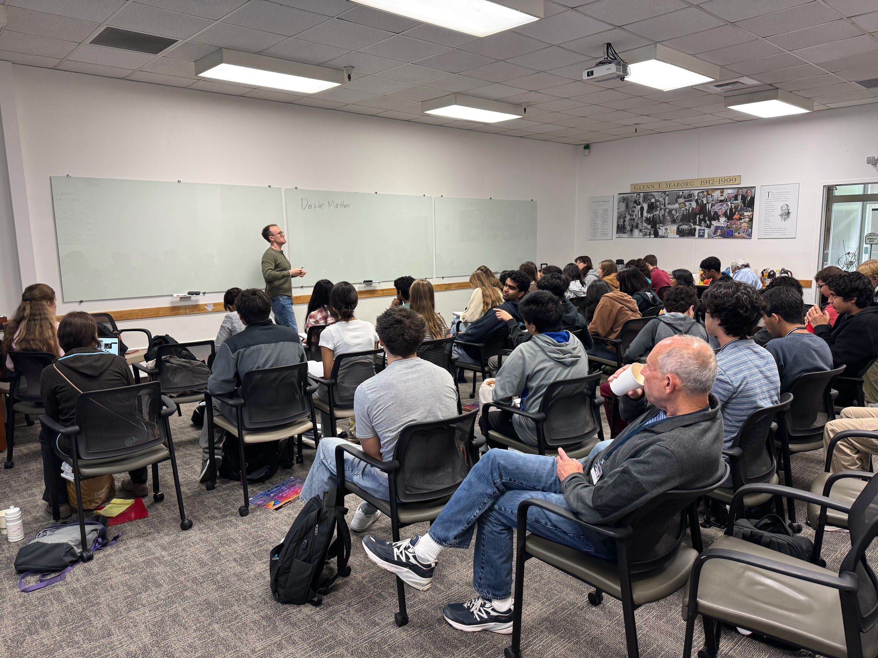
Nick Rodd "Dark Matter: the search for the heaviest and lightest particle in the universe"

Energy

- Dark Energy: It is responsible for the universe's accelerated expansion, making up a significant portion (70% or more) of the universe, and its nature and increasing strength are still unknown.
- Energy-Mass Relationship: Learned about E=mc² and how energy can be converted into mass, influencing particle creation.
- Black Holes: Black holes can be created when enough energy is contained within a small space.
- High Energy Environments: Particles can react unpredictably in high-energy environments, such as particle accelerators.
- Types of Energy: Discussions included dark energy and different energies of various particles, with one response mentioning overall, weak, and strong charges.

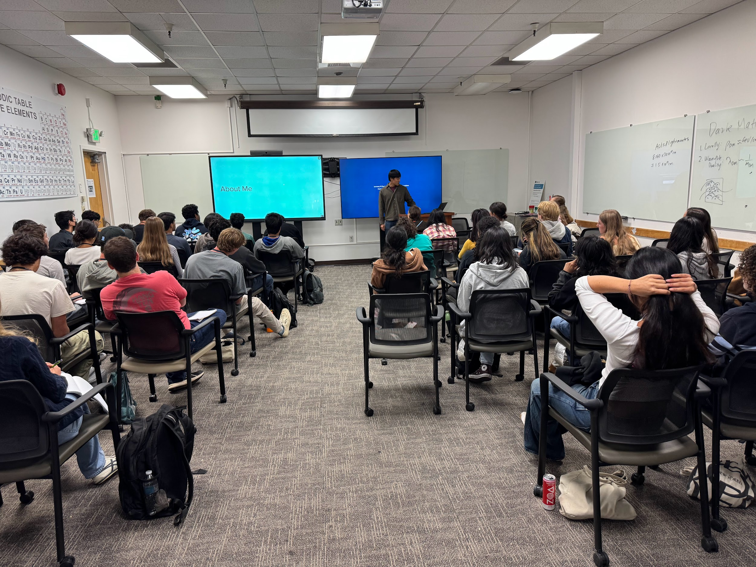
Roger Huang "Neutrinos: Studying the Ghosts of the Universe".

Waves and Electromagnetic Radiation

- Redshift: Several responses highlighted redshift as a key concept, explaining it as the stretching of electromagnetic waves due to the expansion of the universe, allowing us to determine the age and distance of cosmic objects and galaxies.
- Electromagnetic Radiation: Many responses discussed electromagnetic radiation, including photons, as a fundamental concept for understanding energy transfer, the early universe (CMB), and detecting distant signals.
- Wave-Particle Duality: Responses mentioned the dual wave and particle nature of matter, particularly photons, protons, and electrons, as a core connecting point across workshop topics.
- Experimental Challenges: Some responses addressed the challenges of detecting faint signals and designing experiments due to atmospheric interference and the need to filter out background radiation.
- Dark Matter/Energy: Responses touched upon how light and wavelength analysis can be used to measure dark matter and dark energy, and one response noted the concept of dark matter "talking" to forces.
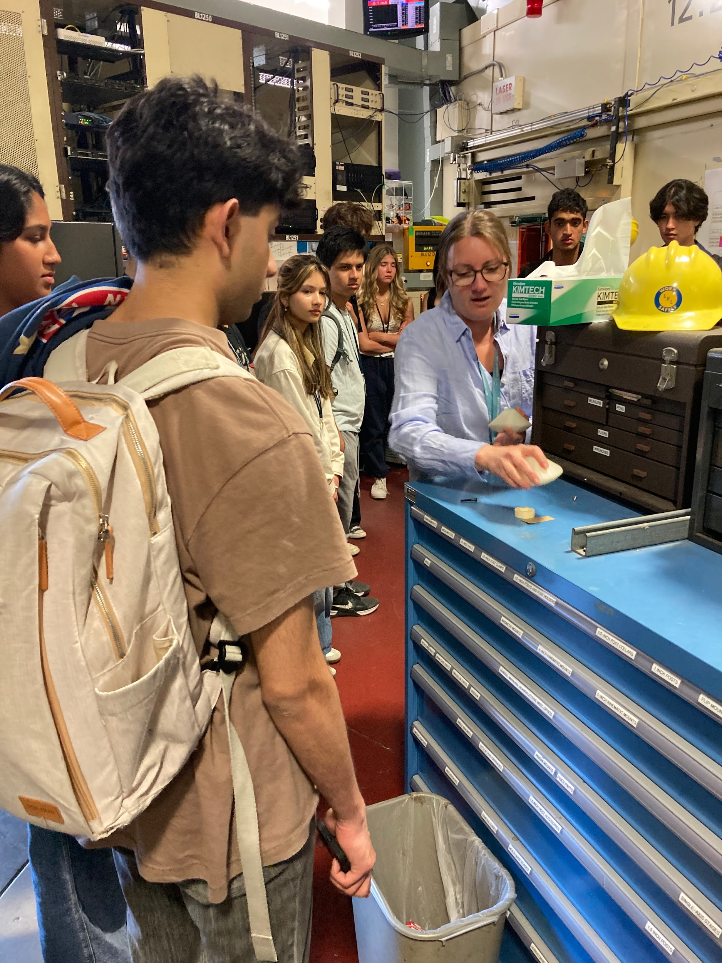
Beam engineer demonstration at the ALS

Engineering Design

- Collaboration & Teamwork: Designing experiments, detectors, accelerators, and telescopes requires extensive collaboration and teamwork among thousands of scientists and engineers.
- Engineering & Design Process: Engineering is crucial for bringing scientific theories to life and involves intricate processes, precise crafting, and considering constraints like cost.
- Particle Detectors & Accelerators: Responses highlight the design, construction, and functionality of particle detectors (e.g., ATLAS, DESI, DUNE) and accelerators (e.g., LHC, CERN), including the advancement to muon colliders.
- Hands-on Physics: Physics often involves hands-on engineering, with a focus on designing and building instruments.
- Improving Inventions: Scientists often design new inventions by identifying improvements to existing ones.

