Summer 2025 Quarknet Workshop at Syracuse University
The Syracuse group hosted a Quarknet workshop from Aug 11-13, 2025. The program was developed by Prof. Steven Blusk (SU), Quarknet staff member Shane Wood, and our lead Syracuse teachers Michael Madden and Brian Bealer. Six teachers were able to join the workshop, which included two first-time teachers.
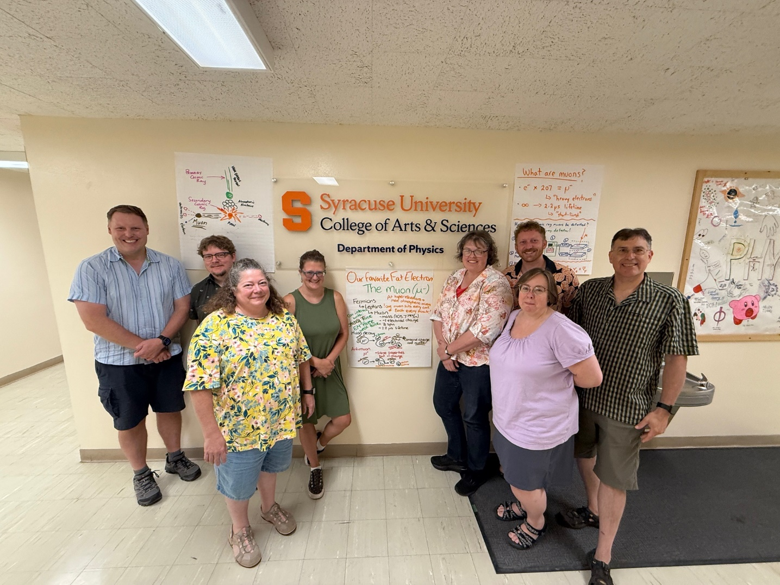
Photo showing the Quarknet 2024 participants: (From left to right): Shane Wood (QN), Rob Jaspersohn, Darlene Bissonette, Hillary Bevens, Anne Huntress, Linda Wicks, Dan Kurzen, Steve Blusk (SU).
The three-day workshop program is available at the following page
https://quarknet.org/syracuse2025
This year’s workshop featured some of the classic QN activities, such as “Shuffling the Particle Deck”, “Rolling with Rutherford”, and the “Mean Lifetime with dice”, which was a refresher for some teachers, but completely new to the first-time teachers. Throughout, whenever possible, the idea of “histogramming the data” was emphasized, as it provide a key way to visualize the experiment. We also worked in groups of two, and each group conducted some investigations into what are muons, and answered a group-specific question.
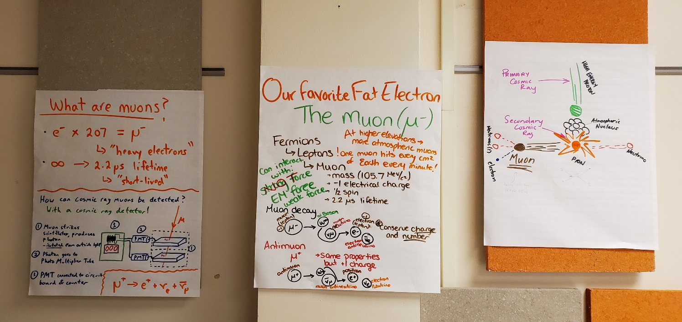
On Day 1, Prof. Blusk gave a 30-minute introductory talk on the Standard Model of particle physics, in order to ensure that all teachers had a basic understanding of the particles and the forces that mediate interactions. He also highlighted that there is a strong need for some kind of deeper theory to address shortcomings of the Standard Model.

The two larger activities carried out on days 2 & 3 included two first-time activities done at the Syracuse center.
LHCb MasterClass (Day 2)
On the second day, Prof. Blusk gave a second 30-minute presentation on the weak force, the notion of “lifetime” in particle decays, and introduced the particles we directly observe in the LHCb experiment (e, muon, pion, kaon, proton and photons), and how we identify them and measure their momenta. Then, from these 6 particles, how do we reconstruct more complex objects, like D0 mesons and beauty hadrons, and determine their mass and decay time.
In the afternoon, the teachers worked through the LHCb MasterClass exercises on the D0 mass and the D0 lifetime
https://lhcb-outreach.web.cern.ch/lhcbinternationalmasterclasses/d0-lifetime/.
They were able to see that the what they measure could be biased by not knowing with certainty where the D0 meson was produced, and by restricting the IP, one could reduce the bias.
Cosmic Watches (Days 2 & 3): Teachers worked in groups of 2 and used CosmicWatch detectors to answer a specific question about muons. The 3 groups came up with the questions:
  - Does the muon rate depend on location. Here, the teachers went all over campus to conduct their measurements.
  - Does the muon rate from “No-Salt” depend on distance, and if so, how much so.
  - Does the muon rate depend on the angle of the cosmic watch relative to the Earth’s normal.
The teachers made posters (electronically) and presented them to the group on day 3. Two of the poster presentations are below.
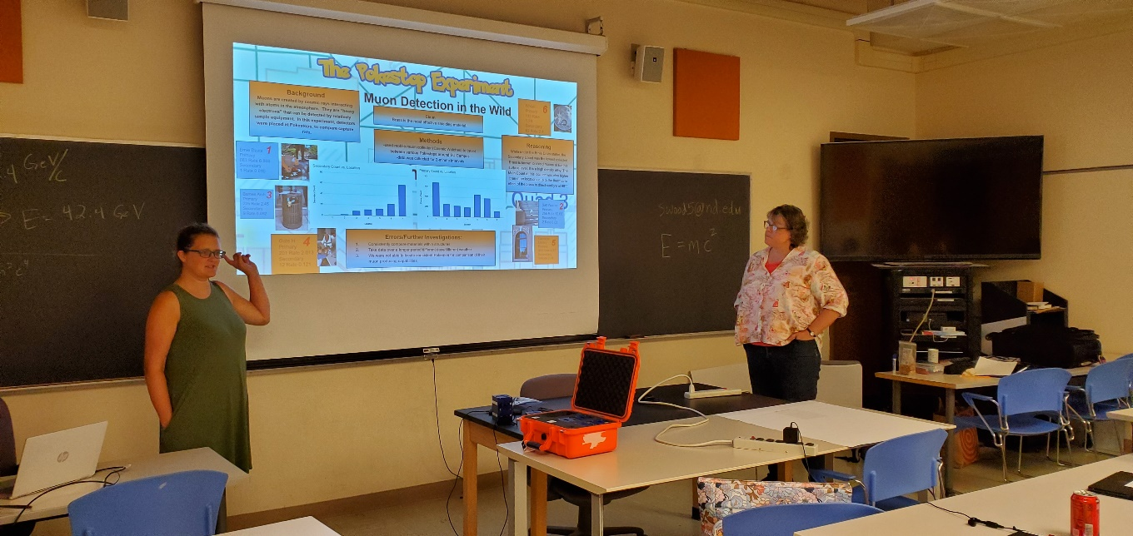 | 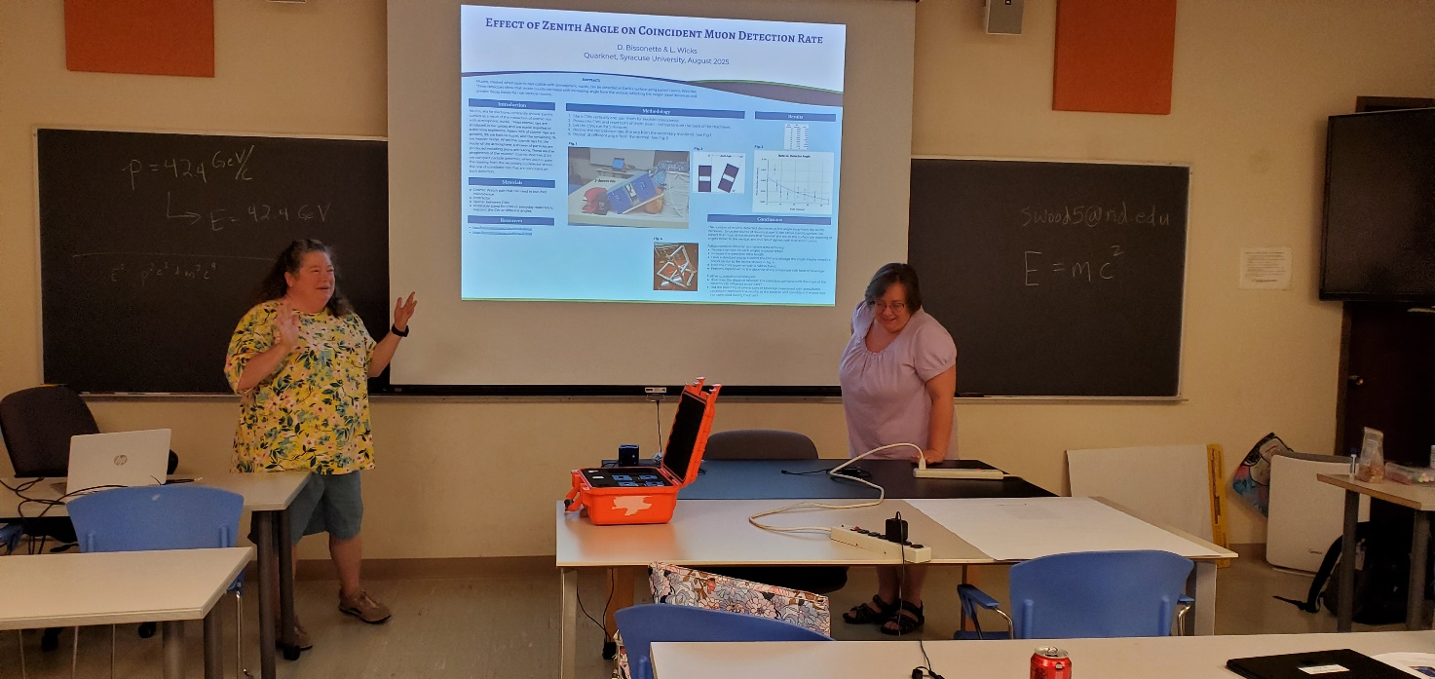
On the morning of the last day, we also had a presentation by a graduate student (Zae Moore) on the DUNE experiment, and worked a bit on the “How Speedy are these muons” activity and discussed how the activity could be used in high school classrooms.
In the afternoon, we also spent some time discussing the new science standards and program level descriptors, and various resources that can help. That was followed by our traditional Share-a-thon, where teachers share some specific resources they find helpful in their teaching. The teachers then spent some time thinking about implementation of some of the ideas presented into their classroom, and then they presented their ideas (groups of 3). Kathy Race joined during this part of the workshop to hear the teachers thoughts and provided feedback.
The workshop ended with the surveys.

