Standard (Collider) Detector

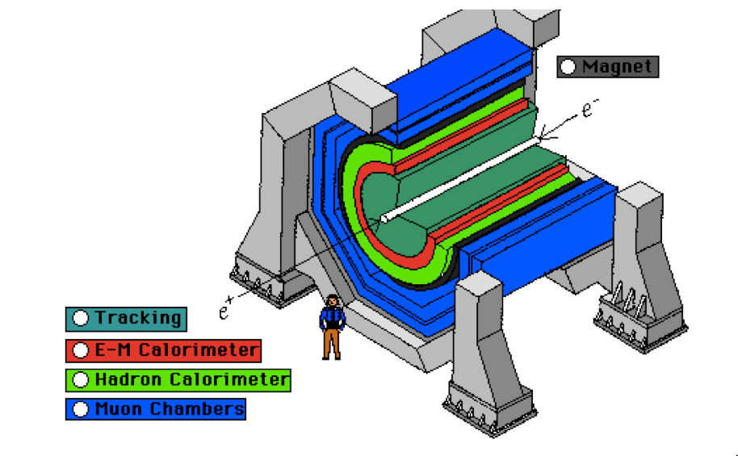

Along the Beam Line
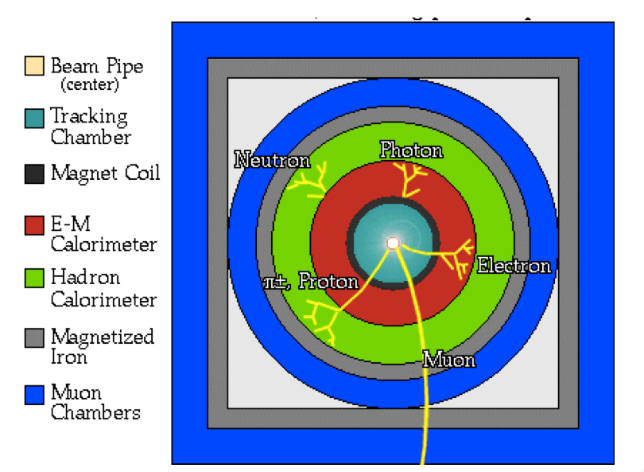

Two-Dimensional Projection
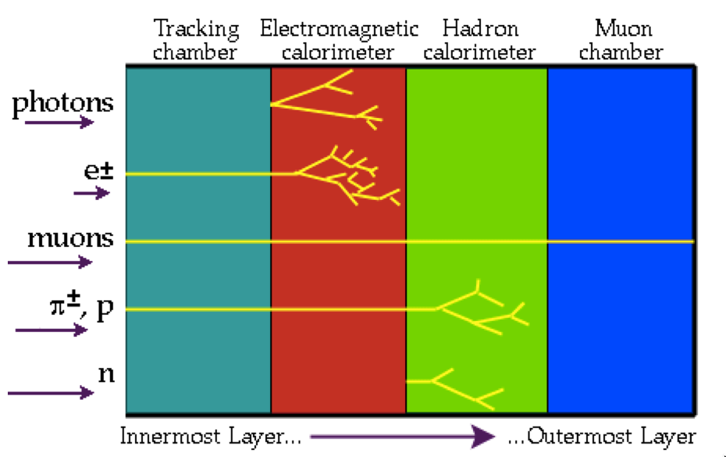

Atlas Interactive
http://atlas.physicsmasterclasses.org/en/zpath_playwithatlas.htm

CMS Interactive
https://cms-docdb.cern.ch/cgi-bin/PublicDocDB/RetrieveFile?docid=4172&version=2&filename=CMS_Slice_elab.swf

