It’s No Coincidence!
DESCRIPTION OF LESSON
In this investigation, students will compare flux data sets collected with varying coincidence rates from the Cosmic Ray e-Lab. Students will run flux studies on the bottom counter when arranged in a stacked configuration. They will analyze this data to find the relationship between flux and the coincidence number. Using their conclusions, students will then predict and model muon paths that represent these phenomena.
STANDARDS ADDRESSED
Next Generation Science Standards:
ESS2-1 Develop a model based on evidence to illustrate the relationships between systems or between components of a system.
ESS1-6 Apply scientific reasoning to link evidence to the claims to assess the extent to which the reasoning and data support the explanation or conclusion.
ESS1-6 Models, mechanisms, and explanations collectively serve as tools in the development of a scientific theory.
ESS2-2Analyze data using tools, technologies, and/or models (e.g., computational, mathematical) in order to make valid and reliable scientific claims or determine an optimal design solution.
Common Core Math Standards:
MP.2 Reason abstractly and quantitatively.
MP.4 Model with mathematics.
Common Core English and Language Arts Standards:
RST.11-12.2 Determine the central ideas or conclusions of a text; summarize complex concepts, processes, or information presented in a text by paraphrasing them in simpler but still accurate terms.
WHST.9-12.1 Write arguments focused on discipline-specific content.
WHST.9-12.2 Write informative/explanatory texts, including the narration of historical events, scientific procedures/ experiments, or technical processes.
LEARNING OBJECTIVES
Students will know and be able to:
- Describe the meaning of coincidence as it applies to the geometry and collection of data with the CRMDs.
- Apply reasoning to predict paths of muons through the stacked counters.
- Defend the reasoning for selecting coincidence number in particular studies.
- Create and interpret a flux plot from stored Cosmic e-Lab data.
- Develop possible extension questions for further study as related to coincidence.
PRIOR KNOWLEDGE
Students must know and understand how muons form, how they trigger a response in the CRMD, and the meaning of flux.

BACKGROUND MATERIAL
Start with the Big Picture in the Library on the Library page of Cosmic Ray e-Lab. Use the Project map--Getting Starting: Describe cosmic rays, Investigate detectors, Analyze Data under Figure it out. In the library, there is a tutorial for a flux study.
IMPLEMENTATION
Hoop It! (Teacher Notes)
Implementation activity for “It’s no Coincidence” Cosmic Ray E-Lab activity Hula hoops model for CRDM simulation.
To explain coincidence, have 4 students hold 4 hula hoops horizontally or vertically in a column with .5 to 1 Meter between each hoop.
Have students carefully toss tennis balls, or some other soft sided ball, through the hoops from their seats.
Discuss how many hoops each ball goes through and what factors influence how many hoops it travels through.
Discuss what is more likely, a ball going through 1 hoop, 2 hoops, 3 hoops, or 4 hoops.
Also discuss the following question: “If a ball goes through 2 hoops, did is also go through 1 hoop?”; “If a ball goes through 3 hoops, did is also go through 2 hoops? 1 hoop?” etc.
Discuss the term coincidence and how 1, 2, 3, and 4 fold coincidence are how we explain particles passing through a detector panel in the same way a tennis ball passes through the Hula hoops.

It’s No Coincidence! Name___________________________
The Plot Thickens Activity
On the Cosmic Ray e-Lab website, locate data from Wednesday, June 25, 2014 from Detector 6436 (Timber Lake High School, LuAnn Lindskov-teacher). The data sets should look similar to those below:
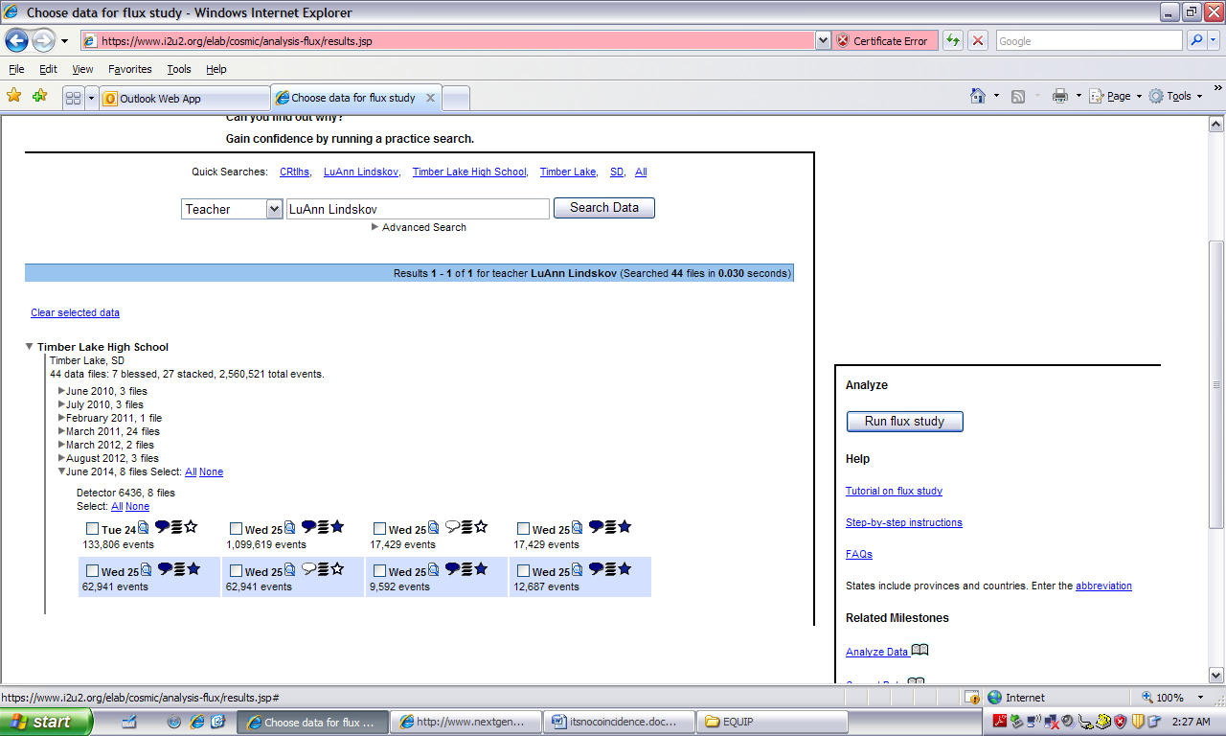
Each data set has an “events” count. Using your knowledge of how the CRMDs operate and the number of events in each stored data file, match the events Count with the conditions of data collection.
Events Count to Match:
1,099619 17,429 62,941 9,592 12,687
Conditions of Data Collection | Events Count
9 hours of 2-fold Coincidence
15 minutes of 1-fold Coincidence
15 minutes of 2-fold Coincidence
15 minutes of 3-fold Coincidence
15 minutes of 4-fold Coincidence

Create flux plots for each of the 15 minute Coincidence data files. Use a bin width of 60 and the Channel assigned to your group by your teacher.
Print each flux plot. Determine the average flux for each. Create and complete a data table in the space below for the average flux for each of the four Coincidences.

Based on this data in your table, hypothesize a relationship between coincidence number and flux. Be sure to use if-then language and complete sentences.

ASSESSMENT
It’s No Coincidence Name __________________________________
Plotting the Path
Making a Graph:
You have created several flux plots to analyze the effect of coincidence number (independent variable) on flux (dependent variable).
Using a graphing program, create a graph that represents the relationship between these two variables. Make a written statement (complete sentence!) below that best describes the relationship between coincidence number and flux.
Making predictions:
Below is a cross-section of the four counters, with Channel 1 on the top and Channel 4 on the bottom. The flux studies you did were for Channel 4. On each cross-section show the muon paths of at least 2 events that would produce the given coincidence. Use different colors for each path.
COINCIDENCE 1

1
2
3
4
COINCIDENCE 2

1
2
3
4
COINCIDENCE 3
1
2
3
4
COINCIDENCE 4
1
2
3
4

Teacher Notes: In a post-lab discussion students will whiteboard their results and compare the differences in muon paths when different channels are analyzed.

Complete the lesson with a 3-2-1 exit slip to assess student understanding:
Name 3 things you discovered in this lesson, 2 things you found interesting, and 1 question you still have.

