______________________________
8/7/2007 Name
R. Dower rick.dower@roxburylatin..org
Particle Physics – Kaon Elastic Scattering

The accompanying photograph shows the trails of bubbles left along the paths of negative kaons (K⁻ mesons) and other particles in the Saclay 80 cm liquid hydrogen bubble chamber at the CERN Proton Synchrotron. Moving negatively charged particles curve counterclockwise due to the magnetic field perpendicular to the plane of the photo. This photo was selected because the three tracks of interest lie in the photo plane. The photo is printed at twice actual linear size. A kaon (track 1) enters from the bottom of the photo. Interaction between the kaon and a target particle produces tracks 2 and 3 on the sketch below. What is the target particle likely to be? Why?

Assume elastic scattering and label each particle tracks (1, 2, 3) with the symbol of the particle that produced it and an arrow indicating the particle’s direction of motion.

3

Describe the event in the form A + B → A + B , θ₂₃ 2
where A and B are replaced by appropriate symbols
for the incident and target particles respectively. θ₃₁ θ₁₂

1
Measure at the interaction vertex and record below the angles (with uncertainties) between each pair of tracks.
θ₁₂ = _____±___ θ₂₃ = _____±___ θ₃₁ = _____±___ θ₁₂ + θ₂₃ + θ₃₁ = _____±___

The measured radius of curvature (r_{m}) for each track on the photo is twice the
actual radius of curvature (r). The r_{m} value for track 2 will be a rough estimate since track 2 is short. Measure r_{m} , calculate r, calculate p, the particle momentum, and enter the values (with uncertainties) in the table below. The magnetic field perpendicular to the photo plane is B = 1.7 tesla. Thus, p (MeV) = 3Br = 5.1 r (for r in cm).

 | r_{m} | ± | r = r_{m}/2 | ± | p | ±
Particle | (cm) | (cm) | (cm) | (cm) | (MeV) | (MeV)
1
2
3
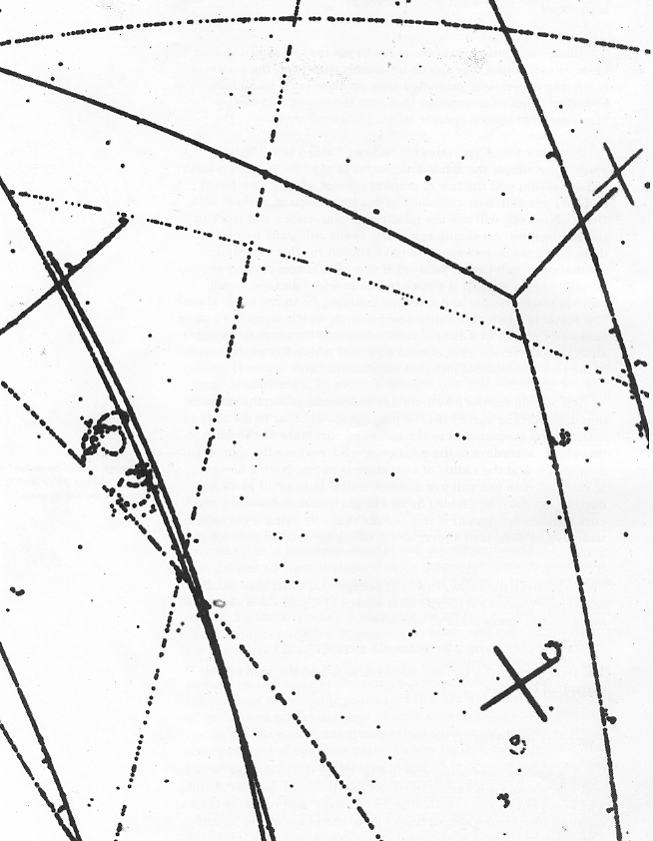
Photo (tracks twice actual linear size) from film of a Stopping K⁻ run at CERN in the Saclay 80 cm Hydrogen Bubble Chamber. Adapted from H. Whiteside, Elementary Particles, 1971, photo from of the University of Maryland High Energy Physics Group.
Derive a more precise value for p₂ with two different techniques.
FIRST, apply momentum conservation. Use your momentum magnitudes for 1 and 3 and the angle between the direction of 1 and the direction of 3 to draw in the space at the lower right corner of this page a scale diagram (scale: 40 MeV/1cm) of the momentum vector arrows for p₁ and p₃ starting from a common point.
Then complete the triangle p₁ = p₂ + p₃ . Explain why this relation should apply.

Measure the magnitude of p₂ on your vector diagram. Record the value below.
Check your measurement with the law of cosines: p₂² = p₁² + p₃² – 2p₁p₃cos(180°-θ₃₁).
p₂ = _______± ____ MeV CHECK: p₂ = _______± ____ MeV
Is this value or the estimate from track-2 curvature likely to be more reliable? Why?

SECOND, assume that a proton produced track 2. Measure the length (L_{m}) of track 2 on the photo. Calculate the proton’s actual range (L) in the liquid hydrogen. Use the proton Momentum vs. Range graph to find the proton’s initial momentum.
L_{m} = _______ ± ____ cm L = L_{m}/2 = _______ ± ____ cm
p₂ = ________± ____ MeV (from the Momentum vs. Range graph)
If your three p₂ values overlap, you have strong evidence that particle 2 was a proton.
List the value of p₂ that you will use in subsequent calculations p₂ = ______± ___ MeV
Now apply energy conservation to identify particle 3. Express E, p, and m in MeV units.

E_{1K} + E_{p} = E_{2p} + E₃

E_{1K} = energy of incident kaon, E_{2p} = energy of scattered proton
E_{p} = energy of target proton = m_{p}, E₃ = energy of particle 3
m_{p} = 938 MeV m_{K-} = 494 MeV

E_{1K} = $\sqrt{m_{K}^{2}+p_{1K}^{2}}$ = _______± ____ MeV

E_{2p} = $\sqrt{m_{p}^{2}+p_{2p}^{2}}$ = _______± ____ MeV

E₃ = E_{1K} + m_{p} − E_{2p} = _______± ____ MeV

m₃ = $\sqrt{E_{3}^{2}−p_{3}^{2}}$ = _______± ____ MeV

What is the sign of the charge on particle 3? How can you tell?

What evidence indicates that particle 3 is a K⁻, and that this event is elastic scattering?
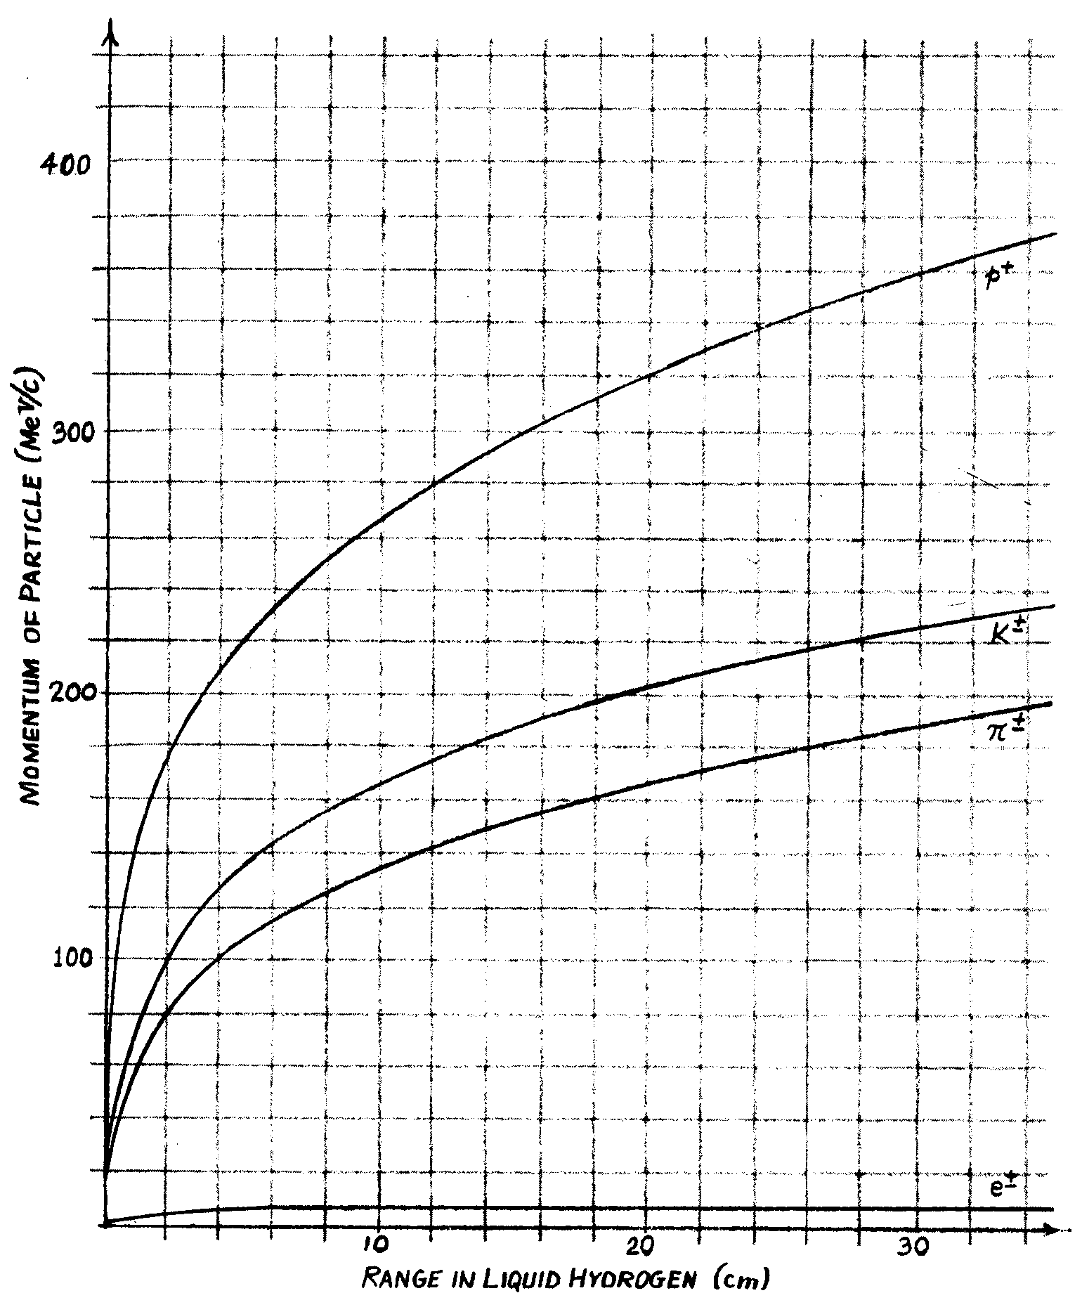

Graph from H. Whiteside, Elementary Particles, 1971.

