**MASS OF U.S. PENNIES**

# Name(s) Date

Particle physicists use graphs like the one shown to look at the results of their experiments. By putting mass readings on a histogram, they can see that the peaks show separate particles.

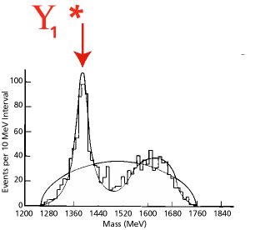

Since we don’t have ready access to particles or machines to make them, we are going to look at something more readily available: U.S. pennies. There are lots of pennies in circulation. Are they all the same? They all represent $0.01 and may be similar in color, but is that the only thing that they have in common?

Divide into groups of two or three students. Obtain a set of pennies from your teacher.

Begin by brainstorming characteristics of a U. S. penny. Identify the characteristics that can be measured or described with a number value. Measure and record as many properties of each penny as you can observe.

Organize your data in a table.

Draw a histogram of your group data and a histogram of the class data.

Answer the following questions on another sheet of paper. Show all calculations.

1. Describe the masses of the pennies in your set. Be as specific as you can.
2. Describe the masses of the pennies in the class set. Are there any differences between your set of data and the class set?
3. Can you suggest an explanation for the mass distribution that you see? What evidence can you provide to support your explanation?
4. Are there more pennies from more recent years or from prior years? Can you suggest an explanation for this? How would you test this idea?
5. Which year is represented by the most pennies? By the second most? By the third most?
6. What conclusion can you draw based on the evidence provided by your two histograms?

**Extension**

If other characteristics were recorded, construct the histogram for these results. What conclusion can you draw from this histogram? Did you make other histograms? Did any of them contribute to your conclusions? How?