X-ray diffraction, Rosalind Franklin, and DNA
7/20/2016
Rick Dower

This exercise is adapted from G. Braun, D. Tierney, and H. Schmitzer, “How Rosalind Franklin Discovered the Helical Structure of DNA: Experiments in Diffraction,” The Physics Teacher, 49, 140-143 (March 2011).

The world’s most famous x-ray diffraction photo is pictured in Figure 1. Called Photo 51 by Rosalind Franklin, it was published by her and R. G. Gosling in Nature 171, 740-741 (25 April 1953).

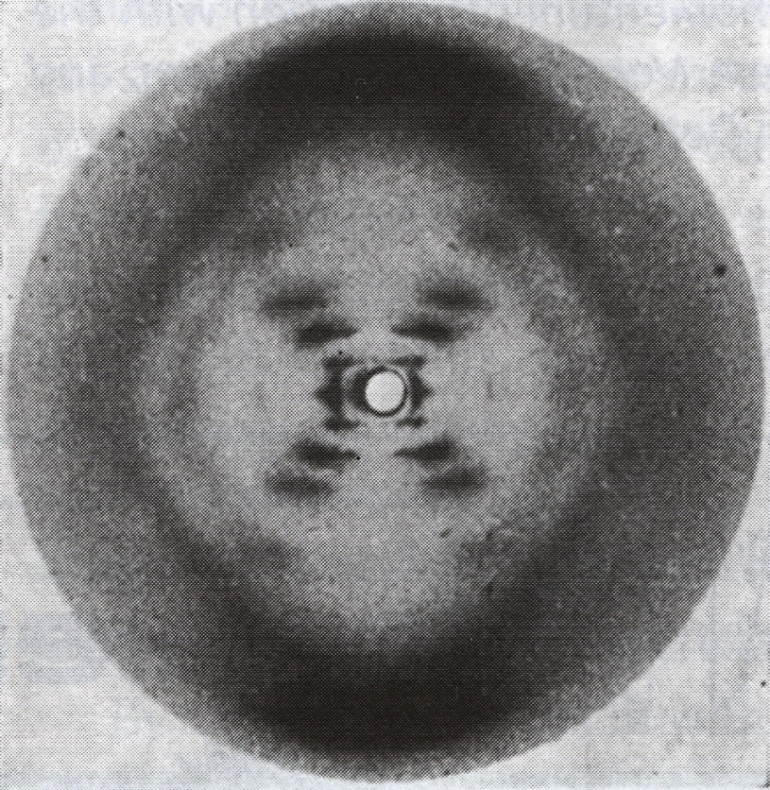
Figure 1 Rosalind Franklin's Photo 51 DNA diffraction photo. The zero order and some of the first order diffraction images are blocked by a lead disc to avoid over exposure of the film (white circle in center).
This diffraction photo of hydrated sodium thymonucleate (DNA) provided the evidence needed by James Watson and Francis Crick to support their proposed double helix DNA structure that they had based on published chemical clues and a physical molecular model they constructed. As they acknowledged, “We have also been stimulated by a knowledge of the general nature of the unpublished experimental results and ideas of Dr. M. H. F. Wilkins, Dr. R. E. Franklin, and their co-workers” Nature 171, 737-738 (25 April 1953).

In this exercise, students use the power of x-ray diffraction analysis to confirm this relatively simple, yet fundamentally important, molecular structure. We start with the analogy of the visible light diffraction pattern of a portion of a single helix formed by the small coil spring from a retractable pen (Figure 2).
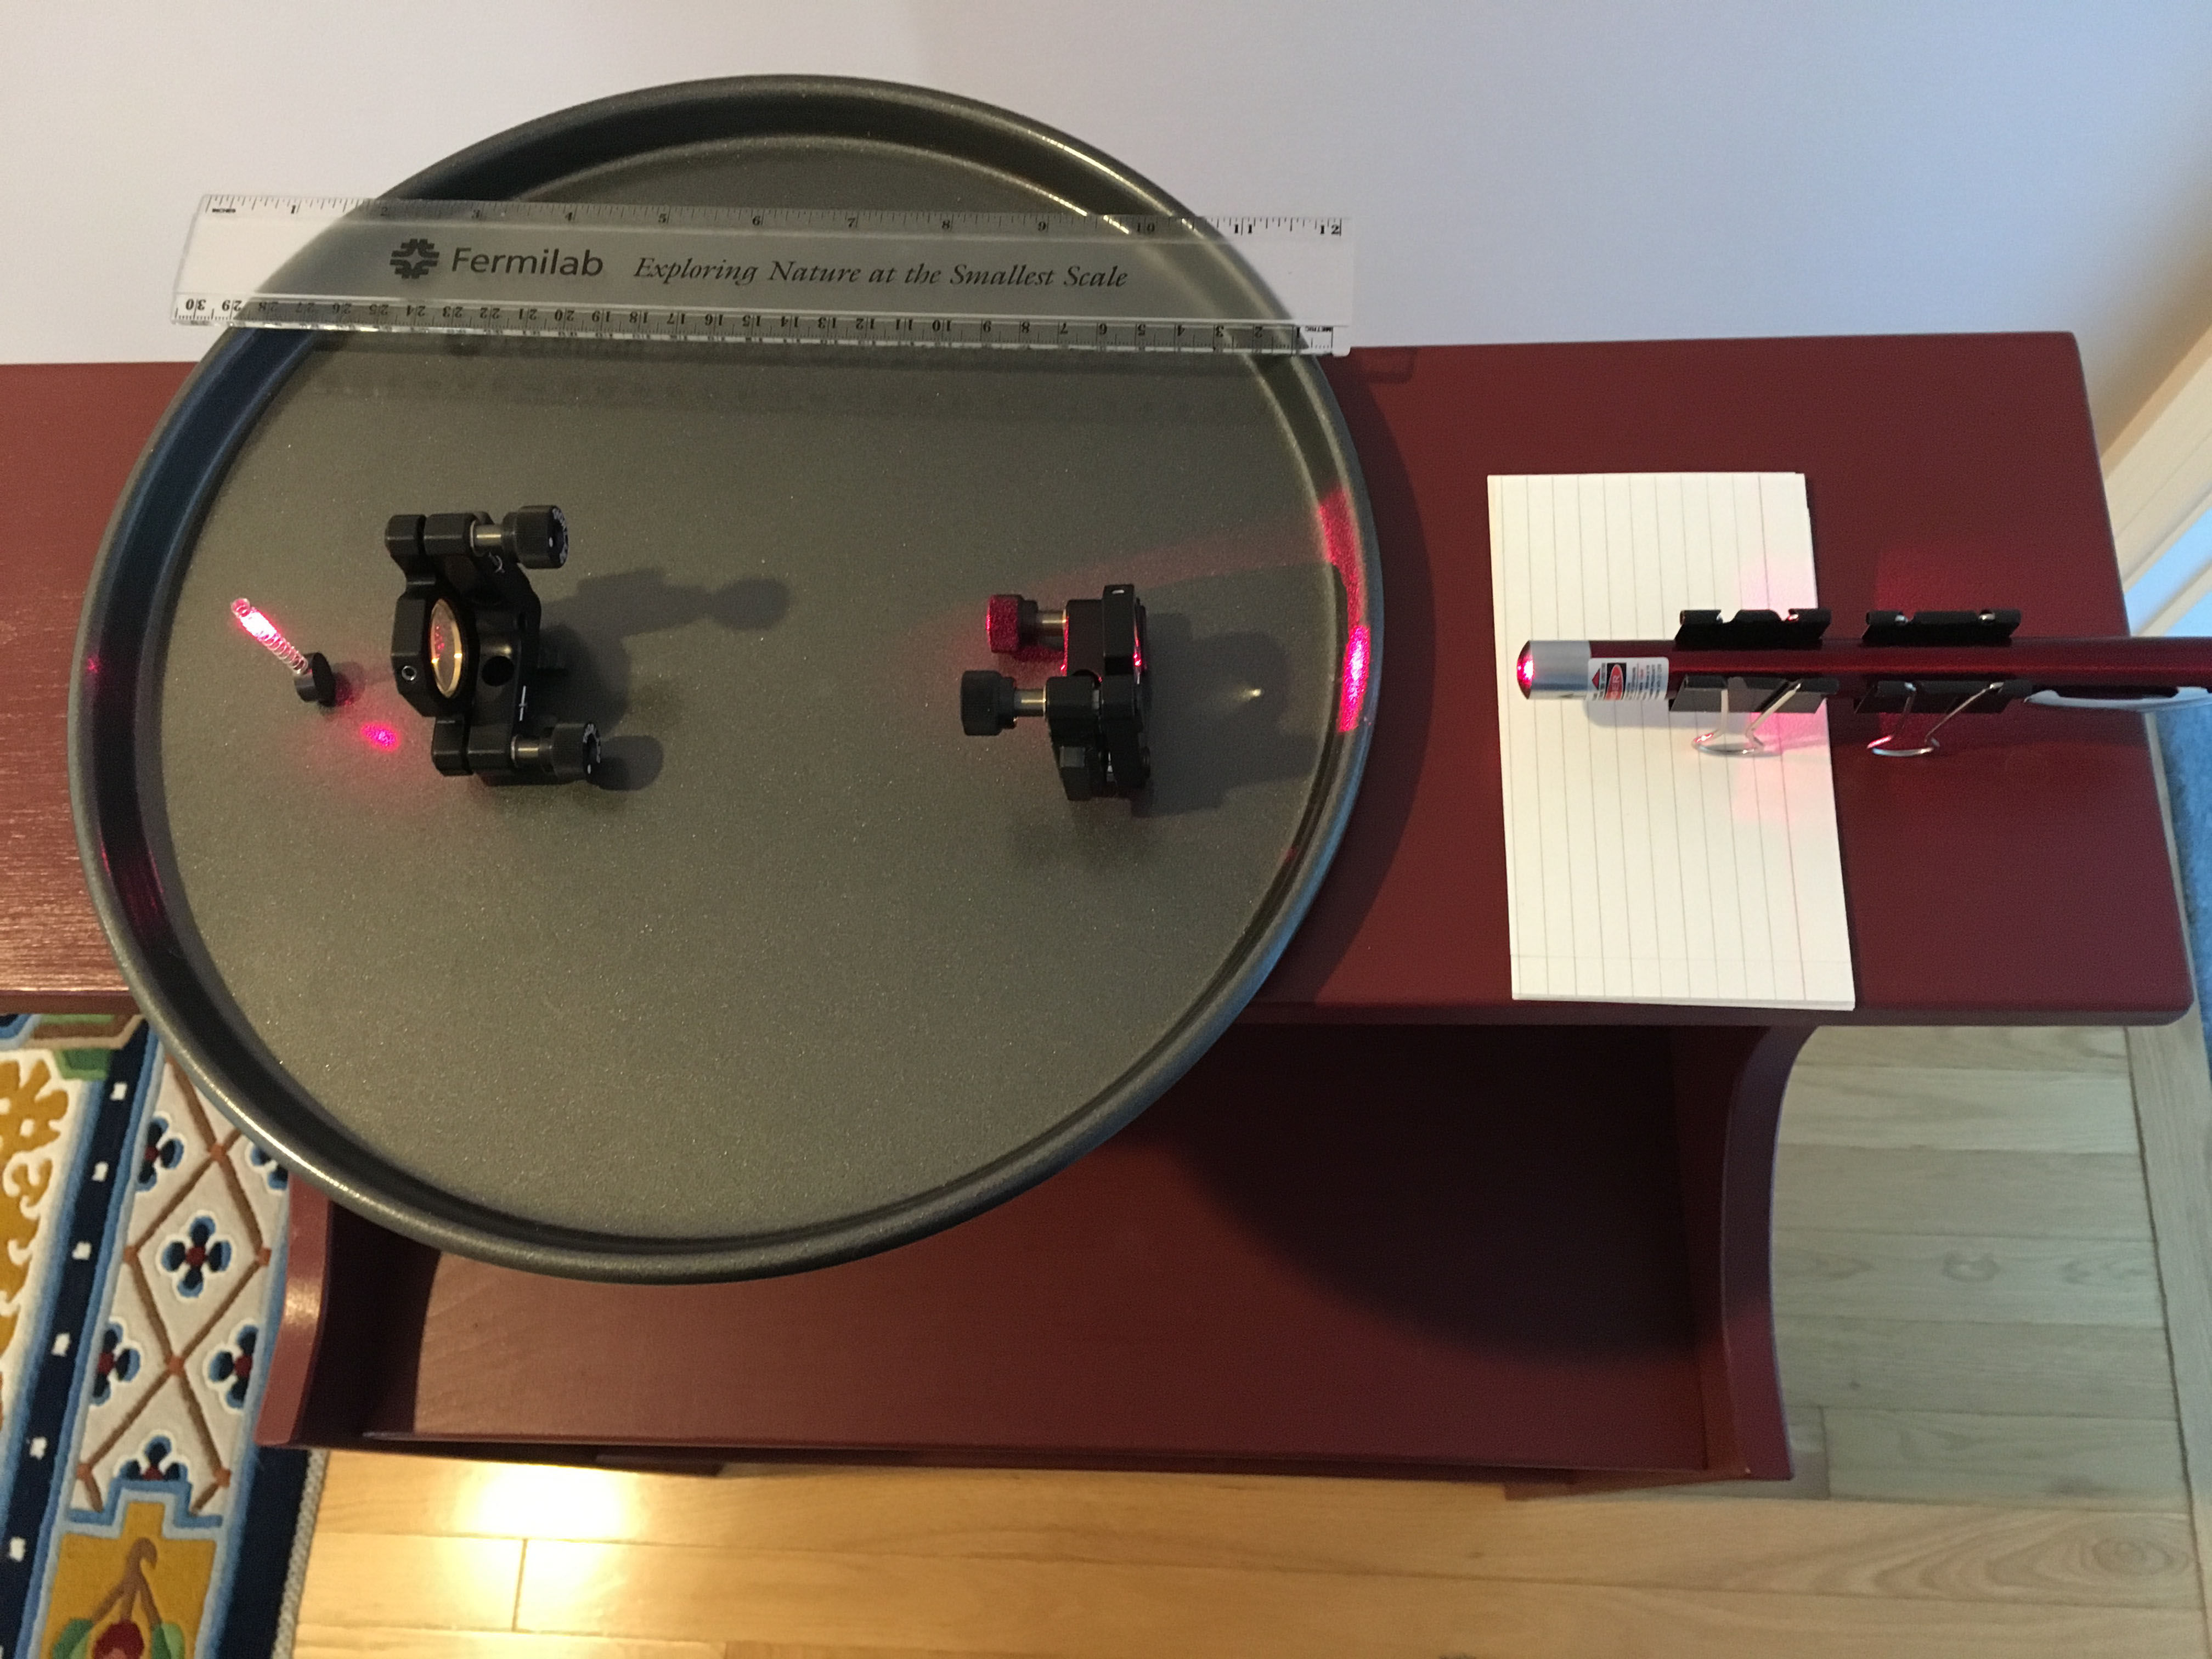
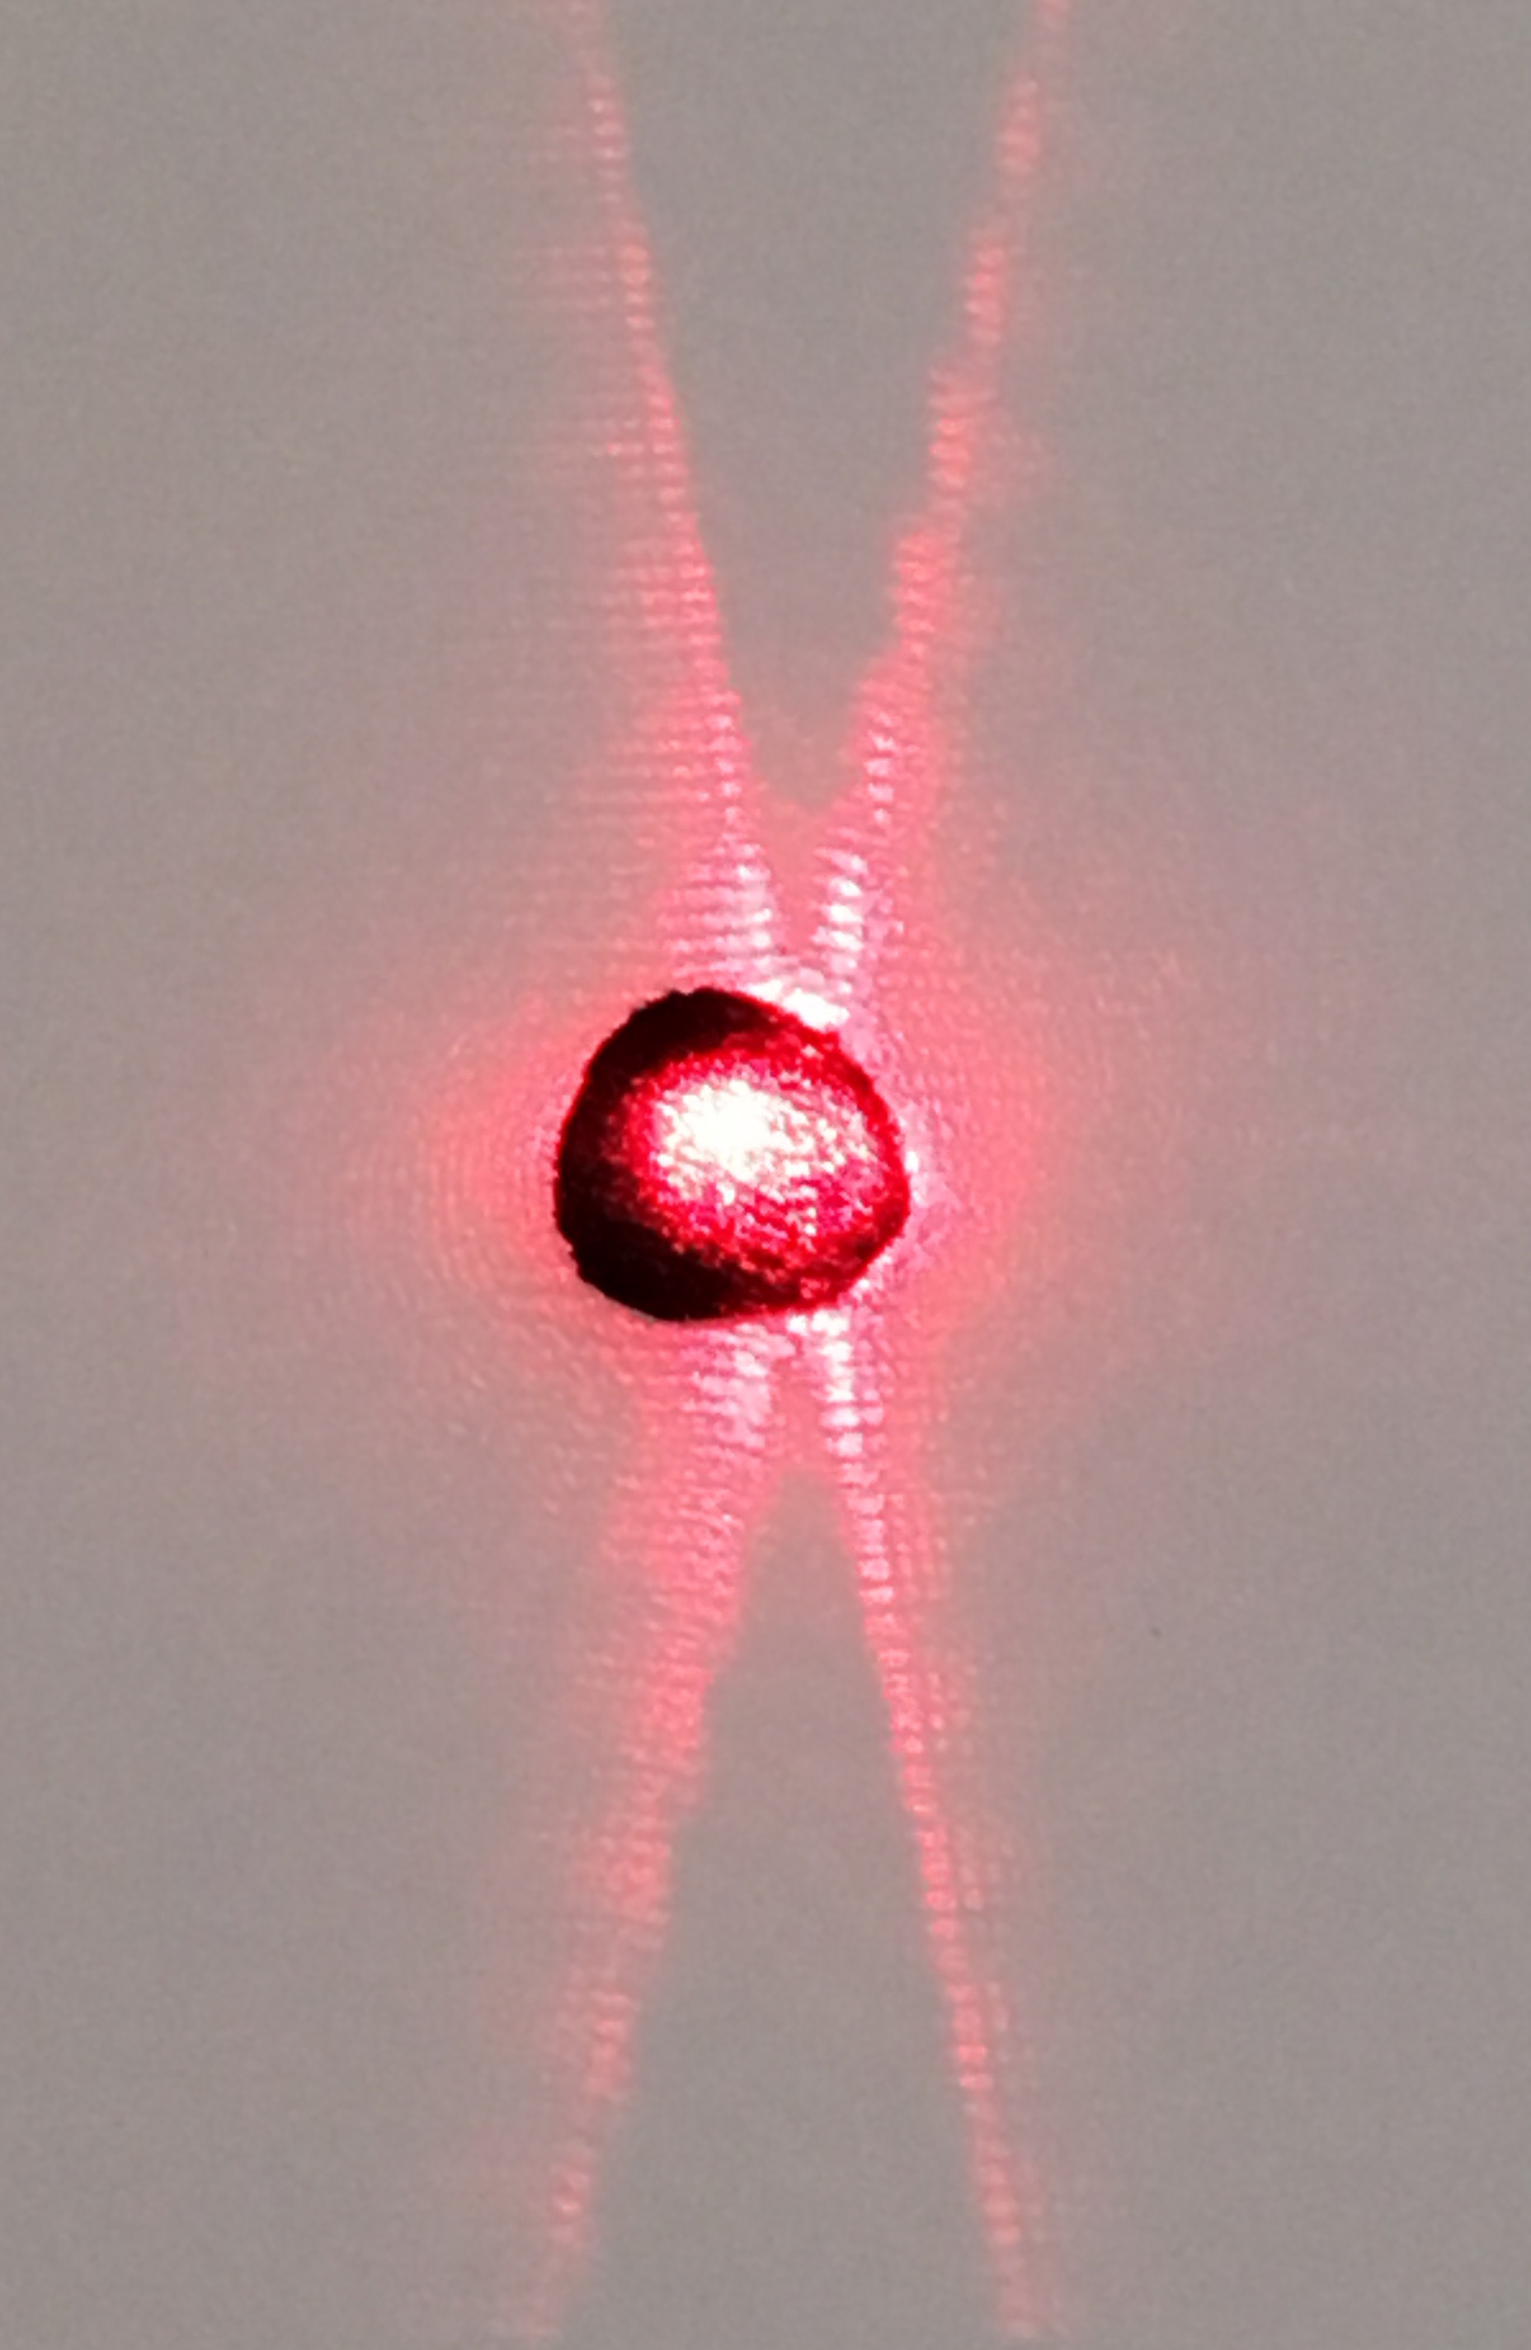

Figure 2 Diffraction pattern of a coil spring Figure 3 Laser, beam expander lenses, and spring coil
Interpretation of this image is assisted by a projection of a right-handed circular helix in the y-z plane. Expressions for a circular helix about the z-axis are
x = Rcos(2πt/T), y = Rsin(2πt/T), z = P(t/T) , as t varies continuously,
Or x = Rcos(2πz/P), y = Rsin(2πz/P), z = z
R = radius of helix circle projected in the x-y plane,
P = pitch of helix, i.e. distance between corresponding points on successive turns of the helix.
T = period of the helix for one full turn
The projection of this helix in the y-z plane is y = Rsin(2πz/P),
which is shown in Figure 4 with y the vertical axis and z the horizontal axis.

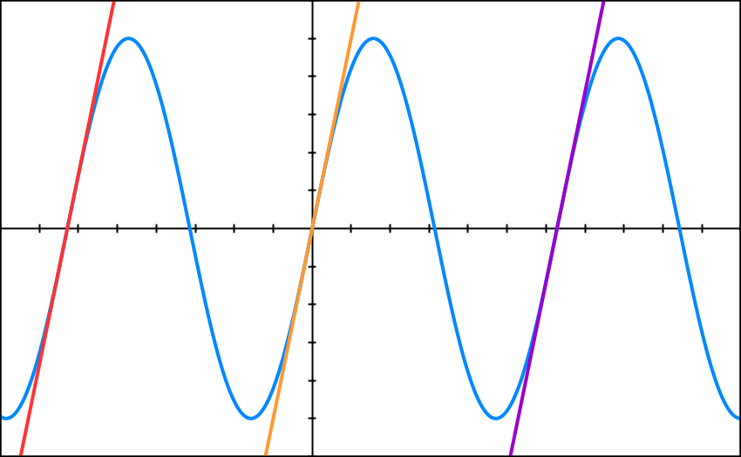
α
P

R
α

d

Figure 4 Graph of helix in the y-z plane with lines
y = R(2πz/P+2π), y = R(2πz/P), and y = R(2πz/P-2π)

The three parallel lines slanted to the right in Figure 4 approximate half of the sine curve shown. The slope of those lines is the slope of the sine curve as it crosses the z-axis (y = 0). The sine curve slope is the derivative of the sine curve. The helix pitch angle (α) is the complement of the slope of the slanted graph lines. So at (0,0),

line slope = $\frac{dy}{dz}=R\left(\frac{2π}{P}\right)\cos\left(\frac{2πz}{P}\right)$= R (2π/P) = tan(90° – α) (1)

Lines slanted to the left at an equal angle α would approximate the other half of the sine curve. The angle between the two groups of lines is 2α. To determine the diffraction pattern of these two groups of lines, we can apply Babinet’s principle: the diffraction pattern of an opaque body is opposite in phase, equal in amplitude, and, therefore, equal in intensity to that of a hole in an opaque screen of the same size and shape. Then the diffraction pattern of half the sine curve of the helix is approximately the same as the pattern of equidistant parallel lines (or equidistant parallel slits), i.e. the pattern of a diffraction grating with the diffraction images spread out perpendicular to the set of parallel lines. Applying the same reasoning to the parallel lines slanted to the left, we get another set of diffraction images spread out perpendicular to those lines.

The angle between the two sets of diffraction images is, therefore, also 2α.

The angles from the grating to image maxima for a diffraction grating are given by

sin(θ_{max}) = mλ/d , (2)
where m = integer
d = perpendicular distance between parallel lines in grating
λ = wavelength incident on grating

Measuring the location of diffraction maxima on a screen and the distance from the helix to the screen allows the calculation of the diffraction angles θ_{max}. Counting images outward from the zero-order maximum in the center of the pattern determines the integer m. With knowledge of the illuminating wavelength λ, one can calculate the grating spacing d. The helix pitch is then given by

P = d/cosα , (3)

as seen in Figure 4. The helix radius R can be calculated with Equation 1.

The laser beam expanded to intercept several coils of the spring (Figure 3) for greater uniformity in the diffraction pattern in Figure 2. A piece of black velvet absorbed much of the light in the center region in Figure 2 to avoid overexposure.

Spring Coil Exercise
- Use a diffraction grating to determine the wavelength (λ) of a laser.
- Use convex lenses to collimate and expand a beam from the laser so it will intercept several coils of the spring from a retractable pen. Aim the laser at a wall several meters away and make sure the beam is collimated.
- Place the coil spring in the laser beam and stick a piece of paper on the wall to intercept the far field diffraction pattern.
- Use a straightedge to mark the axes of the diffraction patterns on the paper. Mark on the paper the locations of 10 or more closely spaced node (dark) lines along one (or more) of the arms of the diffraction “X” pattern.
- Measure the distance (L) from the coil spring to the center of the diffraction pattern.
- Measure the angle 2α between your straightedge lines on the paper that indicate the diffraction pattern. If your spring is mounted vertically, the angle will be between the top arms of the “X”.
- The wire thickness of the coil spring will create a secondary pattern that produces large dark nodes along the diffraction “X”. These will obscure some of the closely and evenly spaced nodes of the coil pattern. Take this into account and determine the average distance (x_{avg}) between the closely spaced nodes in the pattern. This is the same as the distance between antinode (maxima) centers in the pattern. When the distance to the screen is large, the diffraction angles are small and the tangent and sine of the diffraction angles are nearly the same. Then for m = 1, sin (θ_{max}) ≅ x_{avg}/L.
- Calculate the perpendicular distance between coils in the spring (d), the spring coil pitch (P), and the coil radius (R) from your diffraction pattern measurements.
- Measure the coil pitch and radius with a ruler of calipers and compare to your diffraction measurements.

Laser Wavelength = λ = ________________ nm

Twice the coil pitch angle = 2α = ______________ degrees

Coil-to-Diffraction-Pattern Distance = L = ___________________ m

Average distance between closely spaced diffraction nodes = x_{avg} = ___________ m

Diffraction measurements: d = __________ mm P = ___________ mm R = __________mm

Direct measurements: P = ___________ mm R = __________mm

Photo 51 DNA Exercise
- Assume that Rosalind Franklin used the copper Kα x-ray line for her photo.
Then λ = 0.154 nm.
- Assume the x-ray photo emulsion was placed L = 90 mm from the DNA sample. (This assumption is based on the assumption above and the 94 mm diameter of the largest circle in the original photo.)
- With a straightedge draw lines through the approximate centers of the dark spots of the diffraction “X” in Figure 1 and measure the angle 2α at the top for the vertical DNA sample.
- A lead disc blocked to zero order diffraction spot on the photo. Measure the distance (y) along the arms of the “X” to the m = 1 (somewhat obscured), 2, 3, and 5 diffraction spots on each of the arms and take an average (y_{avg}) for each m value.
- Calculate the θ_{max} values from tan(θ_{max}) = y_{avg} /L for each m value.
- Calculate the d, P, and R values for each m value.
- Calculate an average value for P and R of the DNA helix in Photo 51.
- Compare your values to Franklin’s values of P = 3.4 nm and R “about” 1 nm.
- Evidence for a second identical helix in the DNA molecule is obtained from the absence of an m = 4 diffraction spot. As Franklin and Gosling noted, “The structural unit probably consists of two co-axial molecules [helices] which are not equally spaced along the fibre axis,… if one molecule [helix] is displaced from the other by about three-eighths of the fibre-axis period, this would account for the absence of the fourth layer line and the weakness of the sixth. Thus our general ideas are not inconsistent with the model proposed by Watson and Crick in the preceding communication. [Nature 171, 737-738 (25 April 1953)]”
A second helix on the same axis displaced a fraction of a period (i/j , where i, j are integers and i<j) would produce a diffraction pattern like that of a grating with spacing (i/j)d, where d is the spacing of a grating corresponding to the original helix. Such a grating would produce minima in the diffraction pattern at angles given by sin(θ_{min}) = (n+1/2) λ /(i/j)d, where n is an integer.
Find (i/j ) values for which a minimum of the two-helix pattern with n<m occurs at the same angle as the m = 4 maximum of the one-helix pattern.

