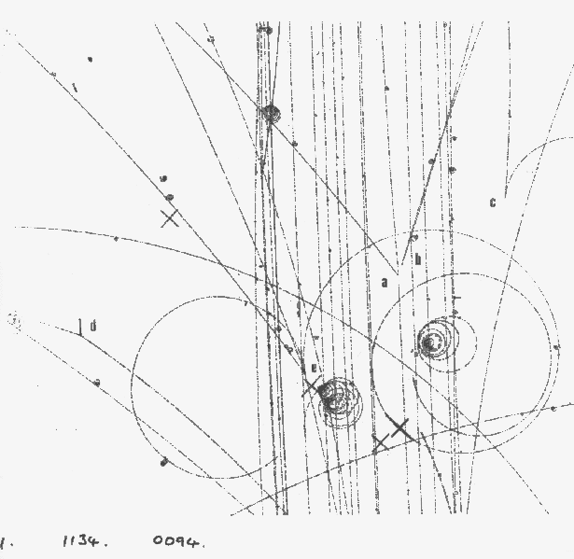

Diagram #1: Can you identify the events labeled a – e? Your task is to identify with your “expert” group all of the events labeled in the diagram. Also, identify any other interesting events that you may notice. When time is called you will return to your original group to discuss and explain all of the events that you are all now “experts” at identifying. Your goal is for every member of the group to become confident in the identification of all particle tracks in the bubble chamber images.

- ___________________________________________________________________________________
- ___________________________________________________________________________________
- ___________________________________________________________________________________
- ___________________________________________________________________________________
- ___________________________________________________________________________________

