**Calculate the Top Quark Mass**

**Student Notes**

**E = mc2 Used in the Creation of the Most Massive Quark Yet Discovered!**

**Analysis of DZero Data From Fermi National Accelerator Laboratory**

Have you ever wondered how scientists can determine the properties of particles so small we cannot see them with microscopes? How do scientists even know that atoms exist? This activity is designed to help you understand how these particles can be found and their mass determined using indirect measurements.

Today you will use Einstein's famous equation and experimental data collected in 1995 from a special event in Fermilab's DØ experiment that is two-dimensional rather than three-dimensional to determine the mass of the **top quark**, the most massive quark discovered.

While this event looks complex at first, notice the following characteristics in the picture below:

1. A proton and antiproton collide to create a top/anti-top pair that exists for a very short  time.
2. Almost immediately the very massive top and anti-top decay into the constituents that are  known to be their signature.
3. These include:

* Four "jets" (large blasts of particles) that are the result of decays of W bosons and some less massive quarks. It is important to note that one of the jets will often contain a low-energy or "soft" muon. The soft muon helps identify the jet as a bottom quark jet.
* A muon and a neutrino. (You can see them in the upper right part of the diagram.)

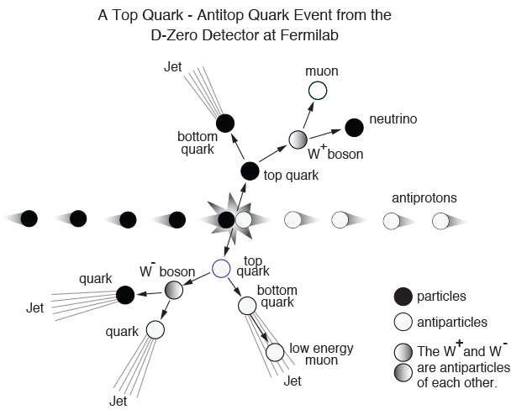

The diagram shows the collision for the event labeled **Run 92704 Event 14022**. Other top-antitop event displays can be represented by similar diagrams but may not have exactly the same debris, going in the directions shown here.

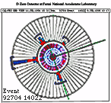

A thumbnail image of data from

**Run 92704 Event 14022**

**What do we know?**

Data from DØ events are displayed in images like this one for event **Run 92704 Event 14022.** It shows the recorded momentum (in GeV/c) of the particle debris that came from the collision. Your class has four event displays.

Can you identify the constituents of the top-antitop signature in data display? Look closely; the only information given about the neutrino is the magenta tower indicating its direction. While scientists can predict with confidence that a neutrino comes out of the collision, DØ cannot detect it. Still, a careful consideration of the momentum before the collision and after the collision may give you a clue as to how much momentum the neutrino has!

1. Momentum is conserved.
2. The total momentum of the system is zero before the proton and antiproton collide.
3. Momentum is a vector.
4. These 2-D events largely occurred in the plane of the paper on which the event display is  printed.
5. Physicists know that with a careful choice of units, it is possible to equate momentum and  energy in a way that is similar to the way mass and energy are related. Specifically, it may be shown that the momentum of the collision debris has the same *numerical value* as the energy or mass of the particles. In other words, E (in GeV) = p (in GeV) = m (in GeV) (GigaelectronVolts). This shows, then, that the total energy that came from the two top quarks that were formed is equal to the *numerical sum* of all the momenta discovered in the collision.

**What tools do we need for our analysis?**

We need a notebook to record masses and decay types (dielectron or dimuon), ruler, protractor, pencil to make a **momentum vector diagram** and our [data file](http://leptoquark.hep.nd.edu/~kcecire/drupal_lib/files2015/ADEevents.pdf).

**What will we do?**

We will work in teams of two to determine the neutrino momentum and the mass of the top quark.

We will share our results with the class.

We will discuss the significance and develop claims based on our data and the class data.

**What are our claims? What is our evidence?**

Your results must include:

* A value for the missing momentum of the neutrino
* A value for the mass of the top quark

These results can help you make a claim that answers these questions:

* Explain how scientists use conservation of momentum to determine the missing momentum carried away by the neutrino
* Explain how scientists use conservation of energy to determine the mass of the top quark.
* Are mass, energy and momentum the same thing given that the units at high energy are the same.
* Use the evidence from your class data to describe how scientists decide when to announce discoveries.
* Describe how the properties of the neutrino make it impossible to directly detect the presence of a neutrino in the event plot.