TOTEM Entanglement - incomplete draft
Teacher Notes
Description
In TOTEM Data Express, students were able to establish that matter has wave properties. They did this by inspecting events from the TOTEM sub-detectors system at the Large Hadron Collider (LHC) to find the elastic scattering angles of protons that collide at the CMS detector. Students uncovered evidence for the quantum nature of the proton. They did this proton-by-proton, showing that the paths of protons in elastic collisions are determined by a wave interference pattern. No one proton makes this pattern. Rather, it is the statistical result of the aggregation of many protons. The interference pattern is probabilistic: the likelihood of a particular path of a particular proton is most likely to follow the greatest maximum in the interference pattern, somewhat less likely to follow lesser maxima, etc.
In TOTEM Entanglement, students use this knowledge to take the next step and ask, “Are pairs of colliding protons quantum entangled?”
Standards Addressed
Note: These standards are taken from TOTEM Data Express and are subject to revision.
Next Generation Science Standards
Science and Engineering Practices
- Analyzing and interpreting data
- Using mathematics and analytical thinking
8. Obtaining, evaluating and communicating information
Common Core Literacy Standards
Reading
9-12.4 Determine the meaning of symbols, key terms . . .
9-12.7 Translate quantitative or technical information . . .
Common Core Mathematics Standards
MP1. Make sense of problems and persevere in solving them.
MP2. Reason abstractly and quantitatively.
MP4. Model with mathematics.
IB Physics Standards

1.2.11 Determine the uncertainties in results.

4.5.5: Constructive and destructive interference

4.5.6: The role of path difference and phase difference in interference
12.1: Wave particle duality
AP Physics Standards
2 1.D: Classical mechanics cannot describe all properties of objects.
2 6.C: Only waves exhibit interference and diffraction.
Enduring Understanding
Particle physicists use the wave nature of particles to discover properties of particles. (Change?)
Learning Objectives
Students will know and be able to:
- Measure the paths of protons on one side of the elastic collision point of two protons using data from the TOTEM detector.
- Predict the paths of unmeasured particles on the opposite side of the collision using conservation of momentum.
- Evaluate the uncertainty in their measurements and thus in their predictions.
- Create plots as graphical evidence of the level of accuracy of the predictions within expected uncertainty.
- Discuss the results of testing their the predictions understanding the protons as subject to the laws of quantum physics, including their probabilistic wave nature.
Prior Knowledge
Students must be able to:
- Demonstrate a working understanding of the results of TOTEM Data Express, including interpretation of a histogram, recognition of wave interference, and attribution of this to the quantum nature of the proton.
- Apply conservation of momentum in elastic collisions.
- Create and interpret scatter plots.
Background Material
These resources on TOTEM, the LHC and the physics related to the activity are included on the student pages:
- TOTEM:
  - Experiment home page: http://totem-experiment.web.cern.ch/totem-experiment/
  - Explanatory video: https://www.youtube.com/watch?v=YsZhwu32Zaw
- Diffraction:
  - Wikipedia: http://en.wikipedia.org/wiki/Diffraction
- Quantum entanglement:
  - Video by Don Lincoln: https://www.youtube.com/watch?v=JFozGfxmi8A
  - Wikipedia: https://en.wikipedia.org/wiki/Quantum_entanglement
Resources
- “Red team” data file: https://quarknet.org/sites/default/files/TOTEMredteam.pdf
- “Green team” data file: https://quarknet.org/sites/default/files/TOTEMgreenteam.pdf
- TOTEM Data Express result, https://quarknet.org/sites/default/files/totemisu_jun2021.jpg
Implementation
The teacher should give students a pre-assignment to learn a little about quantum entanglement and about the TOTEM experiment from the resources above. The question posed at the outset of the measurement is, “Can we find evidence of quantum entanglement in TOTEM data?”

The procedure from the teacher point of view:
- Students are divided into two groups: “red” team and “green team”.
- The red team and green team data tables each have 20 events. Assign each pair of students about 4 events. Oversample if necessary.
- Students in red team will examine TOTEM events which indicate where protons hit one side of the TOTEM detector. This data may be gleaned as x- and y-components of angles in microradians. They will use this data and conservation of momentum to determine where the proton with which theirs collided hit the opposite-side TOTEM apparatus. This should be recorded as θ_{x} and θ_{y} along with the event number.
- Students in green team will examine TOTEM events which indicate where protons hit the opposite side of the TOTEM detector. This data may be gleaned as x- and y-components of angles in microradians. This should be recorded as θ_{x} and θ_{y} along with the event number.
- Have students estimate measurement uncertainty from the event display.
- With all student data collected,
- Take the red team predictions, ordered by event, and put them side by side with green team results. Make plots of red-predicted θ_{x} and θ_{y} vs, green-actual θ_{x} and θ_{y}. Do you get straight lines with slope 1?
- Discuss the meaning of results: Is this quantum entanglement? Use the discussion guide below.

Questions for discussion with students
The teacher should work with the students to determine from evidence and reasoning whether the results indicate quantum entanglement between elastically colliding protons. The purpose of the discussion is to better understand entanglement by discussing the result, regardless of the conclusion. The following questions can guide discussion.

What is the evidence that protons can behave with a wave-like nature when they undergo elastic shallow-angle collisions?

How does this wave nature affect the path of an individual proton after the collision? How does it affect the path of the proton with which it collided?

If the path of any one proton A is probabilistic, how does the opposite, also probabilistic, proton B “know” to go in the direction that conserves momentum with A?

Are their paths entangled…or is it just conservation of momentum, full stop?

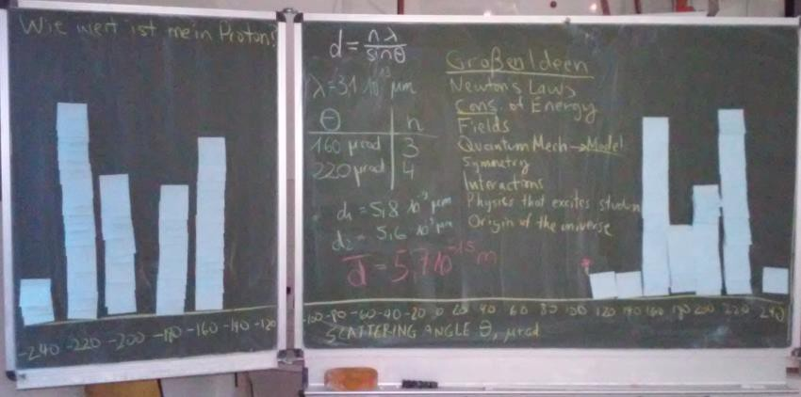
The sticky notes each represent the path of one proton in TOTEM Data Express, forming, together, what appears to be an interference pattern. These results were obtained by a pre-service physics didactics class at Technische Universität Dresden.

