Lawrence Berkeley National Laboratory
Annual Report 2022
July 11, 2022
Mentor: Tony Spadafora
Workshop Coordinator: Laurie Kerrigan
Co- Organizer: Ken Cecire (QuarkNet)

The LBNL Physics Division hosted its sixteenth “Physics in and Through Cosmology” workshop for QuarkNet Leadership teachers and high school students. This two-week virtual workshop from June 21 to July 1, 2022, was held via Zoom. Six physics teachers participated. All of the teachers have been active members of QuarkNet. There was one retired teacher also, who has been active in QuarkNet throughout his career. 46 students participated. Most of the teachers and students joined from public and private high schools in the greater San Francisco Bay Area, although a few joined from throughout the U.S.
We have been making an effort to include underrepresented students in STEM (which include: African Americans, American Indians/Alaska Natives, Latinos, LGBTQ+, students from low income households, and first-generation college attendees) by outreaching to schools in lower income & underrepresented areas.
Saul Perlmutter - feilding student questions at a drop in session.
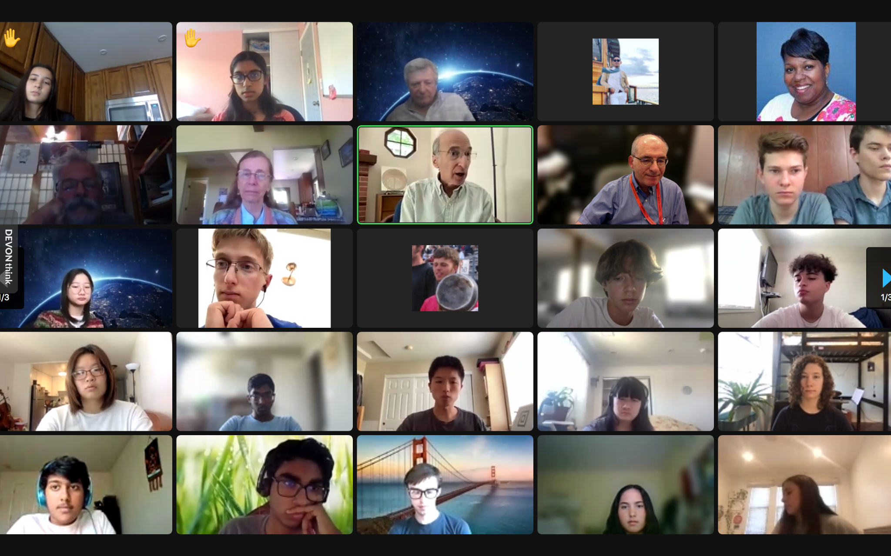

This year we meet each weekday for 2 weeks for 3 hours per day. Most meetings started with a question slide to get students thinking about that day’s topic. Then there was a talk by an LBNL scientist and either small group work or virtual activities. The small group work included a Scientist Interview Project, and QuarkNet activities led by Ken Cecire. Ken led three sessions guiding everyone through a fundamental particle activity, Z mass measurement, and a search for the Higgs in CMS data. A video was shown by Glen Melnik who explained Special Relativity so that he could lead a discussion on cosmic rays and how a cosmic ray detector worked. He also gave students data to interpret that had been collected in previous years.

Highlights of the program were a drop in visit by Nobel Prize winner, Saul Perlmutter, and a round table panel discussion with the Scientists on the last day. Each small group presented a short video or PowerPoint about the work the Scientist they interviewed was doing.

Scientist interviewed by students:
Mariel Pettee Fernando Torales Acosta Karol Krizka Louis-Guillaume Gagnon
Elliot Reynolds Greg Ottino Ryan Roberts Maria Giovanna Foti Julian Borrill
Formal presentations by LBNL scientists included:
Anthony Spadafora “Welcome QuarkNet ‘22
Nao Suzuki "Tour of the Universe"
Haichen Wang "The Large Hadron Collider as a Probe to the Unknown"
Kevin Wood "Neutrinos"
Mariel Pettee "Machine Learning"
Elliot Reynolds “Probing the interaction strength of the Higgs boson to the charm quark”
Anthony Kremin - "Understanding the Unknown: The Mystery of Dark Energy"
Scott Haselschwardt - “Mining for Dark Matter Interactions.”
Nathalie Palanque-Delabrouille - “Research in Cosmology”
Julian Borrill "Big Bang, Big Data, Big Iron".

Scott Haselschwardt presentation - “Mining for Dark Matter Interactions”

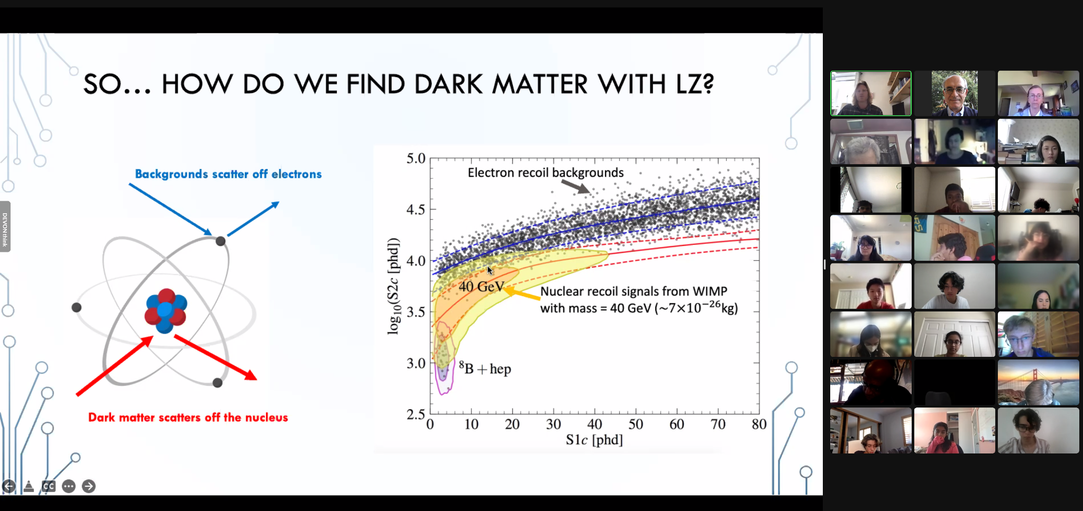

Comments from overall evaluations of workshop by teacher & students:
I liked that there were new speakers every day, it was super interesting to see different perspectives and different people with different interests.

Being able to ask whatever questions I wanted and getting a really great answer

Gave an in depth view on physics (which my school doesn't really offer as a class...)

There were guest speakers who were actually doing research on the frontier of cosmology and we got to ask them about not just the science but also what their careers are like. I feel like I got a good impression of what it is like to be a physicist through this workshop.

I really loved the diverse set of scientists we got to meet and the different topics they all had to share. It really shows the depth of a single field.

I liked hearing about the career paths of all of the scientists. It was also cool getting to do some math with LHC data.

I really liked hearing about the cutting edge physics that was occurring. I really learned a lot and hearing about ATLAS, CERN, dark matter, particle physics, etc. left me in awe wanting to know more.

I loved the opportunity to interview a brilliant researcher. It inspired further to pursue a career in theoretical (or maybe even experimental) physics instead of locking onto math already.

Everyone wants to be here and is passionate about the subjects, it was cool to interact with like minded peers

Mariel Pettee presentation - :Machine Learning”
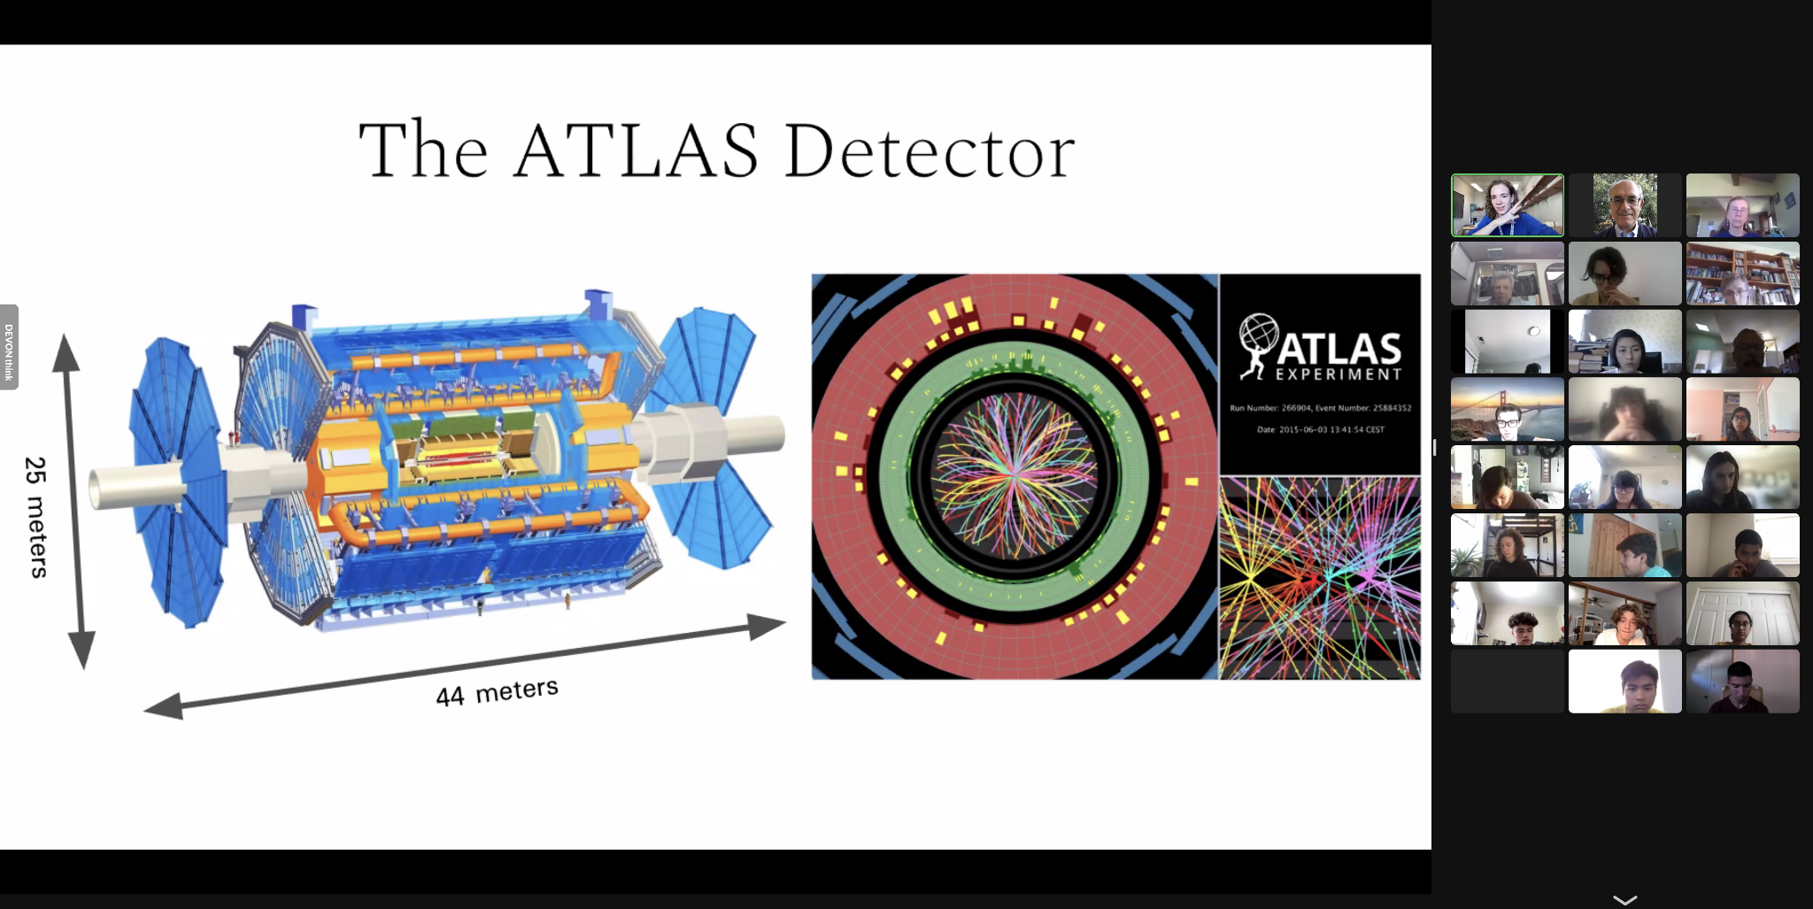
List of Teachers:
Phil Becker Laura Guthrie Virgil Jackson Laurie Kerrigan Glen Melnik Nicholas Tsotu

Comments by students on what they learned according to NGSS major areas in Physics:

Structure and Properties of Matter

Before coming to this workshop I was totally convinced that Protons, Neutrons and Electrons are the building blocks of the universe, and the neutrinos and quarks just float around a bit. But it turns out that the sub-sub-atomic particles are extremely important, and that quarks make up Protons and Neutrons, while electrons are "fundamental".

Matter is a very small part of the known universe. Now that we have studied standard model particles, we need to analyze them to see if they interact with dark matter, because knowing only 5% of what the universe is made of leaves a lot of room to explore what else is out there.

Matter is made up of quarks and leptons, represented by the Standard Model. These fundamental particles interact through the 4 fundamental forces, and by exchanging the corresponding boson. Also, I learned about antimatter - canceling out matter - and dark matter.
Forces and Interactions
Forces cause changes in the speed or direction of the motion of an object. The greater the force placed on an object, the greater the change in motion. Newton’s 3 laws of motion are directly related.
Gravity has yet to be unified with particle physics. I already knew this, but I didn't understand the extent to which the theories were at odds.
There are 4 fundamental forces, 3 of which are incorporated into the standard model. They are electromagnetism, the weak interaction (unified into the electroweak interaction), the strong force, and gravity. Gravity is understood through general relativity, which theorizes the curvature of space-time.

Energy

I learned about a new type of energy, dark energy, a form of energy that acts opposite to gravity.

Energy allows us to find the mass of particles post collision.

Most of the mass of nucleons comes not from the quarks that make them up, but from the energy of all the strong interactions between the quarks and gluons.

Waves and Electromagnetic Radiation

Electromagnetic radiation is light, which can be thought about as either a particle (photon) or a wave. Scientists use electromagnetic radiation coming from the universe to measure many things, such as the cosmic microwave background and the expansion history of the universe (through cosmological redshift of electromagnetic waves).

I learned about gravitational waves and how it helps scientists understand space-time and the expansion of our universe.

Engineering Design

Essential to scientific discovery. Theorizing is all well and good, but without an ability to implement some way to test those theories they are little more than interesting notions.

Engineering is an integral aspect of experimental physics, LHC.

For trying to study SM particles, going far underground is very important to remove background noise. Sometimes a flawed result may not be from a newfound physics topic, it could just be imperfect engineering design, but it is also important to study any diverging data in order to see if you actually did find anything new and important. AI/ machine learning are making it much easier to collect and analyze data

Earth’s Place in the Universe

Earth is one small speck in the vast scheme of things.

We are INCREDIBLY far from anything else. Despite this, developments in our ability to look farther out into the universe are giving us new insight as to how existence works.

Earth is part of the Milky Way which is part of a supercluster which is part of a giant web of galaxy clusters held together by gravity and dark matter.

